**Machine Learning (ML) from beginner to expert level:**

[**StatQuest with Josh Starmer**](https://www.youtube.com/user/joshstarmer)

**Best for:** Beginners to intermediates

**Strengths:** Explains complex ML concepts (like linear regression, decision trees, neural networks) in simple, intuitive ways with visuals.

* + Machine Learning
  + Statistics Fundamentals

[**sentdex (Harrison Kinsley)**](https://www.youtube.com/user/sentdex)

* **Best for:** Practical Python + ML coding
* **Strengths:** Hands-on tutorials using scikit-learn, TensorFlow, PyTorch, and real-world datasets.
* **Top Playlists:**
  + Machine Learning with Python
  + Deep Learning with Python and TensorFlow.

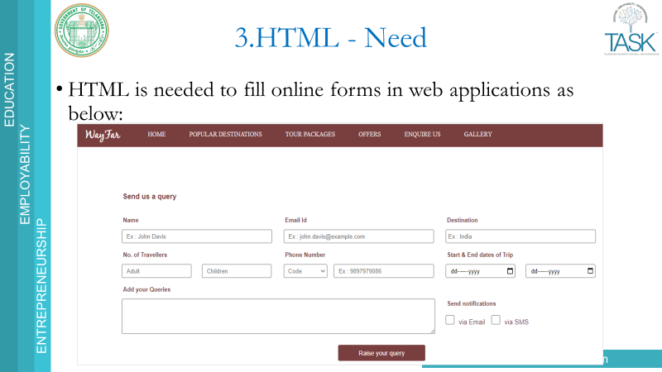

<input type="text" name="username" value="RealCode Synapse">

* `type`: Specifies the type of input (e.g., text, password, checkbox).
* `name`: Provides a name for the input field.
* `value`: Specifies the initial value of the input.

**<form> Tag**:

Used to collect user input.

Common Elements:

<input>: Text, password, radio, checkbox, etc.

<textarea>: Multi-line text input.

<select>: Dropdown list.

<button>: Submit or reset button.

**Types Of Input**

<input type="button">

<input type="checkbox">

<input type="email">

<input type="image">

<input type="number">

<input type="password">

<input type="radio">

<input type="range">

<input type="reset">

<input type="search">

<input type="submit">

<input type="text">

* CSS:  
  How to transform elements to create attractive web pages.
* This course also explains about creating responsive web pages using media queries.
* CSS refers to Cascading Style Sheets. CSS helps in styling the HTML pages.

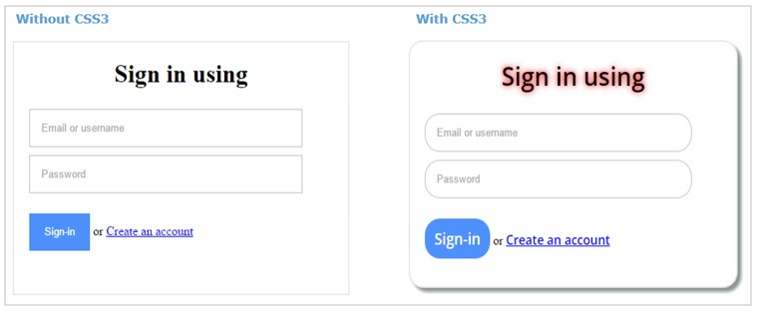

CSS3 is the latest version of CSS. CSS3 provides new styling elements using which we can style webpages without any additional tools.

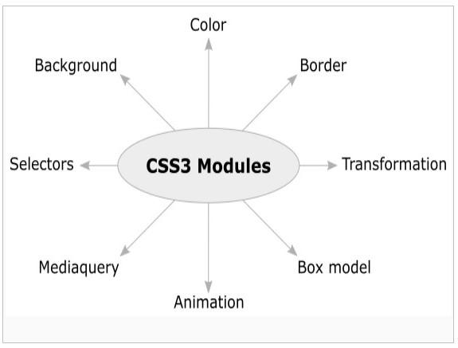

* A CSS rule-set consists of a selector and a declaration block:

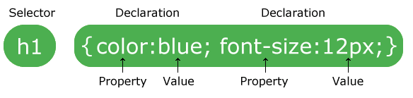

* CSS is a style sheet markup language. CSS styles are written as a property value pair.
* **Syntax:**property: value
* **Example:** color: green;
* The style rules are applied to the HTML elements using selectors.

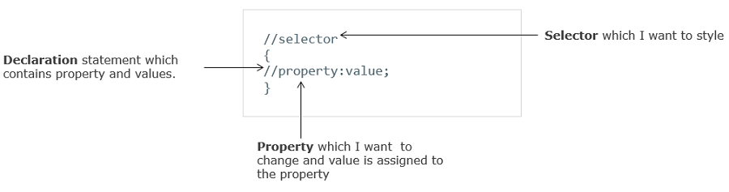

**Types of CSS**

1. **Inline styling**
2. **Internal styling**
3. **External styling**
4. **Importing style sheet**

### 1. ****Inline Styling****

Styling applied directly to an HTML element using the style attribute.

**Syntax**:

<p style="color: red; font-size: 16px;">Hello</p>

### 2. ****Internal Styling****

CSS written inside a <style> tag within the HTML <head>.

**Syntax**:

<head>

<style>

p { color: blue; font-size: 16px; }

</style>

</head>

### 3. ****External Styling****

CSS rules are placed in a separate .css file and linked to the HTML.

**Syntax**:

<head>

<link rel="stylesheet" href="styles.css">

</head>

styles.css:

p { color: green; font-size: 16px; }

### 4. ****Importing Style Sheet****

CSS file is imported using @import inside a <style> tag or another CSS file.

**Syntax**:

<style>

@import url("styles.css");

</style>

Or in another CSS file:

@import url("theme.css");

**Selectors**

* + 1. **Element Selector**

### ****Element Selector****

**Definition**: Selects all HTML elements of a specific type.

Styles all elements of a given type.

**Syntax:**

p { color: blue; }→ Applies blue color to all <p> elements.

**2. ID Selector**

**Definition**: Selects a single, unique element with a specific id attribute.

Styles one specific element using its unique `id`.

**Syntax:**

header { background-color: yellow; }→ Targets the element with id="header".

**3. Class Selector**

Selects all elements that share the same class attribute.

Styles multiple elements that share the same class.

Syntax:

.title { font-size: 20px; }→ Applies style to all elements with class="title".

**Example**: .title { font-size: 20px; }

**4. Group Selector**

Applies the same styles to multiple selectors.

Syntax:

Combines multiple selectors and applies the same styles to all.

h1, h2, p { margin: 10px; } → Applies 10px margin to all listed elements.

**5. Universal Selector**

Selects **all elements** on the page.

Styles all elements on the page.

Syntax:

{

box-sizing: border-box; → Applies style to every element

}

**6. Combination Selectors**

a. Descendant Selector

Styles elements that are inside another element.

Syntax:

div p { color: green; }

**b. Child Selector**

Styles direct child elements only.

Syntax:

ul > li { list-style: square; }

**c. Adjacent Sibling Selector**

Styles an element that is immediately next to another.

Syntax:

h1 + p { color: red; }

**d. General Sibling Selector**

Styles all siblings that follow the specified element.

Syntax:

h1 ~ p { color: purple; }

#### **Descendant Selector**

* **Definition**: Selects elements that are **inside** a specified element (any level deep).
* **Example**: div p { color: green; } → Styles all <p> elements inside <div>s.

#### **b. Child Selector**

* **Definition**: Selects elements that are **direct children** of a specified element.
* **Example**: ul > li { list-style: square; } → Styles <li>s that are direct children of <ul>.

#### **c. Adjacent Sibling Selector**

* **Definition**: Selects the **next sibling** element that immediately follows the specified element.
* **Example**: h1 + p { color: red; } → Styles the first <p> that follows an <h1>.

#### **d. General Sibling Selector**

* **Definition**: Selects **all siblings** that follow the specified element.
* **Example**: h1 ~ p { color: purple; } → Styles all <p> elements that follow an <h1> within the same parent.