CI/CD Document
Contents
Purpose of this document 1
Why CI/CD is needed 2
Continuous Integration (CI) 3
Continuous Deployment (CD) 3
Tools and technologies used 4
How the backend deployment was set up 5
How the frontend deployment was set up 6
How the database was deployed 6
How GitHub Actions was connected to the VM 7
Why automation is better than manual deployment 8
How the backend and frontend communicate after deployment 9
Challenges during setup 9
Conclusion 10
Screenshots taken that CI/CD works 11

Purpose of this document
This document is needed to explain why we need to use the CI/CD pipeline and how it fulfills the LO3.

For this project, I set up a CI/CD pipeline to automate the process of testing and deploying both the backend and the frontend. CI/CD stands for Continuous Integration and Continuous Delivery/Deployment.

The goal of this setup is to make development more reliable, reduce manual mistakes, and make deployment faster and more consistent. Instead of manually uploading files and restarting everything every time I make a change, GitHub Actions now helps automate those steps.

Why CI/CD is needed

A CI/CD pipeline is important because it improves the software development process in several ways.

First, it helps catch errors earlier. When I push code to GitHub, the pipeline can automatically run checks and builds. This means I can quickly see whether the project still works after my changes.

Second, it makes deployment faster and more consistent. Manual deployment can easily lead to mistakes, as well as it becomes a hassle most of the times having to copy the files and sending it to the needed environment.

Third, it improves reliability. Because the deployment process is scripted, it always follows the same steps. This reduces the chance of human error.

Finally, it saves time. Once the pipeline is set up, I only need to push my code to GitHub. The automated workflow then handles building and deploying the application.

Continuous Integration (CI)

For Continuous Integration, I used GitHub Actions.

The CI pipeline is responsible for checking whether the application can still build successfully after code changes. Every time I push changes to the repository, GitHub Actions automatically starts the workflow.

For the backend, the pipeline builds the Spring Boot project using Gradle.
For the frontend, the pipeline builds the React + Vite project using Node.js and npm.

This is useful because it ensures that broken code is detected before deployment happens. If the build fails, deployment should not continue.

In short, CI answers the question:

Does the new code still build correctly?

Continuous Deployment (CD)

For Continuous Deployment, I also used GitHub Actions together with my VM.

The CD part of the pipeline takes the newest version of the application and deploys it to the virtual machine automatically after the CI workflow succeeds.

This means that after I push working code:
• GitHub Actions connects to the VM
• Newest code is pulled from GitHub
• Application is rebuilt
• Backend is restarted

So instead of deploying manually every time, deployment happens automatically.

In short, CD answers the question:

Can the new working version be deployed automatically?

Tools and technologies used

To set up the CI/CD pipeline, I used the following tools:
• GitHub for version control and source code hosting
• GitHub Actions for automating build and deployment workflows
• Spring Boot for the backend
• React + Vite for the frontend
• Gradle to build the backend
• npm to build the frontend
• Ubuntu VM as the deployment server
• Docker to run the SQL Server database
• Nginx as a reverse proxy and static file server
• SSH to allow GitHub Actions to securely connect to the VM

How the backend deployment was set up

The backend is a Spring Boot application. It runs on the VM and connects to the SQL Server database.

To automate the deployment, I created a backend deployment script on the VM. The script performs the following steps:
1. Navigate to the backend project folder
2. Pull the latest backend code from GitHub
3. Build the project with Gradle
4. Stop the old backend process
5. Start the new backend version

The script looked at the latest code from the repository and started the updated backend automatically.

The backend deployment script made it possible for GitHub Actions to deploy the backend without me manually rebuilding and restarting it on the server every time.

How the frontend deployment was set up

The frontend is a React application built with Vite.

For deployment, I created a frontend deployment script on the VM. This script performs the following steps:
1. Clone or update the frontend repository
2. Install dependencies with npm
3. Build the frontend using npm run build
4. Remove the old frontend files from the web server folder
5. Copy the new build files into /var/www/html

Nginx then serves the frontend files from that directory.

This means that every time I push frontend changes, the newest version can be built and placed on the VM automatically.

How the database was deployed

For the database, I used SQL Server in Docker.

This means the database runs inside a Docker container on the VM. This setup has a few advantages:
• it keeps the database environment isolated
• it is easier to restart and manage
• it is more portable than installing everything directly on the system

The database container was started using Docker, and the backend was configured to connect to it through the correct SQL Server connection string.

Because the database is part of the deployment environment, the backend can work with the same data source every time it starts on the VM.

How GitHub Actions was connected to the VM

To allow GitHub Actions to deploy automatically, I used SSH authentication.

The setup worked like this:
1. I generated an SSH key pair
2. The private key was added to GitHub Secrets
3. The public key was added to the VM’s authorized keys
4. GitHub Actions used the private key to securely connect to the VM

This way, GitHub Actions could log into the server automatically and run the deployment scripts.

This is needed because GitHub Actions runs in the cloud, so it must have a secure way to access the VM.

Why automation is better than manual deployment

Before automation, deployment would require repeating many manual steps:
• connect to the VM
• pull code
• rebuild the project
• restart the application
• copy frontend files
• check if everything still works

This takes time and increases the risk of mistakes.

With the automated pipeline:
• Process is faster
• Process is repeatable
• Process is more reliable
• Broken builds can be stopped before deployment
• Newest version is deployed in a more controlled way

Automation is especially useful in team projects and real-world software development, because it ensures that deployment happens the same way every time.

How the backend and frontend communicate after deployment

After deployment, the frontend is served through Nginx, while the backend runs separately on the VM.

The frontend uses /api as its base path for backend communication. Nginx forwards these /api requests to the Spring Boot backend.

This setup is useful because:
• the frontend and backend can use the same public IP/domain
• the frontend does not need to hardcode localhost
• local development and deployment are easier to separate
• the application structure is cleaner

Challenges during setup

During the setup, I ran into several issues:
• SSH host key changes after VM migrations
• Frontend using the wrong backend URL
• Differences between local and deployed configuration
• Database connection issues
• Docker container needing to be restarted
• Problems with permissions and deployment scripts

These problems showed why CI/CD is useful. Once the setup works, deployment becomes much more stable and easier to manage.

Conclusion

Setting up a CI/CD pipeline was important for this project because it improved the development and deployment process. By using GitHub Actions, SSH, Docker, Nginx, and deployment scripts, I automated the building and deployment of both the backend and frontend.

This setup reduced manual work, improved consistency, and made it easier to deploy new versions of the application. It also reflects how modern software projects are deployed in professional environments.

Overall, the CI/CD pipeline helps ensure that code changes can be integrated, tested, and deployed in a faster and more reliable way.

Screenshots taken that CI/CD works
Backend CI/CD
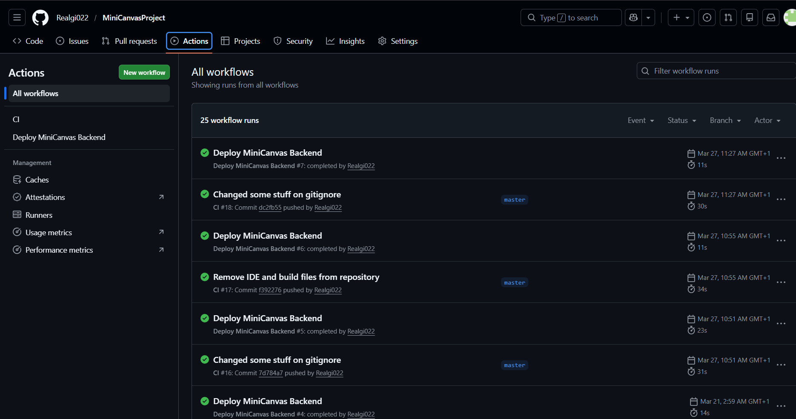

Frontend CI/CD
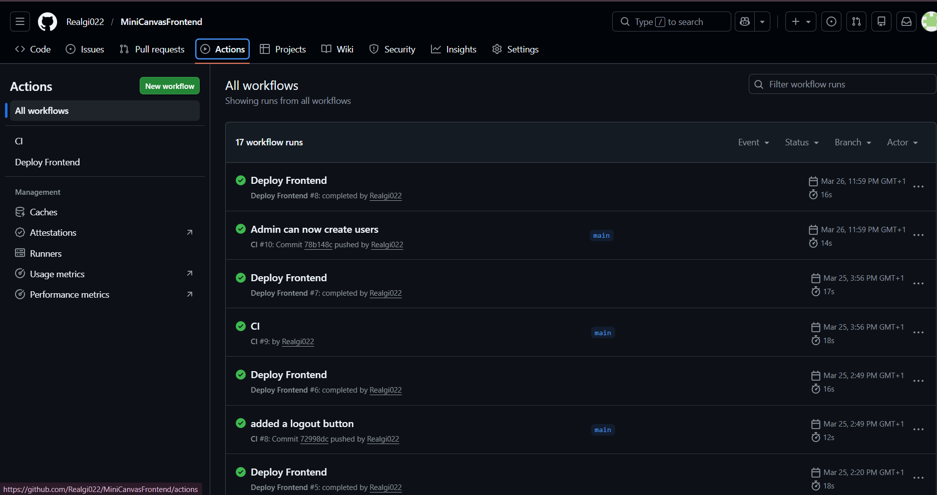

Database running on the VM
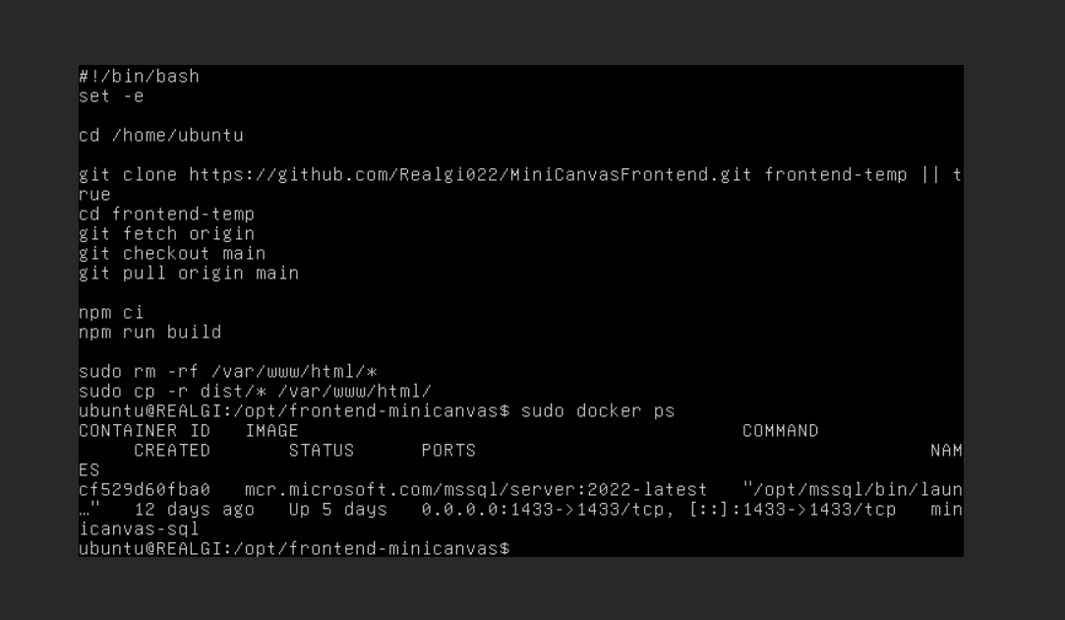

Backend direct health check
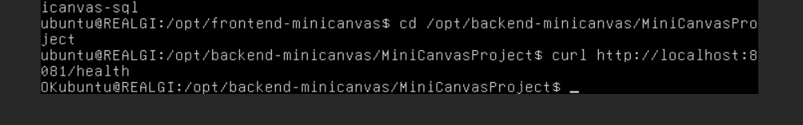

Nginx proxy health check
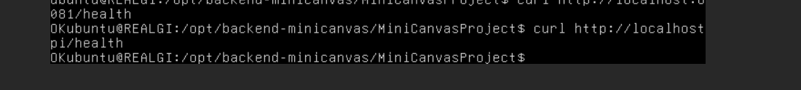

Check Java backend process
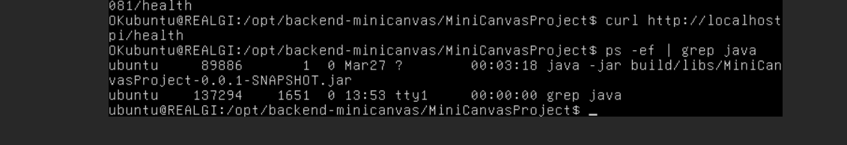

Deployed frontend files
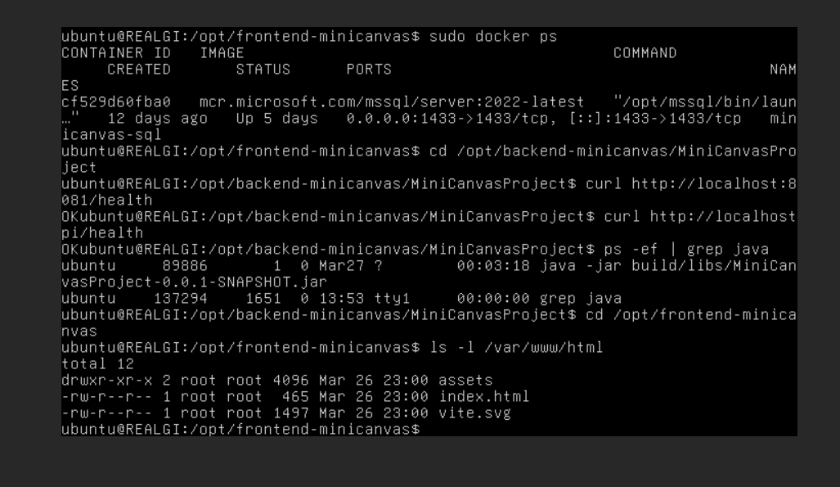

Frontend deploy script
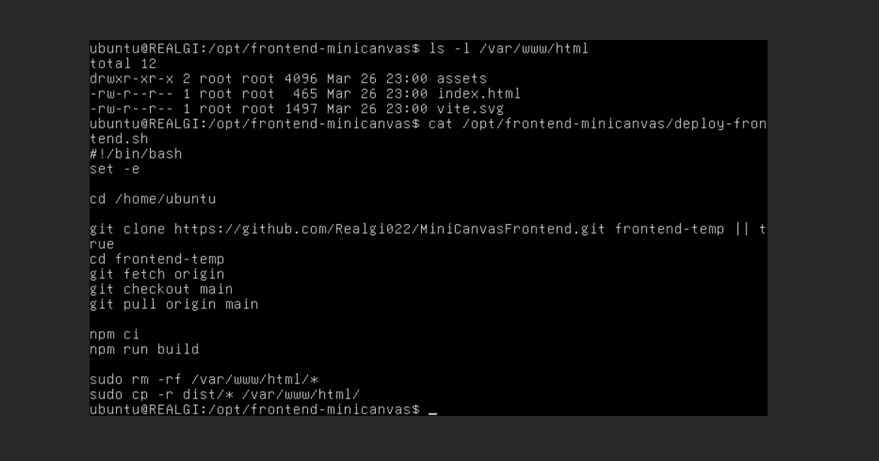

End-to-end proof
Bruno login success
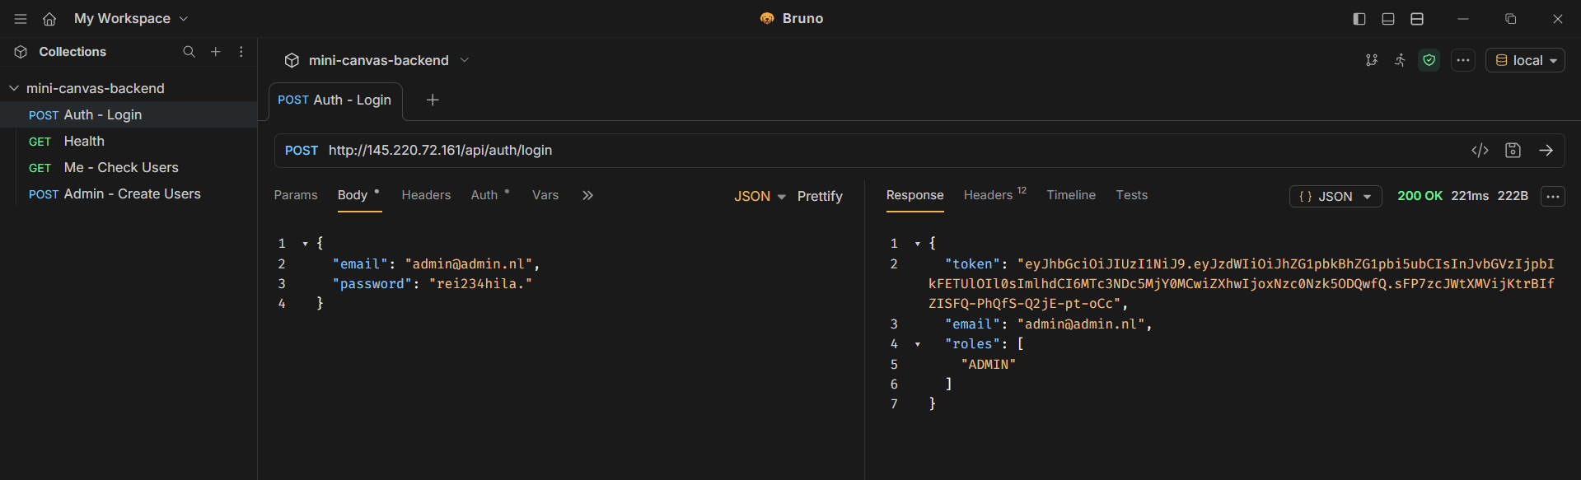

Frontend page login success in the web
