Assignment 02 Summary
- Plot 1A on page 1.3 shows the graphs for 1a, 1d for the first-order transfer function model of the dynamic loads for the signal given in 1a.
- Plot 1B on page 1.4 shows the graphs for 1a, 1d for the first-order transfer function model of the dynamic loads for the signal given in 1c.
- Plot 1C on page 1.5 shows the graphs for 1b, 1d for the second-order transfer function model of the dynamic loads for the signal given in 1a.
- Plot 1D on page 1.6 shows the graphs for 1b, 1d for the second-order transfer function model of the dynamic loads for the signal given in 1c.
- Note: Since the static load curve for 1a and 1d is virtually numerically equal for the given set of load voltages (refer to the curves plotted in Desmos 1), their curve and has only been plotted once in all the graphs.

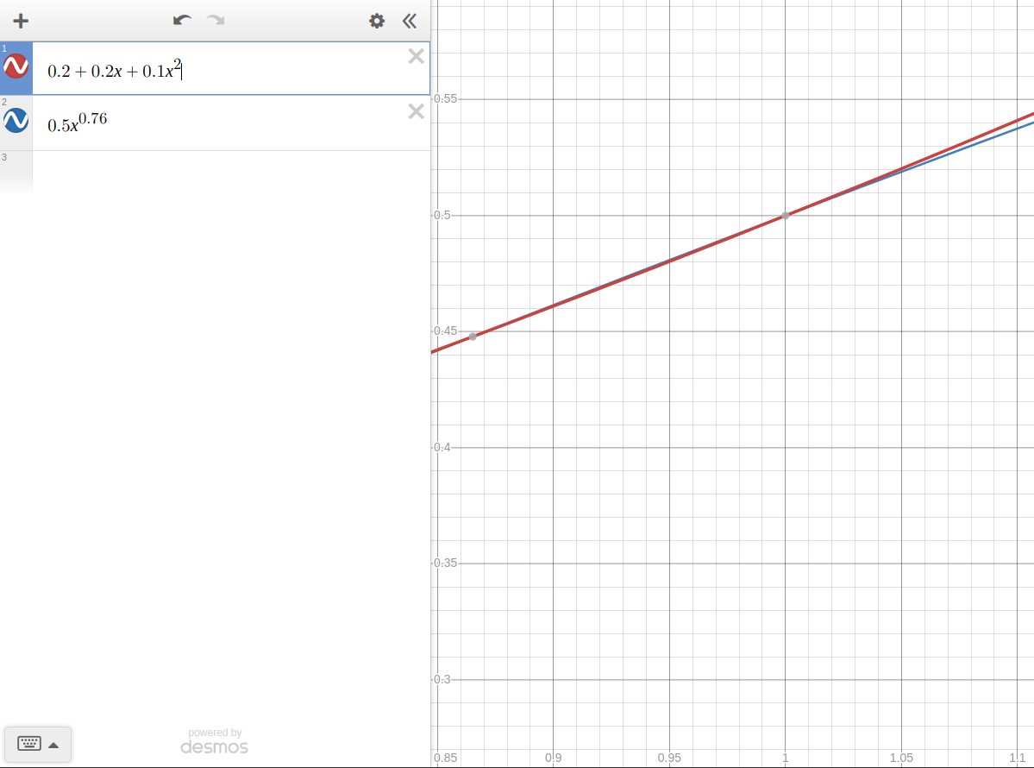Figure 1: Comparsion of the two static load curves for relevant load voltages.

