Lab Report 4 Example: How to get 100% points in Part III.A
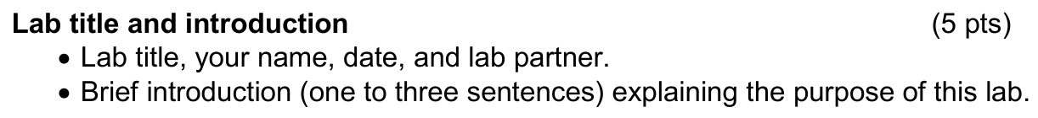
Lab Title | Non-ideal Operational Amplifier Behaviour
Name | Aryan Ritwajeet Jha
Date | 18 September 2025
Lab Partner(s) | Menuka KC, Julian Herrera

Lab Introduction
In this lab, we were exposed to the practical aspects of the op-amp that impose limitations on its behaviour. We did so via experimental determination of parameters like offset voltage, slew rate and bias currents.

This carries 5 points, guys! Also respect your lab mates by writing their full names – also in some cases there could be multiple people with the same first or last names. Also don’t forget to write the lab introduction – people reading real reports don’t carry around a question paper just to understand the context of this report.
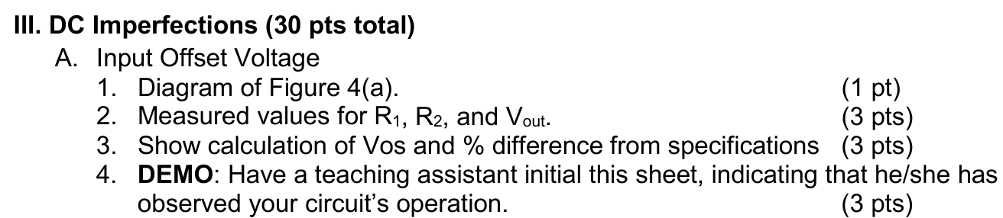
Pasting the checklist item questions here for reference. You’re NOT required to write/paste questions in your report.
III.A.1
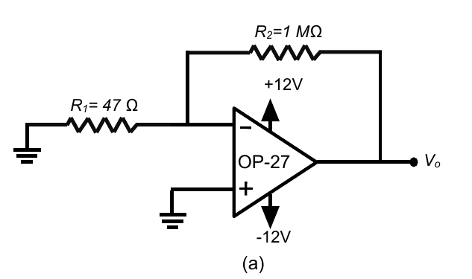
Figure 4. (a) The circuit used to estimate the input offset voltage.
Simple enough. Note how you can insert a 1x1 table and insert your figures (with captions), equations into it to immediately make it look more professional with minimal effort. Also make sure to caption your figures!
III.A.2
$$R_{1}=46.51 Ω$$
$$R_{2}=0.983 MΩ$$
$$V_{out}=0.773V$$
Three quantities are asked, so three quantities are what you should write down.
III.A.3
$$A_{v}=1+\frac{R_{2}}{R_{1}}=21136.24$$
$$V_{os}=\frac{V_{out}}{G}=36.57μV$$

From the datasheet, $V_{os}$ exceeds maximum value of $25μV$ by $46\%$. A potential reason for such a discrepancy is that it is difficult to get good readings on the DMM in low voltage cases.

Show being the keyword — means that not only do I expect the numbers, but also if any formula was used to compute them.
In this instance, the output data for this student’s experiment was out of bounds compared to expected values from the datasheet – While the checklist question does not ask for your remarks, it is best practice to put your remarks when an obvious discrepancy arises.
III.A.4
This checklist item specifically only asks for TA Initials – pasting a photo of the TA initialed sheet at the very end is sufficient. But other TA initial questions can sometimes ask for other items and you need to report them accordingly.

