PROCEDURE (Artwork + Rating Scales presented together – self-paced presentation)
Participant does not recognise the artwork (“No”)
Participant recognises the artwork (“Yes”)
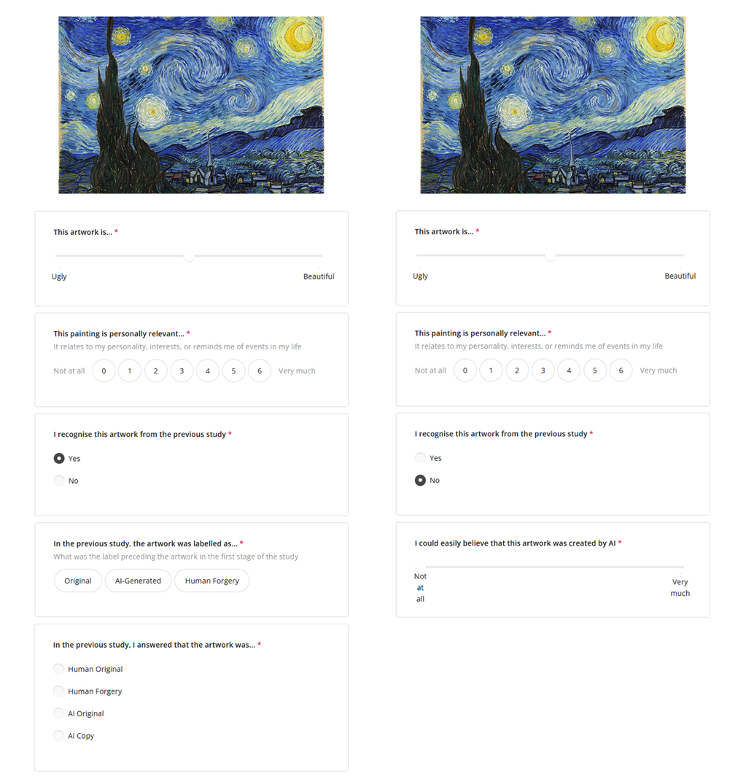

(Example artwork)

