The Effect of Fictional Reappraisal on Subjective Ratings Toward Erotic Images

Ana Neves¹, Marco Viola², Marco Sperduti³, Alessandro Ansani⁴, Marco Marini⁴, Antonio Olivera-La Rosa⁴, Guido Corradi⁴, and Dominique Makowski^{1,8}
¹School of Psychology, University of Sussex
²Department of Philosophy, Communication, and Performing Arts, Roma Tre University
³Tor Vergata University of Rome
⁴Department of Music, Art and Culture Studies, University of Jyväskylä
⁵Institute of Cognitive Sciences and Technologies
⁶Department of Psychology and Social Sciences, Universidad Católica Luis Amigó
⁷Department of Social Psychology and Organization, Universidad Nacional de Educación a Distancia
⁸Sussex Centre for Consciousness Science, University of Sussex

Author Note
Ana Neves https://orcid.org/0009-0006-0020-7599
Marco Viola https://orcid.org/0000-0001-7970-5406
Marco Sperduti https://orcid.org/0000-0002-0974-8811
Alessandro Ansani https://orcid.org/0000-0002-0657-5732
Marco Marini https://orcid.org/0000-0001-5466-8194
Antonio Olivera-La Rosa https://orcid.org/0000-0001-7637-8518
Guido Corradi https://orcid.org/0000-0001-9163-6829
Dominique Makowski https://orcid.org/0000-0001-5375-9967
Author roles were classified using the Contributor Role Taxonomy (CRediT; https://credit.niso.org/) as follows: Ana Neves: data curation, formal analysis, investigation, visualization, writing – original draft, and writing – review & editing. Marco Viola: bla, , and bla. Marco Sperduti: bla, , and bla. Alessandro Ansani: bla, , and bla. Marco Marini: bla, , and bla. Antonio Olivera-La Rosa: bla, , and bla. Guido Corradi: bla, , and bla. Dominique Makowski: project administration, data curation, formal analysis, investigation, visualization, writing – original draft, and writing – review & editing
Correspondence concerning this article should be addressed to Ana Neves, School of Psychology, University of Sussex, Email: A.Neves@sussex.ac.uk

Abstract
Keywords: keyword1, keyword2, keyword3

The Effect of Fictional Reappraisal on Subjective Ratings Toward Erotic Images
Generative artificial intelligence (genAI, Fisher, 2025) poses profound challenges for human cognition by enabling the creation of media content (e.g., images, audios, and videos) that are increasingly indistinguishable from authentic ones (Miller et al., 2023; Velásquez-Salamanca et al., 2025). The increasing accessibility of such content, often called deepfakes, has led to its proliferation across social networks, entertainment, immersive environments, and everyday communication (Fisher et al., 2024). Whereas deepfakes once contained clear perceptual markers of inauthenticity, such as distortions characteristic of early computer-generated contents (De Ruiter, 2021; McDonnell & Breidt, 2010), these cues are rapidly diminishing.
As deepfakes reach perceptual parity with their authentic counterparts, understanding how individuals evaluate and emotionally respond to such ambiguity becomes both a theoretical and practical imperative, with implications for information integrity, social trust, and the ethical deployment of AI systems.
1.1 The prejudice against (putative) AI-generated
Researchers have investigated the impact of authorship (human vs AI) on perceivers’ appraisal across several domains (e.g., visual, poetry, music, faces, people). These studies typically manipulate either the actual origin of the stimulus (authentic vs AI-generated) or the participant’s belief about its origin, and in some cases both. Evidence has accumulated showing that participants often fail to tell apart AI-generated from human-made content at above-chance levels both in artworks (Cenerini et al., 2025; Gangadharbatla, 2022; Grassini & Koivisto, 2024; Köbis & Mossink, 2021) and biological stimuli (Kramer et al., 2025; Nightingale & Farid, 2022).
Interestingly, when authorship is not disclose, AI-generated content is sometimes evaluated more positively. For instance, AI-generated poetry has been shown to receive higher appreciation ratings (e.g., beauty, lyrically, rhythm) than human-made poetry (Porter & Machery, 2024). Similarly, faces that are actually generated by AI are judged as more trustworthy than the real ones (Nightingale & Farid, 2022; Tucciarelli et al., 2022, study 1), possibly because generative algorithms are biases toward average, and familiar-looking faces, and familiarity breeds trustworthiness (Miller et al., 2023; but see Dunn et al., 2026).
In contrast, when some stimuli are presented as AI-generated, they are consistently evaluated more negatively than when they are presented as authentic (i.e., anti-AI bias). Indeed, this negative bias across has been documented across several culturally salient domains such as visual arts (Bellaiche et al., 2023; Chiarella et al., 2022; Di Dio et al., 2023; Ragot et al., 2020), music (Ansani et al., 2025; Shank et al., 2023) and poetry (Porter & Machery, 2024). More broadly, the influence of contextual information on the evaluation of cultural products is well established and extends beyond biases specific to AI. For example, research in neuroasthetics shows that presenting an artwork as an original rather than a (human-made) copy can alter both its perceived worth (Newman & Bloom, 2012) and associated neural responses (Huang et al., 2011). These findings suggest that evaluative processes are highly malleable to contextual cues and beliefs about the origin of the stimuli. And “anti-AI bias” makes no exception, inasmuch it seems driven primarily by cognitive evaluations tied to beliefs about authorship, as shown by the appreciation of “blinded origin” AI-made stimuli.
Interestingly, despite being strongly constrained by evolutionary pressures, more biological salient stimuli such as the perceived appearance of food (Califano & Spence, 2024) or human faces (Liefooghe et al., 2023), are also affected by the anti-AI bias. Califano and Spence (2024) report that, despite preferring AI-generated food when unlabeled (especially ultra processed food), as soon as labels are introduced, participants tend to prefer authentic food pictures. Liefooghe et al. (2023) report that faces were consistently rated as less trustworthy when presented as AI-generated as opposed to real. Eiserbeck et al. (2023) reports that smiling faces labelled as AI-generated were judged less positively, processed more slowly, and elicited reduced early emotional EEG responses. On the contrary, subjective and EEG responses for angry faces were not modulated by the label, probably reflecting the robustness of phylogenetically rooted threat stimuli. Similarly, Döring and Mohseni (2025) found that romantic images of heterosexual couples hanging out were rated more “aesthetic”, “erotic”, “expressive”, and “vivid” when presented as photographs than as deepfakes. Taken together, these results suggest that beliefs about AI authenticity selectively dampen positive affective responses when dealing with biological salient stimuli. However, this conclusion should be interpreted with caution. In the studies discussed above, the positive stimuli could not have been compared to the negative ones in terms of arousal, making it difficult to determine whether the observed effect truly reflects a selective dampening of positive affective responses.
One class of evolutionary salient positive stimuli that may offer a more appropriate comparison is erotic images, which are known to elicit strong motivational and attentional responses. Indeed, erotic images have been shown to capture attention as much as, or even more than, fear- and disgusted-related stimuli (Ciesielski et al., 2010). This makes them a particularly relevant test case for examining whether contextual information, such as an AI label, can modulate responses even to highly salient positive stimuli.
1.2 AI and erotic stimuli
Among many other fields, AI is exerting its disruptive potential over human sexuality in several forms. For instance, LLMs provide sexual counselling, and dedicated sexual chatbots afford spicy conversations. However, the most widespread use of AI in sexuality is arguably generating explicit visual contents (Döring et al., 2024; Lapointe et al., 2025). In several cases, these contents are sexually explicit deepfakes (“2023 STATE OF DEEPFAKES,” n.d.; Ajder et al., 2019).
Given the relevance of these controversial applications of AI, the following questions must be posed: does the anti-AI bias generalises to sexual content? Notably, Easterbrook-Smith (2025) speculate that AI-generated pornography might be valued less inasmuch it lacks the “aura of authenticity” surrounding human-made porn. Similarly, Viola and Voto (2023) propose that, by casting doubts about the authenticity of all media, as the possibility that they may be fake may undercut their allure. Indeed, Tucciarelli et al. (2022) shows how simply suspecting that some faces within a set could be AI-Generated lowered trustworthiness score of the whole set.
Beyond the interest specific to the field of sexuality per se, empirically investigating whether sexual stimuli are also affected by the anti-AI bias could bear more general theoretical relevance. Recall that sexual stimuli represent a paradigmatic category of positively valence and highly arousing stimuli in many popular databases of stimuli for psychological research on emotion, be them visual (Kurdi et al., 2017; Lang et al., 1997; Wierzba et al., 2015) or audio (Holz et al., 2022; Yang et al., 2018).
Yet, to the best of our knowledge, the only empirical findings about sexually explicit images have been collected by Marini et al. (2024). They performed an online experiment presenting subjects with soft erotic images (male and female models in underwear or swim-suits), finding that the same images were rated higher in terms of sexual arousal when judged more likely to be (in Study 1), or presented as (in Study 2) real photos, as opposed to AI-generated images.
However, Marini et al. (2024) studies are based on a sample from a single nation (Italy) and provide scant socio-demographic information. They only investigate a single dependent variable, namely self-reported sexual arousal. However, self-reported first-person, ‘affective’ feelings (“does this arouses me?”) and third-person, ‘semantic’ judgments (“is that supposed to be arousing?”) have been shown to dissociate in some cases (Itkes & Kron, 2019). More relevantly, they used only mildly sexually arousing stimuli not taken from a validated dataset. Lastly, in their direct manipulation of the ‘authentic/AI-generated’ labeling (Study 2) they did not provide any explicit manipulation check.
1.3 The present studies
To fill our knowledge gap about the existence and the exact workings of a putative anti-AI bias about sexual content, we gathered an international team with the aim of a more exhaustive investigation.
In order to control over image properties and enable comparisons with normative data, we employed stimuli from a validated database, the Nencki Affective Picture System (Marchewka et al., 2014), which includes several explicitly sexual pictures (Wierzba et al., 2015), and selected the stimuli via a data-driven, easily reproducible procedures. Moreover, we asked subjects to provide different ratings of first-person ‘affective’ subjective sexual arousal and valence, and a third-person ‘semantic’ judgment on how enticing they found the image to be.
Sociodemographic characteristics, in particular gender, were assessed as a modulator of responses to stimuli, given robust evidence that sexual patterns differ systematically between men and women. For instance, research on arousal indicates that heterosexual men tend to exhibit greater category-specificity in their responses, such that arousal is more strongly aligned with their sexual orientation (i.e., heightened responses to female stimuli). In contrast, heterosexual women’s responses are less category-specific and more variable across stimulus types (Chivers et al., 2004; Chivers, 2017; Huberman et al., 2015; Safron et al., 2020).
Furthermore, the present studies assess whether individual differences in attitudes towards AI influence responses to the stimuli. Beliefs about the origin of a stimulus can bias evaluations, yet it remains unclear whether this effect depends on individuals’ pre-existing attitudes towards AI. Previous findings suggest that such moderation is inconsistent and may be domain-specific. In domains where creativity and authenticity are salient (e.g., art and music), stronger anti-AI biases are often observed (e.g., Ansani et al., 2025), whereas informational contexts (e.g., news) sometimes show a pro-AI bias, with machine-generated content perceived as less biased (e.g., Cloudy et al., 2022). In contrast, research using human faces and bodies consistently finds no reliable moderating role of AI attitudes on evaluative or affective responses (e.g., Liefooghe et al., 2023; Marini et al., 2024). Some evidence, however, suggests that broader constructs such as AI readiness may attenuate anti-AI bias (i.e., composite of positive AI attitudes and higher AI literacy, Döring and Mohseni (2025)). Overall, the influence of AI attitudes on evaluations appears variable and context-dependent, with particularly limited effects observed in the domain of human appearance. Accordingly, the present study includes attitudes towards AI as a potential moderating variable to test whether individual differences in these attitudes shape responses to the stimuli.
Finally, the present study also considers participant’s sexual behaviours as moderators of responses to sexual stimuli. For example, research indicates that frequency of pornographic consumption can influence attentional and evaluative processing of sexual content. Repeated exposure to pornographic material has been associated with attenuated allocation of automatic attentional resources to sexual stimuli, suggesting a degree of habituation (Carvalho et al., 2018). Furthermore, evidence suggests that individuals with lower pornographic use rate erotic stimuli as less pleasant compared to those with moderate or high levels of consumption, indicating that prior exposure shapes subjective appraisal of sexual content (Kunaharan et al., 2017). Similarly, although less frequently examined, frequency of sexual activity may serve as an index of experiential familiarity with sexual stimuli and thus modulate responses. Greater sexual experience has been linked to differences in neural sensitivity to explicit content (Prause et al., 2015), and heightened self-reported sexual arousal (Walton & Bhullar, 2018), although state subjective arousal ratings do not consistently vary (Youn, 2006). Together, these findings suggest that both attentional engagement and explicit evaluations of sexual stimuli are contingent on individuals’ prior experiential exposure, whether through pornography consumption or sexual activity.

Study 1
In our first study, we aimed at gauging whether the prejudice against AI-generated erotic stimuli shows up in a wide and heterogeneous sample, and whether it is modulated by demographic factors, by sexual activity or pornography consumption habits, or by attitudes toward IA. Following Marini et al. (2024), we hypothesise that images presented as AI-generated will elicit lower ratings than those presented as photographs (H1). Additionally, in line with the literature on explicit stimuli Huberman et al. (2015), we hypothesise erotic images relevant to participants’ sexual orientation would result in higher ratings than erotic but irrelevant images and non-erotic images, and that these differences would be less pronounced for women (H2). Research on general attitudes towards AI and its moderating role on ratings is mixed, with some studies finding a moderating effect (Döring & Mohseni, 2025) and others not (Liefooghe et al., 2023; Marini et al., 2024). As such, we explore whether attitudes towards AI moderate responses to the stimuli, without making a strong directional prediction (H3). Lastly, based on previous findings (e.g., Kunaharan et al., 2017), we hypothesise that pornographic consumption will modulate ratings of sexual stimuli (H4); however, no directional hypothesis is proposed for frequency of sexual activity due to mixed evidence regarding its influence on subjective responses (H5).
While prior studies have examined the effect of AI labels on affective ratings, relatively little attention has been paid to whether participants actually believe those labels, and whether belief itself modulate the observed effects. If participants second-guess the authenticity claims (e.g., suspecting that “AI-generated” images are in fact photographs, or vice versa), label-based effects would be attenuated or reversed regardless of the manipulation’s objective content. This concern is not without empirical basis: Tucciarelli et al. (2022) showed that when participants were informed that some faces in a set might be AI-generated, their responses were driven not by the objective category of each face, but by their own judgment of whether that specific face was real, suggesting that individual beliefs about stimulus authenticity, rather than assigned labels, shape evaluative and social responses. Accordingly, we assess the role of individual belief in the label as an additional predictor of affective ratings, without a directional hypothesis, given that disbelief in a label can shift ratings in either direction depending on what the participant believes the image actually is (H6).

Methods

Participants
The initial sample comprised 1,067 participants recruited via multiple channels, including Sona Systems, social media platforms, university classrooms, and snowball sampling. This strategy yielded a heterogeneous pool of both incentivised and non-incentivised individuals, including students and members of the general population from England, France, Italy, Colombia, and Spain. Data collection occurred from the 19th of January to 1st of June 2024 [during this time the best image generator was OpenAI’s [DALL·E 3; ifttt-user]. To ensure data quality, several exclusion criteria were applied. Participants were removed if they showed no variation in arousal ratings across trials (N = 8), displayed a negative correlation between arousal and enticement alongside lower arousal ratings for erotic compared to neutral stimuli, suggesting a possible misunderstanding of scale direction (N = 4). Due to small subgroup sample sizes, participants identifying with a gender other than Female or Male (N = 15), or a sexual orientation other than Heterosexual (N = 335), were excluded from further analysis. The final sample consisted of 705 participants (Mean age = 30.2 years $±$ 11.8; 35.7% female). Participants were primarily from the United Kingdom (28.23%), Italy (18.72%), the United States (14.33%), and Colombia (11.06%), with the remaining 27.66% distributed across other countries. Ethical approval for this study was obtained from the School of Psychology Ethics Committee at the University of Sussex (ER/MHHE20/1).

Materials
All written materials in this study were translated into the participants’ native languages: English, French, Italian and Spanish.

Questionnaires
The Beliefs about Artificial Image Technology (BAIT) was developed to evaluate beliefs about computer-generated imagery, such as “Current Artificial Intelligence algorithms can generate very realistic images” and “Images of faces or people generated by Artificial Intelligence always contain errors and artifacts.” The BAIT includes 4 dimensions with 2 items each: Text ($α$ = .63) , Videos ($α$ = .56 ), Images ($α$ = .38), Environment ($α$ = .58 ). Items were rated on a continuous scale from strongly disagree (0) to strongly agree (1). One item was included to assess self-reported AI knowledge, with anchors ranging from Not at all (0) to Expert (6).
A modified version of the General Attitudes towards Artificial Intelligence Scale (GAAIS, Schepman & Rodway, 2020, 2023) was used, containing 3 items assessing positive (e.g., “Artificial Intelligence is exciting”) and 3 items assessing negative attitudes (e.g., “Artificial Intelligence might take control of people”) towards AI. The resulting GAAIS subscales showed acceptable reliability: Positive ($ω$ = .72), Negative ($ω$ = .73). All items were rated on a continuous scale from strongly disagree (0) to strongly agree (1).
The Consumption of Pornography Scale – General (COPS, Hatch et al., 2023) is a 34-item measure assessing pornography use across multiple dimensions, including frequency, duration and recency of sexual activity. Participants reported how often they had viewed pornography in the past 30 days (e.g., not at all, once or twice, weekly, daily, multiple times per day) and the typical duration of viewing sessions (less than 5 minutes to 46+ minutes). An additional item assessed the recency of any sexual activity (intercourse or masturbation), with response options ranging from within the past 24 hours to more than a year ago. Internal consistency for the COPS was acceptable ($ω$ = .66).

Feedback
Feedback was collected at the end of the experiment. Participants were able to provide open-ended comments and to select one, multiple, or no options, from several predefined statements (10 in total). These statements assessed whether they found the experiment fun or boring; whether they could distinguish which images were AI-generated or perceived no difference between photographs and AI-generated images; whether they felt the AI-generated images were more or less arousing; whether they believed the labels were inaccurate or reversed; and, more generally, whether some images were particularly arousing or elicited no emotional response.

Procedure

Figure 1
Overview of the experimental procedure for Study 1. A) Phase 1: Participants viewed a randomized sequence of erotic and non-erotic images. After each image, they provided ratings on three dimensions: sexual arousal, enticement, and affective valence. B) Phase 2: The same set of images was presented again in a new random order. This time, participants rated each image based on its perceived realism (i.e., how photographic or lifelike it appeared).
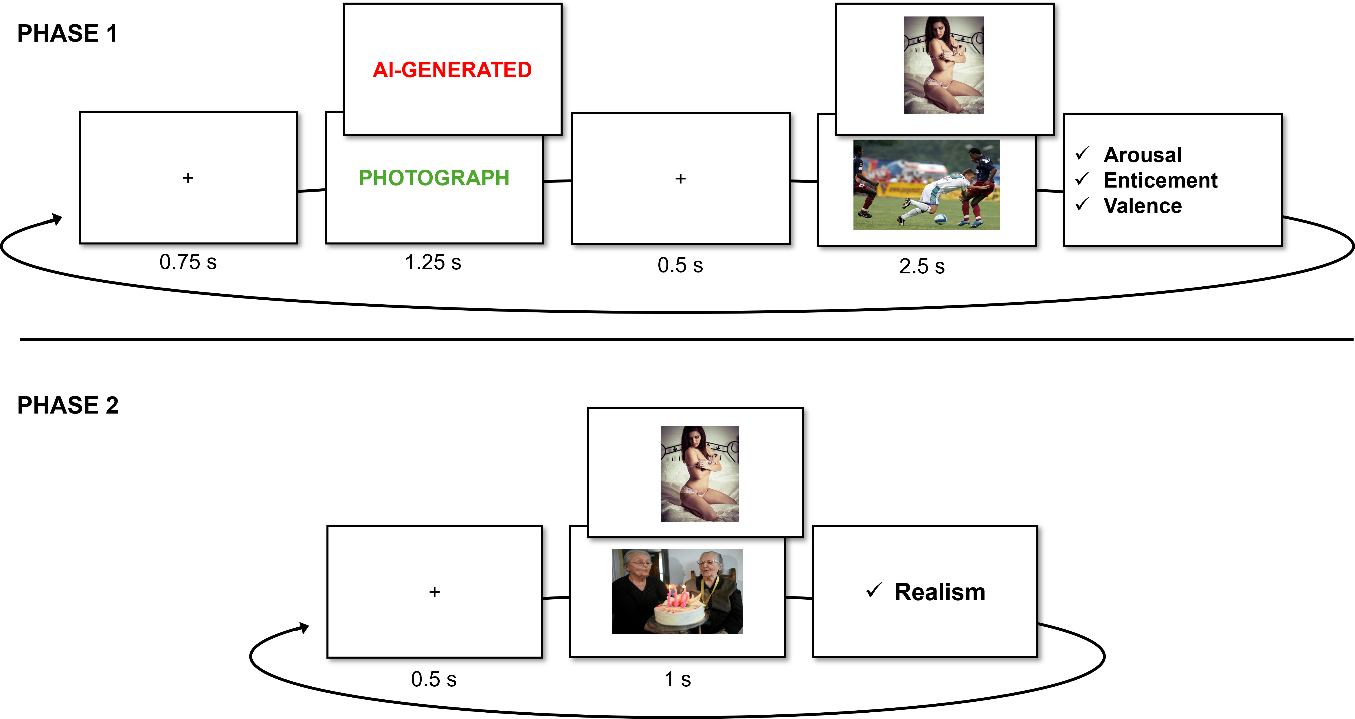
The study was conducted in line with the born-open principle (Leeuw, 2024), ensuring transparency and reproducibility at every stage. The experiment was implemented entirely in jsPsych (De Leeuw, 2015), with the full code hosted publicly on GitHub, which also served as the platform for running the online study. Raw data were automatically stored in a private Open Science Framework (OSF) repository.
Participants first provided informed consent before completing a short demographic questionnaire covering gender, age, ethnicity, country of residence, education, and English proficiency. Optional questions on birth control use were also included. They then proceeded to the experimental tasks (see Figure 1). In the first phase, participants were given the following instructions:
In this study, we aim at validating our new image-generation algorithm (based on a new form of Generative Adversarial Network – GAN – technology) trained to produce high-quality erotic (but also non-erotic) content.
In the following task, you will be presented with erotic and non-erotic images generated by our algorithm (preceded by the word ‘AI-Generated’) intermixed with real photos (preceded by the word ‘Photo’) taken from public picture databases.
Participants were informed that their task was to rate each image on three dimensions: arousal and enticement, each on a continuous scale from Not at all (0) to Very much (1), and valence, on a continuous scale from Unpleasant (-1) to Pleasant (1). Definitions for each affective rating were also provided:
Arousing: How much do you find the image sexually arousing? This question is about your own personal reaction felt in your body when seeing the image.
Enticing: How enticing and sexually appealing would you rate this image to be. Think of how much, in general, people similar to you in terms of gender and sexual orientation would like it.
Valence: Did the image evoke a positive and pleasant (not necessarily sexual) feeling in you, or could it be better characterised as negative and unpleasant? Think of how much you did enjoy (or not) looking at the images.
Each participant viewed 60 images in total: 40 erotic images (20 male and 20 female) from the Erotic subset of the Nencki Affective Picture System (NAPS ERO, Wierzba et al., 2015), and 20 non-erotic images (10 neutral, 10 positively arousing) from the original NAPS database (Marchewka et al., 2014). The final stimuli were selected by sampling, within each category (male, female, faces, and people), the eight highest, and two lowest, arousal erotic images based on gender-specific ratings for men and women, with no overlap between sets. Non-erotic images were selected by computing average arousal across men and women, with 10 low-arousal images, and 10-high arousal images (restricted by positive valence stimuli). Each trial followed a fixed timing sequence: a fixation cross (750 ms), a color-coded textual label (1,250 ms), another fixation cross (500 ms), then the image (2,500 ms). Labels were presented in red, green, or blue, with colours randomly assigned. Additionally, the labels “AI-generated” or “Photograph” were presented to indicate the authenticity of the images, and were randomly assigned.
Following each image, participants rated their emotional response using three continuous sliders assessing sexual arousal, enticement, and valence. This phase was self-paced, with responses required before continuing. After completing the image-rating phase, participants filled out the BAIT scale, followed by the COPS questionnaire.
In the final phase, participants were presented with the following instructions:
In the next phase, we would like to see if you found our image generation algorithm convincing and error-free. We will briefly present you all the images one last time (the AI-generated ones, as well as the photos), and you will have to rate them on how real (how realistic, photography-like) the image is.
Participants then viewed the same 60 images in a newly randomised order. Each trial began with a 500 ms fixation cross, followed by the image presented for 1,000 ms. As in the previous task, participants provided their ratings of Realism, using a continuous scale anchored at AI-generated (0) and Photograph (1), after viewing each image, and these ratings were self-paced. At the end of the experiment, participants completed a feedback form. Finally, participants were debriefed on the true purpose of the study: to examine how image labels (AI-generated vs. real photograph) influence emotional responses. Importantly, they were informed that all images were real photographs, and that the “AI-generated” label was used solely to test the effect of belief on affective reactions. A shareable link to the experiment was also provided.

Data Analysis
Bayesian Linear Mixed Models were fitted separately for Arousal, Valence, and Enticement as dependent variables. Each outcome was predicted from Gender (Female vs. Male), Condition (AI-Generated vs. Photograph), Relevance (Relevant, Irrelevant, Non-Erotic), and Congruence (True vs. False). Relevance was computed post hoc based on participants’ self-reported gender and sexual orientation. For example, images of male-presenting stimuli were coded as “Relevant” for homosexual but not for heterosexual men.
Congruence was also computed post hoc based on whether the chosen label in phase 2 was congruent with the one presented for that image in phase 1.
The full formula for the models are as a follow: Outcome ~ Gender / Relevance / Condition * Congruence + (1 + Relevance / Condition ∣ Participant) + (1 | Item). The zero–one inflated beta (ZOIB) family (Heiss, 2021; Vuorre, 2019) was used to account for the distribution of the dependent variable, which showed excess responses at the boundary values (0 and 1) and weakly informative normal (0, 0.5) priors were placed on all fixed effects. Each model was estimated using 2,000 iterations per chain with 50% warmup - distributed across 96 chains (total post-warmup draws was 96000).
Given the computational complexity of Bayesian mixed-effects models, all models were estimated on the University of Sussex High Performance Computing Cluster (HPC). The models were run using the brms package (Bürkner, 2017) and analysed using the easystats collection of packages (Lüdecke et al., 2021, 2022; Makowski et al., 2019, 2025).
Firstly, to assess whether erotic images elicited higher ratings for men and women, marginal contrasts will be computed from these models, with contrasts defined over Relevance and estimated with levels of Gender. Secondly, to assess the effect of condition, marginal contrasts will be defined over Condition and estimated within levels of Gender and Relevance. Finally, the effect of Congruency between phases will be assessed using marginal contrasts defined over Condition and estimated within levels of Gender, Relevance, and Congruency. Effects will be considered credible when the median estimate and its associated 95% credible interval (CrI) do not include zero, and when the probability of direction (pd) exceeds 97%, indicating a consistent effect direction (Makowski et al., 2019). Marginal contrasts were computed using the modelbased package (Makowski et al., 2025). The Results section will focus on arousal ratings whilst reporting major differences with Enticement and Valence.
To evaluate the reliability of individual-level parameters (i.e., random intercepts and random slopes for each participant and each item), the Variance-over-Uncertainty Ratio index (D-vour, Lüdecke et al., 2021) will be computed. This index estimates the reliability of group-level variance by quantifying the normalised ratio of observed between-group variability to the uncertainty associated with the corresponding random-effect estimates. Values of D-vour greater than 0.666 indicate moderately reliable random-effect estimates, corresponding to a 2:1 ratio of between-group variance to estimation uncertainty. In this context, reliability refers to cases in which variability between groups (e.g., participants) exceeds the uncertainty in the estimates, suggesting that the parameter can meaningfully capture inter-individual differences.
Lastly, a correlation matrix will be computed between the models’ individual-level estimates and potential moderators: beliefs, attitudes towards and knowledge of AI, porn frequency and recency of sexual activity. Correlations, computed with the correlations package (Makowski et al., 2022) will be used to explore whether reliable variation in the random effects can be explained by theoretically relevant individual differences. Pearson’s r and its associated 95% confidence interval (CI) will be reported and interpreted according to Pearson’s criteria (Cohen, 2013). All analyses were conducted in R (version 4.5.2). Anonymized data, together with all preprocessing and analysis scripts, will be openly released on GitHub to facilitate complete reproducibility.

Results

Distributions
As shown in Figure 2, the distributions of arousal and enticement ratings are heavily skewed toward the lower end of the scale, with a high frequency of scores at 0 and only a slight increase in counts toward mid-range of the scale (~0.50 - 0.75). In contrast, valence ratings exhibit a broader distribution, with frequent scores at both extremes as well as in the mid-range of the scale.

Figure 2
Distributions of Arousal, Enticement and Valence ratings (i.e., rated on an analog scale from 0 to 1) for males and females across conditions. Distributions include a higher count of extreme answers (0 and 1s) justifying the use of a ZOIB model.
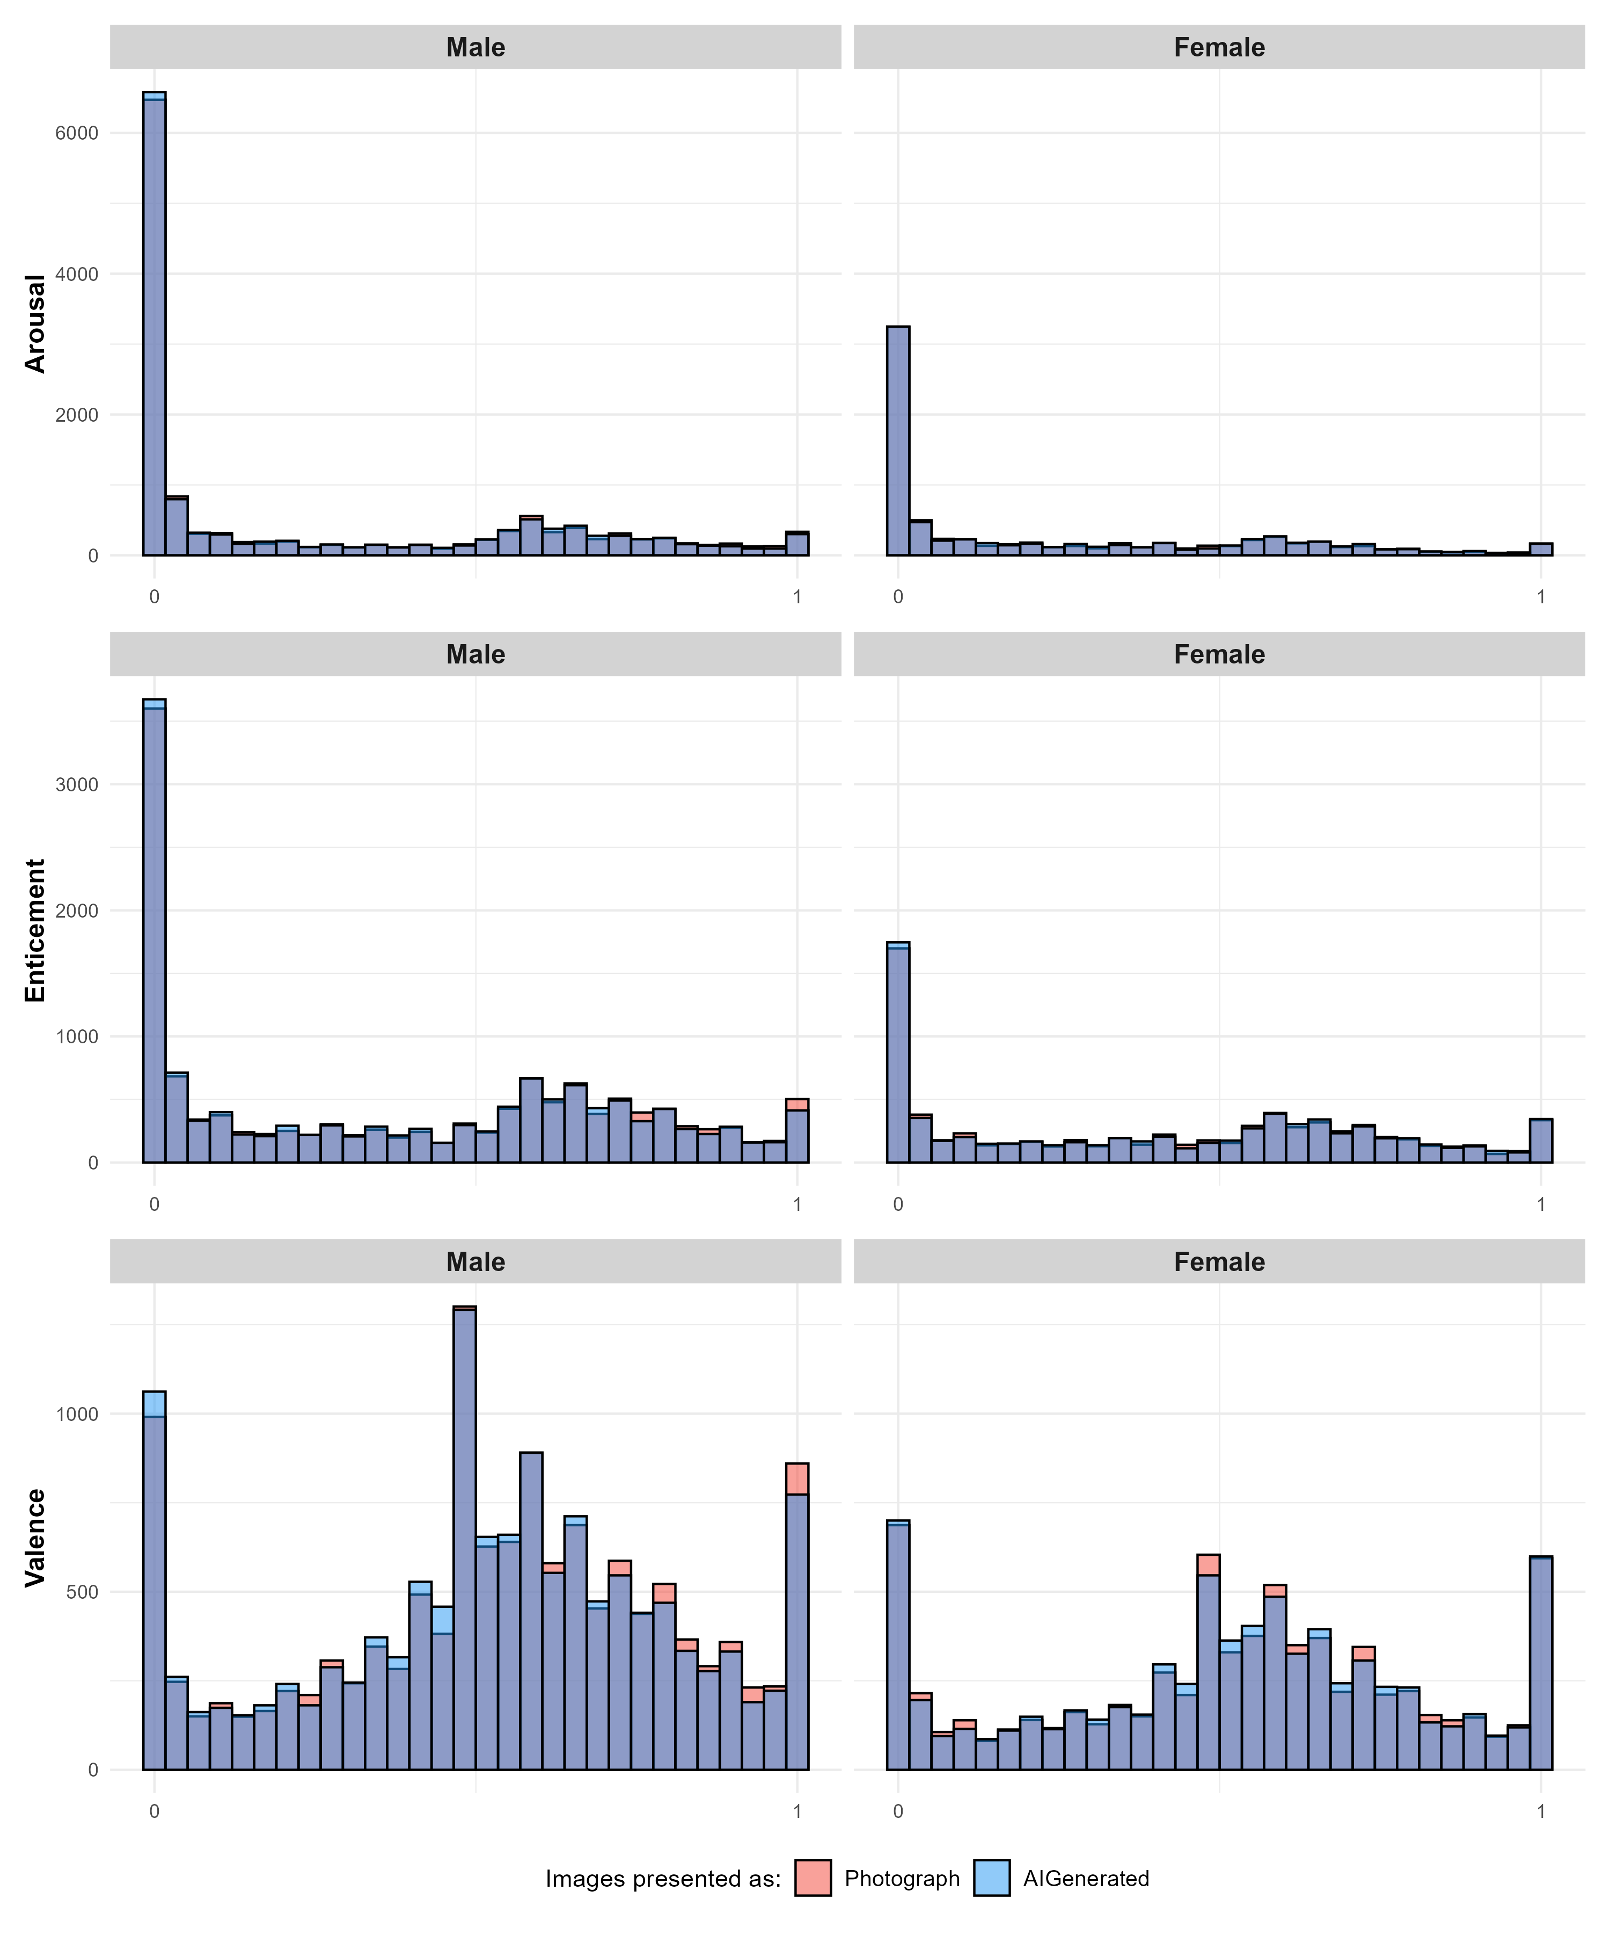

Manipulation Checks
An initial manipulation check was conducted to assess participants’ belief in the instructional cues. Based on participants’ feedback after the initial rating phase, 41.7% of participants reported that they did not believe the labels, indicating that a large proportion of participants perceived the image classifications as incorrect. Additionally, 52.3% of images were rated as being more realistic in phase 2.
To examine whether disbelief in the instructions was associated with differential responses to images labelled AI-generated versus photograph, Bayesian independent-samples t-test were conducted for each outcome variable. These tests compared the difference scores between AI-generated and photographic images as a function of whether participants reported that AI images were less arousing.
For arousal, participants who reported that AI images were less arousing showed a larger difference between AI-generated and photographic images (M_{difference} = −0.02) than participants who did not report this belief (M_{difference} = −0.002). The t-test indicated extreme evidence for a difference between groups (BF₁₀ = 2.17 × 10⁶⁰⁴). The estimated standardised effect size was large (median $δ$ = −1.11, 95% CrI [−1.13, −1.08], pd = 100%). A similar pattern was observed for enticement and valence (for full results see analysis folder on the github link above).

Marginal Contrasts

Effect of Relevance
To evaluate whether the different stimuli (erotic relevant, erotic irrelevant, and non-erotic) elicit dissimilar responses, marginal contrasts from the mixed models were examined, focusing on the effect of relevance. These contrasts assessed differences in arousal ratings across stimulus types separately for males and females.
For males, relevant erotic images were rated as more arousing than both irrelevant ($Δ$ = 0.43, 95% CrI [0.39, 0.46], pd = 100%) and non-erotic images ($Δ$ = 0.44, 95% CrI [0.40, 0.47], pd = 100%). For females, relevant erotic images were rated as more arousing than non-erotic images ($Δ$ = 0.20, 95% CrI [0.17, 0.24], pd = 100%), but not credibly more than irrelevant erotic images ($Δ$ = 0.04, 95% CrI [0.00, 0.08], pd = 96.36%). Similar patterns were found for enticement and valence; although for females non-erotic images were rated more valent than relevant erotic images.

Effect of Condition
Estimated marginal contrasts assessed the effect of condition (photographic vs. AI-generated) across gender and relevance. For males, relevant erotic images presented as photographs were rated as slightly more arousing than those presented as AI-generated, although the effect was small ($Δ$ = 0.02, 95% CrI [0.00, 0.03], pd = 99.6%). In contrast, females showed the opposite pattern, with AI-generated images rated marginally higher than photographic images ($Δ$ = −0.02, 95% CrI [−0.03, 0.00], pd = 98.3%). No other contrasts provided credible evidence for differences (all pd < 88.2%). Similar results were seen for enticement and valence ratings for males, but no credible differences between images labelled as photographs or AI-generated for females.

Effect of Condition Depending on Congruence
Estimated marginal contrasts examined the effect of condition as a function of gender, relevance, and congruence. Under congruent trials, photographic images were rated as more arousing than AI-generated images for relevant stimuli in both males and females. This effect was slightly larger for males ($Δ$ = 0.08, 95% CrI [0.06, 0.10], pd = 100%) than for females ($Δ$ = 0.06, 95% CrI [0.04, 0.08], pd = 100%).
Under incongruent trials, this pattern reversed for relevant stimuli: AI-generated images were rated as more arousing than photographic images. This reversal was more pronounced in females ($Δ$ = −0.09, 95% CrI [−0.12, −0.07], pd = 100%) than in males ($Δ$ = −0.05, 95% CrI [−0.07, −0.03], pd = 100%). Similar crossover patterns were observed for enticement and valence ratings of erotic, relevant images.
For irrelevant and non-erotic stimuli, differences between photographic and AI-generated images were generally small and uncertain, with several credible intervals including zero. Under congruent trials, males rated AI-generated non-erotic images as slightly less arousing than those labelled as photographs ($Δ$ = 0.02, 95% CrI [0.01, 0.04], pd = 99.66%), and a comparable effect was observed in females for erotic but irrelevant images ($Δ$ = 0.02, 95% CrI [0.01, 0.04], pd = 100%). Under incongruent trials, this pattern reversed; however, credible differences in arousal ratings of irrelevant stimuli were observed only in females, with AI-generated labels associated with higher arousal ($Δ$ = −0.03, 95% CrI [−0.05, −0.01], pd = 99.69%). For enticement ratings the same reversal pattern was found, with credible differences for all with the exception of males ratings of non-erotic images. On the other hand, all differences were credible for valence ratings for both genders and the same crossover effect was found.

Figure 3
Estimated means for the effect of Condition depending on Congruency. Green rectangles represent differences in means where the pd > 97.5%, indicating a consistent effect direction (Makowski et al., 2019). A crossover effect can be seen where the difference between arousal ratings between images labelled as AI-generated and those labelled as photographs, is reversed for incongruent trials.
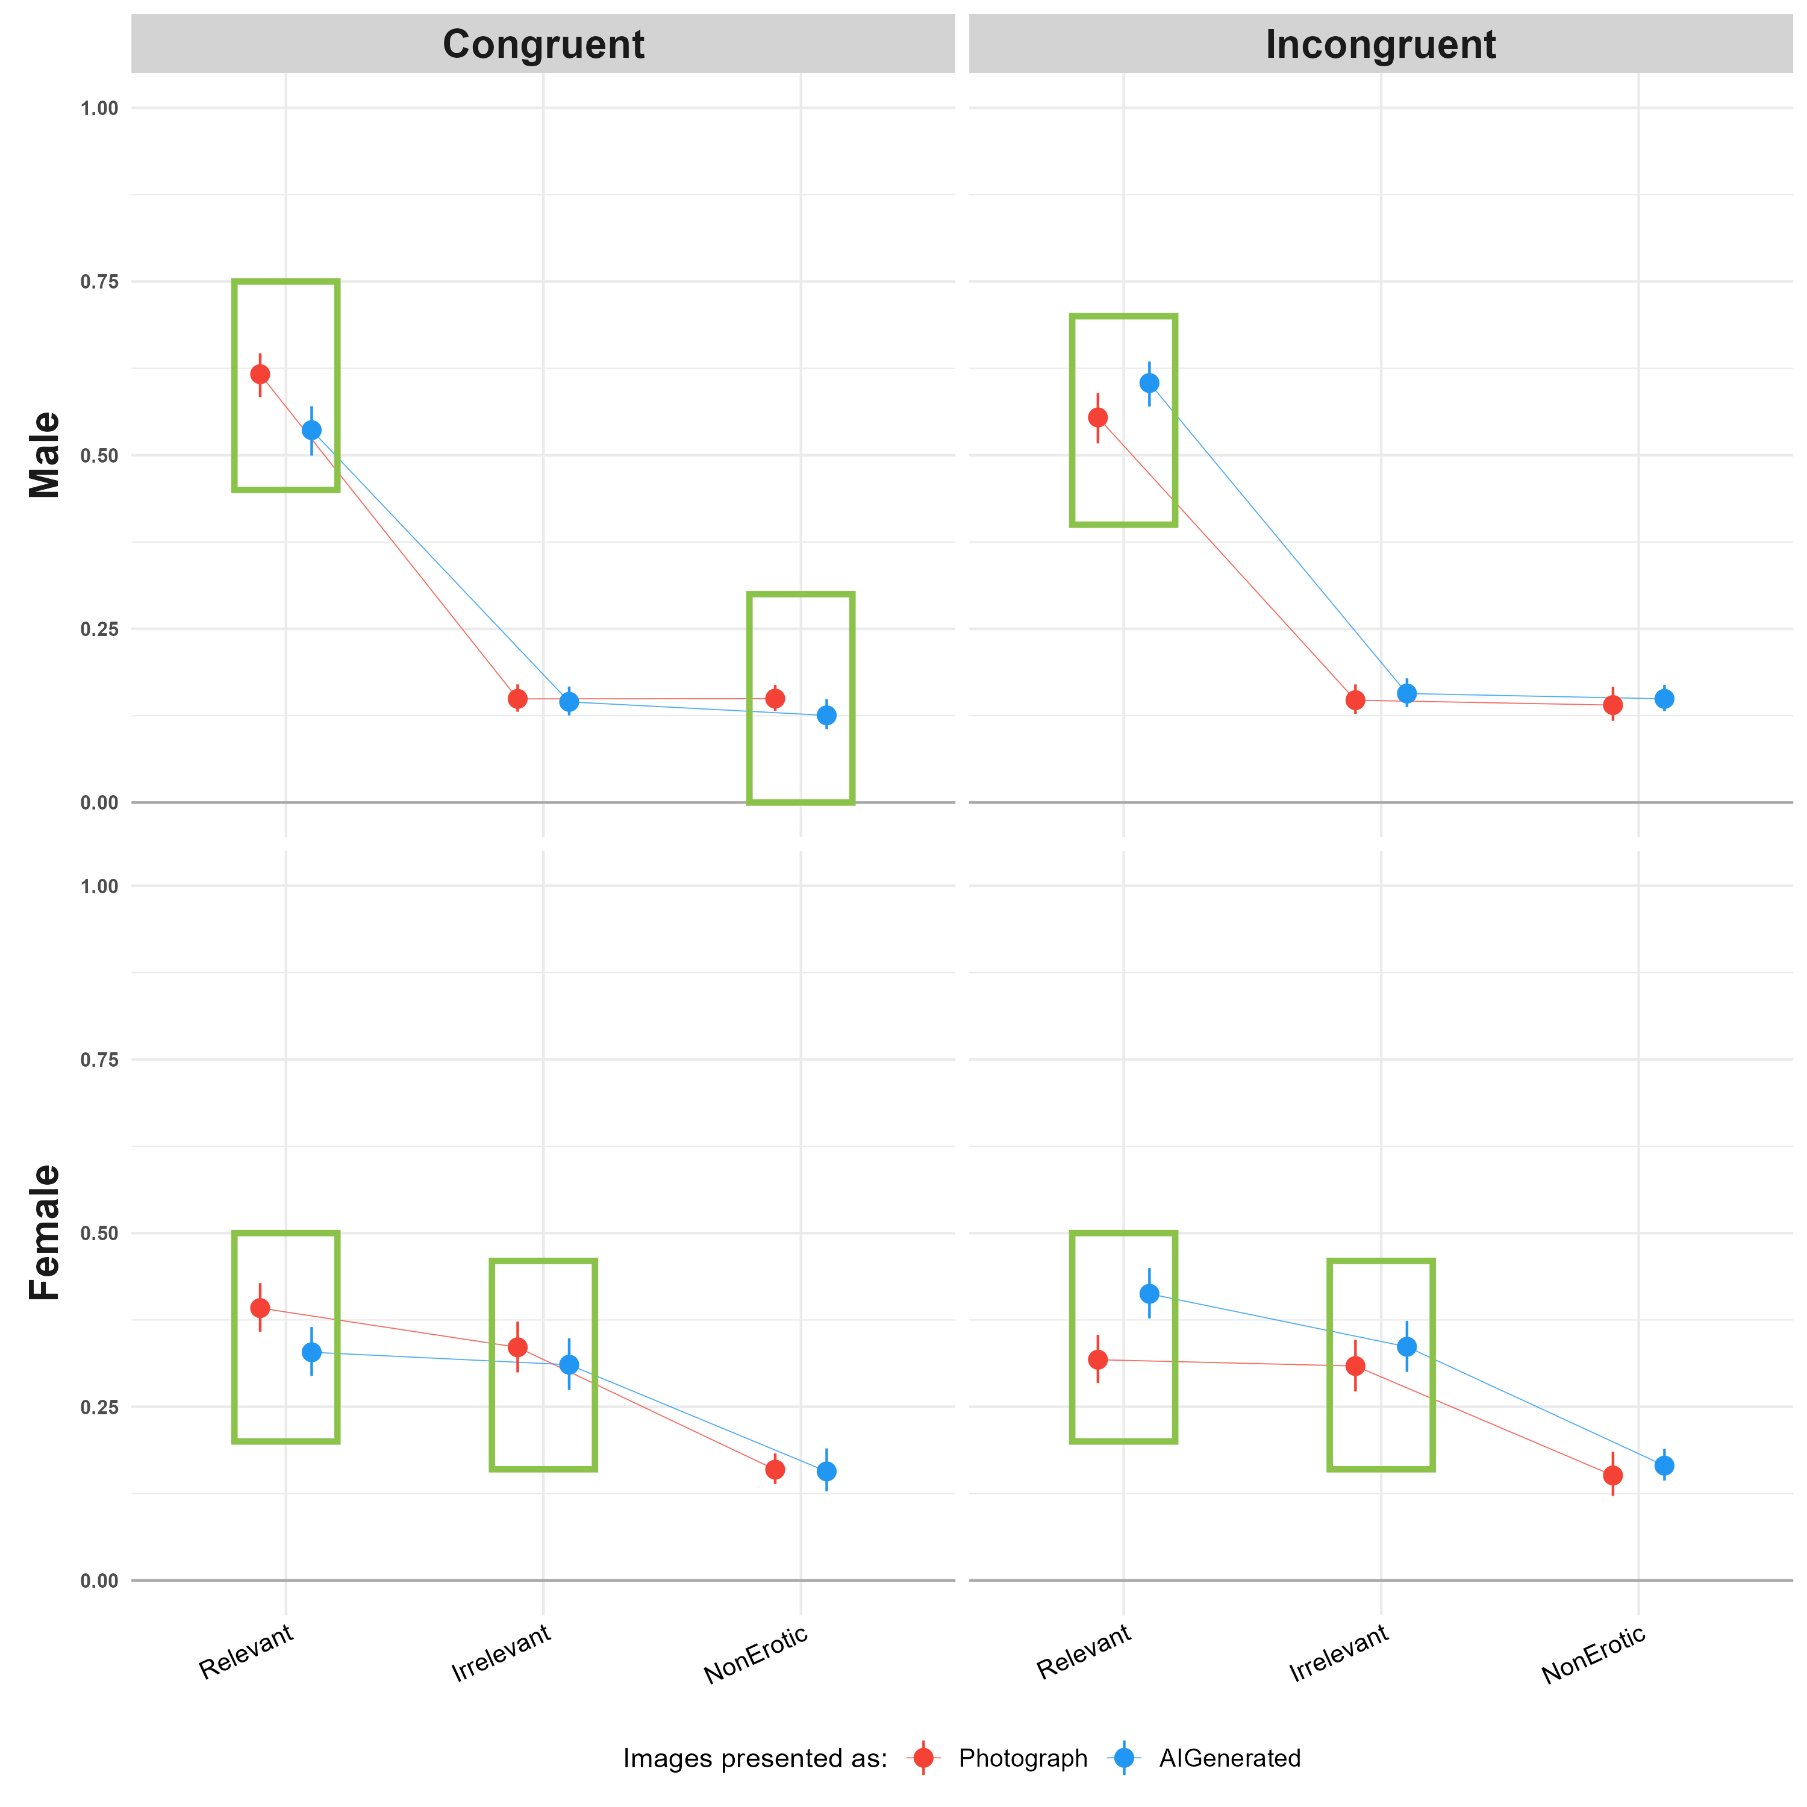

Individual-level parameters
For arousal, the model reliable variability was observed for both item-level (D-vour = 0.917) and participant-level parameters (D-vour = 0.901). For irrelevant images, participant-level random slopes showed moderate reliability (D-vour = 0.704). In contrast, poor reliability was observed for participant-level effects associated with non-erotic images (D-vour = 0.628). Additionally, very low reliability was found for participant-level interactions with the AI-generated condition across all relevance parameters (relevant: D-vour = 0.135; irrelevant: D-vour = 0.016; non-erotic: D-vour = 0.008), indicating minimal reliable inter-individual variability in responses to the labelling manipulation.
Similar patterns were observed for enticement and valence, with reliable variability in both item- and participant-level intercepts and poor reliability for participant-level interactions with the AI-generated condition. The key difference was the presence of reliable participant-level variability for both irrelevant and non-erotic images. Specifically, for enticement, reliable effects were observed for irrelevant (D-vour = 0.838) and non-erotic images (D-vour = 0.835), and for valence, reliable effects were observed for irrelevant (D-vour = 0.845) and non-erotic images (D-vour = 0.835).

Correlation with moderators
The participant-specific intercepts (reflecting individual differences in baseline arousal in the reference condition) showed weak correlations with recency of sexual activity ($r$ = − .05, 95% CI = [-.06, -.04]) and weak correlations with frequency of pornographic consumption in the previous 30 days ($r$ = .09, 95% CI = [.08, .10]). Similarly, beliefs and attitudes towards AI showed only weak associations with the intercept, including positive ($r$ = .12, 95% CI = [.11, .13]) and negative attitudes ($r$ = .05, 95% CI = [.04, .06]). Correlations with self-reported knowledge about AI (r= .02, 95% CI =[.01, .03]), and beliefs about AI’s visual ($r$ =. 04, 95% CI = [.03, .06]) and textual abilities ($r$ = .06, 95% CI = [.05, .07]) were similarly weak. The relevance and AI-generated parameters also showed low correlations with the examined moderators: recency of sexual activity ($r$ = −.02, 95% CI = [-.03, -.01]), frequency of pornographic consumption in the previous 30 days ($r$ = −.03, 05% CI [-.04, -.02]), positive attitudes towards AI ($r$ = .07, 95% CI [.07, .08]), negative attitudes towards AI ($r$ = .03, 95% CI = [.02, .04]), knowledge about AI ($r$ = .04, 95% CI = [.03, .05]), belief on AI’s visual ($r$ = -.03, 95% CI [-.04, -.02]) and textual abilities ($r$ = .03, 95% CI [.02, .04]). Taken together, these findings indicate that variability in the intercept and relevance-related parameters was not meaningfully associated with participants’ sexual behaviour or their beliefs and attitudes towards AI (see Figure 4). For enticement and valence the same pattern of behaviour was found (full analysis available on the link provided above).

Figure 4
Top: Participant- and item-level estimates for the Arousal model parameters, under the distribution of their point-estimates. Reliable effects are characterised by a higher between-group variability (the dispersion of the distribution of point-estimates) relative to their within-group variability (the average uncertainty of individual estimates, reflected by the error bars). For example, the Intercept shows good reliability here, whereas the participant-level interactions with the AI-Generated label condition show low reliability. Bottom: Correlation matrix between participant-level estimates from the Arousal model and individual-difference measures. The model parameters show low to non-existent correlations with all individual characteristics, indicating that sensitivity to the label is not associated with the individual characteristics measured here.
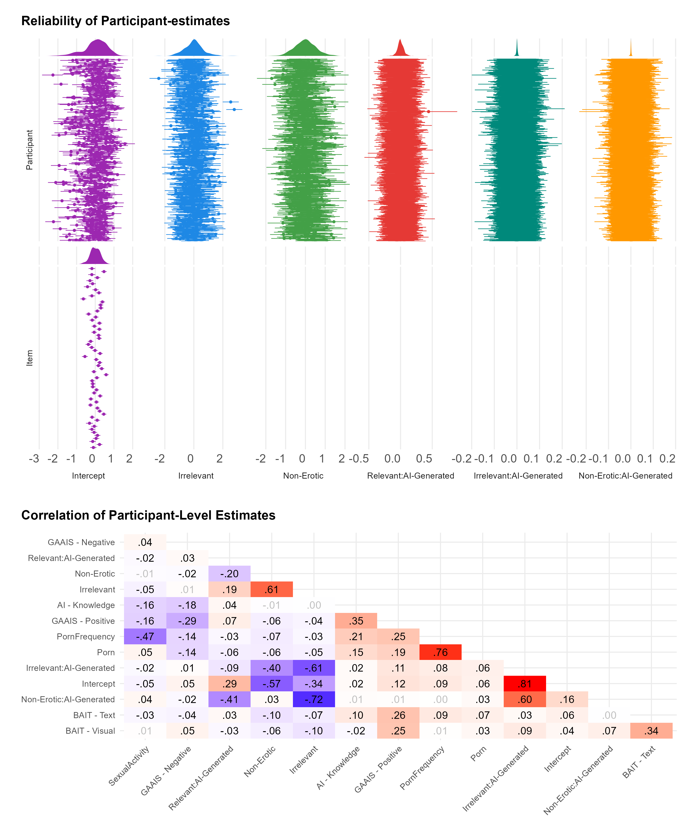

Discussion
In our first study, we presented subjects (heterosexual males and females) with several images from the NAPS database, including non-erotic images and both irrelevant (same gender) and relevant (other gender) erotic images. To manipulate subjects’ belief about the authenticity of the stimuli, each image was cued with a colored label presenting it as either “photograph” or “AI-generated”. After collecting subjective ratings of arousal, enticement and valence for each image, we performed a manipulation check to assess the efficacy of our experimental manipulation by asking them to rate how realistic they deemed the image.
Marginal contrasts indicated that males, but not females, rated relevant erotic images as more arousing than irrelevant erotic images. Additionally, across both genders, non-erotic images were rated as less arousing than relevant erotic images. These findings support our hypothesis and are consistent with prior literature demonstrating stronger category-specificity in men’s subjective responses to explicit stimuli (Chivers et al., 2004; Chivers, 2017; Huberman et al., 2015). One possible explanation for this pattern is the nature of the stimuli used. Prior work suggests that women’s sexual responses are more sensitive to contextual and relational features, such as narrative, emotional connection, and cues of intimacy (Laan et al., 1994; Rupp & Wallen, 2007, 2009). The stimuli in the present study did not include depictions of couples, as given the limitations of genAI at the time, convincing participants genAI could produce such images was thought to not be feasible. This absence of relational context may have reduced the likelihood of observing differential responses among female participants.
In partial alignment with our hypothesis and previous work by Marini et al. (2024), the effect of condition on arousal depended on gender, but only for relevant erotic images. For males, images labelled as AI-generated were rated as slightly less arousing than those labelled as photographs, consistent with our prediction that authenticity labelling would suppress arousal to AI-generated content. For females, however, this pattern reversed: AI-labelled images were rated as marginally more arousing than photographic ones, contrary to our hypothesis. In both cases the effect size was small. No credible differences between conditions emerged for irrelevant or non-erotic images, suggesting this gendered divergence was specific to sexually relevant content rather than a general labelling effect.
Notably, for both genders this difference in ratings was minimal. To further examine the role of stimulus evaluation, we included congruency between the label presented in Phase 1 and participant’s realism ratings in Phase 2 as a predictor. A crossover interaction emerged: when participants’ Phase 2 ratings were incongruent with the initial label, AI-labelled erotic images were rated as more arousing; conversely, when ratings were congruent, images labelled as photographs were rated as more arousing across both genders.
We also examined whether variability in responses could be explained by individual differences in participants’ attitudes towards AI and their sexual behaviours. To do so, we first assessed the extent to which responses to the AI label varied meaningfully between participants. The analysis indicated that between-participant variability in sensitivity to the AI label was minimal, suggesting that participants did not differ reliably in how the label influenced their responses. Consequently, it was not possible to draw meaningful conclusions about whether individual differences predicted sensitivity to the AI manipulation. One possible explanation for this lack of variability is that the label manipulation was not sufficiently strong or salient to elicit differentiated responses across individuals. As a result, any potential influence of individual differences may not have been adequately captured in the present design.

Study 2
The rapid development adoption of genAI (Bick et al., 2026; Bright et al., 2025; Stephenson & Armstrong, 2026) following the conceptualisation of study 1 motivated a second study, designed to address several limitations of the first.
First, at the time of Study 1, limitations in genAI realism prevented convincing depictions of couples, so the role of relational context could not be tested directly. Recent advances now allow for the generation of realistic couple stimuli depicting sexual activity without salient artefacts (e.g., anatomical inconsistencies such as extra fingers), making this test possible. Given that women’s arousal tends to be more sensitive to intimacy, narrative, and the presence of an interacting partner than men’s (Laan et al., 1994; Rupp & Wallen, 2007, 2009), we included couple-based stimuli in Study 2 to assess whether the absence of relational context contributed to the lower arousal ratings observed among female participants in Study 1.
Second, in Study 1, marginal contrasts indicated credible differences in ratings between images labelled as AI-generated and those labelled as photographs only for relevant erotic stimuli, in both genders. Study 2 therefore focused exclusively on erotic images relevant to participants’ gender and sexual orientation.
Third, Study 1 demonstrated that the effect of AI labelling was small and showed minimal variability across participants, limiting our ability to examine individual differences. One possible explanation is that the label manipulation lacked ecological validity. To strengthen its effectiveness, Study 2 used a more elaborate cover story and a more explicit control task: rather than simply judging whether images looked realistic, participants were asked to commit to a judgment of whether each image was an actual photograph or AI-generated.
Finally, to reduce unexplained variability in responses and increase statistical sensitivity, Study 2 employed a more homogeneous sample of English-speaking, incentivised participants.
Based on these aims, we tested the following hypotheses. As in Study 1, we hypothesised that images labelled as AI-generated would be rated lower in arousal than those labelled as photographs (H1). Given the crossover effect observed in Study 1, we hypothesised that this pattern would reverse under incongruent trials, such that AI-labelled images would be rated higher than photograph-labelled images when participants’ realism judgments conflicted with the initial label (H2). Finally, we hypothesised that the inclusion of couple-based stimuli would narrow the gender gap in arousal observed in Study 1, by selectively increasing female arousal ratings (H3).

Methods

Participants
The initial sample comprised 279 participants recruited via Prolific. Inclusion criteria required participants to be native English speakers or residents of countries with high levels of English proficiency. Data collection occurred from 27 of January 2025 to 31 of July 2025 (best image generator at this time was Midjourney v6, Ward). Participant exclusions were applied as follows: five participants were removed for showing no variability in arousal ratings (i.e., they did not move the response scales). An additional five participants were excluded for completing the study on a mobile device. We removed these participants because the change in the presentation of our scales from Likert to analog meaning participants completing the experiment on a phone would not be able to provide nuanced responses due to the smaller size of the screen. One participant was excluded due to displaying negative correlations between arousal and both enticement and valence. Furthermore, five participants who self-identified as neither female nor male, and two participants who reported a sexual orientation other than heterosexual, homosexual, or bisexual, were excluded from further analyses due to lack of sufficient group sizes. Finally, one participant was removed because the stimuli presented were not relevant to their gender and sexual orientation.
The final sample consisted of 261 participants (Mean = 37.4 $±$ 12.7, 48.7% Female). 56.32% of participants were from the United Kingdom, 26.82% from South Africa, 10.34% from the United States, and the remaining 6.51% were from other countries.
Ethical approval for this study was obtained from the School of Psychology Ethics Committee at the University of Sussex (ER/EB672/2).

Materials

Questionnaires.
The questionnaires used in Study 2 were largely the same as those in Study 1, with minor modifications. In the BAIT, two items, assessing beliefs that AI might take control of people and interest in using AI systems in daily life, were removed. Three items assessing AI expertise were added (e.g., “I consider myself an expert in AI technology), as well as four items assessing one’s ability to discriminate between AI and real stimuli (e.g., “I can easily distinguish between real and AI-generated images”). Lastly, 7 items assessing AI-bias were further included (e.g., “Human creators bring a unique perspective that AI cannot replicate”). Items from the GAAIS used in study 1 were incorporated into this version of the BAIT resulting in 5 dimensions: Expectations ($ω$ = .76), Attitudes ($ω$ = .78), Expertise ($ω$ = .77), Discrimination ($ω$ = .80) and Bias ($ω$ = .77).
Items were rated in a 7 Likert scale from 0 (Disagree) to 6 (Agree). Additionally, the wording was streamlined by replacing “Artificial Intelligence” with “AI” throughout the scale.
In the COPS, the item assessing the typical duration of pornography viewing sessions was omitted, retaining only items measuring frequency of pornography viewing and recency of sexual activity ($ω$ = .19).

Measures.
The measures were largely the same as in Study 1 with the only difference being the wording of the reality measure to “I think this face is…Indicate your confidence that the image is fake or real”. Arousal, Enticement, Valence were rated on a 7-point Likert scale from Not at all (0) to Very much (6). The reality measure was rated on a continuous scale from AI-Generated (-3) to Photograph (3).

Feedback.
A survey was provided as a free choice with non-mutually exclusive options. The survey asked participants to indicate whether they found certain images particularly arousing, and whether AI-generated images were more or less arousing than the photographs. Participants were also asked about their perceptions of the AI-generation algorithm, including whether differences between AI-generated and real images were obvious or subtle, whether they perceived any inconsistencies or reversals in the labeling (“Photograph” vs. “AI-Generated”), and whether they believed all images were either photos or AI-generated. If participants indicated that they believed all images were either real or AI-generated, they were further asked to rate their confidence in this judgment on a scale from “Not at all” to “Completely certain.”

Procedure

Figure 5
Paradigm 2
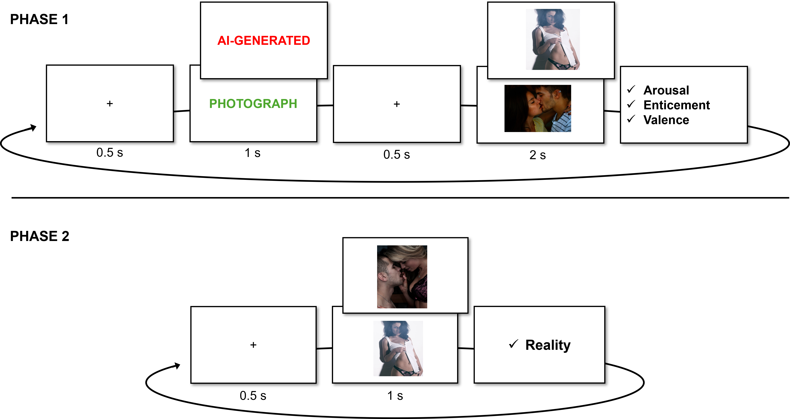
Consistent with Study 1, Study 2 was conducted in jsPsych following born-open principles (De Leeuw, 2015; Leeuw, 2024). Participants first provided informed consent, being informed that they could withdraw at any time; however, once the experiment was completed, withdrawal was not possible because the data were anonymized prior to storage. They then completed the same demographic questions as in Study 1, with the exception of items regarding birth control use.
In the first phase, participants were informed that the researchers were collaborating with a young AI start-up based in Brighton, intended to enhance the believability of the study. The following instructions were given:
This study stems out of an exciting new partnership between researchers from the University of Sussex and a young AI startup based in Brighton, UK, that specializes in making AI technology more ethical. Our goal is to better understand how various people react to different images. For this, we will be using a new image generation algorithm (based on a modified Generative Adversarial Network) trained on a carefully refined material to produce realistic high-quality erotic images. This allows us to manipulate the generation parameters and understand how they impact perception. The illustration below demonstrates how a GAN algorithm generates face images. Our updated version extends this approach to full-body images, including multiple people interacting. This enhancement was achieved by improving the logic of the embedded space obtained from the training data.
Participants were told that they would be presented with AI-generated images intermixed with real photographs both preceded by their respective labels.
They were asked to rate each image on sexual arousal, enticement, and valence. Each measure was defined as per Study 1 (see below). A total of 50 images were presented, drawn from two categories of the NAPS-ERO database (25 images of couples and 25 images of individuals). The stimuli were selected from erotic categories based on sexual orientation, specifically arousal ratings. For heterosexual males and females, the 25 highest-arousal images were selected within each relevant category (female/male and oppositive-sex couples). Parallel sets were constructed for homosexual males and females using the corresponding same-sex categorisations. Images were assigned to be relevant to participants’ self-reported gender and sexual orientation; for example, male participants identifying as homosexual viewed male individuals and male couples. Each trial followed a fixed timing sequence: a fixation cross (500 ms), a color-coded textual cue displayed for 1,000 ms, a second fixation cross (500 ms), and then the image presented for 2,000 ms. Cue colors were the same as in Study 1 and were randomly assigned across trials. Participants identifying as other in gender or bisexual/other in sexual orientation were asked which type of images they preferred, with options including “Women (and heterosexual couples),” “Men (and heterosexual couples),” “Only women (and lesbian couples),” and “Only men (and gay couples).”
Midway through the 50 images, participants were provided with a break and instructed to continue when ready. Following the completion of all images, they completed a brief feedback survey assessing their subjective impressions of the images and AI-generation labels. This survey asked whether certain images were particularly arousing, whether AI-generated images were more or less arousing than the photographs, and participants’ perceptions of the AI-generation algorithm. Specifically, they indicated whether differences between AI-generated and real images were obvious or subtle, whether they perceived inconsistencies or reversals in labeling (“Photograph” vs. “AI-Generated”), and whether they believed all images were either photos or AI-generated. If participants indicated that all images were real or AI-generated, they rated their confidence on a scale from “Not at all” to “Completely certain.” This feedback captured participants’ explicit beliefs and subjective reactions regarding both the content and labeling of the images. Following the first phase, participants completed the BAIT and COPS questionnaires.
In the second phase, participants were informed that some images had been intentionally mislabeled and were asked to judge whether each image was AI-generated or a real photograph, expressing their confidence at the extremes of the scale. They were given the following instructions:
[…] there is something important we need to tell you… In the previous phase, some images were intentionally mislabelled (we told you it was a photograph when it was actually AI-generated and vice versa). In this phase, we want you to tell us for each image what you think is the true category! We will briefly present all the images once more, and your task is to tell us if you think the image is AI-generated or a photograph. Indicate your degree of confidence and certainty by selecting larger numbers.
The timing procedure in this phase was identical to Study 1 (ee Figure 5). After each image, participants provided general feedback regarding their experience and any additional comments. Finally, participants were presented with a debrief page informing them that all images were, in fact, real photographs.

Data Analysis
As in with study 1, Bayesian linear mixed models will be fitted for the three outcome variables, each predicted from Gender, Condition and Condition Belief: Outcome ~ Gender / Condition * Congruence + (Condition | Participant) + (1 | Item). For ease of comparison with study 1 results, all outcome variables will be bounded between 0 to 1, and the ZOIB family will be fitted. Weakly informative priors will again be placed on fixed effects, and each model will be estimated with 2000 iterations across 96 chains resulting in 96000 post-warm up draws and run on the HPC.
Marginal contrasts will be computed to compare marginal means with condition (i.e., AI-Generated and Photograph) as the predicted contrasts, estimated with levels of Gender, and levels of Gender depending on Congruency. The same analysis as study 1 individual-level parameters and correlations with moderators will be conducted, using the same packages. To further assess the effect of the type of image (e.g., couple vs individuals) the same analysis was conducted adding Type as predictor.
Consistent with Study 1, the Results section will focus primarily on arousal, with results for enticement and valence reported elsewhere. All analyses were conducted in R (version 4.5.2; https://github.com/RealityBending/FictionEro contains all materials, data and analysis scripts for study 2).

Results

Distributions
As shown in Figure 6, arousal ratings exhibit different distributional patterns for males and females. Male participants show a broader distribution of arousal scores, with relatively higher frequencies at both the lower end of the scale and across the mid-range (~ 0.50–0.70). In contrast, female participants’ arousal ratings are more heavily concentrated at the lower end of the scale, with frequencies decreasing as arousal values increase. A similar pattern is observed for enticement and valence. For males, higher frequencies are evident in the mid-range of the scale, whereas for females, responses tend to cluster at the lower end of the scale with an additional concentration in the mid-range.

Figure 6
Distributions of Arousal, Enticement and Valence ratings for males and females across conditions. Scores were bounded from 0 to 1.
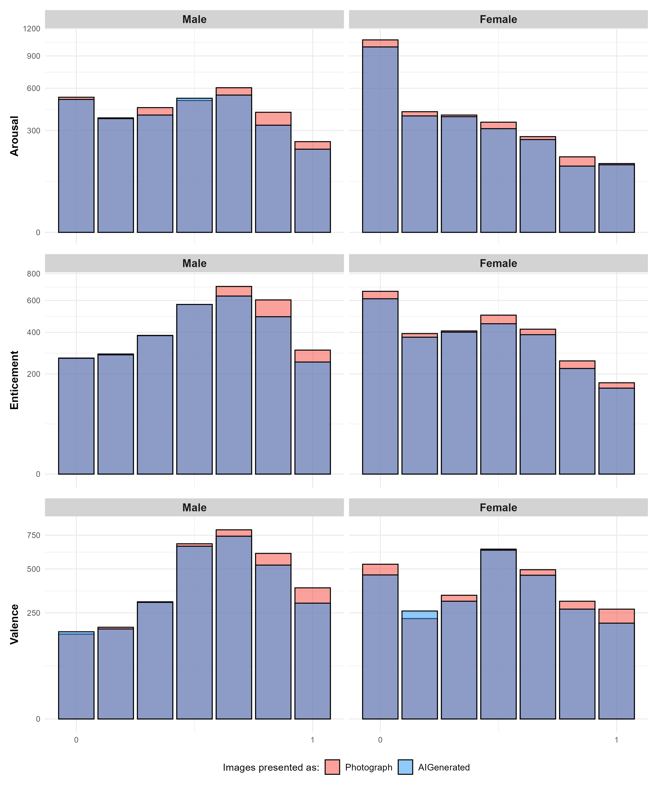

Manipulation checks
In Study 2, 32% of participants reported believing that all images were real based on their feedback after Phase 1, indicating that a third of participants did not believe in the manipulation. However, in Phase 2, 48.2% of images were classified as photographs.
To assess whether image ratings differed between stimuli labelled as AI-generated versus photographs as a function of whether the instructional labels were believed, Bayesian independent-samples t-tests were conducted for arousal, enticement, and valence. The t-test comparing arousal difference scores between participants who did not believe the labels (M_{difference} = −0.009) and those who did (M_{difference} = −0.03) found extreme evidence in favour of a difference between the means (BF₁₀ = 3.4 × 10²⁰³). This estimated effect size was large (median $δ$ = −1.10, 95% CrI [−1.14, −1.06], pd = 100%). A similar pattern was observed for enticement and valence.

Marginal contrasts

Effect of Type.
The addition of image type (e.g., images of couples vs images of individuals) showed a credible difference between ratings of individual images between males and females with the former rating images higher in arousal ($Δ$ = .17, 95% CrI [.11, .22], pd = 100%). No credible differences between ratings of couple images was found between males and females ($Δ$ = 0.009, 95% CrI [-.02, .04], pd = 69.92%). Same patterns were found for enticement and valence (see Figure 7).

Figure 7
Estimated means for Arousal, Enticement and Valence for images of individuals and couples, for both genders. Green rectangles represent differences in means where the pd > 97.5%, indicating a consistent effect direction (Makowski et al., 2019).
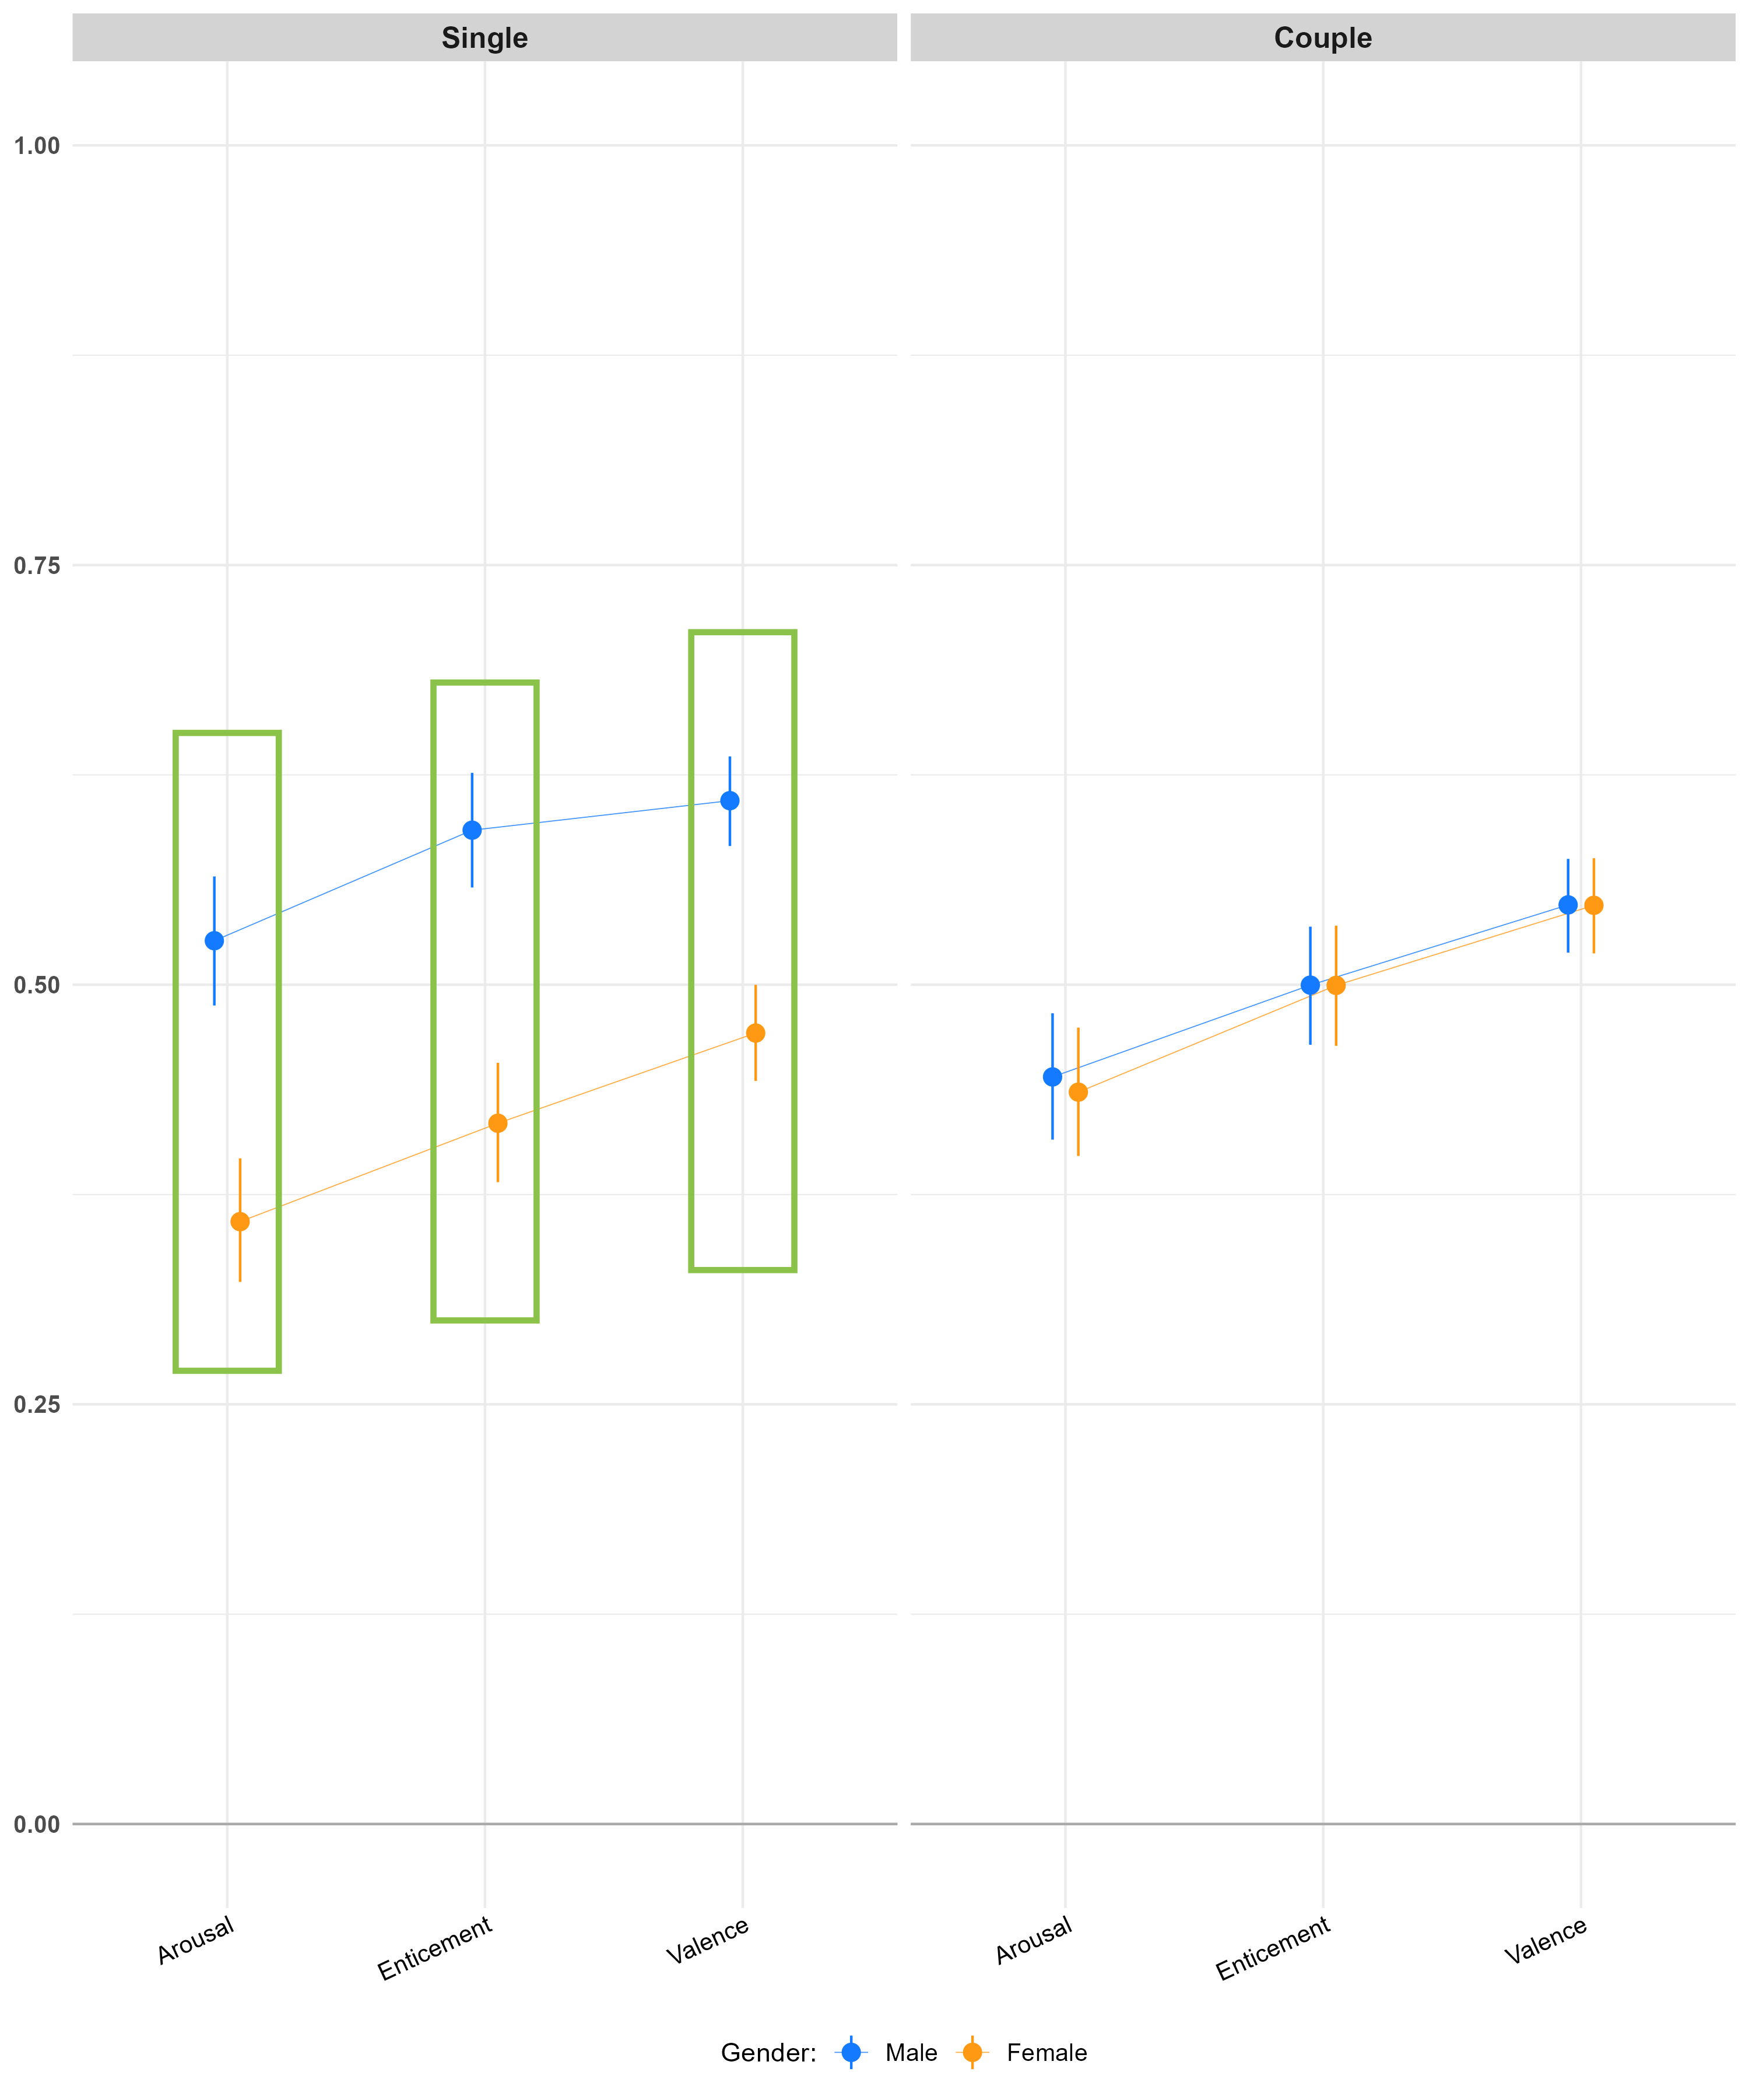
Additionally, credible differences were found for females and males ratings between image types. Couple images were rated higher in arousal compared to images of individuals for females ($Δ$ = .08, 95% CrI [.03, .12], pd = 99.98%), whilst males rated couple images lower ($Δ$ = -.08, 95% CrI [-.12, -.04], pd = 99.98%). Enticement and valence ratings were credibly different (pd > 99.99%) for both females and males, with males ratings for couple images being rated lower than images with individuals, whereas the pattern was reversed for females.

Effect of Condition (with and without Type).
Estimated marginal contrasts assessing the effect of condition across gender showed that the difference was only credible for Males ($Δ$ = .06, 95% CrI [.04, .07], pd = 100%) but not for females ($Δ$ = .01, 95% CrI [.00, .02], pd = 93.57%). The same pattern was found for enticement. For valence ratings, both genders rated images labelled as photograph higher than those labelled AI-generated (pd > 98.8%).
The effect of condition across gender for the type of images showed only males credibly differed in arousal ratings of images of couples labelled photograph vs those labelled AI-generated ($Δ$ = .02, 95% CrI [.00, .04], pd = 99.23%), and ratings of individuals ($Δ$ = .02, 95% CrI [.00, .03], pd = 98.77%). No credible differences were found for females (pd < 88.2%). Enticement ratings followed the same pattern, while for valence ratings the only credible difference was found for females ratings of couple images, with those images labelled photograph being rated higher than those labelled Ai-generated ($Δ$ = .02, 95% CrI [.01, .04], pd = 99.52%).

Effect of Condition Depending on Congruence (with and without Type).
Estimated marginal contrasts examined differences in arousal ratings between photographic and AI-generated images as a function of gender and congruence. Under congruent trials, photographic images were rated as more arousing for both genders, with a stronger effect for males ($Δ$ = .06, 95% CrI [.04, .07], pd = 100%) than females ($Δ$ = .02, 95% CrI [.00, .04], pd = 97.18%). Under incongruent trials, the direction of the effect reversed for males ($Δ$ = −.02, 95% CrI [−.04, −.01], pd = 99.71%), whereas the effect for females was negligible ($Δ$ ≈ 0, 95% CrI [−.02, .02], pd = 57%).
Incorporating image type into the models provided limited additional evidence for differences overall, although some credible effects emerged for males. Specifically, under incongruent trials, males showed higher arousal ratings for photograph- relative to AI-labelled images for both couples ($Δ$ = .06, 95% CrI [.03, .08], pd = 100%) and individuals ($Δ$ = .06, 95% CrI [.04, .08], pd = 100%). Under congruent trials, a credible difference for males was observed only for individual images ($Δ$ = −.03, 95% CrI [−.05, −.01], pd = 99.41%). In contrast, female participants showed no credible differences across trial types or image categories, with estimates centred near zero and credibility intervals spanning zero.
Enticement and valence ratings followed a broadly similar pattern to arousal, with higher ratings for photographic images under congruent trials and weaker, less consistent reversals under incongruent trials. A notable exception was observed for female participants, who showed credible differences under congruent trials, with photograph-labelled images rated higher for both enticement and valence (pd > 99.2%).
When image type was included in the models, credible differences in enticement ratings were largely restricted to males: under congruent trials, males showed higher ratings for photograph-labelled images for both couples and individual stimuli (pd = 100%), whereas under incongruent trials, this effect remained only for individual images (pd > 99%). For valence ratings, most contrasts became credible following the inclusion of image type (pd > 98%), maintaining the same reversal pattern under incongruent trials. The primary exception was for female ratings of couple images under incongruent trials, where evidence remained inconclusive (pd < 59.5%).

Figure 8
Estimated arousal means for the effect of Condition depending on Congruency. Green rectangles represent differences in means where the pd > 97.5%, indicating a consistent effect direction (Makowski et al., 2019).
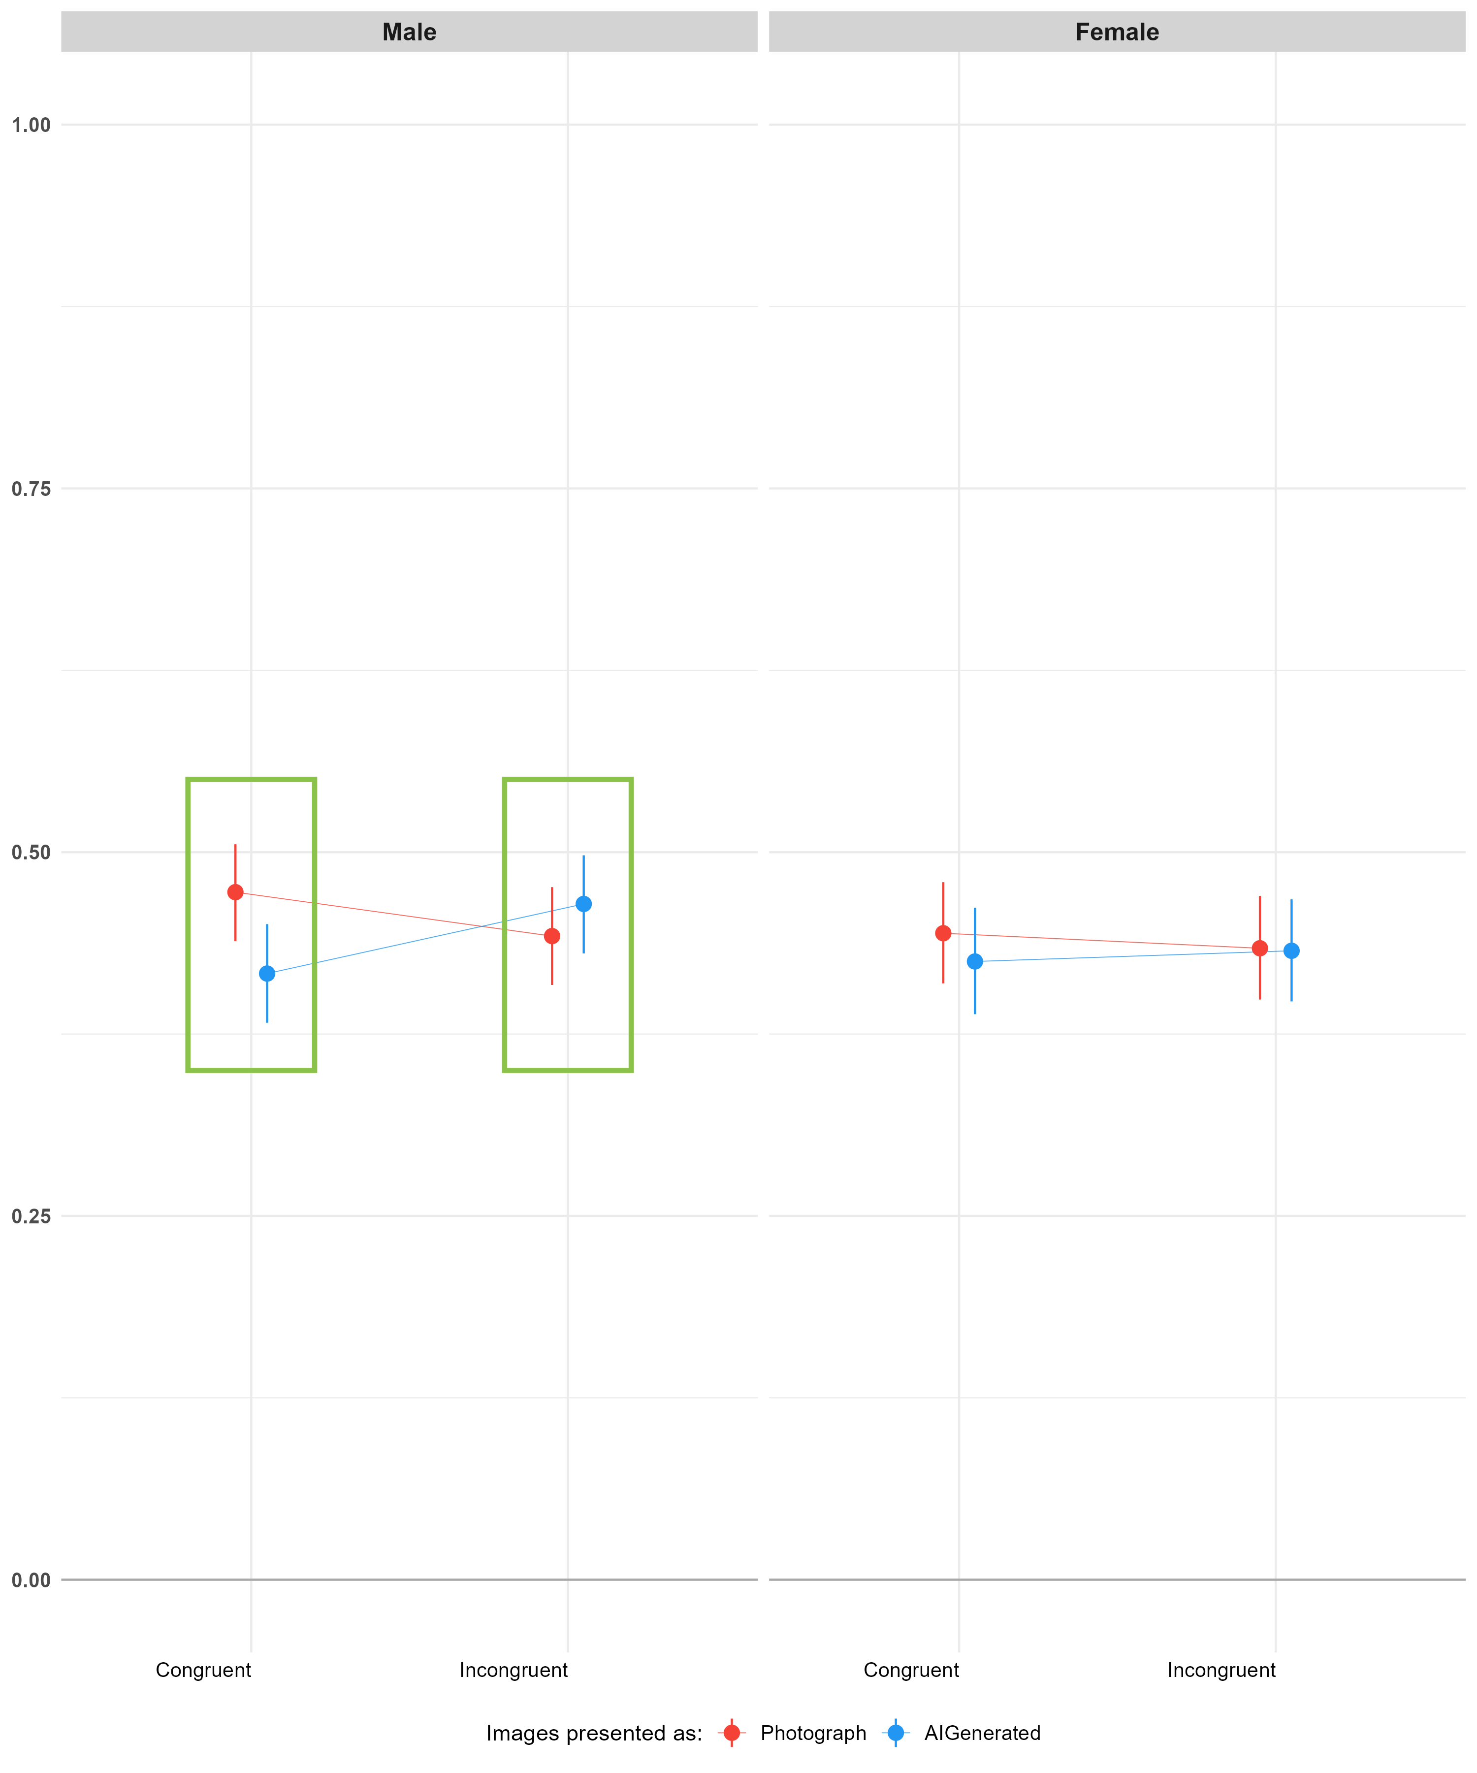

Individual-level parameters.
For arousal, reliable variability was observed for both item-level (D-vour = 0.949) and participant-level parameters (D-vour = 0.914). In contrast, very low reliability was found for participant-level interactions with the AI-generated condition (D-vour = 0.072), indicating minimal reliable inter-individual variability in responses to the belief manipulation, consistent with Study 1.
A similar pattern was observed for enticement and valence, with the key difference that, for valence ratings, the participant-level interaction with the AI-generated condition showed slightly higher reliability (D-vour = 0.203), although reliability is still low.

Correlation with moderators.
For the intercept of the arousal model, correlations with beliefs and attitudes towards AI were overall weak ($r$ = .25, 95% CI [.23, .26]). More specifically, the intercept showed weak positive associations with general expectations about AI ($r$ =.16, 95% CI [.14, .17]), general attitudes towards AI ($r$ =.14, 95% CI [.12, .16]), self-reported expertise about AI ($r$ =.25, 95% CI [.24, .27]), and bias against AI content ($r$ =.15, 95% CI [.13, .17]). The correlation with discrimination ability between AI- and human-generated content was negligible ($r$ =−.01, 95% CI [−.03, .01]). Additionally, weak positive correlations were observed with recency of sexual activity ($r$ =.04, 95% CI [.02, .06]) and frequency of pornographic consumption in the previous 30 days ($r$ =.11, 95% CI [.09, .13]).
The AI-generated parameter also showed weak positive correlations with total beliefs and attitudes towards AI ($r$ =.23, 95% CI [.22, .25]), general expectations about AI ($r$ =.10, 95% CI [.08, .12]), general attitudes towards AI ($r$ =.16, 95% CI [.15, .18]), self-reported expertise about AI ($r$ =.25, 95% CI [.23, .27]), and bias against AI content ($r$ =.14, 95% CI [.13, .16]). Correlations with discrimination ability between AI- and human-generated content were again negligible ($r$ =−.02, 95% CI [−.03, .00]). Finally, weak associations were observed with recency of sexual activity ($r$ =.04, 95% CI [.02, .05]) and frequency of pornographic consumption in the previous 30 days ($r$ =.10, 95% CI [.08, .12]).
For the enticement and valence models, the pattern of results was broadly similar (see https://github.com/RealityBending/FictionEro). Taken together, and consistent with Study 1, these findings suggest that variability in the arousal, enticement, and valence parameters was not meaningfully associated with beliefs and attitudes towards AI or with sexual behaviour.

Figure 9
Top: Forest plots of participant- and item-level random-effect estimates (points = posterior means, lines = 95% credible intervals) for the Intercept (left) and the AI-Generated slope (right), with density curves showing the distribution of point-estimates across participants/items. Reliable effects are those where between-group variability (spread of the point-estimate distribution) is large relative to within-group variability (the average width of the individual credible intervals). By this standard, the Intercept shows good reliability — the spread of estimates clearly exceeds individual measurement error — while the AI-Generated effect shows poor reliability: individual differences in sensitivity to the label are small relative to the uncertainty in each participant’s estimate. Bottom: Correlations between participant-level model estimates (Intercept, AI-Generated slope) and individual-difference measures, self-reported sexual activity, and pornography use frequency. Correlations are uniformly weak (|r| ≤ .11), suggesting that participants’ baseline arousal ratings and their sensitivity to the AI-Generated label are largely independent of the dispositional and behavioral measures assessed here.


Discussion
In study 2, participants viewed erotic images depicting both couples and individuals matched to their sexual orientation. # As in Study 1, images were labelled as either photographs or AI-generated. The strengthening of the manipulation in this study appeared to modestly improve its effectiveness: 32% of participants reported believing that all images were real, compared to a higher proportion in Study 1 (42%), suggesting increased credibility of the manipulation, though still limited.
Overall, the pattern of findings partially replicated those observed in Study 1. Considered independently of congruence, the AI-labelling effect on arousal was credible for males but not for females, providing support for H1 in males only. Under congruent trials, images labelled as photographs were rated as more arousing, enticing, and positively valenced compared to those labelled as AI-generated. Under incongruent trials, this pattern reversed for males, consistent with the crossover effect observed in Study 1 and supporting H2. For females, however, no credible reversal emerged under incongruent trials, indicating an absence of the predicted effect rather than merely a weaker version of it; some credible differences did emerge for females under congruent trials for enticement and valence ratings. Thus, while the predicted crossover interaction was observed, support was essentially confined to male participants, only partially replicating Study 1
A key aim of Study 2 was to examine whether the inclusion of relational context (i.e., via couple-based stimuli) would narrow the gender gap in arousal observed in Study 1. The findings partially support this prediction. Specifically, males and females did not differ credibly in their ratings of couple images, whereas males continued to rate individual images as more arousing than females. However, this convergence did not arise solely from the predicted mechanism of selectively increased female arousal: females rated couple images higher in arousal than images of individuals, but males rated couple images credibly lower than images of individuals. The gender gap therefore appears to have narrowed through change in both directions (i.e., increased arousal to couples among females and decreased arousal to couples among males) rather than through a female-specific increase as H3 specifically predicted. This suggests that relational context shapes male and female responses differently, and that the original hypothesis captured only part of the underlying pattern.
Despite efforts to strengthen the manipulation, the overall effect of AI labelling remained small and showed minimal reliable variability across participants, replicating the pattern observed in Study 1. Consequently, as in Study 1, it was not possible to draw strong conclusions regarding individual differences as moderators of the labelling effect. Nevertheless, correlational analyses provided limited but additional insight: weak associations were found between arousal responses (both baseline and AI-related parameters) and self-reported beliefs, attitudes, and AI expertise, though these effects were small and insufficient to explain meaningful variability in responses.
Taken together, Study 2 extends the findings of Study 1 in two important ways. First, it demonstrates that the inclusion of relational context narrows the gender gap in arousal to erotic stimuli, supporting the interpretation that female sexual responding is more context-dependent. Second, it shows that strengthening the realism manipulation does not substantially increase its impact or reveal meaningful individual differences, reinforcing the conclusion that belief about stimulus origin exerts only a modest influence on affective responses.

General Discussion
The present paper investigated the existence and mechanism of an anti-AI bias in response to erotic stimuli across two studies, with a particular focus on the role of gender and belief-related processes. Across both studies, participants evaluated erotic (Study 1 and Study 2) and non-erotic (Study 1) images that were labelled as either AI-generated or photographs. Overall, the findings provide converging evidence for three main conclusions: (1) gender differences in response to erotic content are robust and context-dependent, (2) the effect of AI labelling on responses is small and primarily observed in males, and (3) belief-related processes (i.e., congruency between initial labels and subsequent realism/reality judgements) play a central role in shaping affective responses.
First, the results replicate and extend prior literature on gender differences in response to erotic stimuli. In Study 1, males showed clear category-specificity, rating sexually relevant images as more arousing than irrelevant ones, whereas females did not, therefore aligning with previous research (Chivers et al., 2004; e.g., Chivers, 2017; Huberman et al., 2015; Safron et al., 2020). Study 2, which presented only relevant stimuli, instead examined whether the gender gap in arousal observed in Study 1 was contingent on the nature of the stimuli. When relational context was introduced through couple-based images, this gap narrowed substantially: males and females did not differ in their ratings of couple images, while a gap persisted for images depicting individuals. Notably, Study 2 also showed that females rated images of couples higher than images of individuals, while males did the opposite. This finding supports the interpretation that female sexual responses are more sensitive to contextual and relational cues (e.g., Laan et al., 1994; Rupp & Wallen, 2007, 2009) and suggests that the absence of such features in Study 1 likely amplified the apparent gender gap in arousal.
Second, evidence for an anti-AI bias was partial and asymmetrical. In line with previous findings (e.g., Marini et al., 2024), images labelled as AI-generated were generally rated as less arousing than those labelled as photographs. However, this effect was small in magnitude and primarily driven by male participants across both studies, with little to no consistent evidence for such a bias in females. In Study 1, females rated relevant erotic images higher in arousal (but not valence or enticement) when they were presented as AI-generated; however, this was not found in Study 2. In both studies, males consistently rated images presented as photographs higher. We had additionally hypothesised that individual differences in AI attitudes and beliefs, pornography consumption frequency and recency of sexual activity might be associated with the strength of this labelling effect. However, as detailed below, individual-level estimates of sensitivity to the AI-generated label showed minimal reliable variability between participants, meaning these hypotheses could not be meaningfully tested in the present data; weak correlations with these variables should accordingly not be read as evidence against an association, but as uninformative given the lack of reliable variance to explain.
Third, and most importantly, the present findings highlight the central role of belief-related processes in shaping affective responses. In both studies, a substantial proportion of participants expressed doubts about the veracity of the labels after Phase 1, based on their feedback on whether they thought labels were incorrect (Study 1) or that all images were real (Study 2). We further evaluated these belief-related effects on ratings by operationalising a congruency variable, which revealed a crossover interaction with condition. When participants’ realism judgments were congruent with the initial label, images labelled as photographs were rated higher than those labelled as AI-generated. In contrast, when judgments were incongruent, this pattern reversed, with AI-labelled images receiving higher ratings, suggesting that participants’ affective responses are closely tied to whether they were second-guessing the authenticity of the images.
The crossover effects can be interpreted in at least two ways. First, participants may form rapid, largely implicit evaluations of stimulus authenticity upon initial exposure, which subsequently shape their arousal responses. Under this account, when an image labelled as AI-generated is nonetheless perceived as photograph-like, it may be experienced as more realistic and therefore more arousing, with this evaluation later reflected in Phase 2 realism ratings. In this sense, arousal ratings would be guided by participants’ initial impressions of authenticity, even if these impressions are not explicitly remembered or consciously endorsed. An alternative interpretation is that the direction of influence is reversed: rather than authenticity judgments driving arousal, some images may simply elicit stronger or weaker affective responses independent of their assigned label, and participants may retrospectively align their realism judgments with these affective reactions, such that less arousing images are more likely to be classified as AI-generated, and more arousing images as photographs. In this case, perceived authenticity would be inferred from the emotional response to the stimulus, rather than determining it. Together, these interpretations suggest that arousal and perceived authenticity may be reciprocally related, with the observed congruency effects reflecting either the influence of initial authenticity impressions on affective response, or post hoc alignment of realism judgments with experienced arousal.
While the present data cannot adjudicate between these accounts, one factor that may help explain variability in the strength of this effect is interoceptive ability. Theoretical accounts of perceptual reality monitoring propose that interoceptive precision shapes whether perceptual content is attributed to external reality, with disrupted interoception implicated in reality-monitoring failures in clinical populations (dijkstra2024disrupted?). We propose that an analogous mechanism may operate in the healthy range: participants who are more attuned to their own bodily arousal may place correspondingly more weight on that signal when judging whether an image is a genuine photograph, producing a stronger crossover effect, whereas participants with lower interoceptive accuracy may rely more heavily on contextual cues such as the assigned label. This account could first be tested correlationally, by incorporating a standard measure of interoceptive accuracy (e.g., a heartbeat discrimination task) alongside the existing paradigm and examining whether interoceptive accuracy predicts the size of the congruency effect. However, any such association could equally reflect a shared underlying trait, such as general emotional sensitivity, rather than a causal contribution of interoception specifically, and so would not on its own establish that interoceptive accuracy drives the effect.
A more direct test would be to manipulate interoceptive accuracy experimentally. Transcutaneous vagus nerve stimulation (tVNS) offers one way to do this: the vagus nerve is the primary pathway conveying internal bodily signals to the brain, and tVNS has been proposed as a tool for manipulating interoceptive processing at multiple levels (paciorek2020vagus?), with one study showing that tVNS improved participants’ accuracy in identifying their own heartbeats relative to sham stimulation, although it did not improve interoceptive awareness specifically (villani2019transcutaneous?). A future study could randomly assign participants to active or sham tVNS while completing the existing two-phase paradigm, and test whether active stimulation increases the size of the crossover effect relative to sham. A larger crossover effect under active tVNS would support the conclusion that interoceptive accuracy contributes causally to the alignment between felt arousal and realism judgements, whereas no difference between conditions would suggest that any correlational link observed in the first step reflects some other shared factor rather than interoception itself.
Notably, this study is not without limitations. Firstly, as expressed above, a substantial proportion of participants did not believe the labels were accurate (42% in Study 1 and 32% in Study 2), meaning the experimental manipulation was not fully convincing for a meaningful portion of the sample. Therefore, caution is required when interpreting the congruency variable effects, particularly given that the wording used to compute this variable differed between the two studies, which makes a direct comparison between them less clear.
Secondly, several of the questionnaire subscales used in this study showed low reliability, most notably the BAIT Images subscale in Study 1 and the revised COPS in Study 2 following removal of an item. These values fall below conventional thresholds for acceptable internal consistency, and conclusions drawn from analyses involving these specific subscales should therefore be interpreted with caution, as the items may not be capturing a coherent underlying construct. Thirdly, individual-level estimates of sensitivity to the AI-generated label showed minimal reliable variability between participants, meaning the planned individual-differences analyses as predictors of this sensitivity could not be meaningfully tested. The weak correlations observed should not be interpreted as evidence that these factors play no role, but rather as uninformative given the absence of reliable variance for them to explain. Future studies seeking to test these hypotheses would benefit from designs or manipulations that more reliably elicit individual variability in sensitivity to the AI label.
Fourthly, while the present findings are consistent with a crossover effect linking arousal and perceived authenticity, the design cannot establish the direction of this relationship. As discussed above, the observed congruency effects are equally consistent with authenticity impressions shaping subsequent arousal, or with arousal being retrospectively used to infer authenticity. Resolving this ambiguity would require designs capable of manipulating, rather than only measuring, one of these two processes.
[IMPLICATIONS]

References
2023 STATE OF DEEPFAKES: Realities, threats, and impact. (n.d.). In Security Hero. https://www.securityhero.io/state-of-deepfakes/
Ajder, H., Patrini, G., Cavalli, F., & Cullen, L. (2019). The state of deepfakes: Landscape, threats, and impact. Amsterdam: Deeptrace, 27.
Ansani, A., Koehler, F., Giombini, L., Hämäläinen, M., Meng, C., Marini, M., & Saarikallio, S. (2025). AI performer bias: Listeners like music less when they think it was performed by an AI. Empirical Studies of the Arts, 43(2), 1137–1161.
Bellaiche, L., Shahi, R., Turpin, M. H., Ragnhildstveit, A., Sprockett, S., Barr, N., Christensen, A., & Seli, P. (2023). Humans versus AI: Whether and why we prefer human-created compared to AI-created artwork. Cognitive Research: Principles and Implications, 8(1), 42.
Bick, A., Blandin, A., Deming, D. J., Fuchs-Schündeln, N., & Jessen, J. (2026). Mind the gap: AI adoption in europe and the US. National Bureau of Economic Research.
Bright, J., Enock, F., Esnaashari, S., Francis, J., Hashem, Y., & Morgan, D. (2025). Generative AI is already widespread in the public sector: Evidence from a survey of UK public sector professionals. Digital Government: Research and Practice, 6(1), 1–13.
Bürkner, P.-C. (2017). Brms: An r package for bayesian multilevel models using stan. Journal of Statistical Software, 80, 1–28.
Califano, G., & Spence, C. (2024). Assessing the visual appeal of real/AI-generated food images. Food Quality and Preference, 116, 105149.
Carvalho, J., Czop, O., Rocha, M., Nobre, P., & Soares, S. (2018). Gender differences in the automatic attention to romantic vs sexually explicit stimuli. The Journal of Sexual Medicine, 15(8), 1083–1092.
Cenerini, C., Keller, F., Pennazza, G., Santonico, M., & Vollero, L. (2025). Artistic turing test: The challenge of differentiating human and AI-generated art. Computers in Human Behavior: Artificial Humans, 100209.
Chiarella, S. G., Torromino, G., Gagliardi, D. M., Rossi, D., Babiloni, F., & Cartocci, G. (2022). Investigating the negative bias towards artificial intelligence: Effects of prior assignment of AI-authorship on the aesthetic appreciation of abstract paintings. Computers in Human Behavior, 137, 107406.
Chivers, M. L. (2017). The specificity of women’s sexual response and its relationship with sexual orientations: A review and ten hypotheses. Archives of Sexual Behavior, 46(5), 1161–1179.
Chivers, M. L., Rieger, G., Latty, E., & Bailey, J. M. (2004). A sex difference in the specificity of sexual arousal. Psychological Science, 15(11), 736–744.
Ciesielski, B. G., Armstrong, T., Zald, D. H., & Olatunji, B. O. (2010). Emotion modulation of visual attention: Categorical and temporal characteristics. PLoS One, 5(11), e13860.
Cloudy, J., Banks, J., & Bowman, N. D. (2022). Ai journalists and reduction of perceived hostile media bias: Replication and extension considering news organization cues. Technology, Mind, and Behavior, 3(3), 364.
Cohen, J. (2013). Statistical power analysis for the behavioral sciences. routledge.
De Leeuw, J. R. (2015). jsPsych: A JavaScript library for creating behavioral experiments in a web browser. Behavior Research Methods, 47(1), 1–12.
De Ruiter, A. (2021). The distinct wrong of deepfakes. Philosophy & Technology, 34(4), 1311–1332.
Di Dio, C., Ardizzi, M., Schieppati, S. V., Massaro, D., Gilli, G., Gallese, V., & Marchetti, A. (2023). Art made by artificial intelligence: The effect of authorship on aesthetic judgments. Psychology of Aesthetics, Creativity, and the Arts.
Döring, N., Le, T. D., Vowels, L. M., Vowels, M. J., & Marcantonio, T. L. (2024). The impact of artificial intelligence on human sexuality: A five-year literature review 2020–2024. Current Sexual Health Reports, 17(1), 4.
Döring, N., & Mohseni, M. R. (2025). Anti-AI bias toward couple images and couple counseling: Findings from two experiments. Archives of Sexual Behavior, 1–14.
Dunn, J. D., White, D., Sutherland, C. A., Miller, E. J., Steward, B. A., & Dawel, A. (2026). Too good to be true: Synthetic AI faces are more average than real faces and super-recognizers know it. British Journal of Psychology.
Easterbrook-Smith, G. (2025). Pornographic aura, AI and the value of authenticity. Porn Studies, 1–13.
Eiserbeck, A., Maier, M., Baum, J., & Abdel Rahman, R. (2023). Deepfake smiles matter less—the psychological and neural impact of presumed AI-generated faces. Scientific Reports, 13(1), 16111.
Fisher, S. A. (2025). Something AI should tell you–the case for labelling synthetic content. Journal of Applied Philosophy, 42(1), 272–286.
Fisher, S. A., Howard, J. W., & Kira, B. (2024). Moderating synthetic content: The challenge of generative AI. Philosophy & Technology, 37(4), 133.
Gangadharbatla, H. (2022). The role of AI attribution knowledge in the evaluation of artwork. Empirical Studies of the Arts, 40(2), 125–142.
Grassini, S., & Koivisto, M. (2024). Understanding how personality traits, experiences, and attitudes shape negative bias toward AI-generated artworks. Scientific Reports, 14(1), 4113.
Hatch, S. G., Esplin, C. R., Hatch, H. D., Halstead, A., Olsen, J., & Braithwaite, S. R. (2023). The consumption of pornography scale–general (COPS–g). Sexual and Relationship Therapy, 38(2), 194–218.
Heiss, A. (2021). A guide to modeling proportions with bayesian beta and zero-inflated beta regression models. Political Science. See Https://Www. Andrewheiss. Com/Blog/2021/11/08/Beta-Regression-Guide/(accessed 8 February 2024).
Holz, N., Larrouy-Maestri, P., & Poeppel, D. (2022). The variably intense vocalizations of affect and emotion (VIVAE) corpus prompts new perspective on nonspeech perception. Emotion, 22(1), 213.
Huang, M., Bridge, H., Kemp, M. J., & Parker, A. J. (2011). Human cortical activity evoked by the assignment of authenticity when viewing works of art. Frontiers in Human Neuroscience, 5, 134.
Huberman, J. S., Maracle, A. C., & Chivers, M. L. (2015). Gender-specificity of women’s and men’s self-reported attention to sexual stimuli. The Journal of Sex Research, 52(9), 983–995.
ifttt-user. Top 11 AI-Powered Image Generators in 2024 | Towards AI — towardsai.com. https://towardsai.com/p/artificial-intelligence/top-11-ai-powered-image-generators-in-2024.
Itkes, O., & Kron, A. (2019). Affective and semantic representations of valence: A conceptual framework. Emotion Review, 11(4), 283–293.
Köbis, N., & Mossink, L. D. (2021). Artificial intelligence versus maya angelou: Experimental evidence that people cannot differentiate AI-generated from human-written poetry. Computers in Human Behavior, 114, 106553.
Kramer, R. S., Jones, A. L., Fitousi, D., & Tree, J. J. (2025). AI-generated images of familiar faces are indistinguishable from real photographs. Cognitive Research: Principles and Implications, 10(1), 70.
Kunaharan, S., Halpin, S., Sitharthan, T., Bosshard, S., & Walla, P. (2017). Conscious and non-conscious measures of emotion: Do they vary with frequency of pornography use? Applied Sciences, 7(5), 493.
Kurdi, B., Lozano, S., & Banaji, M. R. (2017). Introducing the open affective standardized image set (OASIS). Behavior Research Methods, 49(2), 457–470.
Laan, E., Everaerd, W., Bellen, G. van, & Hanewald, G. (1994). Women’s sexual and emotional responses to male-and female-produced erotica. Archives of Sexual Behavior, 23(2), 153–169.
Lang, P. J., Bradley, M. M., Cuthbert, B. N., et al. (1997). International affective picture system (IAPS): Technical manual and affective ratings. NIMH Center for the Study of Emotion and Attention, 1(39-58), 3.
Lapointe, V. A., Dubé, S., Rukhlyadyev, S., Kessai, T., & Lafortune, D. (2025). The present and future of adult entertainment: A content analysis of AI-generated pornography websites. Archives of Sexual Behavior, 1–19.
Leeuw, J. R. de. (2024). DataPipe: Born-open data collection for online experiments. Behavior Research Methods, 56(3), 2499–2506.
Liefooghe, B., Oliveira, M., Leisten, L. M., Hoogers, E., Aarts, H., & Hortensius, R. (2023). Are natural faces merely labelled as artificial trusted less? Collabra: Psychology, 9(1), 73066.
Lüdecke, D., Ben-Shachar, M. S., Patil, I., Waggoner, P., & Makowski, D. (2021). Performance: An r package for assessment, comparison and testing of statistical models. Journal of Open Source Software, 6(60).
Lüdecke, D., Makowski, D., Ben-Shachar, M. S., Patil, I., Wiernik, B. M., Bacher, E., & Thériault, R. (2022). Easystats: Framework for easy statistical modeling, visualization, and reporting. CRAN: Contributed Packages.
Makowski, D., Ben-Shachar, M. S., & Lüdecke, D. (2019). bayestestR: Describing effects and their uncertainty, existence and significance within the bayesian framework. Journal of Open Source Software, 4(40), 1541.
Makowski, D., Ben-Shachar, M. S., Wiernik, B. M., Patil, I., Thériault, R., & Lüdecke, D. (2025). Modelbased: An r package to make the most out of your statistical models through marginal means, marginal effects, and model predictions. Journal of Open Source Software, 10(109), 7969.
Makowski, D., Wiernik, B. M., Patil, I., Lüdecke, D., & Ben-Shachar, M. S. (2022). correlation: Methods for correlation analysis. https://CRAN.R-project.org/package=correlation
Marchewka, A., Żurawski, Ł., Jednoróg, K., & Grabowska, A. (2014). The nencki affective picture system (NAPS): Introduction to a novel, standardized, wide-range, high-quality, realistic picture database. Behavior Research Methods, 46(2), 596–610.
Marini, M., Ansani, A., Demichelis, A., Mancini, G., Paglieri, F., & Viola, M. (2024). Real is the new sexy: The influence of perceived realness on self-reported arousal to sexual visual stimuli. Cognition and Emotion, 38(3), 348–360.
McDonnell, R., & Breidt, M. (2010). Face reality: Investigating the uncanny valley for virtual faces. In ACM SIGGRAPH ASIA 2010 sketches (pp. 1–2).
Miller, E. J., Steward, B. A., Witkower, Z., Sutherland, C. A., Krumhuber, E. G., & Dawel, A. (2023). AI hyperrealism: Why AI faces are perceived as more real than human ones. Psychological Science, 34(12), 1390–1403.
Newman, G. E., & Bloom, P. (2012). Art and authenticity: The importance of originals in judgments of value. Journal of Experimental Psychology: General, 141(3), 558.
Nightingale, S. J., & Farid, H. (2022). AI-synthesized faces are indistinguishable from real faces and more trustworthy. Proceedings of the National Academy of Sciences, 119(8), e2120481119.
Porter, B., & Machery, E. (2024). AI-generated poetry is indistinguishable from human-written poetry and is rated more favorably. Scientific Reports, 14(1), 26133.
Prause, N., Steele, V. R., Staley, C., Sabatinelli, D., & Hajcak, G. (2015). Modulation of late positive potentials by sexual images in problem users and controls inconsistent with “porn addiction.” Biological Psychology, 109, 192–199.
Ragot, M., Martin, N., & Cojean, S. (2020). Ai-generated vs. Human artworks. A perception bias towards artificial intelligence? Extended Abstracts of the 2020 CHI Conference on Human Factors in Computing Systems, 1–10.
Rupp, H. A., & Wallen, K. (2007). Sex differences in viewing sexual stimuli: An eye-tracking study in men and women. Hormones and Behavior, 51(4), 524–533.
Rupp, H. A., & Wallen, K. (2009). Sex-specific content preferences for visual sexual stimuli. Archives of Sexual Behavior, 38(3), 417–426.
Safron, A., Sylva, D., Klimaj, V., Rosenthal, A., & Bailey, J. M. (2020). Neural responses to sexual stimuli in heterosexual and homosexual men and women: Men’s responses are more specific. Archives of Sexual Behavior, 49(2), 433–445.
Schepman, A., & Rodway, P. (2020). Initial validation of the general attitudes towards artificial intelligence scale. Computers in Human Behavior Reports, 1, 100014.
Schepman, A., & Rodway, P. (2023). The general attitudes towards artificial intelligence scale (GAAIS): Confirmatory validation and associations with personality, corporate distrust, and general trust. International Journal of Human–Computer Interaction, 39(13), 2724–2741.
Shank, D. B., Stefanik, C., Stuhlsatz, C., Kacirek, K., & Belfi, A. M. (2023). AI composer bias: Listeners like music less when they think it was composed by an AI. Journal of Experimental Psychology: Applied, 29(3), 676.
Stephenson, R., & Armstrong, C. (2026). Student generative AI survey 2026. Higher Education Policy Institute. Https://Www. Hepi. Ac. Uk/Wp-Content/Uploads/2026/03/HEPI-Report-199-Gen-AI-Survey-2026. Pdf.
Tucciarelli, R., Vehar, N., Chandaria, S., & Tsakiris, M. (2022). On the realness of people who do not exist: The social processing of artificial faces. Iscience, 25(12).
Velásquez-Salamanca, D., Martı́n-Pascual, M. Á., & Andreu-Sánchez, C. (2025). Interpretation of AI-generated vs. Human-made images. Journal of Imaging, 11(7), 227.
Viola, M., & Voto, C. (2023). Designed to abuse? Deepfakes and the non-consensual diffusion of intimate images. Synthese, 201(1), 30.
Vuorre, M. (2019). How to analyze visual analog (slider) scale data. Https://Vuorre. Com/Posts/Analyze-Analog-Scale-Ratings-with-Zero-One-Inflated-Beta-Models/.
Walton, M. T., & Bhullar, N. (2018). Hypersexuality, higher rates of intercourse, masturbation, sexual fantasy, and early sexual interest relate to higher sexual excitation/arousal. Archives of Sexual Behavior, 47(8), 2177–2183.
Ward, C. Best AI Image Generators of 2025 | +Free Style Guide — Curious Refuge — curiousrefuge.com. https://curiousrefuge.com/blog/best-ai-image-generators-2025.
Wierzba, M., Riegel, M., Pucz, A., Leśniewska, Z., Dragan, W. Ł., Gola, M., Jednoróg, K., & Marchewka, A. (2015). Erotic subset for the nencki affective picture system (NAPS ERO): Cross-sexual comparison study. Frontiers in Psychology, 6, 1336.
Yang, W., Makita, K., Nakao, T., Kanayama, N., Machizawa, M. G., Sasaoka, T., Sugata, A., Kobayashi, R., Hiramoto, R., Yamawaki, S., et al. (2018). Affective auditory stimulus database: An expanded version of the international affective digitized sounds (IADS-e). Behavior Research Methods, 50(4), 1415–1429.
Youn, G. (2006). Subjective sexual arousal in response to erotica: Effects of gender, guided fantasy, erotic stimulus, and duration of exposure. Archives of Sexual Behavior, 35(1), 87–97.

