FEP Procedure
Setting up LabRecorder LSL
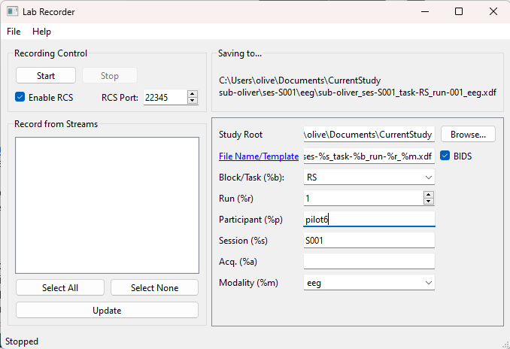
RESTING STATE
Information Sheet and Consent Form (same page)
- “”Tell PP to read info and then indicate their consent (BEFORE SIGNALS)
“About yourself”
- Demographic questions
Instructions for RS – RECORD BEFORE RS TASK BEGINS (“RS”)
- “”Resting period of 8 minutes (to collect baseline physiological measures)
- “”Relax, remain still, and close your eyes. DO NOT FALL ASLEEP!
- “”You will hear a beep when this resting period has ended
- “”Read through, and let me know when you are ready
- RECORD RS


After RS (beep):
- STOP RECORDING RS
- “”Press “Continue” when you are ready to move on from RS – here, you will be presented with some questions about the resting period
FICTION
DO EDA AND TAKE ROOM TEMPERATURE
FP1
- “”Tell PP to answer questions on “About yourself” section – let me know when finished here
Eye movements gaze calibration task:
- “”Ensure PP’s face is in the box (and box is thus green)
- “”INSTRUCTIONS: firstly, you will see some black dots, which you must click on using the mouse. After that, in the second part, you will see the same black dots, where you must look at each one until it disappears
- “”Let me know when you have finished the gaze calibration
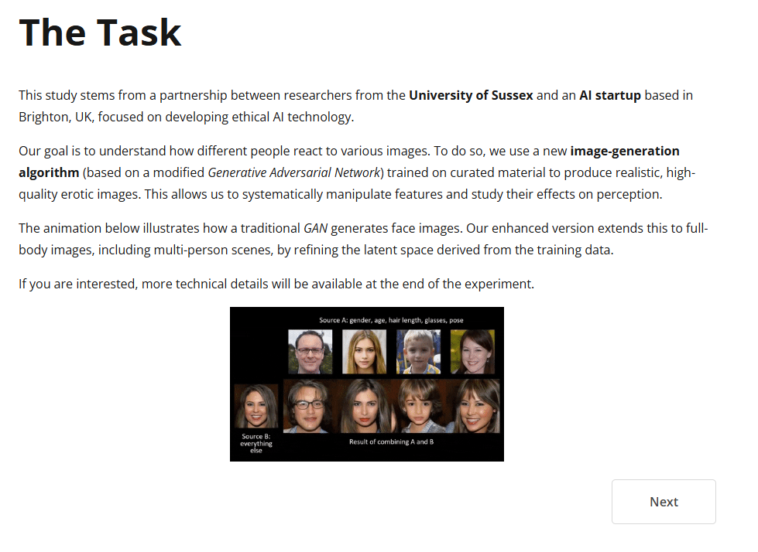
The task:
- “”This section gives background information about the following task
- “”Please read and then continue when you have understood – let me know when you are on the Instructions page
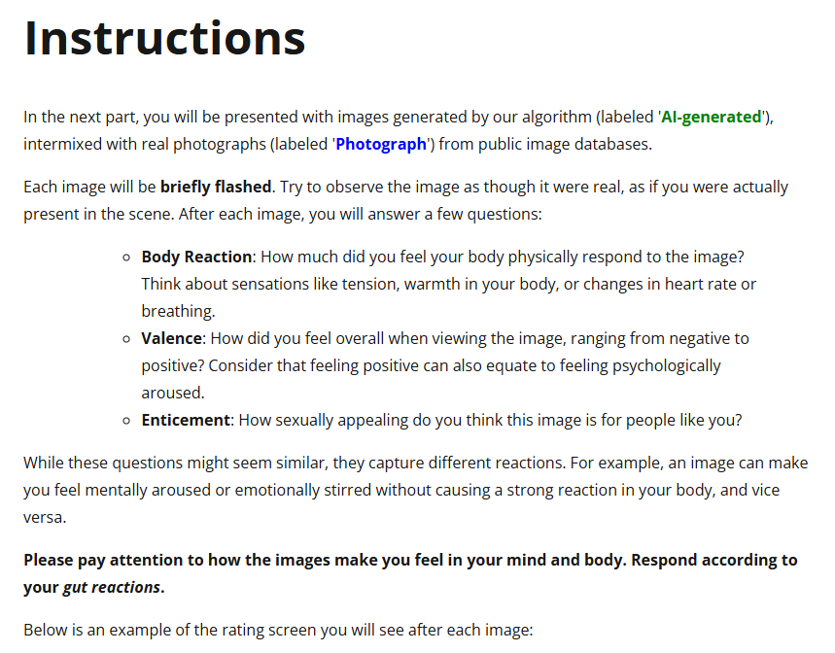
Instructions:
- “”Here, you will see erotic images with labels flashing up before each picture. Each image will be labelled as either “AI-generated” or “Photograph”. Please make sure to pay attention to these labels
- “”You will then be asked three questions about each image after it has been shown, relating to body reaction, valence, and enticement
- “”Answer these questions using your gut reaction – DO NOT OVERTHINK IT!
- “”Please read this section carefully, in full, and then let me know when you are ready – take your time to fully understand these instructions. There will be a break at the half-way point – let me know when you reach this break
- START RECORDING “FP1”
- PP can now press “Start”
- Gaze calibration will occur again after FP1 break (beep) – could apply more isotonic gel to EDA during this stage
- When FP1 finishes, STOP RECORDING FP1, and remove EDA
- “”Now, please answer the following questionnaires (when this comes up)
FP2
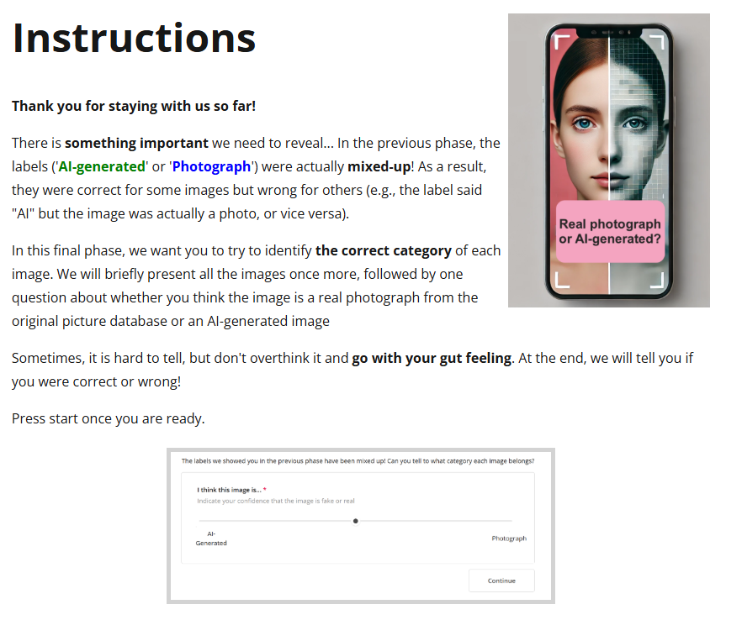
Instructions:
- “”So, the AI-generated/Photograph labels you saw in the previous erotic stimuli task were actually mixed-up, meaning that they were not assigned correctly for every picture
- “”Here, we need you to identify the correct category (again, whether a picture is AI-generated or a Photograph) for each erotic image. You will see each picture again and answer using a sliding scale (as pictured below)
- “”Again, go with your gut reaction – DO NOT OVERTHINK IT
- “”Read through this section fully to understand it and then continue once you are ready

INTEROCEPTION: TAP – RECORD BEFORE TASK STARTS AS “TAP”
Voluntary external (green circle):
- “”Here, you can see a rotating arm that creates a green circle (upon a complete rotation). You should aim to tap the spacebar when the rotating arm reaches the red target arrow, to stop the arm on the target
- “”Read through the instructions and let me know when you are ready (if not started recording yet)
Voluntary internal (blue circle):
- “”Now, you will see another task where a rotating arm creates a blue circle (upon a complete rotation). Here, you can tap the spacebar whenever you would like, but make sure to do so before the arm reaches the end
- “”Please read through the instructions and press the button when you are ready to start the task
Mixed (green circle AND blue circle):
- “”Here, you will see a MIX of the previous two tasks
- “”So, you have the green circle, where, again, you are aiming to press the spacebar when the rotating arm reaches the red target arrow
- “”And you have the blue circle, where, again, you can press the spacebar whenever you would like, BUT before the rotating arm reaches the end
- “”Feel free to read through the instructions again and press the button when you are ready to start the task
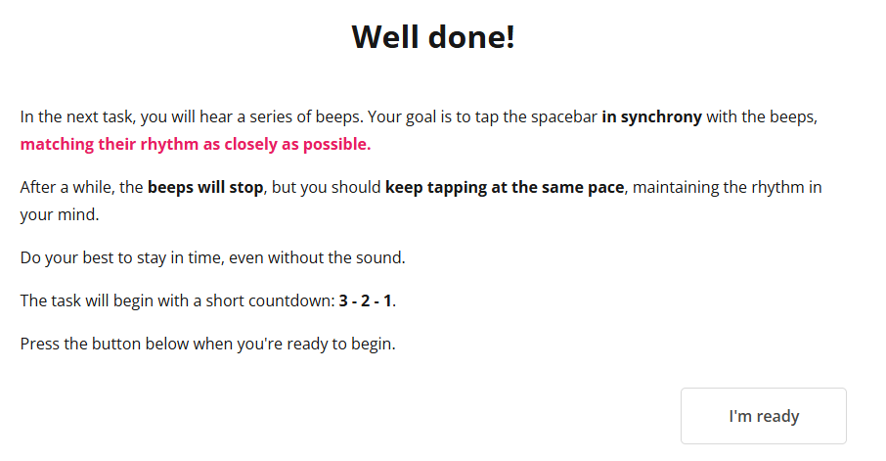
Rhythmic tapping task:
- “”You will now hear some beeps. You need to tap the spacebar in time with these beeps to match their rhythm as best as you can
- “”These beeps will then stop but you must keep tapping the spacebar at that same pace and rhythm
- “”Read through the instructions in full and then carry on when you are ready
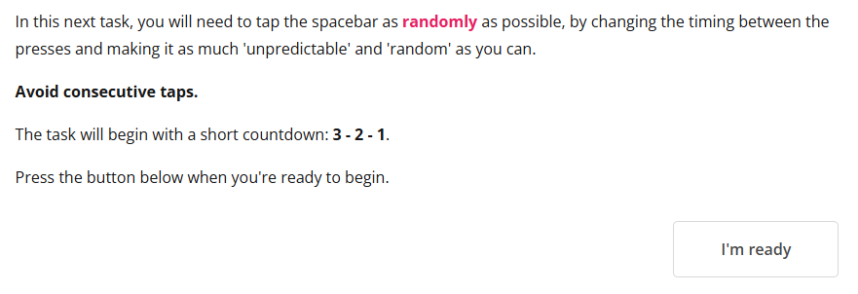
Random tapping task:
- “”Now, you need to tap the spacebar as randomly as you can, avoiding consecutive taps
- “”Again, please read through the instructions and continue when you are ready

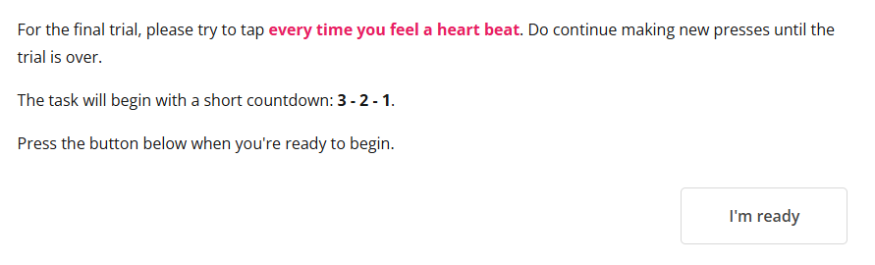
Heartbeat tapping task:
- “”Here, you now need to tap the spacebar whenever you feel a heartbeat, or when you think your heart is beating. BUT please do this without physically measuring your heart or pulse, in the position you are in now
- “”Read the instructions and continue when you are ready
- STOP TAP RECORDING WHEN HEARTBEAT TAPPING TASK IS DONE

INTEROCEPTION: HCT – RECORD BEFORE TASK STARTS AS “HCT”
- “”Now, you must count the number of heartbeats you have over several intervals. At the end of each interval, you will be asked to report how many heartbeats you had during that period
- “”Again, please do this without physically measuring your heart or pulse, in the position you are in now
- “”Please let me know when you have read and fully understood the on-screen instructions
- START HCT RECORDING
- STOP HCT RECORDING
Questionnaires:
- “”Read the following instructions and continue to answer the questionnaires

DEBRIEF
- “”We are testing the effects of believing erotic content is AI-generated vs real on sexual arousal – all erotic images were actually real photographs (mild deception)
- “”Also examining interoception here – one’s ability to perceive their internal bodily sensations. For example, on the tapping tasks, we are seeing how your taps correlate with your actual heartbeat
- “”Any questions?

