FictionEroPhysio Data Collection Guide

- Charge everything
- Muse
- Bitalino
- Turn on thermometer
- Put not disturb sign on outside of door

- Log in (pass: Rxxxl2024)

- Open Box (https://sussex.app.box.com/folder/0)
- In FictionEroPhysio folder, open comments
- Fill in participant id, experimenter name, condition (is counterbalanced Interoception or Fiction first, so do the opposite to the previous participant), incentive (credits or money), temperature

- Set up Participant’s screen
- Make sure webcam is in the center ontop of the screen (follow tape markers)
- Open Resting state html (C:\Users\Reality Bending Lab\Desktop\FictionEroPhysio\experiment\RestingState.html)
- Fit lux: temporarily go through the RS html to see the marker for the lux, and securely tape it in this box
- Close and re-open this, fill in participant ID and press continue so it’s on the informed consent page for the participant
- Ensure webcam is in the center of the participant’s monitor
- Ensure volume is on

- Set-up signals
- Open signals: Tick ‘lab streaming layer’ under the integration tab
- Click on the rectangle icon with a green circle, then the dark grey rectangle in the center of the screen
- Ensure ports are RESP (A1) ECG (A2) LUX (A3) EDA (A4)

- Set-up Lab recorder
- Study root = ‘C:\Users\Reality Bending Lab\Desktop\DATA\FEP_data’
- Participant = S00x (check comments file on box)
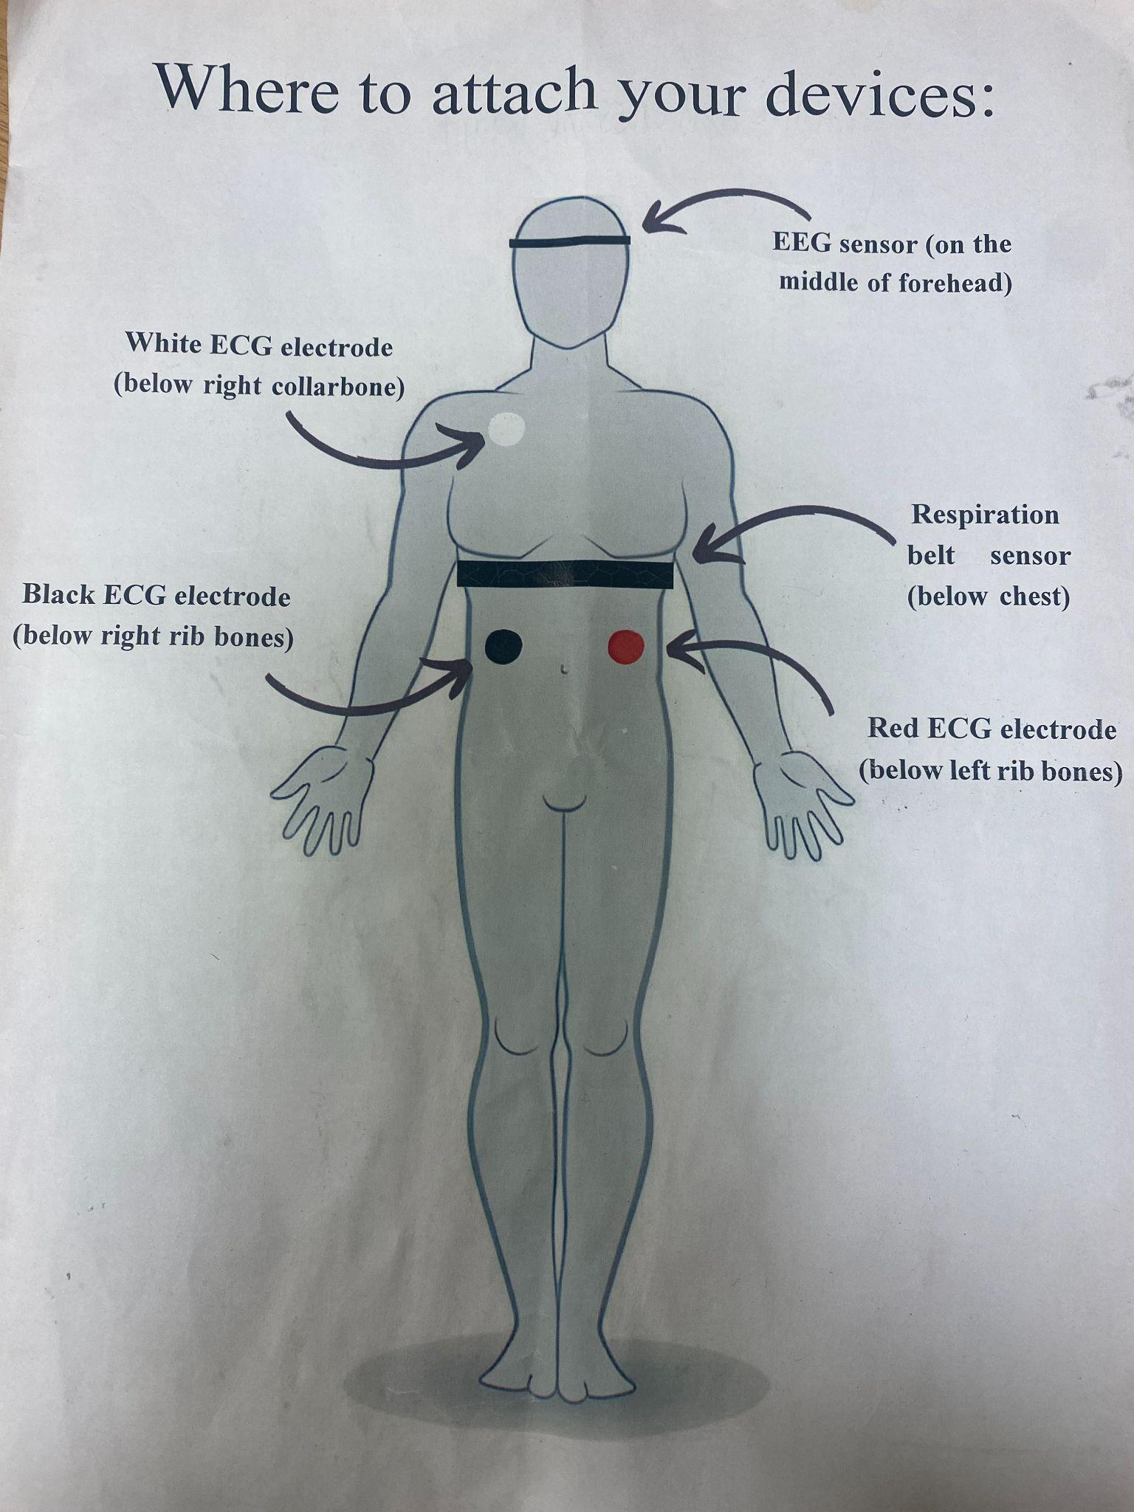
- Block task = RS
- Participant comes
- Fit sensors:

  - RESP
    - Just below chest: snug fit, sensor to the left on the front of their body just below their chest
    - Ensure no folded cloth by sensor
    - Troubleshooting tips: Ask participant to take a deep breath. Move the sensor to the place on their body that moved the most
    - Check it’s not so tight that participant can feel their pulse
    - Further help: https://support.pluxbiosignals.com/wp-content/uploads/2021/11/pzt-sensor-datasheet-revb.pdf
  - ECG
    - Clip electrode sticker on first
    - White: Just below the right collarbone
    - Black: directly below white, just below right ribs. Can suck in the chest to tell where ribs end.
    - Red: parallel to black, in same place below left ribs.
    - As participant to draw a line from the white to red to see if it crosses the heart
    - Troubleshooting tips:
      - Ensure the correct electrode is placed in each position (i.e., white electrode below right collar bone, black electrode below right rib bone, and red electrode below left rib bone)
      - The distance between the white and red electrodes should cross the heart
      - The gap between the white and black electrodes should run in a straight line down the torso
      - Black and red electrodes should be parallel to each other
      - A line crossing the heart should be drawn from the white to the red sensor
    - Further help: https://support.pluxbiosignals.com/wp-content/uploads/2021/11/ecg-sensor-datasheet-assembled-2.pdf

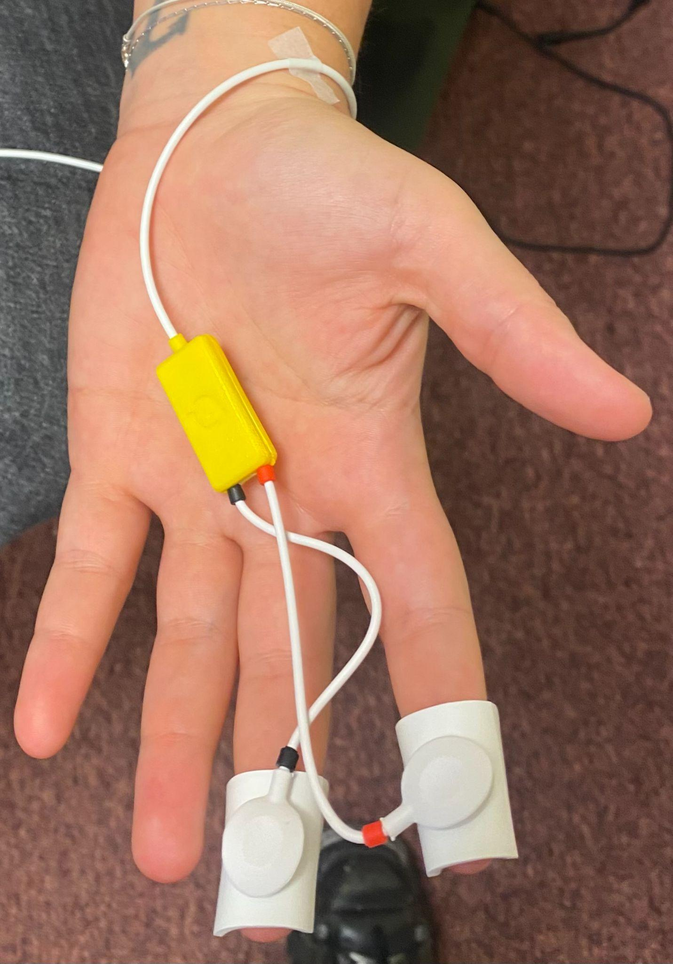
  - EDA-DURING FICTION

- Apply a generous drop of electrode gel.

- Tape the wire by the wrist
- Attach electrodes
- Participant should keep their palm facing up during the experiment
- Check it’s working: ask participant to take a sharp sniff: this should increase EDA. Can also clap loudly in their ear to see if this increases EDA.
- Check it’s not so tight that participant can feel their pulse
- Troubleshooting tips:
  - Hands can’t be cold: Can warm participant’s hand under warm water
  - Reconnect wire from bitalino
  - Replace electrode stickers
  - Add more gel: can use a syringe to put more gel underneath the sponge without taking it off the participant’s finger
- Tips
  - Some people don’t have skin conductance response, and may not respond to all stimuli.
  - Baseline can naturally change during the experiment, this is fine just move the arrow up on open signals to keep viewing the wave.
  - EDA responses may decrease through experiment as participant becomes habituated to stimuli.
- Further help: https://support.pluxbiosignals.com/wp-content/uploads/2021/11/electrodermal-activity-eda-user-manual.pdf

- Turn on bitalino and connect cables
- RESP (A1) ECG (A2) LUX (A3) EDA (A4)
- Press red circle to view signals
- If bitalino not working - re-plug in bluetooth and reconnect (pass: 1234)
- Press automatic on the right side for each signal
- Drag bar at the bottom towards the left

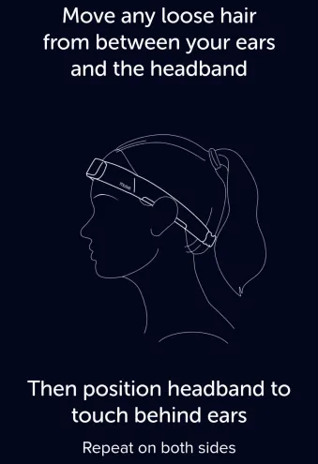
- Fit Muse

- Ask participant to wipe their forehead and above ears
- Remove glasses and tie up hair if applicable
- Clean forehand and above ears with antibacterial wipes
- While loose, clip muse around participant’s neck and lift over the ears.
- Ensure EEG is in the center of the forehead.
- Put hand underneath the Muse athena and pull up hair above the ears on both sides
- Tighten to snug fit

- Connect to Muse
- Vs Code → New terminal
- install the OpenMuse package (dev branch), uninstalling any previous versions (pip uninstall OpenMuse): (pip install https://github.com/DominiqueMakowski/OpenMuse/zipball/dev --upgrade)
- New terminal: (OpenMuse find)
- New terminal: (OpenMuse stream --address 00:55:DA:B9:FA:20 --preset p21 --record " participantid_a.txt” ….participantid_b)
- New terminal: (OpenMuse view)
- Troubleshooting tips:
  - Ensure Bluetooth connections are disabled on all task-irrelevant devices (e.g., nearby phones, headphones, laptops)
  - Make sure no hair is interfering
  - Make sure electrodes are touching the skin
  - Slightly dampen the skin under the electrodes

- Conduct experiment
- Always verbally communicate instructions as well as asking participant to read them.
- Ask participant to let you know when they’re done, to manually open the next html file (interoception/fiction)
- Detach the sensor pod and put it on charge during questionnaires (interoception stage) and eye-tracking calibration (fiction stage). After you’ve reconnected, make sure to update lab recorder streams before next recording session.
- Start new recording for each stage, and change name of lab task on lab recorder accordingly (RS- resting state, TAP- tapping tasks, HCT-heartbeat counting task, FP1 - fiction phase 1)

- Debrief
- Thank participant for their time, give debrief sheet, answer questions
- Administer incentive

- Add important comments to the comments spreadsheet in Box

Notes
- Print / online for checklist
- Print debriefing sheet
- fast charger for muse usb c (amazon - black friday)
- Tissues to clean gel from fingers
- Eye tracking data - check patterns
- Chenge ‘muse 2’ to ‘muse’ on consent

Back to lab recorder
- Update streams (seperate for the muse + bitalino)

Experimenters:
- Roisin – Exp1
- Oliver – Exp2
- Ana – Exp3

