JRA Research Proposal
“Role of the Cardiac Cycle in the Perception of Reality and Illusion”

Introduction
Through the rapidly-expanding interoception literature – where “interoception” constitutes one’s ability to sense, interpret, and integrate their internal bodily signals (Quigley et al., 2021) – it has emerged that the cardiovascular system seems to play a particularly important role in perception and cognition.
The cardiac cycle can be divided into two phases: (1) systole, where the heart’s ventricles contract, ejecting blood into the arteries, with blood pressure peaking, and (2) diastole, in which the ventricles refill with blood, representing a period of relaxation and minimal blood pressure (Pollock & Makaryus, 2025).
Baroreceptors within the arteries detect information pertaining to blood pressure across the cardiac cycle according to the stretching of arterial walls, leading to substantial baroreceptor firing during systole but minimal activity during diastole (Rau & Elbert, 2001). Signals associated with baroreceptor firing, through the glossopharyngeal and vagus nerves, are transmitted to the nucleus tractus solitarius, from where they project to a wide network of brain areas, including the insula, cingulate cortex, and prefrontal cortex (PFC; Suarez‐Roca et al., 2021). Within these regions, evidence suggests that systolic baroreceptor projections suppress cortical excitability, leading to attenuated exteroceptive processing and cognition, with conversely more accurate processing during diastole (Skora et al., 2022). Therefore, communication between the cardiovascular and nervous systems is suggested to create interoceptive-exteroceptive interactions influencing perception and cognition.
Visual illusions (VIs), creating dissonance between objective reality and phenomenological experience, seemingly provide a useful paradigm to explore the role of these interoceptive-exteroceptive interactions through their theoretical influence on higher-level cognitive processes – an area ostensibly relevant to, but arguably neglected by, existing cardiac phase research. This is where the discrepant experience of viewing a VI may create neural conflict, which the brain aims to resolve through cognitive control mechanisms (Bednarek et al., 2024). Conflict monitoring and cognitive inhibition, associated with the cingulate cortex and PFC – regions receiving baroreceptor projections – may be recruited to minimise such conflict and suppress misleading perceptual information, endeavouring to achieve a more accurate percept, despite the illusion generally persisting. Accordingly, during systole, baroreceptor activation may suppress cortical excitability within the cingulate cortex and PFC, consequently impairing cognitive control mechanisms, leading to enhanced illusion sensitivity (the perceived magnitude of an illusion).
The purpose of this proposal is to investigate whether the cardiac phase is linked to the perception of VIs, where this association is unknown, constituting a novel methodology for investigating the role of the cardiovascular system on exteroception. It is predicted that VI sensitivity will be stronger (i.e., perception will be less accurate) during systole than diastole in the “Illusion Game” task (Figure 1).

Figure 1
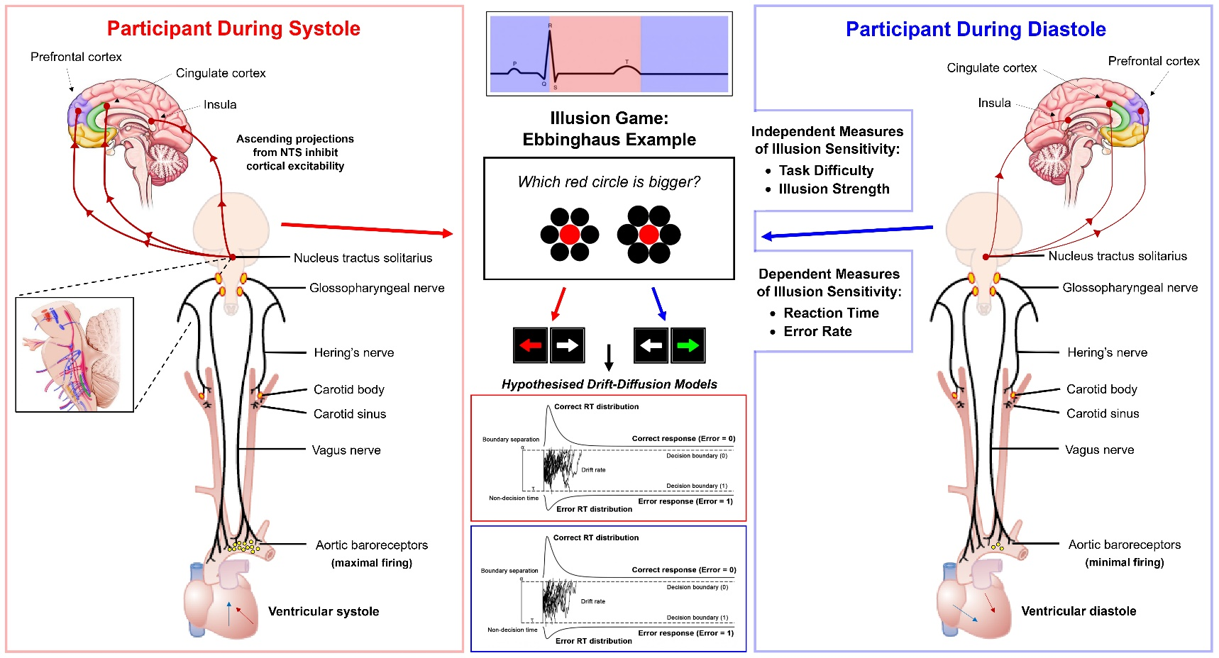
Hypothesised Illusion Sensitivity in Systole vs Diastole
Note. Physiological pathways for systole/diastole and the predicted responses towards illusion sensitivity.

Methods
Participants
The current proposal, forming part of a larger study, will aim to recruit around 40 adult participants, based on sample sizes of other cardiac phase investigations, through posters displayed around the Brighton area and social media advertisements. Participants’ demographic information, relating to gender, education, age, and ethnicity, will be collected. Individuals with diagnosed cardiovascular conditions will be excluded. The study will last approximately 1 hour, with participants remunerated £10.

Procedure
Upon arrival at the testing space (HPL, Pevensey 2), participants will be presented with the Information Sheet and Consent Form. After indicating their consent, participants will answer demographic and screening questions.
An electrocardiogram (ECG) will record participants’ cardiac activity. Using a 3-lead configuration, fitted by the researcher, the reference electrode will be placed below the right clavicle, with the positive and negative electrodes placed on the left and right 10th ribs, respectively. The necessary hardware will include the PLUX Biosignals Assembled ECG Sensor, plugged into the BITalino Core, where signals will be recorded using the OpenSignals and LabRecorder software, at a sampling rate of 1000 Hz.
After fitting the ECG, an 8-minute Resting State Task (RST) will take place to collect baseline data.
Illusion Game
After the RST, whilst their cardiac activity is being recorded, participants will complete a truncated version of Makowski et al.'s (2023) Illusion Game (IG), which measures responses to illusion sensitivity. The IG, based on the computational modelling of illusion perception, is a computerised task wherein participants must compare and judge illusion stimuli in a two-alternative forced choice (2AFC) methodology. Participants will experience two sets of 80 trials for each of three illusion types: Ebbinghaus, Müller-Lyer, and Vertical-Horizontal (Figure 2). Within one set, each illusion type constitutes a block, so that there will be three blocks per set.

Figure 2
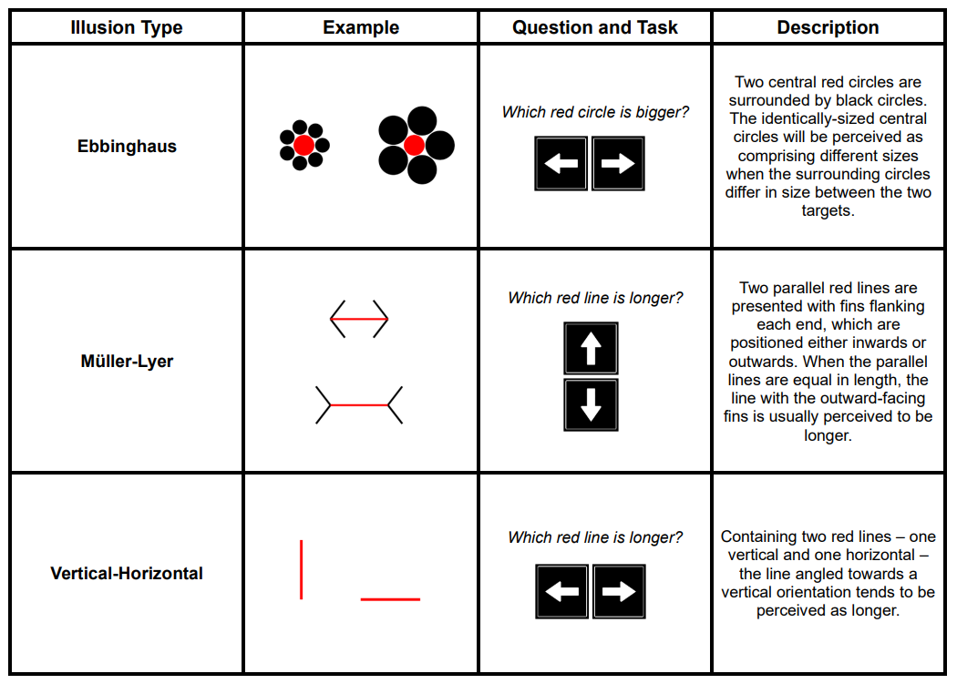
Illusion Game Stimuli
Note. Participants make a perceptual judgement by pressing the corresponding arrow key.
In each trial, two illusion targets of the same type, preceded by a fixation cross (presented for 500-1000 ms), will be shown simultaneously, varying in their respective task difficulty (the objective size difference between core illusion elements) and illusion strength (the extent of perceptual interference from illusion elements) orthogonally. Consequently, the IG uniquely provides a direct manipulation of illusion sensitivity, such that metacognitive processes that seemingly confound other illusion paradigms are removed.
Additionally, illusion targets can be congruent (influencing judgements towards the correct alternative) or incongruent (influencing judgements against the correct alternative).
The objective of each trial is to answer one question, specific to the illusion type, relating to a perceptual judgement across the two targets. For example, in the Ebbinghaus illusion block, the participant must answer “Which red circle is bigger?” by pressing the left or right arrow key. Participants are told to equally aim to maximise speed and accuracy across all trials, with a gamified composite score shown after each block. A practice set with eight trials per illusion type will be completed before the 480 experimental trials.
After completing the IG, electrodes will be removed and participants will be presented with the Debriefing Sheet and given the opportunity to ask questions.

Planned analysis
Behavioural data
Raw data from the IG will be preprocessed and then cleaned in R, excluding trials with reaction times (RTs) < 125 ms or > 4 SD above the mean RT, as well as blocks with an error rate > 50% (Makowski et al., 2023). Illusion sensitivity will be calculated per illusion type, operationalised as the mean error rate across the incongruent trials. Event-related data from the IG will be recorded using the PLUX Biosignals Photosensor, detecting a black marker on the screen at trial onset.

Physiological data
The NeuroKit2 Python package (Makowski et al., 2021) will be used to apply a band pass filter to the ECG data, where the QRS complex within each cardiac cycle will be segmented to delineate the cardiac phase, based on physiological characteristics of the signal. Here, ventricular systole will be defined as occurring between each R peak to the end of the subsequent T wave, whereas ventricular diastole will comprise the remaining signal until the following R peak (Figure 3). The concurrent cardiac phase at each trial will be retrospectively calculated through the photosensor marker detection, recorded in unison with the ECG.

Figure 3
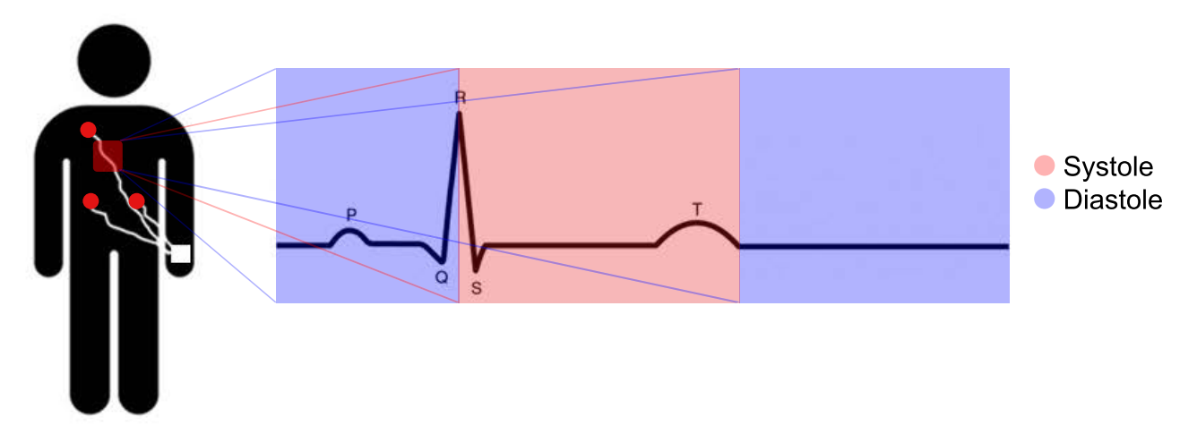
Delineation of Systole and Diastole
Note. ECG signal depicting one cardiac cycle.

Cognitive modelling
The data will be fitted to a drift diffusion model (DDM) – a cognitive model aiming to reproduce the noisy process of evidence accumulation taking place within the brain during 2AFC tasks (Ratcliff & McKoon, 2008). A four-parameter DDM will analyse the speed and accuracy responses in the incongruent trials from the IG to understand the relationship between each cardiac phase and illusion sensitivity. RT distributions according to trial accuracy over the concurrency of systole/diastole will be plotted.

Project timeline
Week 1: Create paradigm in jsPsych by amalgamating necessary materials, conduct pilots, start to advertise the study.
Weeks 2–6: Continue advertising, recruit participants to the lab, carry out data analysis throughout, start working on poster.
Weeks 6–8: Finalise data analysis, interpret findings, finish poster.

References
Bednarek, H., Przedniczek, M., Wujcik, R., Olszewska, J. M., & Orzechowski, J. (2024). Cognitive training based on human-computer interaction and susceptibility to visual illusions. Reduction of the Ponzo effect through working memory training. International Journal of Human-Computer Studies, 184, 103226. https://doi.org/10.1016/j.ijhcs.2024.103226
Makowski, D., Pham, T., Lau, Z. J., Brammer, J. C., Lespinasse, F., Pham, H., Schölzel, C., & Chen, S. H. A. (2021). NeuroKit2: A Python toolbox for neurophysiological signal processing. Behavior Research Methods, 53(4), 1689–1696. https://doi.org/10.3758/s13428-020-01516-y
Makowski, D., Te, A. S., Kirk, S., Liang, N. Z., & Chen, S. H. A. (2023). A novel visual illusion paradigm provides evidence for a general factor of illusion sensitivity and personality correlates. Scientific Reports, 13(1), 6594. https://doi.org/10.1038/s41598-023-33148-5
Pollock, J. D., & Makaryus, A. N. (2025). Physiology, Cardiac Cycle. In StatPearls. StatPearls Publishing. http://www.ncbi.nlm.nih.gov/books/NBK459327/
Quigley, K. S., Kanoski, S., Grill, W. M., Barrett, L. F., & Tsakiris, M. (2021). Functions of Interoception: From Energy Regulation to Experience of the Self. Trends in Neurosciences, 44(1), 29–38. https://doi.org/10.1016/j.tins.2020.09.008
Ratcliff, R., & McKoon, G. (2008). The diffusion decision model: Theory and data for two-choice decision tasks. Neural Computation, 20(4), 873–922. https://doi.org/10.1162/neco.2008.12-06-420
Rau, H., & Elbert, T. (2001). Psychophysiology of arterial baroreceptors and the etiology of hypertension. Biological Psychology, 57(1–3), 179–201. https://doi.org/10.1016/S0301-0511(01)00094-1
Skora, L. I., Livermore, J. J. A., & Roelofs, K. (2022). The functional role of cardiac activity in perception and action. Neuroscience & Biobehavioral Reviews, 137, 104655. https://doi.org/10.1016/j.neubiorev.2022.104655
Suarez‐Roca, H., Mamoun, N., Sigurdson, M. I., & Maixner, W. (2021). Baroreceptor Modulation of the Cardiovascular System, Pain, Consciousness, and Cognition. Comprehensive Physiology, 11(2), 1373–1423. https://doi.org/10.1002/j.2040-4603.2021.tb00152.x

