SOP for IllusionGamePhysio
- Preparation
  - Charge Muse and BITalino
  - Turn on thermometer
  - Put DO NOT DISTURB sign on lab door
  - Recording machine = SOUND OFF; experiment machine = SOUND ON

- Box
  - Add preliminary comments in “IllusionGamePhysio” folder
  - Add more comments throughout data collection session

- jsPsychMarkers Preparation
  - Ensure that BOTH the recording and experiment machines are connected to the SAME network connection (University ethernet)
  - Check IPv4 address is same: type “ipconfig” into Python terminal
  - Run lsl_bridge.py on recording machine
  - Run localhost:8002 port on experiment machine:
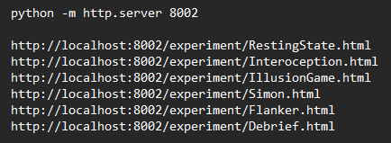

- Set up experiment machine (participant’s screen)
  - SOUND ON
  - Open IllusionGamePhysio repo on VScode
  - Fit the LUX photosensor to top-left of screen
  - Fill in PP ID and open Information Sheet and Consent Form for PP

- Set up signals
  - BITalino: RESP (A1), ECG (A2), LUX (A3)
  - Muse EEG headband

- Set up LabRecorder
  - Study root: IllusionGamePhysio
  - Participant: P00X
  - Block task: RS, TAP, HCT, CC, IG

- Experimental procedure
  - Information Sheet and Consent Form
  - Resting State
  - Interoception battery (tasks and questionnaires)
  - COUNTERBALANCE: cognitive control tasks (flanker, Simon) and Illusion Game
  - Debrief

