
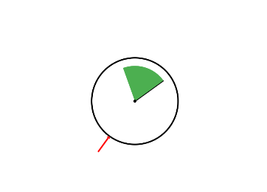
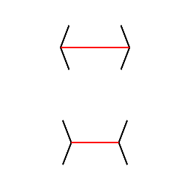
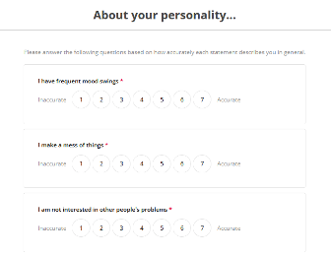

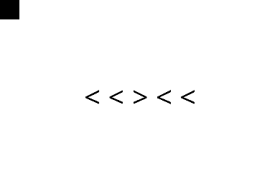

- M-L: 80x Trials
- Ebb: 80x Trials
- V-H: 80x Trials
- M-L: 80x Trials
- Ebb: 80x Trials
- V-H: 80x Trials

- 24x Items

- 6x Tapping Tasks
- HCT
- Mint, MAIA-2, IAS
- 12x Practice Trials
- 4x Blocks, 40x Trials Each
- 12x Practice Trials
- 4x Blocks, 40x Trials Each
RST
- 8-minute RST
- ARSQ
Int. Battery
IG Set 2
Mini-IPIP6
IG Set 1
Arrow Simon Task
Arrow Flanker Task

