Mega-analysis of the Interoceptive Accuracy Scale (IAS) Structure and its Dispositional Correlates

Abstract
Traditional interoceptive questionnaires show poor convergence, suggesting they tap distinct constructs. The Interoceptive Accuracy Scale (IAS), developed to separate accuracy from attention, is increasingly popular but psychometrically underexplored. Using a mega-analytic approach across 17 datasets (N > 33,000), we present the most comprehensive evaluation of the IAS to date, covering its factor structure (Study 1) and dispositional correlates (Study 2). Study 1 triangulated results across multiple dimensionality-reduction algorithms, identifying a stable 14-item core organized into 7 distinct item pairs linked to bodily sensations (e.g., Hunger–Thirst, Cough–Sneeze). Study 2 examined relationships between the IAS and mood, anxiety, psychopathology, neurodevelopmental traits, personality, and belief-related constructs, finding adaptive traits positively associated and maladaptive traits negatively associated with interoceptive scores. The 14-item version performed comparably to the original 21-item scale, with item-pairing enhancing interpretability; the Hungry-Thirsty and Bruise-Blood-sugar pairs showed the strongest associations. These findings support self-perceived interoceptive ability as a differentiated, system-specific construct.
Interoception, interoceptive accuracy, interoceptive sensibility, measurement, exploratory factor analysis, network analysis

Mega-analysis of the Interoceptive Accuracy Scale (IAS) Structure and its Dispositional Correlates

Introduction
Interoception refers to sensing, interpreting and integrating information of internal bodily stimuli by the nervous system, including organs (e.g., heart, lungs, gut) and broader physiological tissues, to convey the body’s current state (Khalsa, Adolphs, Cameron, Critchley, Davenport, Feinstein, Feusner, Garfinkel, Lane, Mehling, & others, 2018). Despite its recognised role in emotion recognition (Terasawa et al., 2021) and regulation (Zamariola et al., 2019), decision making (Pollatos et al., 2023), learning (Joshi et al., 2023), body-ownership (Raimo et al., 2021), physical health (Harrison & Pink, 2024) and psychological health (Nord et al., 2021), and well-being (Ferentzi et al., 2019), the field remains hampered by concerns over its conceptualisation and measurement (Desmedt et al., 2022, 2025; Murphy, 2024).

The Interoceptive Assessment Puzzle
Given interoception’s centrality to brain function, many measures could be seen as “indirectly” assessing (whether intentionally or not) interoceptive processes, including indices quantifying coupling between physiological signals and cognitive or behavioural processes (e.g., Heart Rate Variability), or constructs theoretically dependent on interoceptive information (e.g., alexithymia). Critically, various direct measures have also been developed (see Figure 1), spanning “objective” and “subjective” assessments (e.g., heartbeat counting/tracking tasks vs. questionnaires and scales), “explicit” and “implicit” paradigms (i.e., directing vs. covertly measuring attention to interoceptive processes), multiple modalities (e.g., cardioception, respiroception, gastroception), and theoretical dimensions (e.g., accuracy, sensitivity, awareness). The diversity of measures reflects the absence of a “gold-standard” for interoception, with each having strengths and limitations depending on the research context and dimension assessed (Desmedt et al., 2023; Jahedi & Méndez, 2014).

Figure 1
Schematic Representation of The Interoceptive Assessment Puzzle. The different modalities of interoception (e.g., cardioception) can be assessed directly or indirectly. Direct assessments can be subjective or objective, depending on whether they use conscious metacognitive appraisals or performance-based indices. Objective interoceptive tasks can be explicit (participants must consciously attend to interoceptive signals; e.g., the heartbeat counting task) or implicit (measurements of interoception are covert; e.g., heartbeat evoked potentials measured during rest). Indirect assessments evaluate constructs typically related, or dependent on, interoceptive processes (e.g., physiological indices such as heart rate variability or effect of cardiac phase) or abilities (e.g., self-report measures of emotion regulation or identification abilities).
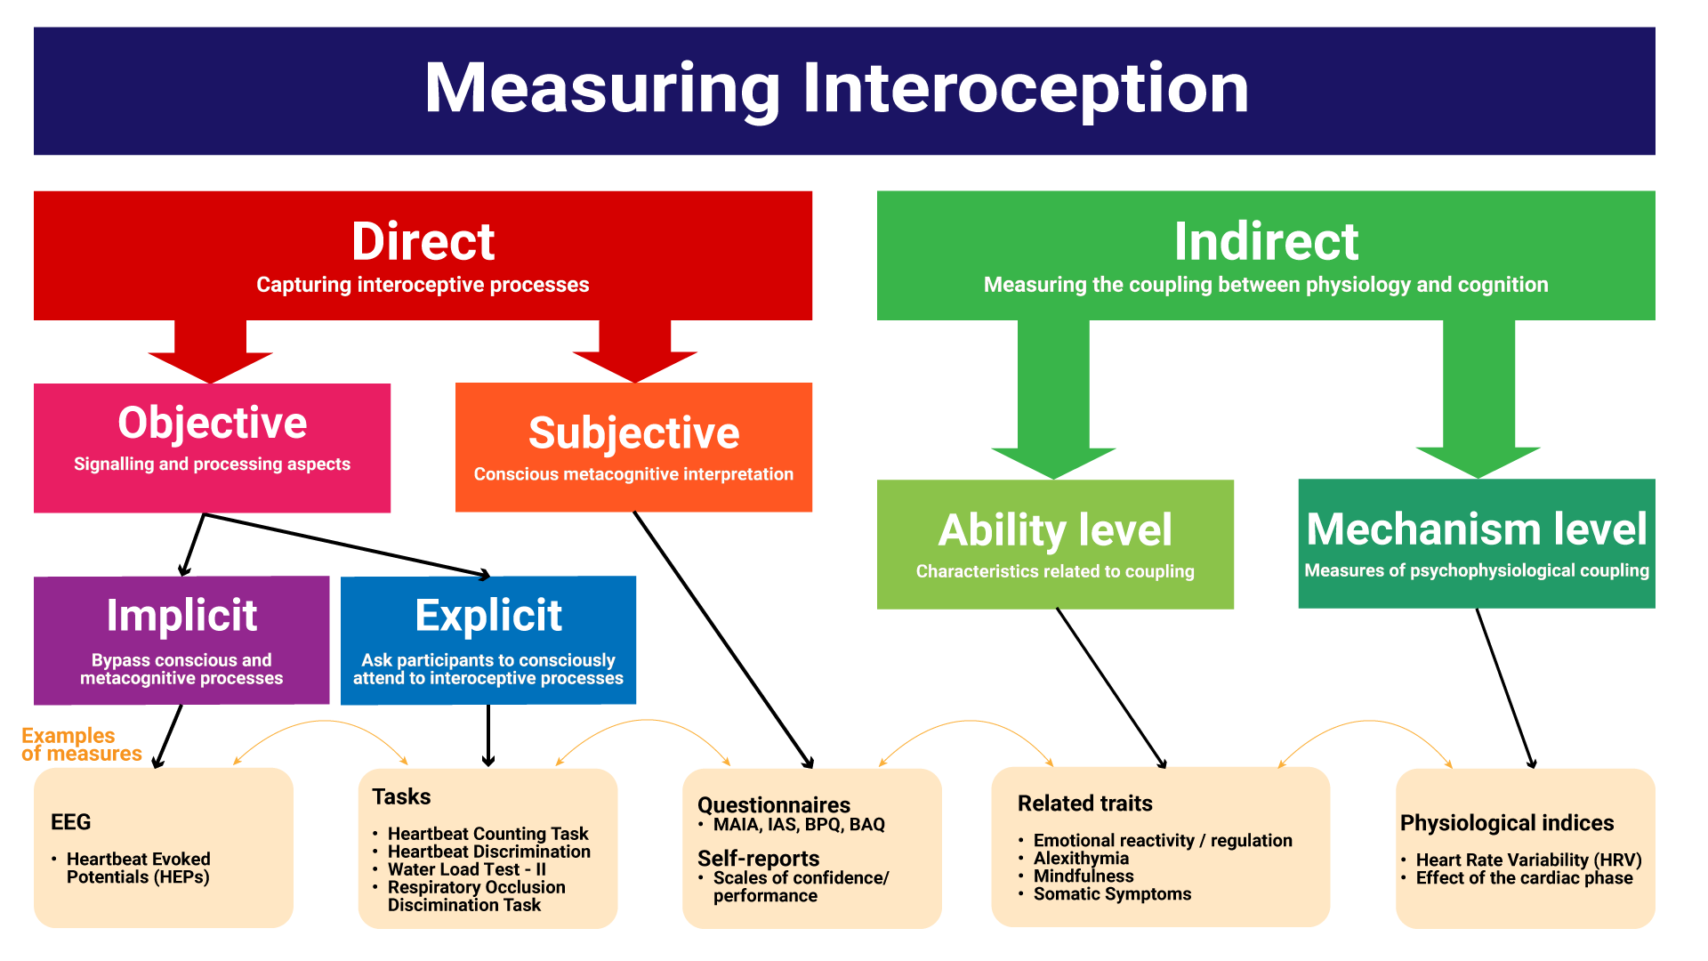

Self-reported Interoception
Although using self-report questionnaires to measure deeply embodied functions might seem paradoxical, recent redefinitions of interoception emphasize the importance of metacognitive elaboration of interoceptive information, supporting the idea that some facets such as metacognitive beliefs, can be assessed subjectively (Khalsa, Adolphs, Cameron, Critchley, Davenport, Feinstein, Feusner, Garfinkel, Lane, Mehling, & others, 2018; Suksasilp & Garfinkel, 2022). The notion that self-reported interoception reflects a fundamentally different aspect of conscious interoceptive processing than objective task measures is thought to be central to understanding the reported lack of convergence between objective and subjective measures (Desmedt et al., 2022). For instance, questionnaires and objective measures (HCT, Schandry, 1981; Heartbeat Detection Task (HDT), Kleckner et al., 2015) show weak or no correlations, even when intended to capture the same theoretical interoceptive dimension (Arslanova et al., 2022; Brand et al., 2023; e.g., task-based accuracy vs. self-reported accuracy, Murphy et al., 2019).
Perhaps more surprisingly, lack of convergence also exists amongst objective or subjective measures purporting to measure the same interoceptive dimension: task-based measures targeting accuracy typically show weak or no intercorrelations (Brand et al., 2023; Hickman et al., 2020), and subjective accuracy scores similarly yield weaker than expected relationships (Vig et al., 2022). As well as posing substantial validity concerns, these findings raise the possibility that even within a broad measurement domain, different measures are targeting fundamentally different facets of interoception, undermining replicability and hindering theoretical and empirical progress in the field.
One striking example concerns the assessment of interoceptive sensibility - the self-reported tendency to focus on (with or without correctly detecting) internal sensations (Garfinkel et al., 2015; Khalsa, Adolphs, Cameron, Critchley, Davenport, Feinstein, Feusner, Garfinkel, Lane, Mehling, & others, 2018). A recent systematic review suggested that questionnaires designed to assess interoceptive sensibility may in fact measure distinct constructs, with researchers often treating them as equivalent despite low overall convergence (Desmedt et al., 2022). The review included popular measures, such as the Body Perception Questionnaire (BPQ, Porges, 1993), the Multidimensional Assessment of Interoceptive Awareness (MAIA, Mehling et al., 2012; MAIA-2, Mehling et al., 2018), the Body Awareness Questionnaire (BAQ, Shields et al., 1989), the Private subscale of the Body Consciousness Questionnaire (PBCS, Miller et al., 1981), and the Self-Awareness Questionnaire (SAQ, Longarzo et al., 2015) which comprised 86% of all citations. Their low-to-moderate intercorrelations suggest they capture different aspects of interoception rather than a common construct, emphasizing the need for conceptual clarity regarding what each measures, how they relate to different interoception dimensions, and their overlap with constructs such as alexithymia and body awareness. One avenue for addressing these issues is the investigation of newer measures not included in prior reviews.

The Interoceptive Accuracy Scale (IAS)
Focusing on self-perceived accuracy, the Interoceptive Accuracy Scale (IAS, Murphy et al., 2019) is a recently developed measure with rapidly growing popularity. The IAS was designed to clarify both what and how interoception is measured, by treating interoceptive accuracy and attention as distinct dimensions, whereas many existing models conflate them (e.g., Garfinkel et al., 2015; Khalsa, Adolphs, Cameron, Critchley, Davenport, Feinstein, Feusner, Garfinkel, Lane, Mehling, & others, 2018). Individuals may thus report attending to bodily signals while recognising their perception of those signals is inaccurate. This distinction positions the IAS as the only tool specifically designed to assess subjective interoceptive accuracy, marking a conceptual advance in interoceptive measurement.
The IAS comprises 21 Likert-scale items assessing perceived accuracy across physiological modalities, one item per modality such as respiration (“I can always accurately perceive when I am breathing fast”), heart (“I can always accurately perceive when my heart is beating fast”), skin (“I can always accurately perceive when something is going to be ticklish”), arousal or bodily functions like coughing (“I can always accurately perceive when I am going to cough”) or urinating (“I can always accurately perceive when I need to urinate”). Its items capture specific interoceptive behaviors and “objective” experiences (albeit subjectively reported), a notable distinction from other popular questionnaires, such as the MAIA-2, which includes broader metacognitive items (e.g., “I trust my body sensations”, “I can notice an unpleasant body sensation without worrying about it”), and dimensions related to attention and emotion regulation (e.g., Not-distracting and Not-worrying subscales respectively).
The original IAS validation study suggested a two-factor structure: one reflecting the perception of interoceptive signals (urinate, hungry, defecate, thirsty, pain, heart, taste, breathing, temperature, muscles, affective touch, vomit, sexual arousal), and another comprising signals difficult to perceive through interoception alone or reflecting socially unacceptable functions (itch, tickle, cough, burp, bruise, blood sugar, sneeze, wind). The authors highlight the imperfect fit of this solution (Murphy et al., 2019, p. 127), with subsequent studies identifying different optimal structures. Specifically, Brand et al. (2023) reported a 1-factor solution as best fit, whereas Lin et al. (2023) and Campos et al. (2021) found bifactor solutions (i.e., one general factor above lower-level factors, Rodriguez et al., 2016). Using Exploratory Factor Analysis (EFA), and constraining the solution to two factors, Koike and Nomura (2023) identified a different 2-factor structure distinguishing cutaneous (e.g., itching, tickling, affective touch, muscle sensations) from visceral sensations (e.g., hunger, thirst, heartbeat, breathing).
Beyond factor structure, discussion has also concerned the specificity of individual IAS items. For instance, Murphy et al. (2019) note that while some items measure direct interoceptive signals (e.g., cardioception), others capture phenomena detectable through non-interoceptive means (e.g., “bruising” via skin discoloration; p. 119). Lin et al. (2023) identify several psychometric limitations, including five locally dependent item pairs and three items (touch, blood sugar, bruise) with high difficulty and low discrimination, suggesting further refinement is needed. Localisation issues also arose, with “itch” and “tickle” mapping to the same Chinese character and thus collapsed into a single item (Lin et al., 2023). Campos et al. (2021) further suggested the IAS is predominantly unidimensional, with all items except “tickle” reflecting a general factor.
Regarding validity, the IAS shows positive correlations with most MAIA facets (Gaggero et al., 2021; Mehling et al., 2018), except the Not-Distracting and Not-Worrying subscales (Brand et al., 2023), previously linked to non-interoceptive abilities (Ferentzi et al., 2021). Comparisons with the BPQ body awareness dimension have been mixed, with studies reporting small positive (Brand et al., 2023; Gaggero et al., 2021; Koike & Nomura, 2023), small negative (Lin et al., 2023), quadratic positive (Campos et al., 2021), or no correlations (Murphy et al., 2019). Positive correlations have been observed for four of five FFMQ subscales (Baer et al., 2006; Brand et al., 2023; Koike & Nomura, 2023), the EDI interoceptive awareness subscale (EDI-IA, Lin et al., 2023), and negative correlations with the Interoceptive Confusion Questionnaire (Brand et al., 2023; ICQ, Brewer et al., 2016; Murphy et al., 2019). Finally, the IAS’ typically small correlation with the Interoceptive Attention Scale (IATS, Gabriele et al., 2022; Koike & Nomura, 2023; Lin et al., 2023) supports the distinction between interoceptive accuracy and attention.
Despite the theoretical challenges of assessing predictive validity, the IAS shows consistent negative associations with alexithymia (Brand et al., 2023; Campos et al., 2021; Koike & Nomura, 2023; Lin et al., 2023; Murphy et al., 2019), somatic (Brand et al., 2023; Koike & Nomura, 2023; Lin et al., 2023) and depressive symptoms (Brand et al., 2023; Koike & Nomura, 2023; Lin et al., 2023), anxiety (Brand et al., 2023), neuroticism (Brand et al., 2023), and self-esteem (Murphy et al., 2019). Together, these findings support the IAS as measuring an adaptive aspect of interoception, though its overlap with other interoception-related questionnaires across theoretical dimensions further highlights limitations of strictly orthogonal interoceptive models. While the IAS shows promise, further refinement is needed; something the present paper seeks to address with two aims.
Given increasing interest in interoception across psychology and neuroscience, and the growing use of the IAS, careful scrutiny of this novel self-report measure of interoceptive accuracy is warranted. Therefore, the current study has two aims. First (Study 1), to clarify the structure of the IAS using a mega-analytic approach which leverages existing data by aggregating datasets and re-analysing them at the raw data level. This aggregated data will then be used to contrast traditional CFA/SEM and Hierarchical Clustering Analysis (HCA) with newer network-based approaches (Exploratory Graph Analysis, EGA). By triangulating results across different samples and conceptually distinct analytical frameworks, the current paper aims to provide a more nuanced and method-independent view of IAS structure, identifying both convergent and potentially overlooked structural features that may not be apparent when relying on a single analytic approach. The second aim (Study 2) is to provide an overview of construct validity and the dispositional correlates of the IAS, clarifying its general pattern of associations with interoception-related constructs, mood, psychopathological and neurodevelopmental traits, and other relevant measures, thereby situating interoceptive questionnaires within a broader context.

Study 1
Study 1 re-analyses the factor structure of the IAS using raw data across 17 open-access datasets (Arslanova et al., 2022; Brand et al., 2022; Brand et al., 2023; Campos et al., 2021; Gaggero et al., 2021; Lin et al., 2023; Murphy et al., 2019; Petzke et al., 2024; Poerio et al., 2024; Todd et al., 2022; Von Mohr et al., 2023). Combining studies yields a more robust and generalizable understanding of the IAS’ factor structure. However, as studies differ in sample size, demographic characteristics, language, and procedure, we also analyse each sample individually to add nuance to the general picture.

Methods

Datasets
We searched papers citing the original IAS validation paper (Murphy et al., 2019), identifying 136 (as of 01/05/2024). Inclusion required open-access raw data with individual IAS item scores; datasets shared directly by authors were also included. Consequently, 17 datasets were used, including five from unpublished studies (see Table 1), totaling 33,526 participants (Mean = 47.96 $±$ 13.1, 71.3% Female).

Table 1
Description of the samples used in Study 1 mega-analysis.
Sample | Reference | Language | N | Difference | Age (Mean ± SD) | Range | Female % | Availability
 | Murphy et al., (2020) |  |  |  |  |  |  | osf.io/3m5nh
Sample 1a |  | English | 451 |  | 25.8 ± 8.4 | 18-69 | 69.4%
Sample 1b |  | English | 375 |  | 35.3 ± 16.9 | 18-91 | 70.1%
Sample 2 | Gaggero et al., (2021) | English and Italian | 814 |  | 24.9 ± 5.3 | 18-58 | 60.3% | osf.io/5x9sg
Sample 3 | Campos et al., (2022) | Portuguese | 515 |  | 30.7 ± 10.5 | 18-72 | 59.6% | osf.io/j6ef3
Sample 4 | Todd et al., (2022) | English | 802 |  | 48.6.6 ± 14.1* | 18-92* | 50%* | osf.io/ms354
Sample 5 | Arslanova et al., (2022) | English | 143 |  | 28.5 ± 7.6 | 18-73 | 46.8% | osf.io/mp3cy
Sample 6 | Brand et al., (2022) | German | 619 |  | 43.9 ± 14.5 | 18-78 | 78.7% | osf.io/xwz6g
 | Brand et al., (2023) |  |  |  |  |  |  | osf.io/3f2h6
Sample 7a |  | German | 522 |  | 23.4 ± 6.7 | 18-79 | 79.5%
Sample 7b |  | German | 1993 |  | 32.0 ± 12.6 | 16-81 | 77.7%
Sample 7c |  | German | 802 |  | 27.3 ± 9.3 | 18-72 | 68.9%
 | Lin et al., (2023) |  |  |  |  |  |  | osf.io/3eztd
Sample 8a |  | Chinese | 1166 | Collapsed "Itch" and "Tickling" | 32.5 ± 8.4 | 16-60 | 57.0%
Sample 8b |  | Chinese | 500 | Collapsed "Itch" and "Tickling" | 37.4 ± 7.4 | 20-60 | 56.2%
Sample 9 | VonMohr et al., (2023) | English | 21843 |  | 56.5 ± 14.4 | 18-93 | 73.2% | osf.io/7p9u5
Sample 10 | Petzke et al., (2024) | German | 254 |  | 31.5 ± 10.7 | 18-73 | 68.5% | osf.io/seru4
Sample 11 | Makowski et al., (2023a) | English | 485 | Analog scales. No Temperature, Blood sugar and Cough items | 30.1 ± 10.1 | 17-76 | 50.3% | github.com/RealityBending/IllusionGameReliability
Sample 12 | Makowski et al., (2023b) | English | 836 | Analog scales | 25.1 ± 11.3 | 18-50 | 53.0% | github.com/DominiqueMakowski/PHQ4R
Sample 13 | Makowski et al., (2023c) | English | 146 | Analog scales | 21.1 ± 4.3 | 17, 87 | 76% | github.com/RealityBending/InteroceptionPrimals
Sample 14 | Makowski et al., (2024) | English | 737 |  | 36.8 ± 14.9 | 18-57 | 57.3% | github.com/RealityBending/InteroceptionScale
Sample 15 | Poerio et al., (2024) | English | 107 |  | 26.8 ± 9.2 | 18-60 | 74.8% | osf.io/49wbv
Sample 16 | Poerio et al., unpublished | English | 131 |  | 30.9 ± 12.0 | 18-79 | 75.9%
Sample 17 | Arjona et al., unpublished | English | 279 |  | 26.4 ± 13.2 | 22-69 | 67.7%
Sample 18 | Total |  | 33526 |  | 47.96 ± 13.1 | 17-93 | 71.3%
*Information taken from the sample description of relevant paper rather than recomputed. Samples using analogue scales were rescaled from a 0–1 range to a 1–5 scale to ensure comparability with the other samples.

Data Analysis
Psychometrically sound items should exhibit validity, reliability, and discrimination. To this end, items where responses clustered narrowly around one option were flagged as potentially problematic, as this limits inter-individual variability.
We then tested for “redundant” items (e.g., due to multicollinearity or local dependency) using Unique Variable Analysis (UVA, Christensen et al., 2023), a network psychometrics method that identifies and merges items sharing substantial variance (which can distort the structure estimation). We applied a conservative threshold of 0.30, detecting “large” to “very large” item overlap, and only suggest scale modifications if strongly justified.
Finally, we analyzed the factor structure of the IAS using three different approaches, each with particular trade-offs and assumptions, to provide a multi-verse picture of likely solutions. We applied traditional exploratory and confirmatory Factor Analysis (EFA/CFA), hierarchical clustering (HCA), and Exploratory Graph Analysis (EGA), to both the combined sample and each dataset separately (full details at https://github.com/RealityBending/InteroceptionIAS) and conclusions draw on both overall and dataset-specific results.
EGA combines network analysis with psychometric methods (H. F. Golino & Epskamp, 2017) to jointly estimate the number of dimensions (i.e., groups of items) and structure stability of a scale (H. Golino et al., 2020; H. F. Golino & Epskamp, 2017). EGA is considered a suitable but still comparable and interpretable alternative to traditional factor analysis, addressing several of its limitations, including the “latent” source of variability assumption and the potential bias in estimating the optimal number of factors as a function of sample size (Christensen & Golino, 2021b). EGA also outperforms methods like the Kaiser criterion and parallel analysis in estimating factor number in complex structures such as bi-factor solutions (Jiménez et al., 2023). At a fundamental level, EGA conceptualizes items as nodes in a network, with connections (edges) between nodes reflecting associations between items. Clustering of nodes reveals distinct communities of related items, in practice akin to traditional latent factors albeit without explicitly assuming their presence (Christensen & Golino, 2021b). We used the EGAnet package (Christensen & Golino, 2021a) to fit a hierarchical EGA with the Leiden community detection algorithm.
Although EGA is an attractive and robust alternative to traditional factor analysis, factor analysis remains a widely used method for dimensionality assessment. Since our goal was to provide a general, yet nuanced picture of IAS factor structure, with capacity to show potential discrepancies depending on the analysis methods used, we also include traditional EFA/CFA here for continuity with past literature. Unlike EGA, factor analysis assumes a latent source of variability (i.e., a common latent variable) underlying the observed variables (Cosemans et al., 2022). A critical step is determining the optimal number of factors, for which we used the Method Agreement Procedure (Lüdecke et al., 2021), a consensus-based decision method approach applying multiple estimation methods concurrently.
We also applied HCA (Murtagh & Legendre, 2014), which unlike factor analysis assumes no latent structure, but instead iteratively groups items based on their similarity (e.g., correlation) into a hierarchy of clusters. The benefits of HCA include its interpretability and ability to capture complex relationships among items without relying on strict assumptions about data distribution or latent variables.
In a typical 2-step fashion, initial analyses were followed by refinement via item selection (e.g., removing items with low stability, weak associations with other items, low reliability, or high cross-loadings), with the final item pool re-tested. Additionally, various solutions (e.g., adding general factors) were compared using Confirmatory Factor Analysis (CFA). Of note, datasets with missing items were excluded from analyses requiring the complete set of scale items.

Results
Item distributions were consistent across samples (Figure 2, top panel), with most participants responding 4/5 (agree) on all IAS items except “blood sugar” and “bruise”, which showed a lower mode (~2/5).
While not problematic per se, this contrast may reflect non-homogeneous psychometric “difficulty”, possibly due to challenges in inferring and reporting these sensations. Lower modes were also observed for “affective touch” in Chinese-language samples, suggesting translation or cultural discrepancies (Sorokowska et al., 2021). More generally, response spread was narrow — with few extreme values (1 and 5) and most responses clustering around 4 (assuming the IAS is implemented as a 5-point Likert scale following its validation), potentially limiting psychometric sensitivity. Samples using an analogue scale (samples 10, 11, 12 in Figure 2) showed greater spread and inter-individual variability, though a secondary mode at ~2 hints at potential participant clusters. The correlation matrix (Figure 2, bottom panel) reveals an overall positive pattern, with notably correlated pairs (e.g., Tickle-Itch, Urinate-Defecate, Pain-Wind, Hungry-Thirsty) and triplets (e.g., Vomit-Sneeze-Cough, Temperature-Muscles-Pain).

Figure 2
Top: Distribution of responses across datasets reveals a consistent modal value, typically 4 or 5 (indicating agreement), except for ‘blood sugar’ and ‘bruise’ (dashed lines) and ‘affective touch’ (dotted lines) in the Chinese validation sample, which have lower modes. Most responses cluster around middle values, with few extreme scores (1 and 5). Samples using an analogue scale (10a-10c in Table 1 but 10-12 below) show a more continuous distribution and increased interindividual variability. Bottom: The correlation matrix between all items shows an overall positive correlation pattern, with correlated item pairs (e.g., Wind-Burp) and triplets (e.g., Vomit-Sneeze-Cough).
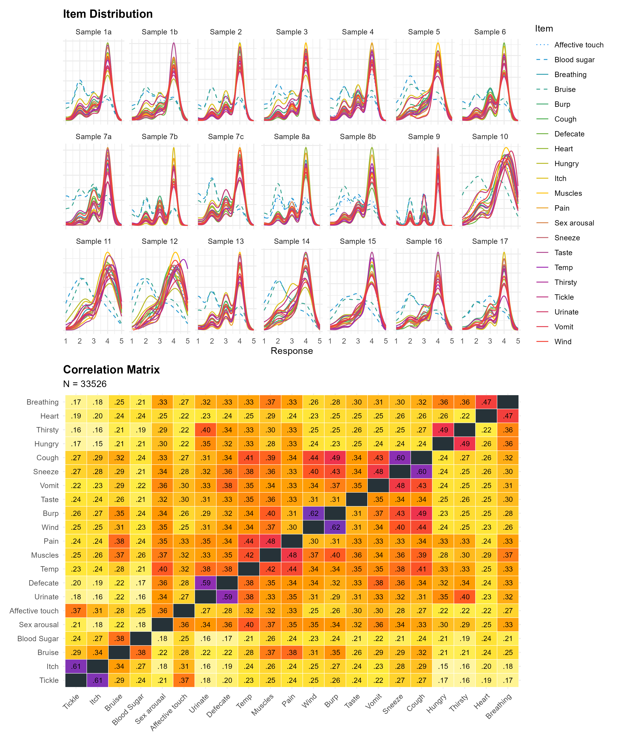
UVA flagged “itch” and “tickle” as strongly redundant; “tickle” was removed from further analyses given its redundancy and absence from some datasets due to translation issues. Additional pairs were flagged as moderately redundant (“wind”/“burp”; “urinate”/“defecate”) or mildly redundant (“sneeze”/“cough”; “heart”/“breathing”; “hungry”/“thirsty”), consistently across most samples.

Structure Exploration
HCA consistently grouped item pairs and triplets across samples: “wind”/“burp”, “sneeze”/“cough”, “itch”/“bruise”, “urinate”/“defecate”, and “pain”/“muscles”/“temperature”. EGA largely replicated this, with an additional cluster comprising “sexual arousal”, “affective touch”, “temperature”, “pain”, “muscles”, and “taste”. EFA suggested an optimal 3-factor solution: expulsion-related items (“burp”, “wind”, “cough”, “sneeze”, “vomit”), visceroceptive items (“heart”, “breathing”, “hungry”, “thirsty”, “urinate”, “defecate”), and items not directly accessible via internal sensation alone (“bruise”, “blood sugar”). Full results are available via the GitHub repository above.
Initial structural analyses flagged six further problematic items beyond “tickle”: “taste” showed a lone or unstable association pattern; “affective touch” exhibited cross-loadings and instability; “vomit” was weakly associated with other items; “itch” formed no consistent cluster; and “temperature” and “sexual arousal” showed redundant but unreliable associations. These six items, alongside “tickle”, were removed, and structural analyses were re-run on the remaining 14 items (see Figure 3).

Figure 3
Four structure analysis methods (HCA, EGA, EFA, CFA) were applied and converged on a consistent optimal solution of 14 items formed seven pairs: Hungry-Thirsty, Bruise-Blood sugar, Urinate-Defecate, Muscles-Pain, Breathing-Heart, Cough-Sneeze, Wind-Burp. While EFA suggested 3 factors, CFA confirmed the superiority of the 7-factor model over alternative structures.
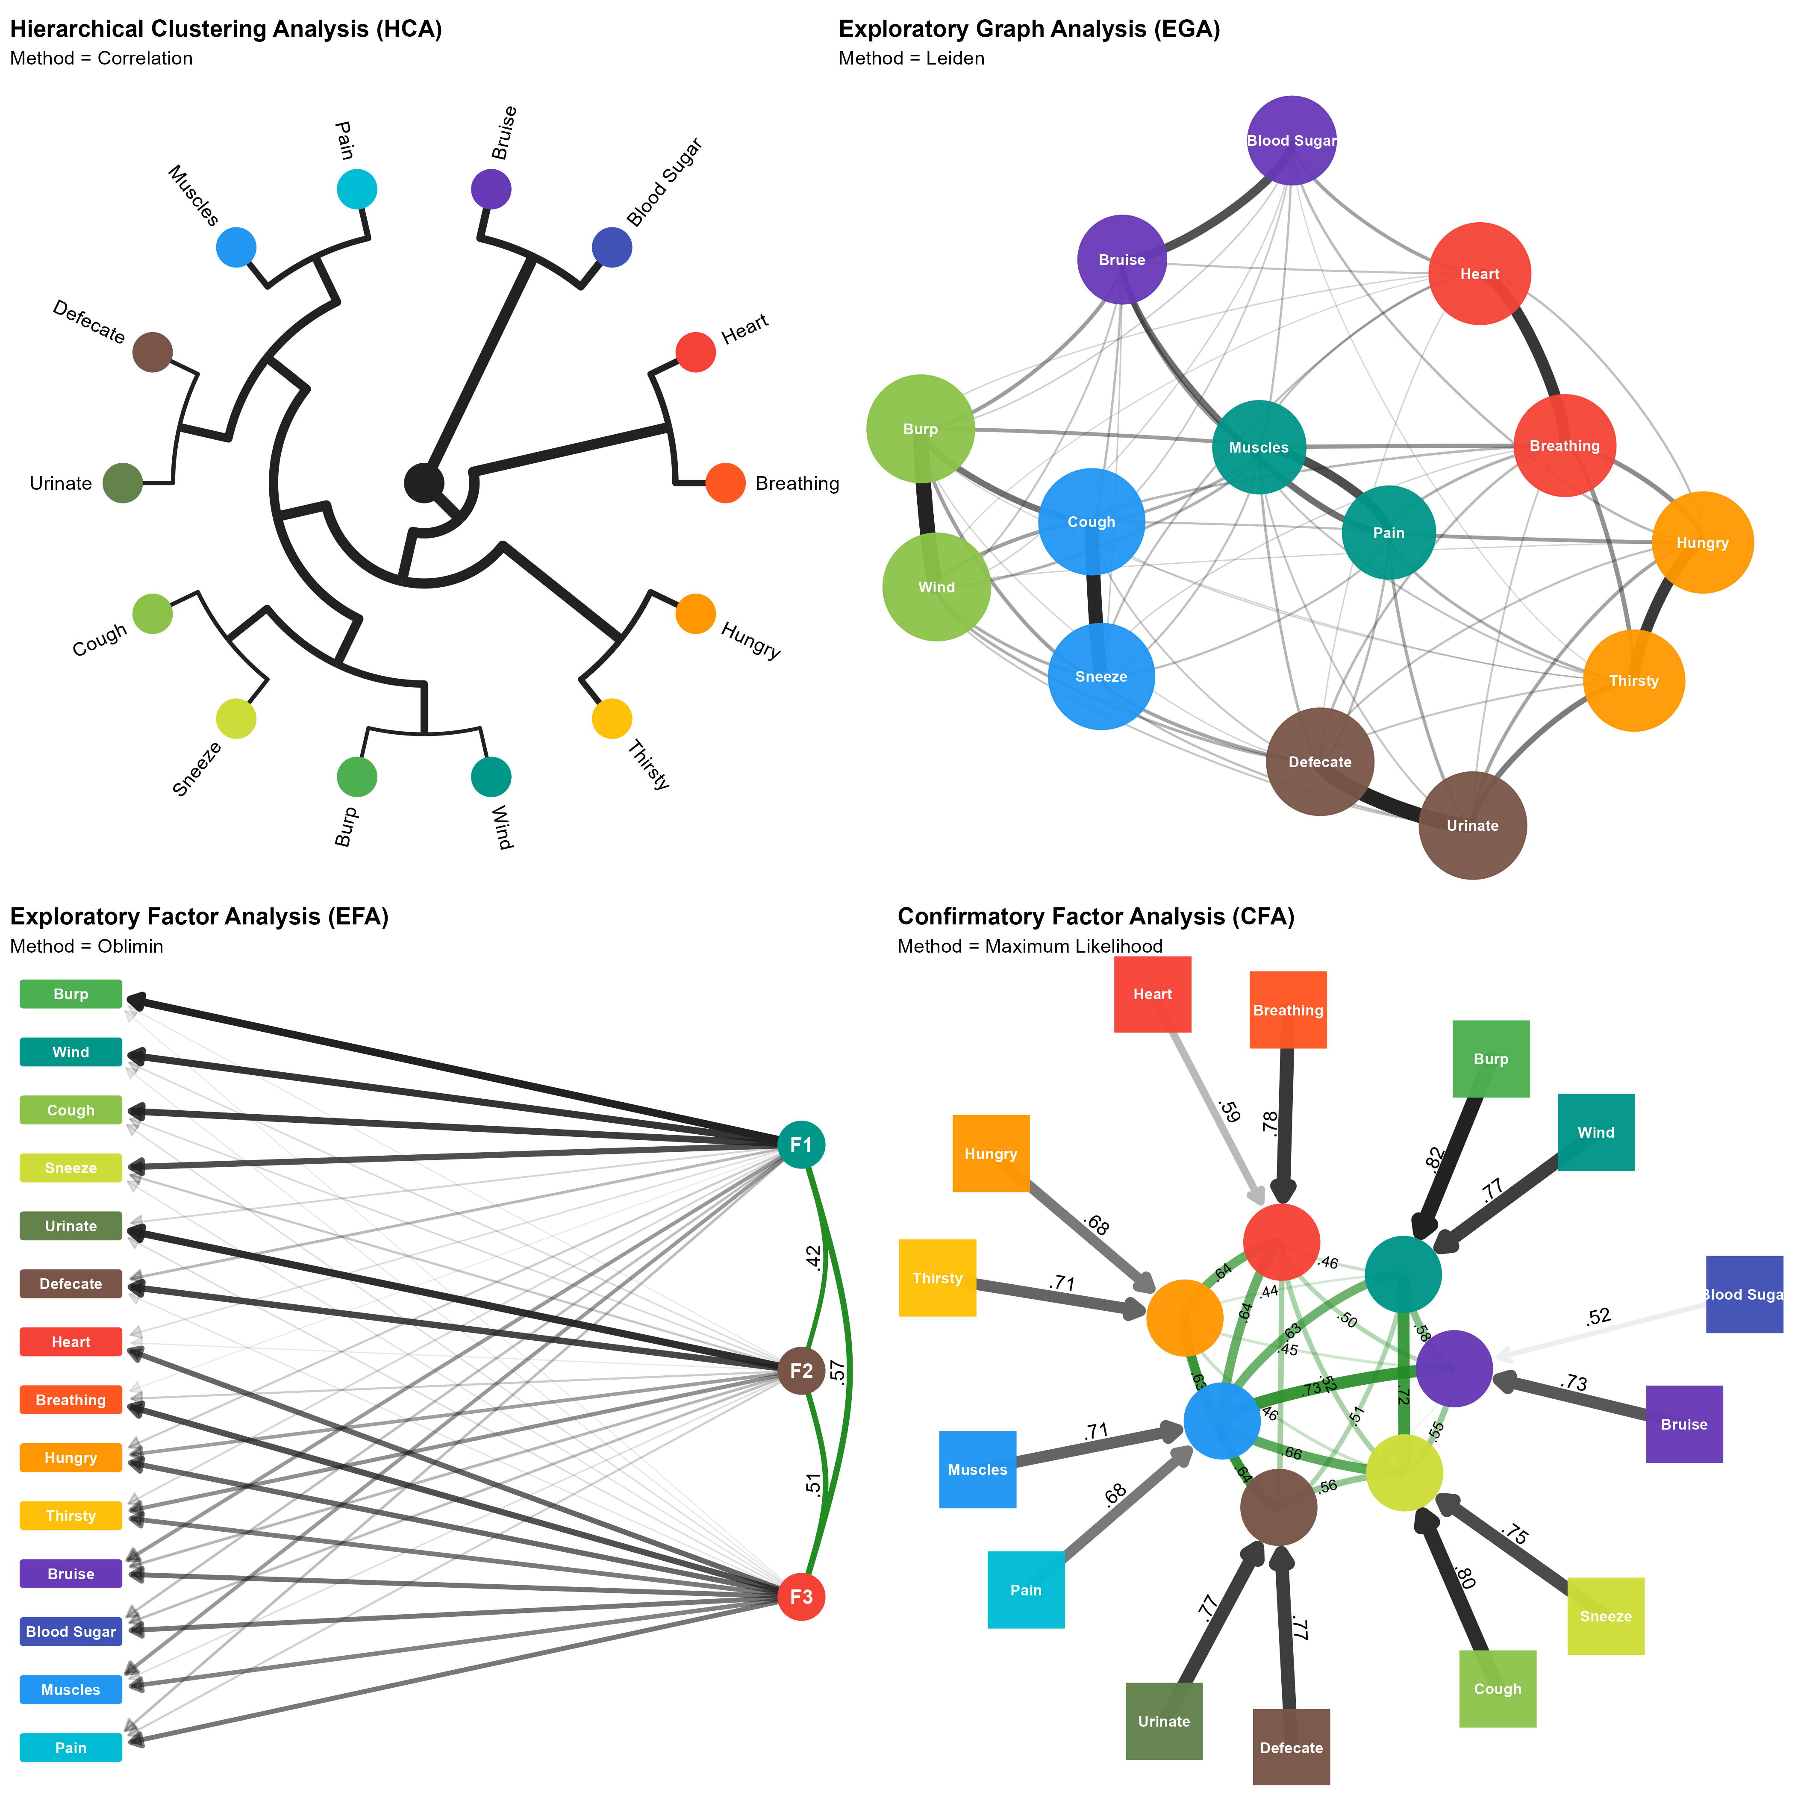
HCA and EGA yielded highly consistent results, identifying seven stable item pairs: Hungry-Thirsty, Bruise-Blood sugar, Urinate-Defecate, Muscles-Pain, Breathing-Heart, Cough-Sneeze, and Wind-Burp. HCA additionally grouped Urinate-Defecate with Muscles-Pain, and the two expulsion pairs (Wind-Burp, Cough-Sneeze) together. EFA again suggested a 3-factor solution: expulsion items (“burp”, “wind”, “cough”, “sneeze”), the Urinate-Defecate pair, and the remaining items.

Confirmatory Factor Analysis (CFA)
We used CFA to fit and compare candidate structures from the previous analyses: a 1-factor (G-model), 3-factor (EFA), 3+1 (EFA + general factor), 5-factor (HCA), 5+1 (HCA + general factor), 7-factor (EGA), and 7+1 (EGA + general factor) model. The 7-factor EGA model provided the best fit (RMSEA = 0.035, χ2^2 χ2 = 2,334.112, CFI = 0.984), followed by EGA + general factor (RMSEA = 0.054, χ2^2 χ2 = 6,876.395, CFI = 0.952) and the 5-factor HCA model (RMSEA = 0.078, χ2^2 χ2 = 13,441.878, CFI = 0.906). All remaining models performed poorly (RMSEA > 0.08, CFI < 0.90). The EGA model also yielded the lowest BIC; all other models showed substantially weaker evidence (BIC-based Bayes Factor < 1/100).
Across individual datasets, the 7-factor EGA model provided the best fit in 8 of 13 samples where CFA converged. In these samples, the 7-factor EGA model showed excellent performance, with low RMSEA values (≈ 0.025–0.057), high CFI values (≥ 0.95), and substantially lower χ2 values compared to alternative models. Adding a general factor improved fit in three samples for which the 7-factor EGA + general factor model showed acceptable RMSEA (≈ 0.048–0.061) and CFI (≈ 0.929–0.957) values. The 5-factor + general factor model was preferred in two (RMSEA = 0.049/0.057, CFI = 0.955/0.919). Bayes factor comparisons aligned with BIC-based conclusions. Overall, while the EGA model was preferred in most samples, bifactor models provided some evidence for a common IAS factor.

Discussion
Study 1 aimed to systematically evaluate the structure of the IAS using a mega-analytic approach with both factor-analytic and network-based methods. Previous research has highlighted inconsistencies in optimal factor structure [e.g., unidimensional, bifactor, and two-factor solutions; Brand et al. (2023); Campos et al. (2021); Lin et al. (2023); Murphy et al. (2019); Koike and Nomura (2023)] and raised concerns about specific items (e.g., low discrimination, local dependencies, items less accessible to interoception). To address these concerns and issues, we combined 17 datasets with over 33,000 participants, to provide the most comprehensive analysis of IAS structure to date. We conducted analyses across both combined and individual datasets, allowing an examination of overall and dataset-specific results and how they compared across three different structural analysis methods (EFA, HCA, EGA).
Seven item pairs (Hungry-Thirsty, Bruise-Blood Sugar, Urinate-Defecate, Muscles-Pain, Breathing-Heart, Cough-Sneeze, Wind-Burp) emerged consistently across datasets and methods, yielding a refined 14-item IAS with superior fit over alternative models. Rather than measuring a broad “interoceptive accuracy” construct, the IAS appears to reflect clusters of tightly coupled items tied to specific bodily sensations - both directly felt and inferred or anticipatory (e.g., Bruise-Blood Sugar). Notably, while $χ^{2}$ and BIC can be sensitive to large samples, conclusions are further supported by replication across analytic approaches and individual datasets.
Alternatively, item pairings may also reflect shared temporal or functional characteristics. For instance, Cough-Sneeze and Wind-Burp involve rapid reflexive responses and frequent co-occurrence, while Hungry-Thirsty and Urinate-Defecate reflect homeostatic regulation and recurrent need states, potentially eliciting similar response strategies despite distinct underlying physiology. These explanations need not exclude interpretation of pairings as intuitive bodily domains (e.g., visceral, expulsion, musculoskeletal). Indeed, temporal and functional similarities are themselves grounded in bodily organisation, suggesting multiple overlapping sources of structure. This convergence may contribute to the intuitive coherence of the item pairs while also increasing redundancy and instability when weakly discriminating items are retained, thereby complicating factor-analytic solutions and likely contributing to inconsistencies in prior findings (Campos et al., 2021; Lin et al., 2023).
Study 1 findings highlight the need for targeted scale refinement and context-sensitive interoception measures. Many bodily sensations are inherently ambiguous (e.g., a racing heart may signal exertion, anxiety, or excitement), making it unclear which state participants reference when responding. Such ambiguity likely constrains ecological validity and contributes to cross-study variability; context-specific phrasing may therefore be necessary to more accurately capture interoceptive beliefs and reduce measurement noise (Makowski, Neves, et al., 2025; e.g., Vlemincx et al., 2023).
Overall, Study 1 suggests that, after removal of problematic items the IAS is best conceptualized as a set of item clusters rather than a unidimensional scale. This structural insight forms the foundation for Study 2, where dispositional correlates are examined to further evaluate the IAS’s construct validity.

Study 2
Although widely adopted, evidence on the IAS’s associations with personality traits, affective dispositions, and related constructs remains scattered and inconsistent (Brand et al., 2023; Lin et al., 2023; Murphy et al., 2019; Todd et al., 2022). In Study 2 we aimed to provide a robust overview of the dispositional correlates of the IAS by leveraging and combining a large number of available datasets containing both the IAS, other measures of interoception, and dispositional correlates. We also sought to assess whether structural improvements of the 14-item IAS translate into clearer, more interpretable, and more reliable external associations by comparing associations to dispositional variables with the original 21-item unidimensional solution, offering a more efficient alternative to the longer version for future research.

Methods

Materials
We selected measures appearing in at least one Study 1 dataset and/or relevant to the study scope (physiology, mood, personality, psychopathological and neurodevelopmental traits, and beliefs). Where applicable, regular and abridged scale versions were merged (e.g., the 2-item GAD and PHQ measures were combined into the PHQ-4).

Interoception and Interoception Related Measures.
Interoception-related measures included the Multidimensional Assessment of Interoceptive Awareness Version-2 (MAIA-2, Mehling et al., 2018), the Body Perception Questionnaire Short Form (BPQ-SF, Cabrera et al., 2018), and the Interoceptive Confusion Questionnaire (ICQ, Brewer et al., 2016). We also included the Bermond–Vorst Alexithymia Questionnaire (BVAQ, Vorst & Bermond, 2001), and the Toronto Alexithymia Scale (TAS-20, Bagby et al., 1994), due to the close relationship between interoception deficits and alexithymia (e.g., Brewer et al., 2016; Gaggero et al., 2021).

Mood and Anxiety Related Measures.
Scores from depression and anxiety-related measures were included due to their established associations with interoceptive processing (Khalsa, Adolphs, Cameron, Critchley, Davenport, Feinstein, Feusner, Garfinkel, Lane, Mehling, Meuret, et al., 2018); namely the Patient Health Questionnaire-4 (PHQ-4, Kroenke et al., 2009), the Patient Health Questionnaire-15 (PHQ-15, Kroenke et al., 2002), the Patient Health Questionnaire-9 (PHQ-9, Kroenke et al., 2001), the Short Mood and Feelings Questionnaire (MFQ, Angold et al., 1995), the Beck Depression Inventory-II (BDI-II, Beck et al., 1996), the State–Trait Anxiety Inventory Trait Version (STAI-T, Spielberger, 1970; and STAIT-T, Zsido et al., 2020), the Generalized Anxiety Disorder Scale (GAD-7, Spitzer et al., 2006), and General Anxiety Disorder-2 (GAD-2, Kroenke et al., 2007, obtained from the PHQ-4).

Psychopathological and Neurodevelopmental Traits.
Dimensional psychopathological and neurodevelopmental-related trait scores were included from the Personality Inventory for DSM-5 Short Form (PID-5-SF, Thimm et al., 2016), the Autism Spectrum Quotient Short Form (ASQ-S, Hoekstra et al., 2011), the Schizotypal Personality Questionnaire – Brief Revised (SPQ-BR, Davidson et al., 2016), and the McLean Screening Instrument for Borderline Personality Disorder (MSI-BPD, Zanarini, 2003).

Personality.
Personality-related measures included the NEO Five-Factor Inventory, Neuroticism subscale (NEO-FFI, Costa et al., 1992), the Mini International Personality Item Pool (MINI-IPIP6, Sibley et al., 2011), and the Big Five Inventory Short Form (BFI-S, Rammstedt & John, 2007).

Beliefs and Misbeliefs.
Beliefs- and misbeliefs-related measures included the Lie Scale (LIE, Makowski et al., 2023), the Generic Conspiracist Beliefs Scale (GCBS, Brotherton et al., 2013), and the Primal World Beliefs Inventory (PI-99, Clifton et al., 2019) and its short form (PI-18, Clifton & Yaden, 2021). These instruments assess individual differences in conspiracist, world, and lying beliefs. This domain represents a novel avenue of research in the context of interoception, as such beliefs have not been previously assessed in relation to interoceptive processes.

Data Analysis

Figure 4
Meta-analytic associations (95% CI of standardised coefficients) between the IAS (total score and seven item pairs) and dispositional measures across 17 open-access datasets. Positive associations are shown in red, negative associations in blue. Non-significant associations (CI crossing zero) are transparent. The IAS-21 showed positive associations with most MAIA facets and BPQ-Body Awareness, negative associations with interoceptive deficit measures (TAS, ICQ), negative associations with the BPQ-Autonomic Reactivity, moderate negative associations with mood measures, and weaker, more selective associations with psychopathological and neurodevelopmental traits and belief measures. Certain item pairings, particularly Hungry–Thirsty and Bruise–Blood sugar, drove the strongest effects, highlighting domain-specific patterns in self-perceived interoceptive accuracy.
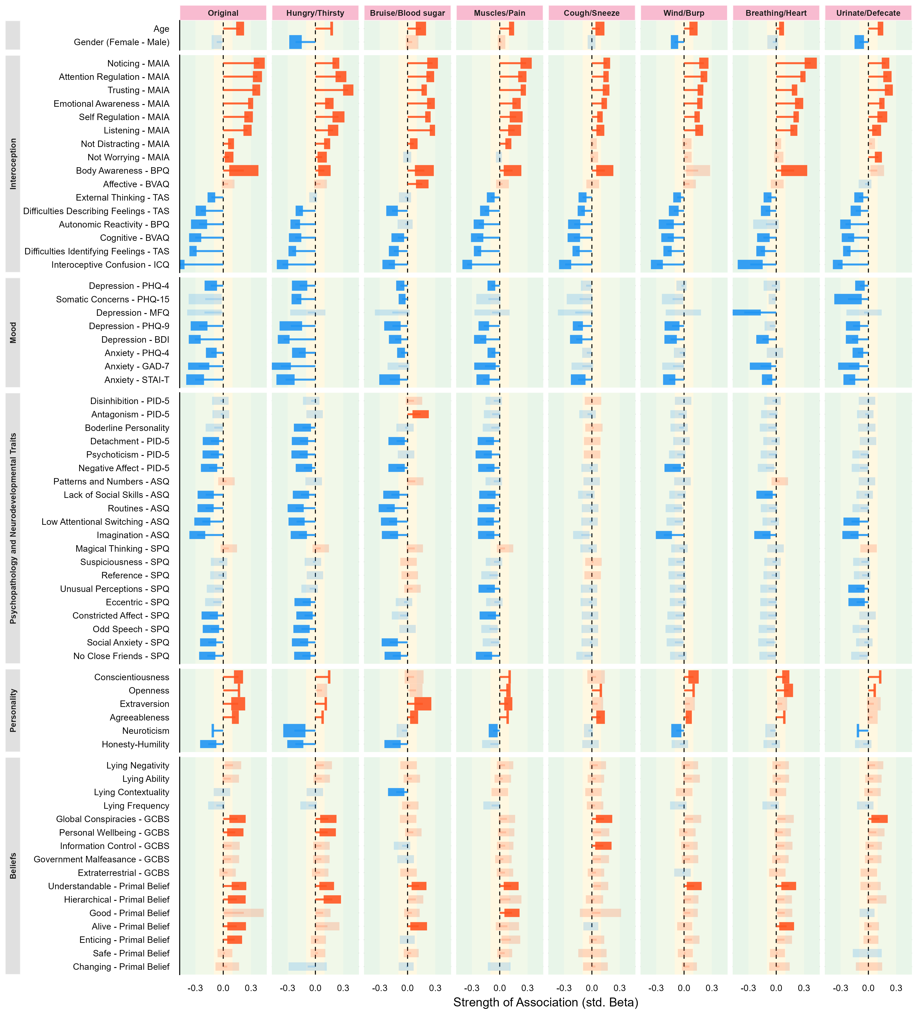
All variables were extracted and standardised (z-scored) for the aggregated dataset. Scores were harmonised where meaningful (e.g., the 18-item and 99-item PI versions were combined) and missing data were excluded per-model to maximise statistical power.
Akin to a meta-analytic framework, datasets were treated as clusters (random groups), and pooled estimates of the associations that account for both within- and between-sample variability were computed. This approach allowed for the estimation of multiple associations while still accounting for study heterogeneity and intra-study uncertainty (i.e., measurement uncertainty within the studies). Specifically, associations were estimated using mixed models via the glmmTMB package (McGillycuddy et al., 2025), postprocessed with the easystats ecosystem (Ben-Shachar et al., 2020; Lüdecke et al., 2020; Makowski, Ben-Shachar, et al., 2025). Each predictor was entered separately with the seven IAS item pairs from Study 1 (Hungry–Thirsty, Muscles–Pain, Wind–Burp, Urinate–Defecate, Breathing–Heart, Bruise–Blood Sugar, Cough–Sneeze) and the original IAS total score as outcomes, with dataset as a random intercept and predictor as a random slope. Given the large sample size, we focus on effect sizes and confidence intervals rather than p-values.
From each fitted model, we extracted standardised regression coefficients (interpretable as a correlation index), and 95% confidence intervals (additional details on p-values, convergence status, and sample sizes are available in the GitHub repository). Results are summarized in Figure 4 and we report the mean coefficient in the text when consistent across measures.

Results

Demographics
Age showed consistent positive standardised associations across IAS correlates (β = .13), including both the IAS total scores and the scores for the 7-pairs, with all effects significant. Gender displayed near-zero effects (β = −.06) and was only significant for the Hungry–Thirsty, Wind–Burp, and Urinate–Defecate pairs.

Interoception and Interoception Related Measures
MAIA subscales showed robust positive standardised associations with the IAS. Noticing had the strongest association (β = .26), followed by Attention Regulation (β = .25) with other subscales (Body Listening, Trusting, Emotional Awareness and Self-Regulation) in the .19–.24 range, all significant. Effects were generally strongest for the full IAS, except for Body Listening, which peaked for the Bruise–Blood sugar pair. Not Distracting was significant only for the full IAS, Hungry-Thirsty, Bruise-Blood sugar and the Muscles-Pain pairs, albeit weakly (β ≈ −.02 to .06). Not Worrying was significant only for the full IAS and the Hungry–Thirsty and Urinate–Defecate pairs (β ≈ −.01 to .04).
The BPQ’s Autonomic Reactivity subscale was reliably negatively associated across the seven item pairs (β = −.19), reaching significance for all pairs except Bruise–Blood sugar and Breathing–Heart. In contrast, the Body Awareness subscale of the BPQ was positive and significant across most pairs (β = .15; range = .10 to .22) except for Wind-Burp and Urinate-Defecate.
Interoceptive deficits showed consistent negative associations: Alexithymia measures (TAS, BVAQ) were robustly negative (β ≈ −.13 to −.2), except for the BVAQ Affective subscale, which was positive for Bruise–Blood sugar (β = .16). Interoceptive confusion (ICQ) was also negative across all IAS measures (β = −.32; range = −.49 to −.20).

Mood and Anxiety Related Measures
Depression (β = −.20) and anxiety (β = −.20) showed consistent negative associations across the IAS and all its pairs, with the strongest effects observed for the Hungry–Thirsty dimension. However, looking at specific measures revealed some differences.
The MFQ was largely nonsignificant except for a negative association with Breathing–Heart, while somatic concerns (PHQ-15) were unrelated to the IAS total scale but had weak negative associations with the Hungry–Thirsty, Bruise–Blood sugar, and Urinate–Defecate pairs (from −.22 to −.05).
Other mood indices (PHQ-9, PHQ-4, GAD-7) produced generally weaker but often reliable negative coefficients (typically −.10 to −.15), though effects sometimes appeared only for specific pairs (e.g., PHQ-4 was significant for all pairs except Wind–Burp and Breathing–Heart). Across anxiety and depression measures, the Hungry–Thirsty pair consistently had the strongest standardised effects.

Psychopathological and Neurodevelopmental Traits
Psychopathological traits were generally negatively associated with the IAS scores. Detachment, Psychoticism, and Negative Affect demonstrated the most reliable, albeit weak, negative associations with IAS scores (from −.08 to −.10), again primarily driven by the Hungry–Thirsty, Bruise–Blood sugar, and Muscles–Pain pairs.
Other maladaptive traits were unrelated to IAS scores. Notably, Antagonism showed a significant positive association, limited to the Bruise–Blood sugar pair (β = .14), whereas Borderline Personality was uniquely negatively associated with Hungry–Thirsty (β = −.14).
A comparable trend was observed for autistic traits (ASQ), with the strongest effects driven by the Hungry–Thirsty, Bruise–Blood sugar, and Muscles–Pain pairs, which yielded the largest negative coefficients. Among ASQ subscales, Imagination (β = −.18) exhibited the most consistent pattern of negative associations across pairs except for Cough–Sneeze.
Schizotypal traits showed a similarly negative pattern of associations to IAS scores. Social Anxiety (β = −.11) and No Close Friends (β = −.12) displayed the most consistent effects. Although some facets were unrelated to the total IAS score, they were associated with specific item pairs: Unusual Perceptions with Muscles–Pain and Urinate–Defecate, and Eccentric with Hungry–Thirsty and Urinate–Defecate.

Personality
Among the Big Five traits, Openness (β = .10), Agreeableness (β = .08), and Conscientiousness (β = .11) exhibited small yet consistent positive associations, most clearly for the total IAS score. Extraversion showed a weak but positive association, driven primarily by the Bruise–Blood sugar pair (β = .17). In contrast, Honesty–Humility (β = −.10) had a small negative effect, most clearly for the Hungry–Thirsty and Bruise–Blood sugar pairs. Finally, Neuroticism (β = −.23) was negatively associated with the IAS, with the strongest effect observed for the Hungry–Thirsty pair (β = −.22).

Beliefs and Misbeliefs
Within the Lying Profile, only Lying Contextuality showed a modest negative coefficient for Bruise–Blood sugar (β = −.12). Global Conspiracies (GCBS) beliefs were associated with the total IAS and three pairs (β = .10): Hungry–Thirsty, Cough-Sneeze and Urinate-Defecate. Primal world beliefs were largely null, with small positive associations for appraising the world as being “Understandable”, “Alive”, and “Hierarchical”, with Hungry–Thirsty (β = .09). Appraising the world as “Good” was uniquely positively related with Muscles–Pain (β = .09).
Overall, the original IAS total score had the greatest number of significant standardised effects (28), though many were driven by specific item pairs rather than uniform scale-wide associations. Hungry–Thirsty (17) and Bruise–Blood sugar (10) consistently yielded the largest standardised coefficients, especially for interoception, mood, and psychopathological and neurodevelopmental trait measures. Other item pairs (Cough–Sneeze, Wind–Burp, Urinate–Defecate) contributed little unique variance and rarely had meaningful standardised effects.

Discussion
Using a meta-analytical approach across 17 datasets, Study 2 examined the dispositional correlates of the IAS and whether the refined 14-item version translated into clearer and more reliable associations than the original 21-item scale.
The IAS showed positive associations with all MAIA facets except Not-Distracting and Not-Worrying, replicating prior findings (Brand et al., 2023; Todd et al., 2022), and positive associations with the BPQ Body Awareness subscale, consistent with previous research (Brand et al., 2023; Gaggero et al., 2021; Koike & Nomura, 2023). Autonomic reactivity indices were more strongly and negatively associated with IAS scores, supporting earlier observations that reactivity may reflect bodily signal processing captured by self-reported interoceptive accuracy (Todd et al., 2022). Measures of interoceptive difficulties — alexithymia and interoceptive confusion — were negatively associated with IAS scores, consistent with prior work (Brand et al., 2023; Koike & Nomura, 2023; Lin et al., 2023; Murphy et al., 2019).
Although the BPQ Body Awareness–IAS association replicates some findings, others have reported null (Murphy et al., 2019), negative (Lin et al., 2023), or even quadratic relationships (Campos et al., 2021). Mixed findings may reflect inconsistent interpretations of BPQ items; specifically, whether they capture attentional focus or perceived detection accuracy (Campos et al., 2021; Gabriele et al., 2022) and should therefore be interpreted cautiously. Future studies should assess participants’ understanding of BPQ items to clarify this relationship.
Across mood measures, most item pairs showed small-to-moderate associations, indicating shared variance between interoceptive self-reports and affective tendencies (Koike & Nomura, 2023; Murphy et al., 2019). Associations with psychopathological and neurodevelopmental traits were more selective, with negative effects concentrated in visceral pairings (Hungry–Thirsty, Bruise–Blood Sugar), suggesting self-reported interoceptive accuracy for visceral sensations is more strongly linked to affective and clinical traits than accuracy for somatic or respiratory reflexes.
Personality associations followed a similar domain-specific pattern. Extraversion was most strongly associated with Bruise–Blood Sugar, Neuroticism and Honesty–Humility with Hungry–Thirsty, and Openness, Conscientiousness, and Agreeableness with the full scale. These results partially align with prior work (Brand et al., 2023) but require replication, as well as evaluation of associations involving other personality traits. Overall, these results suggest that IAS–personality associations depend on the bodily domain represented.
Associations with belief systems were uniformly small. Weak positive associations emerged with certain primal world beliefs (e.g., perceiving the world as comprehensible or alive) and selected conspiracy belief dimensions (Global Conspiracies, Personal Wellbeing), concentrated in Hungry–Thirsty and Bruise–Blood Sugar pairs. This suggests links between interoceptive self-report and broader cognitive or worldview constructs are modest and domain-specific.
Notably, this study prioritised general patterns across aggregated datasets rather than systematic between-sample differences; dataset-specific effects were not examined in detail. Although cross-sample variability is reflected in estimate uncertainty, future research could profitably investigate sample-specific associations and the causes of divergences across datasets.
In summary, the 14-item IAS performed comparably to the original 21-item version across mood, psychopathological, neurodevelopmental, and interoceptive measures. However, associations were often non-uniform across bodily domains, driven primarily by specific item pairs — particularly Hungry–Thirsty and Bruise–Blood Sugar, which showed the strongest and most consistent associations with interoceptive, affective, and personality measures. Other pairs contributed little unique information, especially for psychopathological, neurodevelopmental, and belief measures. The homeostatic salience of Hungry–Thirsty and the contextual relevance and visual/psychological prominence of Bruise–Blood Sugar may underlie their stronger dispositional associations.
Overall, findings support the validity of the original IAS general score while positioning the refined 14-item scale as a more efficient and interpretively nuanced alternative.

General Discussion
Across two studies, we used a mega-analytic approach combining data from 17 datasets with over 33,000 participants to provide the most comprehensive evaluation to date of the IAS, including both its structure (Study 1) and dispositional correlates (Study 2). These studies offer new insights into the conceptual interpretation and practical applications of the IAS, with suggestions for how researchers may use the IAS in future research.
Study 1 challenges interpretations of the IAS as a single latent construct (Brand et al., 2023; Murphy et al., 2019), instead suggesting it captures multiple domain-specific clusters of bodily sensations. Seven stable item pairs (Hungry–Thirsty, Urinate–Defecate, Muscles–Pain, Breathing–Heart, Cough–Sneeze, Wind–Burp, Bruise–Blood Sugar) yielded a refined 14-item structure with superior fit and cross-dataset stability over unidimensional or bifactor models. Redundant or unstable items (e.g., Tickle, Taste, Affective Touch) likely weaken interpretability and contribute to prior inconsistencies (Campos et al., 2021; Lin et al., 2023). Unlike Lin et al. (2023), whose 12-item solution supported unidimensionality, we interpret local dependencies as reflecting meaningful coupling among functionally related signals (e.g., Heart–Breathing) — mirroring the physiological or phenomenological co-occurrence of bodily sensations (e.g., hunger with thirst, coughing with sneezing). Perceived accuracy in one bodily system may thus generalise to linked sensations, yielding clustered rather than continuous interoceptive beliefs.
Consistent with this, self-reported interoceptive abilities across related bodily axes (e.g., cardiac and respiratory) show positive associations (Garfinkel et al., 2016), whereas objective measures of interoceptive accuracy across modalities typically show weak or absent correlations (Banellis et al., 2026; Bruni, 2023; Ferentzi et al., 2018). This dissociation suggests that objective interoceptive performance may be largely domain-specific while subjective beliefs generalise across functionally related systems. We therefore interpret the present clustering as reflecting the conceptual organisation of interoceptive beliefs structured by perceived bodily interdependence, rather than a single general interoceptive capacity.
Study 2 examined the IAS’s associations with interoceptive, affective, personality, and belief-related traits. Consistent with prior research, the IAS correlated positively with adaptive interoceptive sensibility (e.g., MAIA noticing, attention regulation, and body trusting subscales) and negatively with interoceptive difficulties such as alexithymia and interoceptive confusion (Brand et al., 2023; Gaggero et al., 2021; Garfinkel et al., 2015).
Also consistent with prior research, higher depression and anxiety symptoms were associated with lower perceived interoceptive accuracy (Brand et al., 2023; Khalsa, Adolphs, Cameron, Critchley, Davenport, Feinstein, Feusner, Garfinkel, Lane, Mehling, Meuret, et al., 2018; Nord & Garfinkel, 2022). Crucially, these associations were not uniform across bodily domains: the strongest effects involved drive-states (hunger, thirst), while cardiorespiratory and expulsion domains showed weaker or inconsistent relationships. This domain specificity suggests that beliefs about gastrointestinal accuracy may be more psychologically and clinically relevant than beliefs about reflexive or surface sensations, or that these signals are more salient and easier to appraise, yielding greater inter-individual variation.
Domain-specific links to anxiety and depression may help explain inconsistencies in the interoception–emotion literature. Performance-based measures of interoceptive accuracy, typically cardioception, show weak or absent correlations with depression and anxiety (Adams et al., 2022; Banellis et al., 2025; Jenkinson et al., 2024), whereas self-reported measures spanning multiple bodily domains show stronger negative associations with internalising traits (Brand et al., 2022; Clemente et al., 2024; Lin et al., 2023). This discrepancy likely reflects both conceptual distinctions between perceptual accuracy and metacognitive beliefs (Garfinkel et al., 2015; Khalsa, Adolphs, Cameron, Critchley, Davenport, Feinstein, Feusner, Garfinkel, Lane, Mehling, Meuret, et al., 2018; Suksasilp & Garfinkel, 2022) and variation in bodily domains assessed. Study 2 extends this by showing that interoceptive belief–affect associations concentrate in psychologically salient visceral domains, suggesting the field’s reliance on cardioceptive tasks may have obscured meaningful relationships between affective traits and other interoceptive modalities.
Similar but weaker patterns emerged for autistic traits, schizotypy, and maladaptive personality dimensions, which correlated negatively with interoceptive accuracy beliefs in visceral and musculoskeletal, but not other, domains. Rather than reflecting a general interoceptive deficit, diminished accuracy beliefs in specific domains may contribute to particular socio-emotional and personality features. This aligns with prior research linking interoceptive self-beliefs to emotional awareness, social connectedness, and psychopathology (Brand et al., 2022; Torregrossa et al., 2022; Williams et al., 2023), and extends it by showing these associations are domain-specific rather than global.
Together, Studies 1 and 2 suggest that self-perceived interoceptive accuracy is a differentiated construct varying systematically across bodily systems. Beliefs about gastrointestinal accuracy showed the most consistent associations with affective and dispositional features — although modest in magnitude, they highlight the value of domain-specificity when linking interoceptive beliefs to emotion and mental health. Clinically, this domain-specific structure suggests that interoceptive disruptions in affective, psychopathological, and neurodevelopmental conditions may centre primarily on visceral beliefs rather than global deficits, pointing to new avenues for targeted assessment and intervention.
Our results support use of the refined 14-item IAS, illustrating how network-informed scale refinement (H. F. Golino & Epskamp, 2017) can enhance parsimony and construct clarity. Methodologically, combining traditional psychometrics with network-based approaches proved valuable: EGA complemented, and often surpassed, factor analysis by identifying meaningful inter-item dependencies, yielding a more interpretable and stable structure.
Nevertheless, use of the 14-item IAS warrants careful consideration. Although item pairs improved interpretability and outperformed the full IAS in associations with affective and dispositional traits, two-item dimensions remain suboptimal — particularly for broad or conceptually ambiguous constructs (Allen et al., 2022) like interoceptive accuracy beliefs across multiple bodily systems. Two-item clusters may overemphasize links between functionally related sensations while failing to capture variability across unrelated domains. Conversely, overall scores risk obscuring domain-specific relationships and assume interoceptive abilities generalise across bodily systems. Building on Desmedt et al. (2022)’ “jingle fallacy” observation, the present results caution against assuming self-reported accuracy generalises across domains or can be captured by a single construct.
Although this study focused on the IAS, future research should re-evaluate the structure and correlates of other interoception questionnaires, such as the BPQ and MAIA, which have documented shortcomings (Campos et al., 2021; Ferentzi et al., 2021; Rogowska et al., 2023; Vig et al., 2023), ideally using a mega-analytic approach. Incorporating objective interoceptive accuracy measures across specific domains (cardiac, respiratory, gastric) would clarify whether domain-specific self-reports reflect true perceptual ability or primarily metacognitive beliefs. Although subjective and objective measures show weak or absent within-domain correlations (Arslanova et al., 2022; Brand et al., 2023; Petzke et al., 2024), examining additional modalities such as gastric perception could reveal whether this generalises across interoceptive systems.
In summary, our research demonstrates that the IAS is a solid measure of self-reported interoceptive accuracy with typical patterns of associations with external measures. However, our findings challenge its optimal structure and scoring approach, instead suggesting that a refined 14-item version with seven item-pairs related to intuitive bodily domains might be better suited to capture interpretable and ecologically valid domain-specific interoceptive beliefs. More broadly, our results highlight the value of conceptualising interoceptive processes as domain-specific rather than unidimensional, and underscore the need for targeted scale refinement and development of novel, context-sensitive, multidimensional interoception measures.

References
Adams, K. L., Edwards, A., Peart, C., Ellett, L., Mendes, I., Bird, G., & Murphy, J. (2022). The association between anxiety and cardiac interoceptive accuracy: A systematic review and meta-analysis. Neuroscience & Biobehavioral Reviews, 140, 104754.
Allen, M. S., Iliescu, D., & Greiff, S. (2022). Single item measures in psychological science. In European journal of psychological assessment. Hogrefe Publishing.
Angold, A., Costello, E. J., Messer, S. C., & Pickles, A. (1995). Development of a short questionnaire for use in epidemiological studies of depression in children and adolescents. International Journal of Methods in Psychiatric Research.
Arslanova, I., Galvez-Pol, A., Kilner, J., Finotti, G., & Tsakiris, M. (2022). Seeing through each other’s hearts: Inferring others’ heart rate as a function of own heart rate perception and perceived social intelligence. Affective Science, 3(4), 862–877.
Baer, R. A., Smith, G. T., Hopkins, J., Krietemeyer, J., & Toney, L. (2006). Using self-report assessment methods to explore facets of mindfulness. Assessment, 13(1), 27–45.
Bagby, R. M., Parker, J. D., & Taylor, G. J. (1994). The twenty-item toronto alexithymia scale—i. Item selection and cross-validation of the factor structure. Journal of Psychosomatic Research, 38(1), 23–32.
Banellis, L., Nikolova, N., Ehmsen, J. F., Courtin, A. S., Vejlø, M., Tyrer, A., Böhme, R. A., Fardo, F., & Allen, M. G. (2026). Interoceptive ability is uncorrelated across respiratory and cardiac axes in a large scale psychophysical study. Communications Psychology.
Banellis, L., Nikolova, N., Fischer Ehmsen, J., Courtin, A. S., Vejlo, M., Tyrer, A., Bohme, R., Bavato, F., Hoogervorst, K., Fardo, F., et al. (2025). Interoceptive ability is unrelated to mental health symptoms: Evidence from a large scale multi-domain psychophysical investigation. medRxiv, 2025–2008.
Beck, A. T., Steer, R. A., & Brown, G. (1996). Beck depression inventory–II. Psychological Assessment.
Ben-Shachar, M. S., Lüdecke, D., & Makowski, D. (2020). Effectsize: Estimation of effect size indices and standardized parameters. Journal of Open Source Software, 5(56), 2815.
Brand, S., Meis, A. C., Tünte, M. R., Murphy, J., Woller, J. P., Jungmann, S. M., Witthöft, M., Hoehl, S., Weymar, M., Hermann, C., & Ventura-Bort, C. (2023). A multi-site German validation of the Interoceptive Accuracy Scale and its relation to psychopathological symptom burden. Communications Psychology, 1(1). https://doi.org/10.1038/s44271-023-00016-x
Brand, S., Petzke, T. M., & Witthöft, M. (2022). The differential relationship between self-reported interoceptive accuracy and attention with psychopathology. Zeitschrift für Klinische Psychologie Und Psychotherapie.
Brewer, R., Cook, R., & Bird, G. (2016). Alexithymia: A general deficit of interoception. Royal Society Open Science, 3(10), 150664.
Brotherton, R., French, C. C., & Pickering, A. D. (2013). Measuring belief in conspiracy theories: The generic conspiracist beliefs scale. Frontiers in Psychology, 4, 279.
Bruni, P. (2023). Interoception across domains: Assessing the role of age. Innovation in Aging, 7, 755.
Cabrera, A., Kolacz, J., Pailhez, G., Bulbena-Cabre, A., Bulbena, A., & Porges, S. W. (2018). Assessing body awareness and autonomic reactivity: Factor structure and psychometric properties of the body perception questionnaire-short form (BPQ-SF). International Journal of Methods in Psychiatric Research, 27(2), e1596.
Campos, C., Rocha, N. B., & Barbosa, F. (2021). Untangling self-reported interoceptive attention and accuracy: Evidence from the european portuguese validation of the body perception questionnaire and the interoceptive accuracy scale. http://dx.doi.org/10.31234/osf.io/a7wdj
Christensen, A. P., Garrido, L. E., & Golino, H. (2023). Unique variable analysis: A network psychometrics method to detect local dependence. Multivariate Behavioral Research, 58(6), 1165–1182.
Christensen, A. P., & Golino, H. (2021a). Estimating the stability of psychological dimensions via bootstrap exploratory graph analysis: A monte carlo simulation and tutorial. Psych, 3(3), 479–500.
Christensen, A. P., & Golino, H. (2021b). On the equivalency of factor and network loadings. Behavior Research Methods, 53(4), 1563–1580.
Clemente, R., Murphy, A., & Murphy, J. (2024). The relationship between self-reported interoception and anxiety: A systematic review and meta-analysis. Neuroscience & Biobehavioral Reviews, 167, 105923.
Clifton, J. D., Baker, J. D., Park, C. L., Yaden, D. B., Clifton, A. B., Terni, P., Miller, J. L., Zeng, G., Giorgi, S., Schwartz, H. A., et al. (2019). Primal world beliefs. Psychological Assessment, 31(1), 82.
Clifton, J. D., & Yaden, D. B. (2021). Brief measures of the four highest-order primal world beliefs. Psychological Assessment, 33(12), 1267.
Cosemans, T., Rosseel, Y., & Gelper, S. (2022). Exploratory graph analysis for factor retention: Simulation results for continuous and binary data. Educational and Psychological Measurement, 82(5), 880–910.
Costa, P., McCrae, R. R., & Revised, N. (1992). Personality inventory (NEO-PI-r) and NEO five-factor inventory (NEO-FFI): Professional manual. Psychological Assessment Resources, Odessa, FL.
Davidson, C. A., Hoffman, L., & Spaulding, W. D. (2016). Schizotypal personality questionnaire–brief revised (updated): An update of norms, factor structure, and item content in a large non-clinical young adult sample. Psychiatry Research, 238, 345–355.
Desmedt, O., Heeren, A., Corneille, O., & Luminet, O. (2022). What do measures of self-report interoception measure? Insights from a systematic review, latent factor analysis, and network approach. Biological Psychology, 169, 108289.
Desmedt, O., Luminet, O., Maurage, P., & Corneille, O. (2025). Discrepancies in the definition and measurement of human interoception: A comprehensive discussion and suggested ways forward. Perspectives on Psychological Science, 20(1), 76–98.
Desmedt, O., Luminet, O., Walentynowicz, M., & Corneille, O. (2023). The new measures of interoceptive accuracy: A systematic review and assessment. Neuroscience & Biobehavioral Reviews, 153, 105388. https://doi.org/https://doi.org/10.1016/j.neubiorev.2023.105388
Ferentzi, E., Drew, R., Tihanyi, B. T., & Köteles, F. (2018). Interoceptive accuracy and body awareness–temporal and longitudinal associations in a non-clinical sample. Physiology & Behavior, 184, 100–107.
Ferentzi, E., Horváth, Á., & Köteles, F. (2019). Do body-related sensations make feel us better? Subjective well-being is associated only with the subjective aspect of interoception. Psychophysiology, 56(4), e13319.
Ferentzi, E., Olaru, G., Geiger, M., Vig, L., Köteles, F., & Wilhelm, O. (2021). Examining the factor structure and validity of the multidimensional assessment of interoceptive awareness. Journal of Personality Assessment, 103(5), 675–684.
Gabriele, E., Spooner, R., Brewer, R., & Murphy, J. (2022). Dissociations between self-reported interoceptive accuracy and attention: Evidence from the interoceptive attention scale. Biological Psychology, 168, 108243.
Gaggero, G., Bizzego, A., Dellantonio, S., Pastore, L., Lim, M., & Esposito, G. (2021). Clarifying the relationship between alexithymia and subjective interoception. PLoS One, 16(12), e0261126.
Garfinkel, S. N., Manassei, M. F., Hamilton-Fletcher, G., In den Bosch, Y., Critchley, H. D., & Engels, M. (2016). Interoceptive dimensions across cardiac and respiratory axes. Philosophical Transactions of the Royal Society B: Biological Sciences, 371(1708), 20160014.
Garfinkel, S. N., Seth, A. K., Barrett, A. B., Suzuki, K., & Critchley, H. D. (2015). Knowing your own heart: Distinguishing interoceptive accuracy from interoceptive awareness. Biological Psychology, 104, 65–74.
Golino, H. F., & Epskamp, S. (2017). Exploratory graph analysis: A new approach for estimating the number of dimensions in psychological research. PloS One, 12(6), e0174035.
Golino, H., Shi, D., Christensen, A. P., Garrido, L. E., Nieto, M. D., Sadana, R., Thiyagarajan, J. A., & Martinez-Molina, A. (2020). Investigating the performance of exploratory graph analysis and traditional techniques to identify the number of latent factors: A simulation and tutorial. Psychological Methods, 25(3), 292.
Harrison, O. K., & Pink, A. (2024). Interoception and physical health. In Interoception: A comprehensive guide (pp. 227–264). Springer.
Hickman, L., Seyedsalehi, A., Cook, J. L., Bird, G., & Murphy, J. (2020). The relationship between heartbeat counting and heartbeat discrimination: A meta-analysis. Biological Psychology, 156, 107949.
Hoekstra, R. A., Vinkhuyzen, A. A., Wheelwright, S., Bartels, M., Boomsma, D. I., Baron-Cohen, S., Posthuma, D., & Van Der Sluis, S. (2011). The construction and validation of an abridged version of the autism-spectrum quotient (AQ-short). Journal of Autism and Developmental Disorders, 41, 589–596.
Jahedi, S., & Méndez, F. (2014). On the advantages and disadvantages of subjective measures. Journal of Economic Behavior & Organization, 98, 97–114. https://doi.org/10.1016/j.jebo.2013.12.016
Jenkinson, P. M., Fotopoulou, A., Ibañez, A., & Rossell, S. (2024). Interoception in anxiety, depression, and psychosis: A review. EClinicalMedicine, 73.
Jiménez, M., Abad, F. J., Garcia-Garzon, E., Golino, H., Christensen, A. P., & Garrido, L. E. (2023). Dimensionality assessment in bifactor structures with multiple general factors: A network psychometrics approach. Psychological Methods.
Joshi, S. A., Aupperle, R. L., & Khalsa, S. S. (2023). Interoception in fear learning and posttraumatic stress disorder. Focus, 21(3), 266–277.
Khalsa, S. S., Adolphs, R., Cameron, O. G., Critchley, H. D., Davenport, P. W., Feinstein, J. S., Feusner, J. D., Garfinkel, S. N., Lane, R. D., Mehling, W. E., et al. (2018). Interoception and mental health: A roadmap. Biological Psychiatry: Cognitive Neuroscience and Neuroimaging, 3(6), 501–513.
Khalsa, S. S., Adolphs, R., Cameron, O. G., Critchley, H. D., Davenport, P. W., Feinstein, J. S., Feusner, J. D., Garfinkel, S. N., Lane, R. D., Mehling, W. E., Meuret, A. E., Nemeroff, C. B., Oppenheimer, S., Petzschner, F. H., Pollatos, O., Rhudy, J. L., Schramm, L. P., Simmons, W. K., Stein, M. B., … Zucker, N. (2018). Interoception and Mental Health: A Roadmap. Biological Psychiatry: Cognitive Neuroscience and Neuroimaging, 3(6), 501–513. https://doi.org/10.1016/j.bpsc.2017.12.004
Kleckner, I. R., Wormwood, J. B., Simmons, W. K., Barrett, L. F., & Quigley, K. S. (2015). Methodological recommendations for a heartbeat detection-based measure of interoceptive sensitivity. Psychophysiology, 52(11), 1432–1440.
Koike, H., & Nomura, M. (2023). Development and validation of japanese versions of the interoceptive accuracy scale and interoceptive attention scale. SAGE Open, 13(4), 21582440231214639.
Kroenke, K., Spitzer, R. L., & Williams, J. B. (2001). The PHQ-9: Validity of a brief depression severity measure. Journal of General Internal Medicine, 16(9), 606–613.
Kroenke, K., Spitzer, R. L., & Williams, J. B. (2002). The PHQ-15: Validity of a new measure for evaluating the severity of somatic symptoms. Psychosomatic Medicine, 64(2), 258–266.
Kroenke, K., Spitzer, R. L., Williams, J. B., & Löwe, B. (2009). An ultra-brief screening scale for anxiety and depression: The PHQ–4. Psychosomatics, 50(6), 613–621.
Kroenke, K., Spitzer, R. L., Williams, J. B., Monahan, P. O., & Löwe, B. (2007). Anxiety disorders in primary care: Prevalence, impairment, comorbidity, and detection. Annals of Internal Medicine, 146(5), 317–325.
Lin, X.-X., Shen, H.-R., Lin, J.-X., Zhang, Y.-H., Murphy, J., Wang, Y.-Z., Sun, Y.-B., Wang, N., Wang, J.-Y., Wei, G.-X., & Luo, F. (2023). Psychometric validation and refinement of the Chinese Interoceptive Accuracy Scale (IAS) in general population and patients with chronic pain. Journal of Psychosomatic Research, 175, 111541. https://doi.org/10.1016/j.jpsychores.2023.111541
Longarzo, M., D’Olimpio, F., Chiavazzo, A., Santangelo, G., Trojano, L., & Grossi, D. (2015). Self-awareness questionnaire. Frontiers in Psychology.
Lüdecke, D., Ben-Shachar, M. S., Patil, I., & Makowski, D. (2020). Extracting, computing and exploring the parameters of statistical models using r. Journal of Open Source Software, 5(53), 2445.
Lüdecke, D., Ben-Shachar, M. S., Patil, I., Waggoner, P., & Makowski, D. (2021). Performance: An r package for assessment, comparison and testing of statistical models. Journal of Open Source Software, 6(60).
Makowski, D., Ben-Shachar, M. S., Wiernik, B. M., Patil, I., Thériault, R., & Lüdecke, D. (2025). Modelbased: An r package to make the most out of your statistical models through marginal means, marginal effects, and model predictions. Journal of Open Source Software, 10(109), 7969.
Makowski, D., Neves, A., Benn, E., Bennett, M., & Poerio, G. (2025). The mint scale: A fresh validation of the multimodal interoception questionnaire and comparison to the MAIA, BPQ and IAS.
Makowski, D., Pham, T., Lau, Z. J., Raine, A., & Chen, S. A. (2023). The structure of deception: Validation of the lying profile questionnaire. Current Psychology, 42(5), 4001–4016.
McGillycuddy, M., Warton, D. I., Popovic, G., & Bolker, B. M. (2025). Parsimoniously fitting large multivariate random effects in glmmTMB. Journal of Statistical Software, 112(1), 1–19. https://doi.org/10.18637/jss.v112.i01
Mehling, W. E., Acree, M., Stewart, A., Silas, J., & Jones, A. (2018). The multidimensional assessment of interoceptive awareness, version 2 (MAIA-2). PloS One, 13(12), e0208034.
Mehling, W. E., Price, C., Daubenmier, J. J., Acree, M., Bartmess, E., & Stewart, A. (2012). The Multidimensional Assessment of Interoceptive Awareness (MAIA). PLoS ONE, 7(11), e48230. https://doi.org/10.1371/journal.pone.0048230
Miller, L. C., Murphy, R., & Buss, A. H. (1981). Consciousness of body: Private and public. Journal of Personality and Social Psychology, 41(2), 397.
Murphy, J. (2024). Interoception: Where do we go from here? Quarterly Journal of Experimental Psychology, 77(2), 223–229.
Murphy, J., Brewer, R., Plans, D., Khalsa, S. S., Catmur, C., & Bird, G. (2019). Testing the independence of self-reported interoceptive accuracy and attention. Quarterly Journal of Experimental Psychology, 73(1), 115–133. https://doi.org/10.1177/1747021819879826
Murtagh, F., & Legendre, P. (2014). Ward’s hierarchical agglomerative clustering method: Which algorithms implement ward’s criterion? Journal of Classification, 31(3), 274–295.
Nord, C. L., & Garfinkel, S. N. (2022). Interoceptive pathways to understand and treat mental health conditions. Trends in Cognitive Sciences, 26(6), 499–513.
Nord, C. L., Lawson, R. P., & Dalgleish, T. (2021). Disrupted dorsal mid-insula activation during interoception across psychiatric disorders. American Journal of Psychiatry, 178(8), 761–770.
Petzke, T. M., Köteles, F., Pohl, A., & Witthöft, M. (2024). Somatic symptom distress is not related to cardioceptive accuracy. Journal of Psychosomatic Research, 181, 111655.
Poerio, G. L., Klabunde, M., Bird, G., & Murphy, J. (2024). Interoceptive attention and mood in daily life: An experience-sampling study. Philosophical Transactions of the Royal Society B, 379(1908), 20230256.
Pollatos, O., Mönkemöller, K., Groppe, K., & Elsner, B. (2023). Interoceptive accuracy is associated with benefits in decision making in children. Frontiers in Psychology, 13, 1070037.
Porges, S. (1993). Body perception questionnaire. Laboratory of Developmental Assessment, University of Maryland, 10, s15327752jpa5304_1.
Raimo, S., Boccia, M., Di Vita, A., Cropano, M., Guariglia, C., Grossi, D., & Palermo, L. (2021). The body across adulthood: On the relation between interoception and body representations. Frontiers in Neuroscience, 15, 586684.
Rammstedt, B., & John, O. P. (2007). Measuring personality in one minute or less: A 10-item short version of the big five inventory in english and german. Journal of Research in Personality, 41(1), 203–212.
Rodriguez, A., Reise, S. P., & Haviland, M. G. (2016). Evaluating bifactor models: Calculating and interpreting statistical indices. Psychological Methods, 21(2), 137.
Rogowska, A. M., Tataruch, R., & Klimowska, K. (2023). Validation of the shortened 24-item multidimensional assessment of interoceptive awareness, version 2 (brief MAIA-2). Scientific Reports, 13(1), 21270.
Schandry, R. (1981). Heart beat perception and emotional experience. Psychophysiology, 18(4), 483–488.
Shields, S. A., Mallory, M. E., & Simon, A. (1989). The body awareness questionnaire: Reliability and validity. Journal of Personality Assessment, 53(4), 802–815.
Sibley, C. G., Luyten, N., Purnomo, M., Mobberley, A., Wootton, L. W., Hammond, M. D., Sengupta, N., Perry, R., West-Newman, T., Wilson, M. S., et al. (2011). The mini-IPIP6: Validation and extension of a short measure of the big-six factors of personality in new zealand. New Zealand Journal of Psychology, 40(3).
Sorokowska, A., Saluja, S., Sorokowski, P., Frąckowiak, T., Karwowski, M., Aavik, T., Akello, G., Alm, C., Amjad, N., Anjum, A., et al. (2021). Affective interpersonal touch in close relationships: A cross-cultural perspective. Personality and Social Psychology Bulletin, 47(12), 1705–1721.
Spielberger, C. D. (1970). Manual for the state-trait anxiety inventory (self-evaluation questionnaire). (No Title).
Spitzer, R. L., Kroenke, K., Williams, J. B., & Löwe, B. (2006). A brief measure for assessing generalized anxiety disorder: The GAD-7. Archives of Internal Medicine, 166(10), 1092–1097.
Suksasilp, C., & Garfinkel, S. N. (2022). Towards a comprehensive assessment of interoception in a multi-dimensional framework. Biological Psychology, 168, 108262.
Terasawa, Y., Motomura, K., Natsume, A., Iijima, K., Chalise, L., Sugiura, J., Yamamoto, H., Koyama, K., Wakabayashi, T., & Umeda, S. (2021). Effects of insular resection on interactions between cardiac interoception and emotion recognition. Cortex, 137, 271–281.
Thimm, J. C., Jordan, S., & Bach, B. (2016). The personality inventory for DSM-5 short form (PID-5-SF): Psychometric properties and association with big five traits and pathological beliefs in a norwegian population. BMC Psychology, 4, 1–11.
Todd, J., Swami, V., Aspell, J. E., Furnham, A., Horne, G., & Stieger, S. (2022). Are some interoceptive sensibility components more central than others? Using item pool visualisation to understand the psychometric representation of interoception. Plos One, 17(12), e0277894.
Torregrossa, L. J., Amedy, A., Roig, J., Prada, A., & Park, S. (2022). Interoceptive functioning in schizophrenia and schizotypy. Schizophrenia Research, 239, 151–159.
Vig, L., Ferentzi, E., & Köteles, F. (2023). Self-reported interoception, worries and protective behaviors during the COVID-19 pandemic: A longitudinal study. Psicologia: Reflexão e Crı́tica, 36(1), 23.
Vig, L., Köteles, F., & Ferentzi, E. (2022). Questionnaires of interoception do not assess the same construct. Plos One, 17(8), e0273299.
Vlemincx, E., Walentynowicz, M., Zamariola, G., Van Oudenhove, L., & Luminet, O. (2023). A novel self-report scale of interoception: The three-domain interoceptive sensations questionnaire (THISQ). Psychology & Health, 38(9), 1234–1253.
Von Mohr, M., Silva, P. C., Vagnoni, E., Bracher, A., Bertoni, T., Serino, A., Banissy, M. J., Jenkinson, P. M., & Fotopoulou, A. (2023). My social comfort zone: Attachment anxiety shapes peripersonal and interpersonal space. Iscience, 26(2).
Vorst, H. C., & Bermond, B. (2001). Validity and reliability of the bermond–vorst alexithymia questionnaire. Personality and Individual Differences, 30(3), 413–434.
Williams, Z. J., Suzman, E., Bordman, S. L., Markfeld, J. E., Kaiser, S. M., Dunham, K. A., Zoltowski, A. R., Failla, M. D., Cascio, C. J., & Woynaroski, T. G. (2023). Characterizing interoceptive differences in autism: A systematic review and meta-analysis of case–control studies. Journal of Autism and Developmental Disorders, 53(3), 947–962.
Zamariola, G., Frost, N., Van Oost, A., Corneille, O., & Luminet, O. (2019). Relationship between interoception and emotion regulation: New evidence from mixed methods. Journal of Affective Disorders, 246, 480–485.
Zanarini, M. C. (2003). Zanarini rating scale for borderline personality disorder (ZAN-BPD): A continuous measure of DSM-IV borderline psychopathology. Journal of Personality Disorders, 17(3), 233–242.
Zsido, A. N., Teleki, S. A., Csokasi, K., Rozsa, S., & Bandi, S. A. (2020). Development of the short version of the spielberger state—trait anxiety inventory. Psychiatry Research, 291, 113223.

