Where to attach your devices:

EEG sensor (on the middle of forehead)

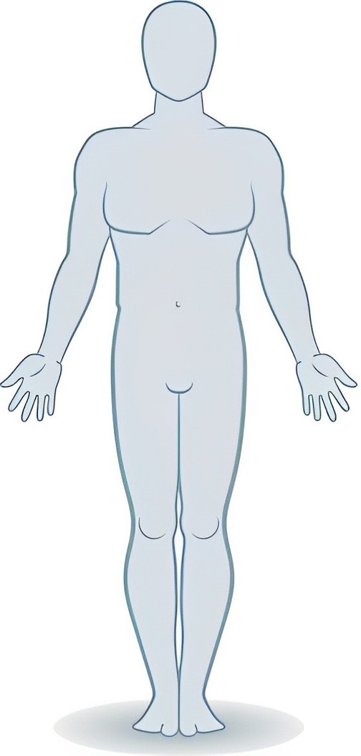

White ECG electrode (below right collarbone)

Black ECG electrode (below right rib bones)

Respiration belt sensor (below chest)

Red ECG electrode (below left rib bones)