Where to attach your devices:

EEG sensor (on the middle of forehead)

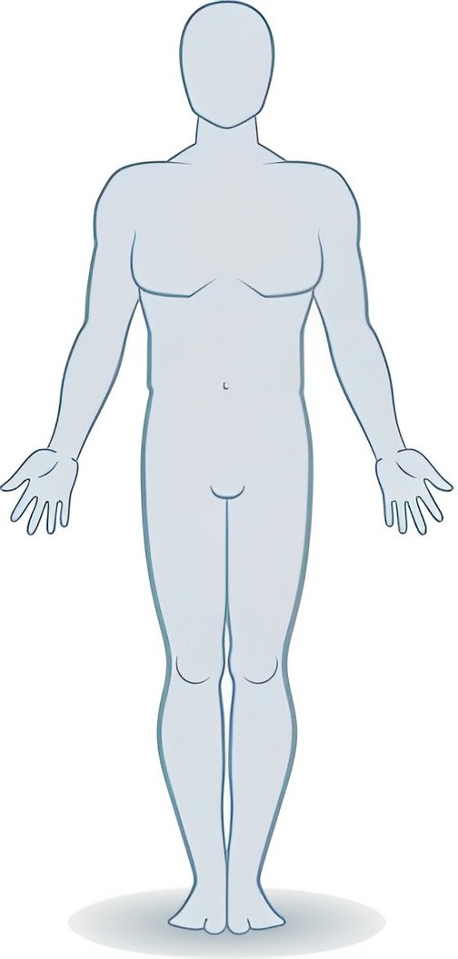

Black ECG electrode (below right collarbone)

Red ECG electrode (below left collarbone)

Respiration belt sensor (below chest)

White ECG electrode (below left rib bones)