The Mint Scale: A Fresh Validation of the Multimodal Interoception Questionnaire and Comparison to the MAIA, BPQ and IAS

Abstract
Interoception, the sensing of the body's internal state, is an important component of homeostatic and allostatic regulation with wide-ranging implications for mental and physical health, yet its measurement is hindered by tools with conceptual and psychometric issues. To address these limitations, we developed the Multimodal Interoception Questionnaire (Mint). In Study 1 (N=559), a comprehensive item pool using a "modality-by-context" framework was generated and then reduced using psychometric network analysis. In Study 2 (N=737), we further assessed the structure of the Mint in an independent sample, and compared its predictive power against established interoception questionnaires (MAIA-2, BPQ, IAS), and across a wide range of clinical and cognitive outcomes. This rigorous process yielded a 33-item scale with a stable hierarchical structure comprising three metaclusters (Interoceptive Deficit, Interoceptive Awareness, Visceroception) and 11 distinct facets. The Mint demonstrated superior criterion validity, consistently outperforming existing scales in predicting outcomes tied to altered bodily perception, including alexithymia, ADHD, autism, and somatic symptom clusters. The Mint offers a psychometrically robust and nuanced measure of self-reported interoception that integrates and extends existing scales, providing researchers and clinicians with a practical and readily usable tool to investigate the role of bodily sensations in health and disease.
Keywords: Interoception questionnaire, interoceptive accuracy scale, MAIA, Mint Validation, Body Awareness, Health

The Mint Scale: A Fresh Validation of the Multimodal Interoception Questionnaire and Comparison to the MAIA, BPQ and IAS

Introduction
Interoception - the sensing and interpretation of the body’s internal physiological signals - plays a fundamental role in processes ranging from homeostatic regulation to emotion, decision-making, and mental health (Craig, 2002; Critchley & Garfinkel, 2017). Despite its growing recognition, the field has been hindered by inconsistent definitions and fragmented measurement approaches (Desmedt et al., 2022, 2025; Khalsa et al., 2018). Available tools include “objective” physiological tasks (e.g., heartbeat counting or tracking) and “subjective” self-reports, and encompass both “explicit” paradigms that direct participants’ attention to internal sensations and “implicit” paradigms that do not (e.g., heartbeat evoked potentials recorded during rest). These assessments are often targeted at only one of several interoceptive modalities (e.g., cardioception, respiroception, gastroception), and are mapped onto theoretical dimensions (e.g., accuracy, sensitivity, awareness, Garfinkel et al., 2015) within a rapidly evolving theoretical landscape.
However, no consensus exists on a gold-standard measure with each approach having distinct limitations. For example, physiological tasks often require specialised equipment and expertise, are time-consuming, and are challenging to administer at scale, whereas questionnaires are constrained by their inherent subjectivity. Crucially, the psychometric quality of many of these measures is questionable (e.g., see criticism about the heartbeat counting task, Zamariola et al., 2018), yielding low inter-task correlations (Murphy et al., 2018) and raising important concerns regarding their reliability and validity (e.g., measures presented as measuring one theoretical dimension but likely measuring something else). This lack of conceptual clarity and measurement convergence impedes scientific progress in comparing, replicating, and interpreting interoception-related findings, emphasising the need to develop improved tools that align with modern psychometric standards.
The present work focuses on self-report questionnaires, which offer a scalable and accessible tool complementing physiological tasks. Among the numerous interoceptive questionnaires available, a handful dominate the literature (Desmedt et al., 2022), including the Body Perception Questionnaire (BPQ, Kolacz et al., 2018), the Body Awareness Questionnaire (BAQ, Shields et al., 1989), the Multidimensional Assessment of Interoceptive Awareness (MAIA, Mehling et al., 2018), and the Interoceptive Accuracy Scale (IAS, Murphy et al., 2018).
These tools were developed in different eras of a rapidly evolving field, each with its own objectives and philosophies. For example, the BPQ, one of the earliest measures, captures bodily awareness and autonomic nervous system (ANS) reactivity by focusing on experiences of physiological stress reactions in organs innervated by the ANS, such as those triggered by stress or trauma (Kolacz et al., 2018). In contrast, the BAQ was developed to address limitations of earlier measures by assessing beliefs about one’s sensitivity to normal, non-emotive bodily processes, explicitly targeting the domain of reported awareness of normal bodily processes not typically associated with emotion or somatic complaint. The MAIA incorporated ideas from the then-booming emotion regulation and mindfulness fields, including subscales assessing adaptive coping strategies and metacognitive insights about the body. More recently, the IAS was developed to circumvent these high-level - possibly tangential - constructs, instead capturing subjective reports of concrete bodily events (e.g., coughing, sneezing) as proxies for interoceptive accuracy. Other proposed measures include the Body Consciousness Questionnaire (BCS, Miller et al., 1981), the Self-Awareness Questionnaire (SAQ, Longarzo et al., 2015), the Interoceptive Sensitivity and Attention Questionnaire (ISAQ, Bogaerts et al., 2022), the Interoceptive Confusion Questionnaire (ICQ, Brewer et al., 2016), and the Interoceptive Attention Scale (IATS, Gabriele et al., 2022); for comprehensive reviews see Desmedt et al. (2022) and Mehling et al. (2009).
These differing philosophies have practical consequences, leading to poor convergence between scales that are assumed to measure the same construct (Vig et al., 2022) - a classic example of the “jingle fallacy” where the shared label of “interoception” can mask underlying measurand differences, hindering replication and theoretical integration. In acknowledgement of this issue, efforts have been made to align subjective measures with theoretical models that outline different facets of interoception (e.g., accuracy, attention, deficits). However, focusing on developing measures that are theory-driven may be premature when theoretical models are in flux, and when a topographic mapping to self-report dimensions is not guaranteed. For example, interoceptive distinctions that are relevant at a neuroanatomical or cognitive level might not necessarily map onto the structure of subjective experiences, because the body constitutes a unitary representation produced by multisensory integration of bottom-up information, with substantial influence from top-down factors (Kirsch & Kunde, 2023). More fundamentally, existing interoception questionnaires typically fail to consider the full range of interoceptive modalities and the context in which interoceptive experiences occur. Most existing questionnaires focus on a narrow range of bodily modalities, with a heavy bias towards cardio-respiratory sensations at the expense of others like gastric, urogenital, or thermoregulatory signals.
Perhaps most critically, existing measures often ask participants to make general assessments across most/all contexts, which does not capture the potential homeostatic relevance of attending or detecting internal signals. For example, the BPQ asks participants to reflect on how often during most situations a person is aware of various bodily sensations, such as their heart beating. Without a contextual reference point, there is likely to be substantial variability in how participants interpret and respond to items as well as what those responses might mean about their interoceptive abilities. A general item about “feeling your heart beat” is ambiguous since its salience, frequency, experience and interpretation would differ depending on the context (e.g., during physical exercise, a moment of anxiety, excitement, or quiet rest), which may or may not be relevant homeostatically.
This is further complicated by retrospective memory biases such that individuals respond with the most easily accessible or recent instances of awareness; for example, someone who exercises regularly, or is anxious, might more easily recall an instance of occurrence of feeling their heart beating and respond based on that contextual saliency. As an exception, the MAIA does provide some contextual cues for participants (e.g., “When something is wrong in my life I can feel it in my body”) but this is inconsistent across items and focuses almost exclusively on negative (e.g., painful) and emotional (e.g., angry, joyful) contexts as well as general ‘body’ sensations rather than specific interoceptive modalities. Thus, no existing scale captures subjective assessments across multiple interoceptive modalities and across different contexts in which interoceptive experiences occur.
To address this gap, we developed and assessed the Multimodal Interoception Questionnaire (Mint), a new questionnaire that systematically addresses the above limitations. In Study 1, we describe the development of the Mint, using a “modality-by-context” framework to generate a comprehensive item pool, which was then refined using psychometric network analysis. Network psychometrics is an emerging framework for studying relationships among psychological variables by representing them as a network structure (Epskamp et al., 2018). In this approach, psychological variables (e.g., traits or questionnaire items) are modelled as nodes, while the statistical relationships between them are represented as edges connecting the nodes. These edges can be weighted to reflect the strength and direction of associations between variables. Beyond descriptive modelling, network psychometrics has increasingly been applied to scale development and dimensionality assessment (Christensen et al., 2020; H. F. Golino & Epskamp, 2017; Magnavita & Chiorri, 2022; Wongvorachan, 2025). When analysing psychological measurement data, a central question concerns whether observed variables organise into groupings that reflect underlying constructs. Within a latent variable framework, items measuring the same construct are expected to show stronger mutual associations, resulting in cohesive clusters within a network representation. Accordingly, clusters of interconnected nodes in psychometric networks have been proposed to correspond to latent variables (H. F. Golino & Epskamp, 2017). In Study 2, we evaluate the final 33-item version of the Mint against the established interoception questionnaires, demonstrating that Mint scores have a robust structure and predictive validity for a range of clinically-relevant outcomes.

Study 1: Item Selection
The aim of Study 1 was to develop a new interoception questionnaire by generating a comprehensive item pool and subsequently refining it into a scale yielding psychometrically robust scores. To overcome the limitations of existing questionnaires, we adopted a theoretically agnostic approach. Rather than imposing a pre-defined theoretical structure on questionnaire items, we instead focused on two tangible and systematically controllable aspects of interoceptive experience: the modality of the sensation and the context in which it occurs. Our objective was not to develop a questionnaire measuring a new or theoretically distinct facet, but instead build on existing research and synthesise existing ideas and frameworks into a comprehensive and modern tool that captures both the richness of interoceptive experiences and the most prominent facets of interoception.
Item development proceeded through a structured process aimed at maximising consistency and breadth across interoceptive modalities and experiential contexts. Existing interoception questionnaires were first systematically reviewed to characterise the current measurement landscape, including content scope, item phrasing, and response formats. Insights from this stage, together with relevant theoretical literature and expert domain knowledge, informed the construction of a modality-by-context grid (see item generation section below), which was designed to capture and structure core principles of interoceptive experience while identifying gaps in existing measures. Items were then generated to populate each cell of this grid, using simple, first-person statements with a consistent grammatical structure. Where relevant, item wording drew inspiration from existing instruments; however, all items were newly formulated to explicitly specify both the bodily modality and the experiential context. Items were iteratively refined through internal discussion to ensure clarity, uniformity of phrasing within facets, and balanced representation across modalities and contexts. Throughout this process, redundant or ambiguous items were revised or removed, and additional items were generated where coverage was deemed insufficient. Importantly, item generation was not guided by anticipated latent dimensions or clustering, but rather by the goal of comprehensive and conceptually coherent coverage of objectively defined modalities and contexts.
For modalities, we expanded beyond the typical cardio-respiratory focus to encompass a wide range of bodily systems: cardiac, respiratory, gastric, genital, bladder & colon, and skin & temperature (the latter of which being increasingly recognized as a key interoceptive channel, Crucianelli & Ehrsson, 2023). We also included a “general state” category to capture the integrated sense of the body’s overall physiological condition (Craig, 2002; Craig, 2003). For contexts, we designed facets to capture specific situational contexts like negative (anxious) and positive (sexual) arousal, which reflect distinct bodily states with differing interoceptive signatures. Facets were also designed to capture other experiential qualities tapping into elaboration and threshold of perception, such as sensitivity, accuracy, and confusion. This systematic framework yielded a diverse pool of 120 initial items, ensuring comprehensive coverage while minimising the ambiguity inherent in context-free questions.
The initial pool of 120 was then reduced using psychometric network-based techniques, identifying and removing redundant items and revealing the most stable and coherent dimensional structure. We also designed the study to enable an examination of structural invariance depending on presentation format (e.g., how items are grouped together, whether by modality, facet or randomly) which is an often overlooked psychometric quality. This rigorous, multi-stage process was designed to produce a subset of items with a clear, stable, and theoretically rich hierarchical structure, ready for formal validation in Study 2.

Methods

Participants
We recruited 760 English-speaking participants using Prolific. We excluded 191 for failing at least one attention check, and 10 based on measures significantly related to the probability of failing attention checks (namely, the multivariate distance obtained with the OPTICS algorithm, Thériault et al., 2024). The final sample includes 559 participants (age = 37.0 $±$ 12.2 [18, 77]; 50.8% women, 1.07% non-binary; country of residence: 63.86% UK, 26.65% USA, 9.48% other). Within this sample, 68.3% identified as White, 11.3% as Black, 5.7% as Mixed ethnicity, and 4.1% as South Asian, 9.3% as others and 0.7% preferred to not disclose. This study was approved by the University of Sussex’ Ethics Committee (ER/MB2021/1).

Item Generation
Based on the two goals outlined for this scale, namely to include different interoceptive modalities, and to explicitly state the context of the interoceptive experience (e.g., whether negative or positive), we generated items in a systematic way following a combinatory approach, where each item’s category corresponds to the union of a specific modality and context (Figure 1).
We identified 7 “modalities” (cardiac, respiratory, gastric, genital, skin & temperature (thermoregulation), bladder & colon, and a “general state” category corresponding to a holistic and general awareness of an interoceptive state or dimension). Through iterative refinement (e.g., splitting or merging different categories together), we settled on 6 “facets”, which encompass both contexts of experience (negative and positive arousal, e.g., anxious and sexual states), and potential distinct mechanisms (nociception & pleasure, sensitivity, accuracy, and confusion). Using this orthogonal 7x6 modality/facet grid as a conceptual scaffolding, we generated 120 initial items, striving for a balanced number of items with consistent phrasing within modalities and facets. Items were generated through conversations between the researchers/authors of this paper.
We additionally crafted 8 “attention check” items blending in (and distributed across) each category. These items were designed to match the grammatical structure and response format of the surrounding items, in order to minimise their salience and reduce the risk of demand characteristics. Each attention check explicitly instructed participants to select a specific response option (e.g., the lowest, leftmost, or rightmost point on the scale), thereby allowing us to assess whether participants were attentively reading and following item instructions (see items in green in initial item list for more information).

Procedure
To avoid presenting all the 120 items on a single long and discouraging page, we split them into different pages. Participants were randomly assigned to one of three conditions, driving how items were grouped on the same page: 1) items grouped by modality (i.e., all cardiac items on the first page, all colon & bladder items on the second, etc.), 2) items grouped by facet, or 3) items presented fully randomly (but with their number balanced across 6 pages). The order of the item on any given page and the order of the modalities/facets was randomized. Each participant completed the full set of 120 items, with 8 attention check items interspersed throughout. The online experiment was implemented using JsPsych (De Leeuw, 2015), and item responses were recorded using 7-points Likert scales (0 = Disagree, 6 = Agree).

Data Analysis
To test whether the grouping condition had an effect on the structure (i.e., how items relate to one-another), we compared the correlation matrix obtained in the random condition to the ones obtained in the modality and facet conditions, focusing on 3 indices of correlation matrix similarity - the Procrustes Similarity Index (PSI, Sibson, 1978), the Adjusted RV (Rvadj, Mayer et al., 2011), and the Similarity of Matrices Index (SMI, Indahl et al., 2018). For each index, we bootstrapped the difference between the similarity with the facet and modality conditions to test whether the correlation matrix in the random-grouping condition is significantly more similar to any of the two other conditions. Items deemed “redundant” (which can distort the item structure estimation by introducing multicollinearity or local dependencies) were identified (using the recommended threshold of 0.25) using Unique Variable Analysis (UVA, Christensen et al., 2023), a principled method derived from network psychometrics.
The structure of the items was analyzed using the recently-developed Exploratory Graph Analysis (EGA, H. F. Golino & Epskamp, 2017) framework, which allows to jointly estimate the number of dimensions (i.e., clusters of items), the structure, as well as its stability using bootstrapping (H. Golino et al., 2020). At a fundamental level, EGA conceptualizes variables as nodes in a network, with connections (edges) reflecting associations between them.
We selected this approach for both conceptual and methodological reasons. The item pool was intentionally heterogeneous, spanning multiple physiological domains and psychological contexts. We therefore anticipated cross-domain associations and potential correlated or partially overlapping dimensions. Traditional factor analytic models explained this covariance among items by assuming latent variables that generate shared variance. However, in complex structures characterised by high inter-factor correlations or low cross-loadings, global variance patterns can dominate, potentially biasing the estimating of the number of dimensions (Christensen & Golino, 2021b). In contrast, EGA estimates a network of conditional associations among items and identifies dimensions as communities of strongly connected nodes (H. F. Golino & Epskamp, 2017). Rather than attributing associations to latent causes, this approach allows structure to emerge from patterns of direct relationships among items. This framework is particularly appropriate when constructs may reflect interacting components (e.g., bodily sensations that co-activate across systems such as heart rate and breathing increasing at the same time) rather than purely reflective latent traits. Moreover, simulation studies indicate that EGA performs comparably to or better than traditional factor retention methods in complex and highly correlated structures (Christensen & Golino, 2021b; Jiménez et al., 2023).
After removing redundant items using UVA, we iteratively fitted hierarchical EGA models (which additionally estimate higher-order “meta” clusters) using “glasso” (Friedman et al., 2008) and the “Leiden” algorithm (Traag et al., 2019) for community detection, refining the item pool at each step. We then evaluated item stability (e.g., extent to which items shift between clusters across bootstrapped samples). Stability ranges from 0 (no stability) to 1 (perfect stability), with values below 0.75 indicating insufficient stability (Christensen & Golino, 2021a). Although the recommended removal threshold is $≥$ 0.70 we applied a more conservative criterion and removed items with stability below 0.80 to preserve stronger indicators from a large initial item pool. We also removed items that did not belong to any cluster and item pairs, retaining only items from clusters with more than two items. Finally, within each lower-level cluster, we selected the three items with the highest node centrality (i.e., the strongest loadings within the cluster). To assess dimension stability, we evaluated the robustness of the identified clusters using bootstrapping, which provides indices of structural consistency (i.e., the proportion of bootstrap samples in which the original dimension is exactly replicated). High stability (e.g., >70%, Christensen & Golino, 2021a) indicates a robust dimension, whereas lower values suggest unstable, sample-dependent, or poorly defined dimensions. Lastly, we assessed model fit using the Generalized Total Entropy Fit Index (TEFI, H. Golino et al., 2021), where higher values (i.e., values closer to zero) indicate better fit. We additionally conducted an exploratory factor analysis (EFA) following the same item-removal procedure and compared the resulting structure with the EGA solution to complement the psychometric network approach with a traditional factor-analytic framework.
For both studies, data analysis was carried out using R (4.4.3, R Core Team, 2025), leveraging the easystats ecosystem (Lüdecke et al., 2019, 2020) and the EGAnet package (Christensen & Golino, 2021a). The reproducible code and additional details are available at [MASKED FOR REVIEW].

Results
The correlation matrix similarity analysis yielded no significant differences between the similarity of the random-grouping condition with the modality-grouping and facet-grouping conditions ($PSI_{\text{Random vs. Facet}}=0.81$, $PSI_{\text{Random vs. Modality}}=0.82$, $p=.45$; $RVadj_{\text{Random vs. Facet}}=0.77$, $RVadj_{\text{Random vs. Modality}}=0.78$, $p=.74$; $SMI_{\text{Random vs. Facet}}=0.49$, $SMI_{\text{Random vs. Modality}}=0.51$, $p=.52$), despite a consistent bias in favour of the modality-grouping condition.
From the 120 initial items, 4 redundant items were flagged by UVA. We then removed 40 items that showed low cluster stability, and 9 items that were part of clusters with less than 3 items. Finally, We kept the 3 items with the highest loading in their lower-level structure (removing 13 items in the process), resulting in 54 items in the final item pool. The final hierarchical EGA model (TEFI = -119.18) - in which all 54 items yielded a high cluster stability (> 90%) suggested 3 metaclusters and 15 lower-level clusters (each containing 3 items): “Interoceptive Deficits” (containing 5 clusters: Urointestinal Inaccuracy - UrIn; Cardiorespiratory Confusion - CaCo; Cardiorespiratory Noticing - CaNo; Olfactory Contribution - Olfa; Satiety Noticing - Sati), “Interoceptive Awareness” (containing 7 clusters: Sexual Arousal Awareness - SexA; Sexual Arousal Sensitivity - SexS; Sexual Organs Sensitivity - SexO; Urointestinal Sensitivity - UrSe; Relaxation Awareness - RelA; State Specificity - StaS; Expulsion Accuracy - ExAc), and “Interoceptive Sensitivity” (containing 6 clusters: Cardioception - Card; Respiroception - Resp; Signalling - Sign; Gastroception - Gast; Dermal Hypersensitivity - Derm; Sexual Arousal Changes - SexC). Of note, the dimension stability of the higher clusters showed low structure consistency for all high-order clusters (23%-47%). Within the factor-analytic framework, factor retention using oblimin rotation indicated both a 1-factor and a 17-factor solution for the original 120-item pool. The single-factor solution explained 15.67% of the variance ($χ^{2}=23694.21,RMSEA=0.07\left[0.06,0.07\right],TLI=0.35$), whereas the 17-factor solution showed improved fit ($χ^{2}=14152.21,RMSEA=0.06\left[0.05,0.06\right],TLI=0.68$) and accounted for 52.23% of the total variance, supporting a multidimensional structure. Item reduction followed the same criteria applied in the EGA, and this procedure resulted in a final set of 44 items. A subsequent factor analysis of the reduced item pool showed acceptable model fit ($χ^{2}=1101.05,RMSEA=0.05\left[0.05,0.06\right],TLI=0.86$). Overall, the EFA solution showed substantial convergence with the EGA structure, with several factors corresponding closely to clusters identified by EGA (e.g., gastric sensitivity, respiratory sensitivity, dermal hypersensitivity, urointestinal sensitivity, and sexual organ sensitivity). However, some differences emerged, particularly in the cardiorespiratory domain, where items were distributed across multiple factors in EFA rather than forming distinct clusters, and in the treatment of accuracy and confusion items, which were occasionally combined in EFA but separated in the EGA solution. Together, these results suggest that while the factor-analytic solution broadly replicated the domain structure identified by EGA, it tended to yield slightly broader factors.
To further reduce and balance the remaining items, we collectively decided on removing the lower-level clusters Sexual Arousal Awareness (too general and overlapping with the other more specific sex-related items), Signalling (which items started with “when something important is happening in my life”, which meaning we deemed too open to interpretation), and Sexual Arousal Changes (low fit with the other modality-focused clusters of its group). The final set included 45 items.

Discussion
The aim of Study 1 was to develop and refine a large, systematically generated pool of interoceptive items into a psychometrically sound and structurally coherent questionnaire. Starting with 120 items derived from a modality-by-context grid, we employed a multi-step, data-driven reduction process using structure analysis methods. This procedure yielded a final, balanced set of 45 items, organised within a stable hierarchical structure comprising three higher-order dimensions (Interoceptive Deficits, Interoceptive Awareness, Interoceptive Sensitivity) and 12 distinct lower-level facets.
The resulting hierarchical structure offers interpretable insights into self-reported interoception, with flexible degrees of granularity. Notably, we categorised several facets (typically related to objective external behaviours, like coughing or sneezing) under the label “Awareness”. Although other questionnaires might refer to this as “Accuracy”, we preferred to preserve the notion that subjective self-reports, by their very nature, cannot be a pure measure of objective accuracy and are, at best, a proxy for subjective certainty or awareness of interoceptive processes. Furthermore, our approach revealed intriguing facets, such as “Olfactory Contribution”. This finding provides evidence for a pseudo-interoceptive pathway, whereby individuals with poorer access to internal signals may compensate by relying on external cues (e.g., odours) to infer their bodily state. The “Sensitivity” metacluster also grouped core visceroceptive facets (e.g., “Cardioception”, “Gastroception”) with “Dermal Hypersensitivity”, pointing to a potential common dimension of heightened perceptual sensitivity to bodily sensations.
Study 1 also examined whether item presentation, grouping by modality, facet, or randomly, affected the psychometric structure. No significant effects emerged, though a consistent trend suggested modality-based grouping may better reveal the underlying structure. This remains preliminary given per-condition sample sizes ($N±200$), but represents an under-investigated aspect of questionnaire design worthy of future research.

Study 2: Convergent and Criterion Validity
Study 1 successfully leveraged a systematic item generation process and modern analytical techniques to produce a 45-item interoception questionnaire with a clear, stable, and theoretically rich hierarchical structure. Study 2 then sought to examine the psychometric properties of Mint scores and its relationship with existing measures in a large, independent sample. To this end, we sought to 1) re-assess the structure of the shorter Mint version and 2) establish its convergent validity by examining correlations with other established and popular interoception questionnaires (namely the MAIA-2, BPQ, and IAS), as well as other related measures (e.g., alexithymia). Finally, we assessed the criterion validity of Mint scores by directly comparing the predictive power of all interoception questionnaires across a broad range of outcomes, including emotional, cognitive, and clinical variables. We hypothesised that if the Interoceptive Deficit metacluster reflects difficulties recognising bodily signals, it should correlate positively with constructs reflecting impaired bodily and emotional awareness, such as alexithymia and dissociative experiences, and be elevated in conditions characterised by altered interoceptive processing (e.g., autism or ADHD). In contrast, Visceroception, capturing perceived sensitivity to cardiac, respiratory, and gastric signals, should relate more strongly to measures of bodily noticing and physiological monitoring behaviours, including the Noticing dimension of the MAIA-2. Finally, Interoceptive Awareness, which captures perceived access to specific bodily states such as relaxation or sexual arousal, should relate more strongly to measures assessing conscious awareness.

Methods

Participants
We recruited 921 English-speaking participants via SONA and Prolific, from which 118 were excluded for failing at least one attention check and 6 based on multivariate distance (using the same procedure as for study 1). 60 participants were further excluded due to missing data following a technical issue. The final sample includes 737 participants (age = 36.8 $±$ 14.7 [18, 87]; 57.3% women, 1.63% non-binary; Country of residence: 75.17% United Kingdom, 24.83% other). Within this sample, 80.3% identified as White, 6.6% as Black, 4.9% as Mixed ethnicity, and 3.0% as South Asian and 4.3% as others. This study was approved by the University of Sussex’ Ethics Committee (ER/EB672/2).

Measures

Interoception Questionnaires.
The 45 items of the Multimodal Interoception Questionnaire (Mint) scale were presented in a random order, with the same 7-point Likert scale as in study 1 (0 = Disagree, 6 = Agree). Scores should be calculated as the average of the items within each lower-order cluster. However, when a broader summary is required, average scores for the higher-order meta-clusters can be computed from the average of all their corresponding items. Correspondingly, the high-order meta-clusters of the mint showed good to excellent internal consistency: Interoceptive Awareness ($ω$ = 0.85), Interoceptive Deficit ($ω$ =0.74), Visceroception ($ω$ = 0.88).
The Multidimensional Assessment of Interoceptive Awareness (MAIA-2, Mehling et al., 2018) measures 8 dimensions with 37 items presented on a 7-point Likert scale (0 = Never, 6 = Always). It includes bodily dimensions such as Body Listening, Noticing, Emotional Awareness, dimensions related to emotion regulation, such as Trust, Not-worrying, and Self-Regulation, as well as dimensions related to attention, such as Attention Regulation and Not-distracting. The relationship of some of these dimensions to interoception remains debated, particularly Not-Distracting and Not-Worrying, which tend to show weak or non-existent correlations with the other MAIA subscales (Ferentzi et al., 2021). The subscales of the MAIA-2 showed an acceptable to good internal consistency: $ω$ Attention regulation = 0.87, $ω$ Body listening = 0.76, $ω$ Emotional awareness = 0.79, $ω$ Not-distracting = 0.80, $ω$ Noticing = 0.68, $ω$ Not-worrying = 0.79, $ω$ Self regulation = 0.84, and $ω$ Trusting = 0.84.
The Body Perception Questionnaire - Very Short Form (BPQ-VSF, Cabrera et al., 2018) measures a general score of bodily awareness with 12 items presented on 5-point Likert scale (0 = Never, 5 = Always). Internal consistency for the BPQ-Awareness was good ($ω$ = 0.91).
The Interoceptive Accuracy Scale (IAS, Murphy et al., 2020) measures a general score of interoceptive accuracy to physical sensations with 21 items presented on a 5-point Likert scale (1 = Disagree Strongly, 5 = Strongly Agree). The IAS had good internal consistency ($ω$ = 0.88).

Emotions and Cognition.
The Toronto Alexithymia Scale TAS (TAS-20, Leising et al., 2009) measures 3 Alexithymia dimensions with 20 items 5-point Likert scale (1 = Strongly Disagree, 5 = Strongly Agree: Difficulty Identifying Feelings (DIF), Difficulty Describing Feelings (DDF), and Externally Oriented Thinking (EOT). In this study, the TAS subscales showed poor to acceptable internal consistency: $ω$ DIF = 0.77, $ω$ DDF = 0.53 and $ω$ EOT = 0.69.
The Emotion Reactivity Scale - Brief Version (B-ERS, Veilleux et al., 2024) measures 3 dimensions with 6 items on a 5-point Likert scale (0 = Not like me at all, 4 = Extremely like me): Arousal (“My moods are very strong and powerful”), Sensitivity (“I tend to get very emotional very easily”), and Persistence (“When I am angry/upset, it takes me much longer than most people to calm down”). The subscales of the B-ERS showed acceptable to good internal consistency: $ω$ Arousal = 0.76, $ω$ Sensitivity = 0.90 and $ω$ Persistence = 0.74.
The Cognitive Emotion Regulation Questionnaire (CERQ-short, Garnefski & Kraaij, 2006) measures 9 adaptive and maladaptive emotion regulation strategies with 18 items (1 = Almost Never, 5 = Almost Always). The strategies include Self-blame ($ω$ = 0.78), Other-blame ($ω$ = 0.8), Rumination ($ω$ = 0.61), Catastrophizing ($ω$ = 0.84), Putting into Perspective ($ω$ = 0.70), Positive Refocusing ($ω$ = 0.80), Positive Reappraisal ($ω$ = 0.75), Acceptance ($ω$ = 0.75), and Planning ($ω$ = 0.66). The internal consistency for these dimensions ranged from acceptable to good.
The Černis Felt Sense of Anomaly scale - short form (CEFSA-14, Černis et al., 2024) measures 7 dissociative experiences with 14 items on a 5-point Likert scale (0 = Never, 4 = Always). This scale is designed to measure dissociative experiences in adolescence and adulthood, specifically focusing on the felt sense of anomaly-type dissociation. It includes Anomalous Experience of the Self ($ω$ = 0.75), Anomalous Experience of the Body ($ω$ = 0.77), Anomalous Experiences of Emotion ($ω$ = 0.81), Altered Sense of Familiarity ($ω$ = 0.72), Altered Sense of Connection ($ω$ = 0.86), Altered Sense of Agency ($ω$ = 0.78), and Altered Sense of Reality ($ω$ = 0.58). The internal consistency of the subscales were mostly good with the exception of Sense of Reality.
The Primal World Beliefs Inventory (PI-18, Clifton & Yaden, 2021) measures higher-order beliefs about the basic character of the world: Good, Safe, Enticing, and Alive. The 18 items are presented on a 6-point Likert scale (0 = Strongly Disagree, 5 = Strongly Agree). In this study, the internal consistency of the subscales were all good: $ω$ Good = 0.84, $ω$ Safe = 0.80, $ω$ Enticing = 0.80 and $ω$ Alive = 0.84.

Health and Wellbeing.
The Single Item Life Satisfaction scale (SILS, Jovanović & Lazić, 2020) was followed by the PHQ-4 (Kroenke et al., 2009) assessing depression and anxiety symptoms with 4 items. We used the refined version of the PHQ-4 (Makowski et al., 2025), which adds an additional response option (“Once or twice”), increasing sensitivity to subclinical fluctuations. PhQ-Anxiety showed excellent reliability ($ω$ = 0.91) and PHQ-Depression showed good reliability ( $ω$ = 0.84).
Participants were asked to self-report any current, medically diagnosed psychiatric disorders using a checklist based on DSM-5 categories. If one or more conditions were endorsed, participants were asked to indicate any current treatments, including pharmacological (e.g., antidepressants, anxiolytics, antipsychotics, mood stabilizers), psychological (e.g., psychotherapy, mindfulness), or lifestyle interventions. Binary variables (0 = absent, 1 = present) were created to identify participants reporting mood disorders (Major Depressive Disorder, Bipolar Disorder; with a stricter subgroup of participants undergoing a pharma- or psychological treatment), anxiety-centred disorders (Generalised Anxiety Disorder, Panic Disorder, Social Anxiety Disorder, Specific Phobias), eating disorders, addiction-related disorders, borderline personality disorder, autism spectrum disorder (ASD), and ADHD.
Participants were asked to select somatic symptoms or conditions they experienced from a list of 36 options. To facilitate mechanistic interpretation and reduce redundancy, answers were grouped into four non-overlapping clusters based on shared physiological pathways and known etiological mechanisms. The Afferent Sensitivity cluster included conditions associated with heightened interoceptive awareness and neurogenic excitability, such as migraine, neuropathy, dizziness, nausea, muscle tension, epilepsy, and frequent urination. The Central Sensitization cluster comprised syndromes characterized by chronic pain and fatigue, likely reflecting central amplification of sensory signals and HPA-axis dysregulation, such as fibromyalgia, chronic fatigue syndrome, chronic pain, back pain, pelvic pain, irritable bowel syndrome (IBS). The Autonomic Dysfunction cluster captured disorders linked to dysregulation of the autonomic and cardiopulmonary systems, including joint hypermobility, cardiac arrhythmia, chest pain, shortness of breath, hypo-/hypertension, sleep apnea, chronic obstructive pulmonary disease (COPD), and chronic bronchitis. Finally, the Immune-Inflammatory cluster encompassed conditions associated with immune dysregulation, barrier dysfunction, and gut-brain axis disturbance, such as eczema, psoriasis, skin rashes, asthma, celiac disease, gluten and lactose sensitivity, inflammatory bowel diseases (Crohn’s disease and ulcerative colitis), gastroesophageal reflux disease (GERD), multiple sclerosis, and Sjögren’s syndrome. We scored each cluster as a binary variable based on whether the participant selected at least one symptom from that cluster.

Lifestyle.
Participants reported about owning any wearable devices to monitor health indices such as heart rate, number of steps, calories burned, sleep quality, and weight. For each selected device, a follow-up question inquired about the frequency of usage and subjective importance of that measure. Participants were asked to rate how physically active they consider themselves and how many hours of active workout they engage in per week. Participant’s BMI was computed using height and weight.

Procedure
To avoid the repetition of similar types of questions and balance longer and shorter questionnaires, we partitioned the measures into three groups (and randomized the order within them): 1) interoception questionnaires (MAIA, IAS, BPQ), 2) emotions (TAS, CERQ, ERS, PI-18), and 3) health (somatic symptoms, mental health, LS + PHQ-4, CEFSA). After completing demographic questions, participants always started with the Mint scale, and each following interoception questionnaire was interspersed with two questionnaires from the emotions and pathology groups. 7 attention checks were embedded throughout (one within each major questionnaire). Specifically, the following items were used: “I can always accurately answer to the extreme left on this question to show that I am reading it” (Mint); “I notice that I am being asked to respond all the way to the right” (MAIA-2); “I can always accurately choose the lowest option” (IAS); “Respond all the way to the right” (BPQ-VSF); “I am able to respond all the way to the left” (TAS-20); “On the whole, I know I must press the highest option” (PI-18); and “I feel that to show I am being attentive I will press the lowest option” (CEFSA-14). To make the experiment more enjoyable, the experiment ended with a radar chart summarizing the participants’ responses to the Mint scale.

Data Analysis
We started by confirming and further refining the structure of the Mint scale (see Figure 2) using the same EGA model as in Study 1. We then computed the lower-level dimensions and the higher-level metaclusters’ scores by averaging their corresponding items. Descriptive statistics were calculated for each cluster, and potential demographic differences were examined using independent-samples t-tests. The convergent validity of scores from the final set of items was assessed by computing the correlations between the Mint scale and the other interoception questionnaires (MAIA, BPQ, IAS).
Next, we tested the predictive power of the Mint scale relative to other interoception questionnaires. We assessed the importance of each interoceptive dimension (from all the scales) as a unique predictor by fitting regression models (linear for continuous measures - e.g., depression score - and logistic for binary variables - e.g., presence vs. absence of mood disorders) to predict different outcomes, and compare the best between the 4 interoception scales based on the total explained variance (R2 or pseudo-R2 for logistic models, Lüdecke et al., 2021). We then evaluated the predictive performance of each scale as a whole by comparing regression models with all the dimensions entered as predictors (note that the IAS and BPQ only have one total score variable).
We assessed the models based on their R2, as well as on the Bayesian Information Criterion (BIC), which penalizes for predictor number, thus offering a balance between model parsimony and predictive power. For the logistic models, we quantified the discriminative power by computing the Area Under the Curve (AUC) of the Receiver Operating Characteristic (ROC) curve, which assesses the model’s discriminative power (the combination of sensitivity and specificity).

Results
The application of EGA to the initial set of 45 items reproduced the expected 14 lower-level clusters of triplets and 3 higher-order metaclusters, with the exception of the UrSe (Urointestinal Sensitivity), for which one item moved to the Olfa (Olfactory Contribution) cluster. To further balance and reduce the items, we removed the UrSe cluster, as well as StaS (State Specificity), which in comparison to the other items stood out as containing vague and overlapping items ; SexO (Sexual Organs Sensitivity), which overlapped with the SexS (Sexual Arousal Sensitivity) cluster; and CaNo (Cardiorespiratory Noticing), which overlapped with the CaCo (Cardiorespiratory Confusion) cluster. We considered a 45-item scale overly lengthy given the aims of the instrument, and following a further evaluation of item redundancy, conceptual overlap, and face validity (e.g., Sexual Organs Sensitivity items overlapped with Sexual Arousal Awareness items), reduced the pool to 33 items.
The final set of 33 items yielded a good fit (TEFI = -77.23), with all items showing high cluster stability (> 90%), with the exception of Olfa. The final structure included 11 lower-level clusters, grouped into 3 higher-order metaclusters: “Interoceptive Deficit”, “Interoceptive Awareness”, and “Visceroception”. Dimension stability for the lower clusters was generally very high, ranging from 100% (SexS, Card, Gast, Resp, RelA, ExAc) to 99.2% (Urin). Other dimensions also exhibited strong stability, with Derm and Sati at 99.6%, RelA at 99.8%, and CaCo at 99.4%. Additionally, two out of the three high-order clusters showed good dimension stability (Interoceptive Awareness = 96.6% , Visceroception = 99.4%), while Interoceptive Deficit showed poor dimension stability (42%). Figure 7 presents gender differences across these clusters. The largest metacluster-level difference was observed for Interoceptive Awareness, whereas the largest lower-level difference was found for Cardiorespiratory Confusion. Item centrality (interpretable as loadings in traditional factor analysis frameworks) are shown in Figure 3. Additionally, we applied hierarchical clustering analysis which replicated this structure (see Figure 2), suggesting consistency across methods.
The Interoceptive Awareness metacluster captures self-perceived awareness of specific bodily states. We use “awareness” broadly, meaning general bodily states accessible to self-report, not the accuracy–metacognition correspondence of Garfinkel et al. (2015), and its items assess perceived awareness of relaxation (RelA), sexual arousal (SexS), and impending expulsive events (ExAc; e.g., burping, sneezing, or flatulence). The Interoceptive Deficit metacluster reflects difficulties, uncertainty, or inaccuracies in recognising internal bodily signals, capturing confusion about cardiorespiratory sensations (CaCo), uncertainty about urinary or gastrointestinal needs (UrIn), delayed recognition of hunger or thirst (Sati), reliance on external cues such as body odours (Olfa), and heightened dermal sensitivity (Derm). Finally, Visceroception captures the self-reported tendency to notice visceral sensations (cf. interoceptive sensibility, Khalsa et al., 2018), specifically cardiac (Card), respiratory (Resp), and gastric (Gast) signals.
Lastly, to complement EGA, we conducted factor analysis on the final 33 items using oblimin rotation and polychoric correlations. The optimal 2-factor solution showed poor fit ($χ^{2}=5247.37,RMSEA=0.12\left[0.12,0.12\right],TLI=0.50$) and explained only 30% of the variance. The next-best nine-factor solution demonstrated improved fit ($χ^{2}=1053.59,RMSEA=0.06\left[0.06,0.07\right],TLI=0.86$) and explained 56.88% of the total variance. This solution comprised eight 3-item factors (Gastroception, Sexual Sensibility, Urointestinal Inaccuracy, Dermal Hypersensitivity, Expulsion Accuracy, Olfactory Compensation, Satiety Noticing, and Relaxation Awareness) and one six-item factor combining Cardioception, Respiroception, and Cardiorespiratory Confusion. Overall, this structure closely resembled the EGA lower-level clusters, with the main difference being that cardiorespiratory items loaded onto a single factor rather than forming separate clusters.

Mint.
The correlation matrix of the Mint dimensions revealed an interesting and rich tapestry of relationships (see Figure 4), with contrasting patterns of associations with dimensions from the same group. For instance, Derm and Olfa, despite being positively correlated with the other dimensions from the Deficit cluster, were not negatively correlated to Awareness and its dimensions. Similarly, Sati, unlike the other Deficit dimensions, was not positively correlated to Visceroception. This complex structure suggests that the dimensions indeed capture distinct aspects of interoception, and that the metaclusters, rather than being simple aggregates of rather-redundant elements, might actually capture unique combinations (greater than the sum of their parts). It also provides evidence against a simplistic adaptive vs. maladaptive dichotomy, as Deficit was not negatively but positively correlated with Visceroception. Interestingly, while Awareness was also positively correlated with Visceroception, it yielded an insignificant negative correlation with Deficit (this finding was also aligned with the hierarchical clustering results, showing a greater proximity between Deficit and Visceroception than with Awareness), underlining again the complex web of relationships captured by the Mint.

Interoception Questionnaires.
The correlation matrix between the Mint and the other interoception scales revealed high levels of overlap, as well as some unique contributions (see Figure 4). The BPQ was positively correlated with most Mint dimensions (the highest with Visceroception, $r=.46,95\%CI=\left[0.40,0.51\right]$). The IAS was positively correlated with Visceroception and Awareness dimensions (the highest with Awareness, $r=.63,95\%CI=\left[0.58,0.67\right]$), but negatively with most Deficit dimensions (with the exception of Olfa and Derm). In turn, the Visceroception metacluster most strongly correlated with MAIA’s Noticing ($r=.55,95\%CI=\left[0.50,0.60\right]$). Interestingly, MAIA’s Trusting correlated selectively with Awareness, and negatively with Deficit dimensions, but not with Visceroceptive dimensions (underlining its high-level metacognitive nature). MAIA’s Emotional Awareness and Body Listening displayed a similar pattern to Noticing, and Attention Regulation and Self Regulation positively correlated with Awareness and Visceroception dimensions, but negatively with some Deficit dimensions (CaCo and UrIn). Not-distracting only yielded mild negative associations with Sati and Olfa. Overall, the Mint dimensions were able to capture most of the (relevant) variance and intricacies present in the other interoception scales.

Emotions and Cognition.
Exploratory correlations with the emotion regulation (CERQ) dimensions revealed stronger associations with most of the MAIA dimensions (supporting its proximity with emotion regulation). Interestingly, Rumination (and Self-Blame) stood out as selectively related to the Mint’s Visceroception and Deficit dimensions (note that Rumination was also related to the MAIA’s interoceptive dimensions, namely Noticing, Emotional Awareness and Body Listening). The only primal world belief that correlated particularly with the Mint’s Visceroception and the MAIA’s interoceptive dimension was the belief that the world was alive (i.e., the belief that the universe is conscious, purposeful, and in active relationship with oneself, Clifton & Yaden, 2021).
Most of the target outcomes measured in the study to assess validity were best predicted by one of the Mint dimension (see Figure 5). For example, Deficit was the strongest predictor for several outcomes, including Alexithymia ($R^{2}$ = 20–22%), ERS’ Arousal ($R^{2}$ = 20%), ADHD and Autism ($R^{2}$ = 3% each), Self and Reality ($R^{2}$ = 21%), and somatic symptoms ($R^{2}$ = 3–7%). CaCo best predicted CEFSA’s anomalous experiences of the body ($R^{2}$ = 23%), while Sati was the strongest predictor for BMI ($R^{2}$ = 3%). A few outcomes were better predicted by MAIA dimensions. In particular, Not-worrying predicted ERS’ Sensitivity ($R^{2}$ = 22%) and Persistence ($R^{2}$ = 20%), whereas Trusting was the strongest predictor for Life Satisfaction ($R^{2}$ = 28%), Depression ($R^{2}$ = 21%), Anxiety ($R^{2}$ = 24%), CEFSA’s Emotion ($R^{2}$ = 17%) and Connection ($R^{2}$ = 25%), as well as self-reported physical activity ($R^{2}$ = 3%). Remaining model fits can be reviewed in the data analysis folder project’s GitHub repository. Model comparison included the full Mint (including all lower-level clusters - 33 items), and the analysis confirmed the clear advantage for the Mint over the other interoception scales. The full Mint model was typically the best model based on R2. Moreover, most of the instances where the MAIA was the best model were explainable by the inclusion of Trusting, and the interoception-only version iMAIA typically yielded worse performance than the Mint.

Health, Wellbeing and Lifestyle.
The predictive performance for the mental health outcomes (see Figure 6) displayed a consistent pattern, with an advantage for the MAIA for depression and anxiety which dropped below the Mint versions for its iMAIA variant. The Mint, however, displayed a clear advantage for the prediction of autism, ADHD, and all somatic groups of symptoms (with the exception of Central Sensitization, where the Mint and MAIA performed comparitively).
Finally, the importance of heart monitoring (for owners of such wearable) was best predicted by MAIA’s Body listening ($r=.36,95\%CI=\left[0.35,0.68\right]$), followed the Card dimension of the Mint ($r=.37,95\%CI=\left[0.23,0.51\right]$). The importance of sleep monitoring importance was best predicted by RelA ($r=.33,95\%CI=\left[0.11,0.56\right]$), followed by MAIA’s not worrying ($r=-.219,95\%CI=\left[-0.58,-0.11\right]$). Daily activity via steps monitoring was best predicted by MAIA’s Noticing ($r=.28,95\%CI=\left[0.32,0.67\right]$), followed by Awareness ($r=.26,95\%CI=\left[0.37,0.83\right]$).

Discussion
Study 2 sought to formally evaluate the convergent and criterion validity of the Mint in a large, independent sample. The analysis confirmed a final and stable 33-item version with 11 lower-level clusters grouped into three metaclusters (Interoceptive Deficit, Interoceptive Awareness, Visceroception). Structure re-validation is an important step following item reduction, as removing items can alter the perceived meaning and relationships among those that remain. The mostly successful replication across an independent sample is therefore an encouraging indicator of structural robustness. The exception was the Olfa (Olfactory Contribution) cluster, which showed lower stability within the Deficit metacluster, suggesting a more nuanced role. For instance, this cluster could be related to adaptive compensatory processes in some participants and maladaptive strategies in others. Future studies should further investigate its place and invariance across different populations and contexts.
The criterion validity analysis revealed a consistent advantage for the Mint, particularly its Deficit metacluster, in predicting outcomes tied to altered bodily experience, including alexithymia, dissociative experiences, ADHD, autism, and somatic symptoms. The MAIA-2 outperformed the Mint for general well-being outcomes (e.g., life satisfaction, depression, anxiety); however, this advantage was almost entirely attributable to its Trusting and Not-Worrying subscales, which are dimensions more aligned with emotion regulation than interoceptive processing (Ferentzi et al., 2021). When these were excluded (in the iMAIA variant), the MAIA-2’s predictive advantage largely disappeared, underscoring that its superiority for well-being reflects coping-related variance rather than interoceptive specificity.

General Discussion
Across two studies, we developed and assessed the convergent and criterion validity of the Multimodal Interoception Questionnaire (Mint), a new 33-item self-report measure of interoception. Our approach addressed key limitations of existing questionnaires by starting with a systematically generated, broad item pool that explicitly accounted for context and assessed a wide range of interoceptive modalities. Mint scores are psychometrically robust, reflecting a stable, hierarchical structure comprising three higher-order metaclusters, namely Interoceptive Deficit, Interoceptive Awareness, and Visceroception, and 11 distinct lower-level facets. Study 2, demonstrated that the Mint not only captures variance present in other popular scales (MAIA-2, BPQ and IAS) but also offers superior predictive power for a range of clinical and cognitive outcomes, particularly those tied to altered bodily perception.
A key advantage of the Mint is its potential ability to disentangle core interoceptive experiences from more general emotion regulation abilities, an identified problem in interoception research where findings may be misattributed to “interoception” when they are driven by emotion regulation capacities (Murphy et al., 2020). Our findings show that although the MAIA-2 is a strong predictor of general well-being, this predictive power is driven by its Trusting and Not-Worrying subscales, which heavily tap into emotion regulation skills and coping strategies. The Mint, in contrast, taps more directly into interoceptive components, and has excellent predictive power for conditions where alterations in bodily sensing are a core feature, including alexithymia, ADHD, autism, and somatic symptoms. Overall, the Mint provides a more specific measure of self-reported interoceptive processing across contexts and modalities, offering researchers a granular and comprehensive tool with which to further understand the contribution of bodily awareness to human health and disease. In particular, the multidimensional structure of the Mint may allow future work to identify distinct interoceptive profiles, rather than assuming that individuals vary along a single continuum of interoceptive ability.
We note several limitations that could serve as the impetus for future research efforts. Firstly, as a self-report measure, the Mint captures subjective beliefs about interoceptive abilities, not objective accuracy. A natural next step will be to establish the extent to which subjective reports on the Mint correspond to objective interoceptive performance (e.g., heartbeat tracking tasks, heartbeat evoked potentials). Secondly, preliminary analyses of abbreviated Mint versions (available at [MASKED]) suggest a reasonable brevity–performance trade-off, though formal validation in independent and clinical samples is needed. Thirdly, although the final version of the MINT provides broader coverage of interoceptive domains than many existing alternatives, it remains non-exhaustive. In particular, several content areas were not retained, including sexual arousal awareness and related physiological changes ((e.g., cardiac changes), interoceptive signalling (e.g., during personally significant events), and pain- or illness-related interoceptive sensitivity. Future work may therefore benefit from reintroducing and refining these domains to further expand the scope of the instrument, while balancing content coverage against psychometric performance and scale length.
A further limitation concerns the predominantly Western, UK-based composition of the samples, which restricts the extent to which the Mint’s structure can be assumed to generalise cross-culturally, particularly given that interoceptive processes, and their cognitive elaborations, vary according to demographic factors such as gender/sex and culture (e.g., Ma-Kellams et al., 2024). For example, the Japanese validation of the MAIA-2 (Shoji et al., 2018) identified a six-factor structure rather than the original eight-factor model, partly due to the removal of items from the Self-Regulation and Not-Worrying dimensions, reflecting conceptual and translation-related differences. Similarly, (Freedman et al., 2021) reported that Japanese participants required greater contextual specification of items, highlighting cultural variation in how bodily experiences are interpreted. Language-related constraints have also been observed in cross-cultural scale adaptation, such as item-level ambiguities in (Lin et al., 2023) IAS validation. Future research should therefore formally test measurement invariance across culturally diverse samples to determine whether the identified clusters are structurally stable or culturally contingent.
While the overall structure of the Mint is stable, some facets warrant deeper investigation. The Olfa (Olfactory Contribution) and Derm (Dermal Hypersensitivity) clusters, for instance, showed more complex patterns of association. Their placement within the Deficit metacluster is theoretically intriguing since the former aligns with predictive coding models of pseudo-interoception (or extero-interoception) where individuals rely on exteroceptive cues (like odours) to infer internal states (Paulus & Stein, 2010), while the latter links visceral and cutaneous sensitivity, possibly reflecting a general trait of heightened bodily awareness or a shared mechanism of central sensitization, observed in conditions like chronic pain (Di Tella & Castelli, 2016). Future studies should examine the invariance of the Mint’s structure across different populations (e.g., clinical vs. non-clinical groups) and contexts (e.g., heightened arousal vs. rest) to clarify the role of these more nuanced facets. This work could reveal whether the relevance and pattern of associations are shared or dissociable across conditions like anxiety disorders, chronic pain, and neurodevelopmental disorders.
In conclusion, the Mint scale represents a fresh take on interoception questionnaires and a significant methodological advancement for the field of interoception research. By providing a structurally coherent, nuanced measure whose scores demonstrate strong convergent and criterion validity, it allows for a more precise assessment of self-reported interoceptive experiences, paving the way for a deeper understanding of the multifaceted role of interoception in human psychology and pathophysiology.

Data Availability
Data, code, and all materials are available at [MASKED FOR REVIEW].

References
Bogaerts, K., Walentynowicz, M., Van Den Houte, M., Constantinou, E., & Van den Bergh, O. (2022). The interoceptive sensitivity and attention questionnaire: Evaluating aspects of self-reported interoception in patients with persistent somatic symptoms, stress-related syndromes, and healthy controls. Biopsychosocial Science and Medicine, 84(2), 251–260.
Brewer, R., Cook, R., & Bird, G. (2016). Alexithymia: A general deficit of interoception. Royal Society Open Science, 3(10), 150664. https://doi.org/10.1098/rsos.150664
Cabrera, A., Kolacz, J., Pailhez, G., Bulbena-Cabre, A., Bulbena, A., & Porges, S. W. (2018). Assessing body awareness and autonomic reactivity: Factor structure and psychometric properties of the body perception questionnaire-short form (BPQ-SF). International Journal of Methods in Psychiatric Research, 27(2), e1596.
Černis, E., Loe, B. S., Lofthouse, K., Waite, P., Molodynski, A., Ehlers, A., & Freeman, D. (2024). Measuring dissociation across adolescence and adulthood: Developing the short-form Černis felt sense of anomaly scale (ČEFSA-14). Behavioural and Cognitive Psychotherapy, 52(2), 163–177.
Christensen, A. P., Garrido, L. E., & Golino, H. (2023). Unique variable analysis: A network psychometrics method to detect local dependence. Multivariate Behavioral Research, 58(6), 1165–1182.
Christensen, A. P., & Golino, H. (2021a). Estimating the stability of psychological dimensions via bootstrap exploratory graph analysis: A monte carlo simulation and tutorial. Psych, 3(3), 479–500.
Christensen, A. P., & Golino, H. (2021b). On the equivalency of factor and network loadings. Behavior Research Methods, 53(4), 1563–1580.
Christensen, A. P., Golino, H., & Silvia, P. J. (2020). A psychometric network perspective on the validity and validation of personality trait questionnaires. European Journal of Personality, 34(6), 1095–1108.
Clifton, J. D., & Yaden, D. B. (2021). Brief measures of the four highest-order primal world beliefs. Psychological Assessment, 33(12), 1267.
Craig, A. D. (2002). How do you feel? Interoception: The sense of the physiological condition of the body. Nature Reviews Neuroscience, 3(8), 655–666. https://doi.org/10.1038/nrn894
Craig, A. D. (2003). Interoception: The sense of the physiological condition of the body. Current Opinion in Neurobiology, 13(4), 500–505.
Critchley, H. D., & Garfinkel, S. N. (2017). Interoception and emotion. Current Opinion in Psychology, 17, 7–14. https://doi.org/10.1016/j.copsyc.2017.04.020
Crucianelli, L., & Ehrsson, H. H. (2023). The role of the skin in interoception: A neglected organ? Perspectives on Psychological Science, 18(1), 224–238.
De Leeuw, J. R. (2015). jsPsych: A JavaScript library for creating behavioral experiments in a web browser. Behavior Research Methods, 47, 1–12.
Desmedt, O., Heeren, A., Corneille, O., & Luminet, O. (2022). What do measures of self-report interoception measure? Insights from a systematic review, latent factor analysis, and network approach. Biological Psychology, 169, 108289.
Desmedt, O., Luminet, O., Maurage, P., & Corneille, O. (2025). Discrepancies in the definition and measurement of human interoception: A comprehensive discussion and suggested ways forward. Perspectives on Psychological Science, 20(1), 76–98.
Di Tella, M., & Castelli, L. (2016). Alexithymia in chronic pain disorders. Current Rheumatology Reports, 18(7), 41.
Epskamp, S., Maris, G., Waldorp, L. J., & Borsboom, D. (2018). Network psychometrics. The Wiley Handbook of Psychometric Testing: A Multidisciplinary Reference on Survey, Scale and Test Development, 953–986.
Ferentzi, E., Olaru, G., Geiger, M., Vig, L., Köteles, F., & Wilhelm, O. (2021). Examining the factor structure and validity of the multidimensional assessment of interoceptive awareness. Journal of Personality Assessment, 103(5), 675–684.
Freedman, A., Hu, H., Liu, I., Stewart, A., Adler, S., & Mehling, W. E. (2021). Similarities and differences in interoceptive bodily awareness between US-american and japanese cultures: A focus-group study in bicultural japanese-americans. Culture, Medicine, and Psychiatry, 45(2), 234–267.
Friedman, J., Hastie, T., & Tibshirani, R. (2008). Sparse inverse covariance estimation with the graphical lasso. Biostatistics, 9(3), 432–441.
Gabriele, E., Spooner, R., Brewer, R., & Murphy, J. (2022). Dissociations between self-reported interoceptive accuracy and attention: Evidence from the interoceptive attention scale. Biological Psychology, 168, 108243. https://doi.org/https://doi.org/10.1016/j.biopsycho.2021.108243
Garfinkel, S. N., Seth, A. K., Barrett, A. B., Suzuki, K., & Critchley, H. D. (2015). Knowing your own heart: Distinguishing interoceptive accuracy from interoceptive awareness. Biological Psychology, 104, 65–74. https://doi.org/10.1016/j.biopsycho.2014.11.004
Garnefski, N., & Kraaij, V. (2006). Cognitive emotion regulation questionnaire–development of a short 18-item version (CERQ-short). Personality and Individual Differences, 41(6), 1045–1053.
Golino, H. F., & Epskamp, S. (2017). Exploratory graph analysis: A new approach for estimating the number of dimensions in psychological research. PloS One, 12(6), e0174035.
Golino, H., Moulder, R., Shi, D., Christensen, A. P., Garrido, L. E., Nieto, M. D., Nesselroade, J., Sadana, R., Thiyagarajan, J. A., & Boker, S. M. (2021). Entropy fit indices: New fit measures for assessing the structure and dimensionality of multiple latent variables. Multivariate Behavioral Research, 56(6), 874–902. https://doi.org/10.1080/00273171.2020.1779642
Golino, H., Shi, D., Christensen, A. P., Garrido, L. E., Nieto, M. D., Sadana, R., Thiyagarajan, J. A., & Martinez-Molina, A. (2020). Investigating the performance of exploratory graph analysis and traditional techniques to identify the number of latent factors: A simulation and tutorial. Psychological Methods, 25(3), 292.
Indahl, U. G., Næs, T., & Liland, K. H. (2018). A similarity index for comparing coupled matrices. Journal of Chemometrics, 32(10), e3049.
Jiménez, M., Abad, F. J., Garcia-Garzon, E., Golino, H., Christensen, A. P., & Garrido, L. E. (2023). Dimensionality assessment in bifactor structures with multiple general factors: A network psychometrics approach. Psychological Methods.
Jovanović, V., & Lazić, M. (2020). Is longer always better? A comparison of the validity of single-item versus multiple-item measures of life satisfaction. Applied Research in Quality of Life, 15, 675–692.
Khalsa, S. S., Adolphs, R., Cameron, O. G., Critchley, H. D., Davenport, P. W., Feinstein, J. S., & Zucker, N. (2018). Interoception and mental health: A roadmap. Biological Psychiatry: Cognitive Neuroscience and Neuroimaging, 3(6), 501–513. https://doi.org/10.1016/j.bpsc.2017.12.004
Kirsch, W., & Kunde, W. (2023). On the role of interoception in body and object perception: A multisensory-integration account. Perspectives on Psychological Science, 18(2), 321–339.
Kolacz, J., Holmes, L., & Porges, S. W. (2018). Body perception questionnaire (BPQ) manual. Traumatic Stress Research Consortium.
Kroenke, K., Spitzer, R. L., Williams, J. B., & Löwe, B. (2009). An ultra-brief screening scale for anxiety and depression: The PHQ–4. Psychosomatics, 50(6), 613–621.
Leising, D., Grande, T., & Faber, R. (2009). The toronto alexithymia scale (TAS-20): A measure of general psychological distress. Journal of Research in Personality, 43(4), 707–710.
Lin, X.-X., Shen, H.-R., Lin, J.-X., Zhang, Y.-H., Murphy, J., Wang, Y.-Z., Sun, Y.-B., Wang, N., Wang, J.-Y., Wei, G.-X., et al. (2023). Psychometric validation and refinement of the chinese interoceptive accuracy scale (IAS) in general population and patients with chronic pain. Journal of Psychosomatic Research, 175, 111541.
Longarzo, M., D’Olimpio, F., Chiavazzo, A., Santangelo, G., Trojano, L., & Grossi, D. (2015). The relationships between interoception and alexithymic trait. The self-awareness questionnaire in healthy subjects. Frontiers in Psychology, 6, 1149.
Lüdecke, D., Ben-Shachar, M. S., Patil, I., & Makowski, D. (2020). Extracting, computing and exploring the parameters of statistical models using r. Journal of Open Source Software, 5(53), 2445.
Lüdecke, D., Ben-Shachar, M. S., Patil, I., Waggoner, P., & Makowski, D. (2021). Performance: An r package for assessment, comparison and testing of statistical models. Journal of Open Source Software, 6(60).
Lüdecke, D., Waggoner, P. D., & Makowski, D. (2019). Insight: A unified interface to access information from model objects in r. Journal of Open Source Software, 4(38), 1412.
Magnavita, N., & Chiorri, C. (2022). Development and validation of a new measure of work annoyance using a psychometric network approach. International Journal of Environmental Research and Public Health, 19(15), 9376.
Ma-Kellams, C., Prentice, F., Spooner, R., & Murphy, J. (2024). Demographic differences in interoception. Interoception: A Comprehensive Guide, 357–403.
Makowski, D., Te, A., Neves, A., & Chen, S. A. (2025). Measuring depression and anxiety with 4 items? Adaptation of the PHQ-4 to increase its sensitivity to subclinical variability. PsyArXiv. https://doi.org/10.31234/osf.io/436np_v2
Mayer, C.-D., Lorent, J., & Horgan, G. W. (2011). Exploratory analysis of multiple omics datasets using the adjusted RV coefficient. Statistical Applications in Genetics & Molecular Biology, 10(1).
Mehling, W. E., Acree, M., Stewart, A., Silas, J., & Jones, A. (2018). The multidimensional assessment of interoceptive awareness, version 2 (MAIA-2). PloS One, 13(12), e0208034.
Mehling, W. E., Gopisetty, V., Daubenmier, J., Price, C. J., Hecht, F. M., & Stewart, A. (2009). Body awareness: Construct and self-report measures. PloS One, 4(5), e5614.
Miller, L. C., Murphy, R., & Buss, A. H. (1981). Consciousness of body: Private and public. Journal of Personality and Social Psychology, 41(2), 397.
Murphy, J., Brewer, R., Plans, D., Khalsa, S. S., Catmur, C., & Bird, G. (2020). Testing the independence of self-reported interoceptive accuracy and attention. Quarterly Journal of Experimental Psychology, 73(1), 115–133.
Murphy, J., Catmur, C., & Bird, G. (2018). Classifying individual differences in interoception: Implications for the measurement of interoceptive accuracy. Psychonomic Bulletin & Review, 25(4), 1424–1431. https://doi.org/10.3758/s13423-017-1339-z
Paulus, M. P., & Stein, M. B. (2010). Interoception in anxiety and depression. Brain Structure and Function, 214(5), 451–463.
R Core Team. (2025). R: A language and environment for statistical computing. R Foundation for Statistical Computing. https://www.R-project.org/
Shields, S. A., Mallory, M. E., & Simon, A. (1989). The body awareness questionnaire: Reliability and validity. Journal of Personality Assessment, 53(4), 802–815.
Shoji, M., Mehling, W. E., & Hautzinger, M. (2018). Investigating multidimensional interoceptive awareness in a japanese population.
Sibson, R. (1978). Studies in the robustness of multidimensional scaling: Procrustes statistics. Journal of the Royal Statistical Society: Series B (Methodological), 40(2), 234–238.
Thériault, R., Ben-Shachar, M. S., Patil, I., Lüdecke, D., Wiernik, B. M., & Makowski, D. (2024). Check your outliers! An introduction to identifying statistical outliers in r with easystats. Behavior Research Methods, 56(4), 4162–4172.
Traag, V. A., Waltman, L., & Van Eck, N. J. (2019). From louvain to leiden: Guaranteeing well-connected communities. Scientific Reports, 9(1), 1–12.
Veilleux, J. C., Schreiber, R. E., Warner, E. A., & Brott, K. H. (2024). Development and validation of a brief version of the emotion reactivity scale: The b-ERS. Current Psychology, 43(14), 12586–12600.
Vig, L., Köteles, F., & Ferentzi, E. (2022). Questionnaires of interoception do not assess the same construct. PLoS One, 17(8), e0273299.
Wongvorachan, T. (2025). Item revision with network psychometrics and natural language processing.
Zamariola, G., Maurage, P., Luminet, O., & Corneille, O. (2018). Interoceptive accuracy scores from the heartbeat counting task are problematic: Evidence from simple bivariate correlations. Biological Psychology, 137, 12–17.

Figure 1
The conceptual grid used to generate the 120 initial items (top-left). Each item belongs both to an interoceptive modality (vertical) and a facet (horizontal), with the number of each item per category indicated in the circles. The asterisk denotes the additional presence of an attention check item in that category. In the experiment, these items were presented on different pages grouped either by modality (bottom-left), by facet (top-right), or randomly. The Correlation Similarity (bottom-right) analysis suggested that the correlation matrix obtained from the participants assigned to the random-grouping condition was slightly more similar (but non-significantly) to the one obtained in the modality-grouping condition, suggesting that Mint scores are robust to different presentation conditions, and that the modality-grouping might potentially tend to facilitate the emergence of the underlying item structure (and thus be interpreted as being more “natural”).
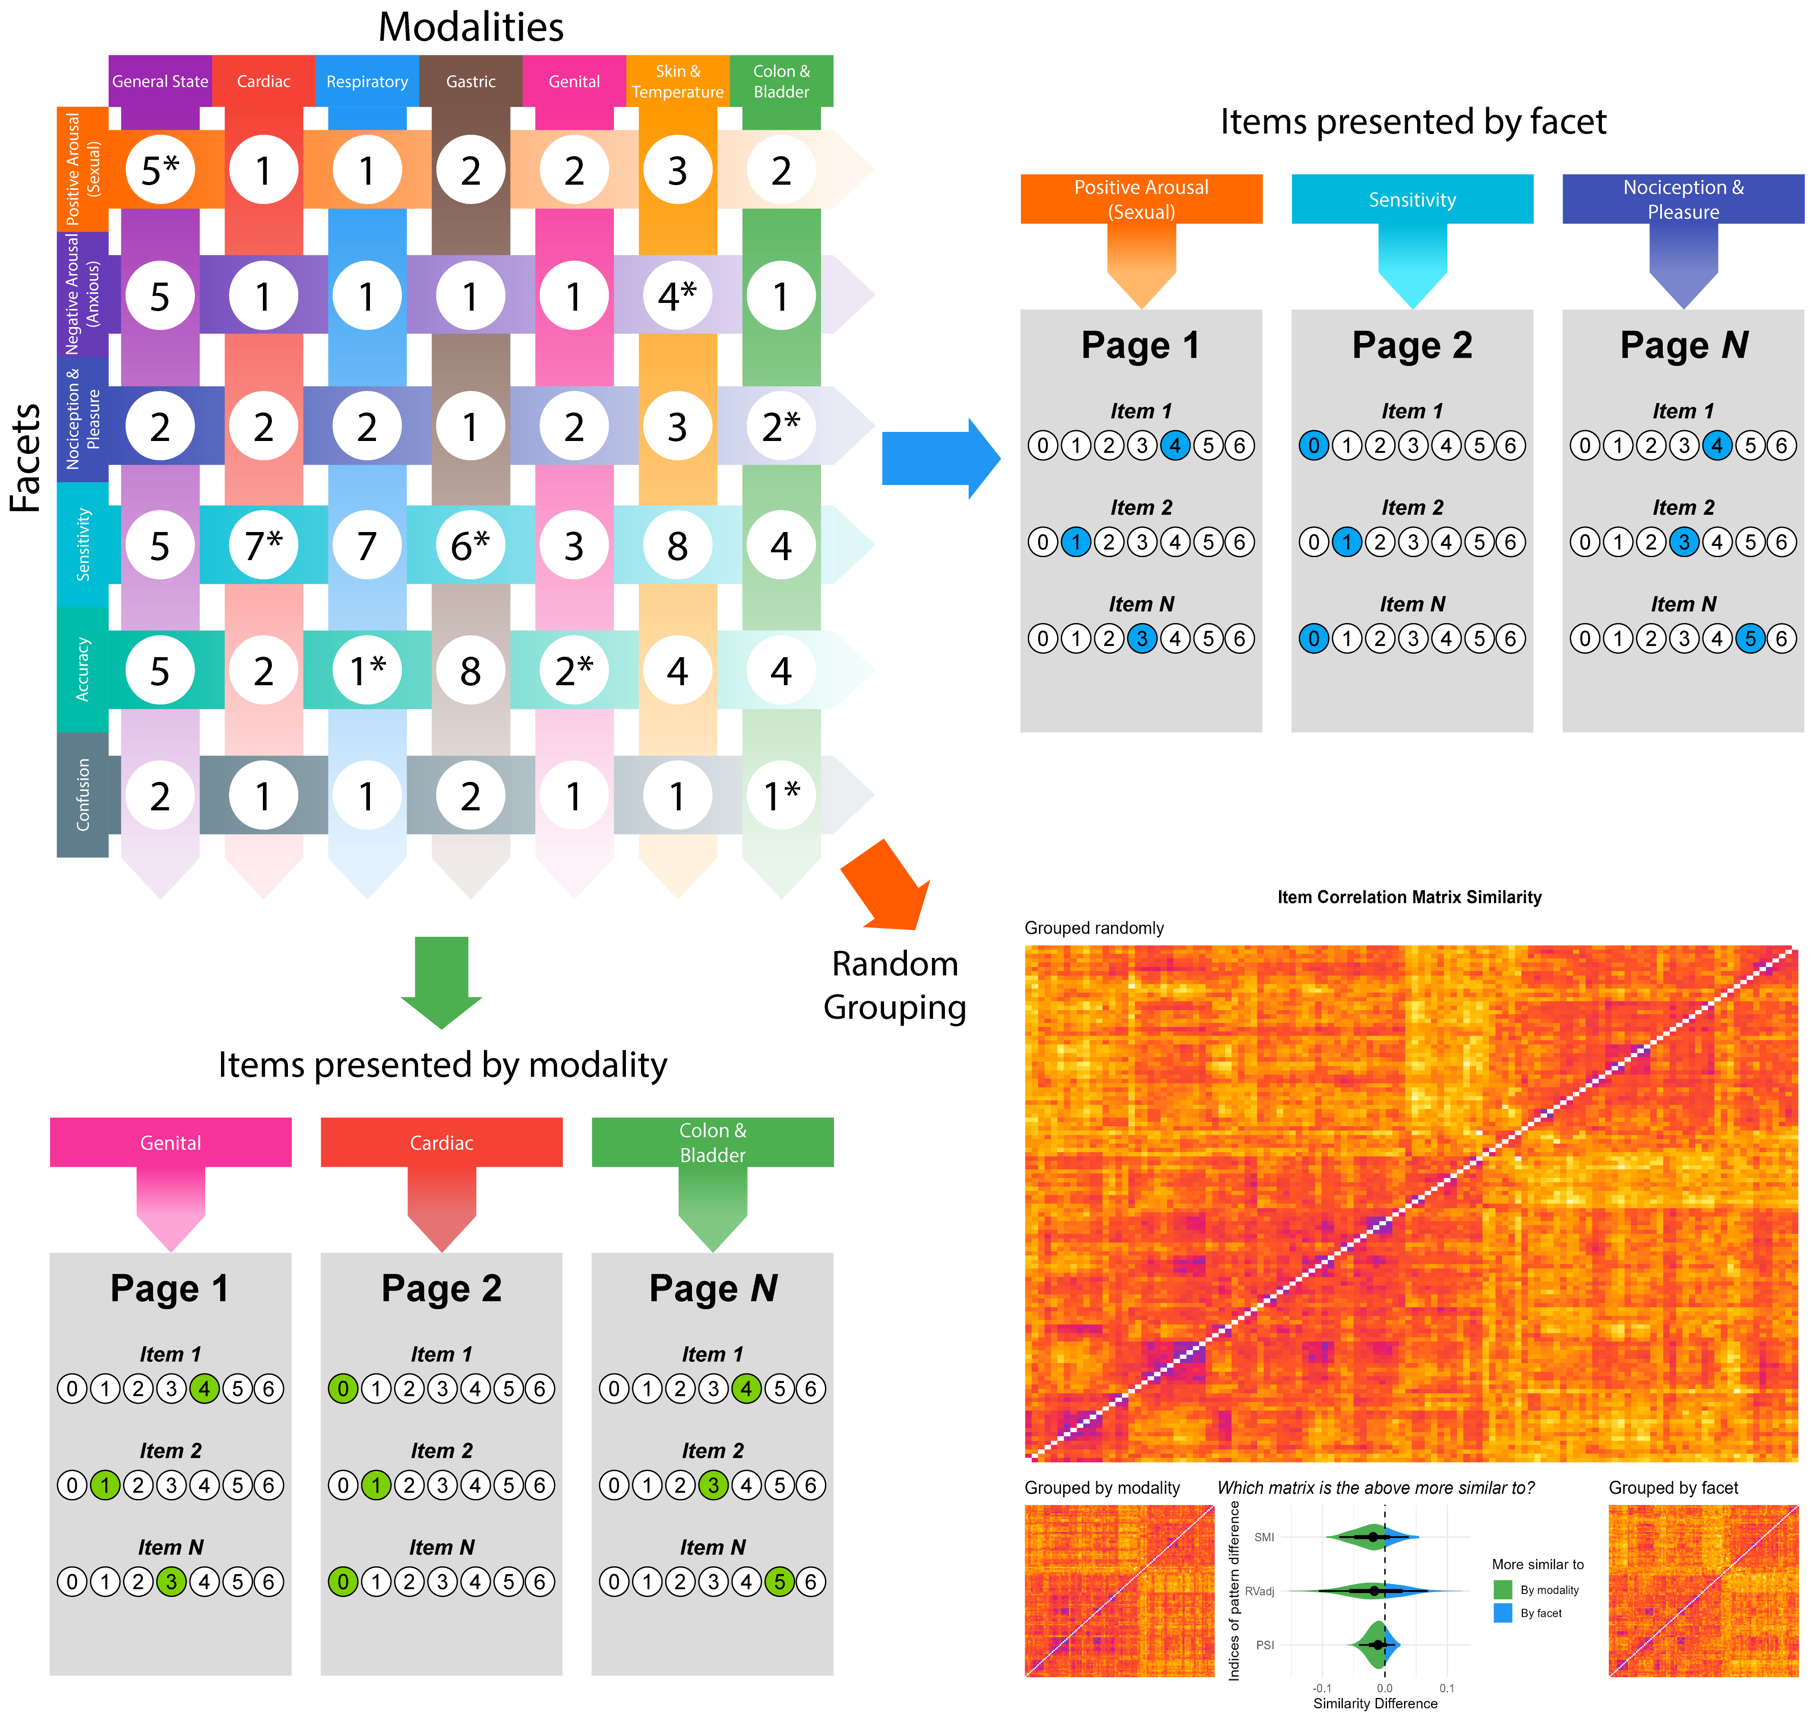

Figure 2
Structure analysis of the final set of 33 Mint items. Hierarchical Exploratory Graph Analysis (EGA) was applied to jointly identify clusters of items, as well as higher-order metaclusters. Score reliability at the item level can be quantified by the proportion of structure replication across bootstrapped samples, with high values indicative of high structural stability. The Mint scale displayed an excellent structural consistency, with the exception of the Olfa cluster which belonging to the Deficit metaclusters warrants further research. Bottom plot shows the result of hierarchical clustering, providing evidence for structure stability across methods, and allowing for more granular understanding of the relationships between variables.
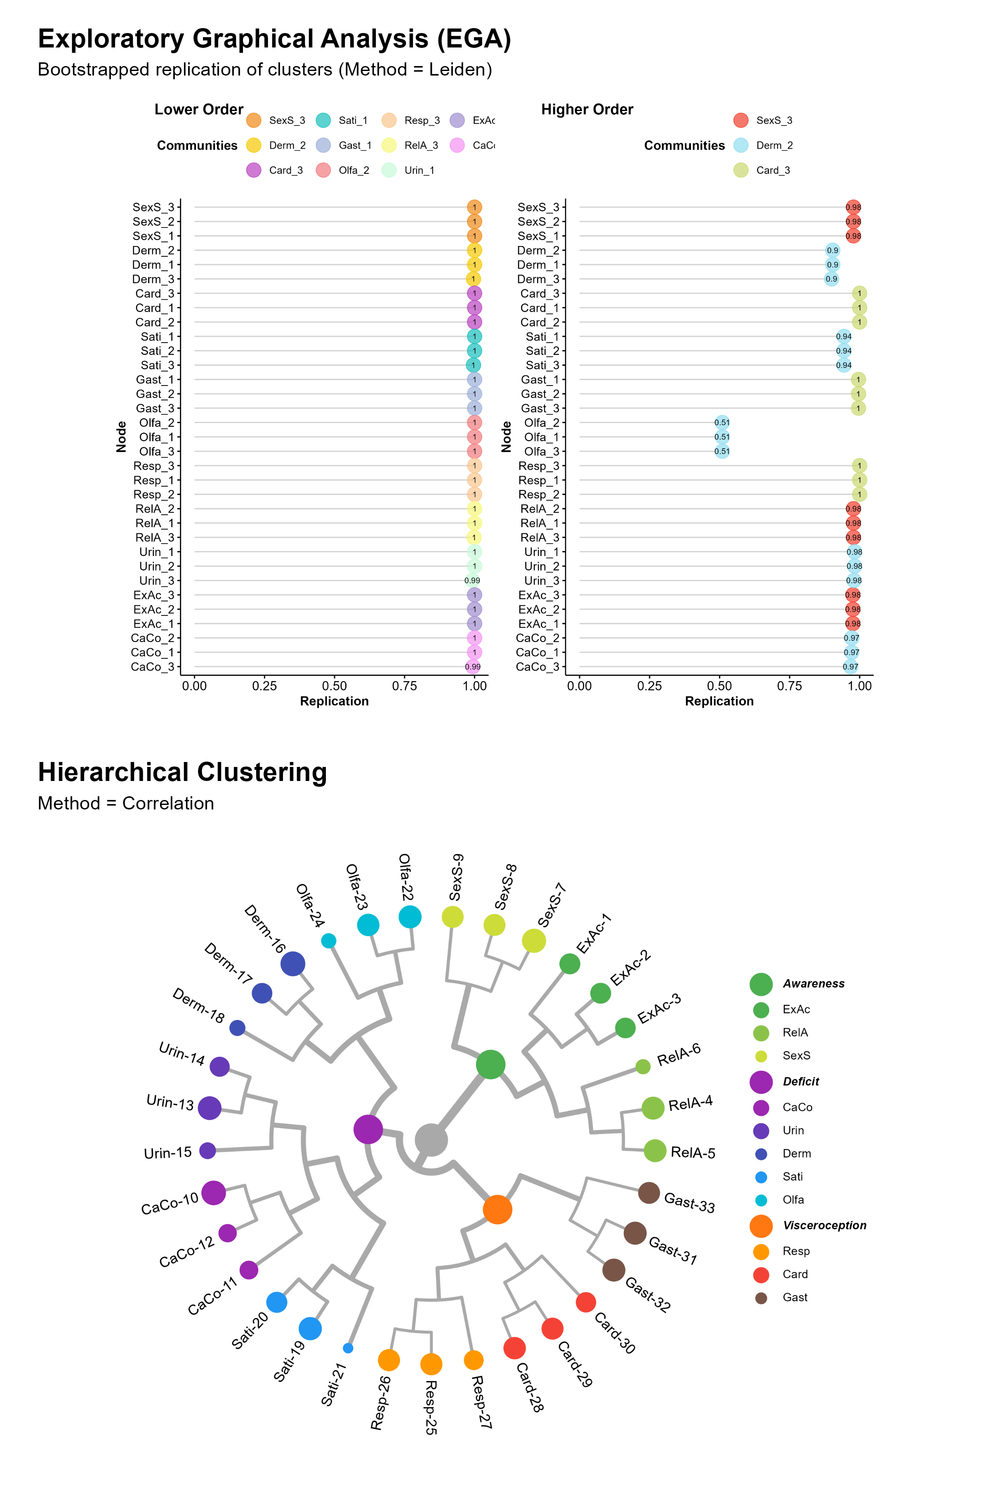

Figure 3
Item loadings. The table shows each item of the Mint with its cluster centrality, which is the EGA equivalent (in terms of interpretation) of factor loadings. It also shows how each lower-level cluster is related to higher-order metaclusters. The lower-level clusters are Expulsion Accuracy (ExAc), Relaxation Awareness (RelA), Sexual Arousal Sensitivity (SexS), Cardiorespiratory Confusion (CaCo), Urointestinal Inaccuracy (UrIn), Dermal Hypersensitivity (Derm), Satiety Noticing (Sati), Olfactory Contribution (Olfa), Respiroception (Resp), Cardioception (Card), Gastroception (Gast).
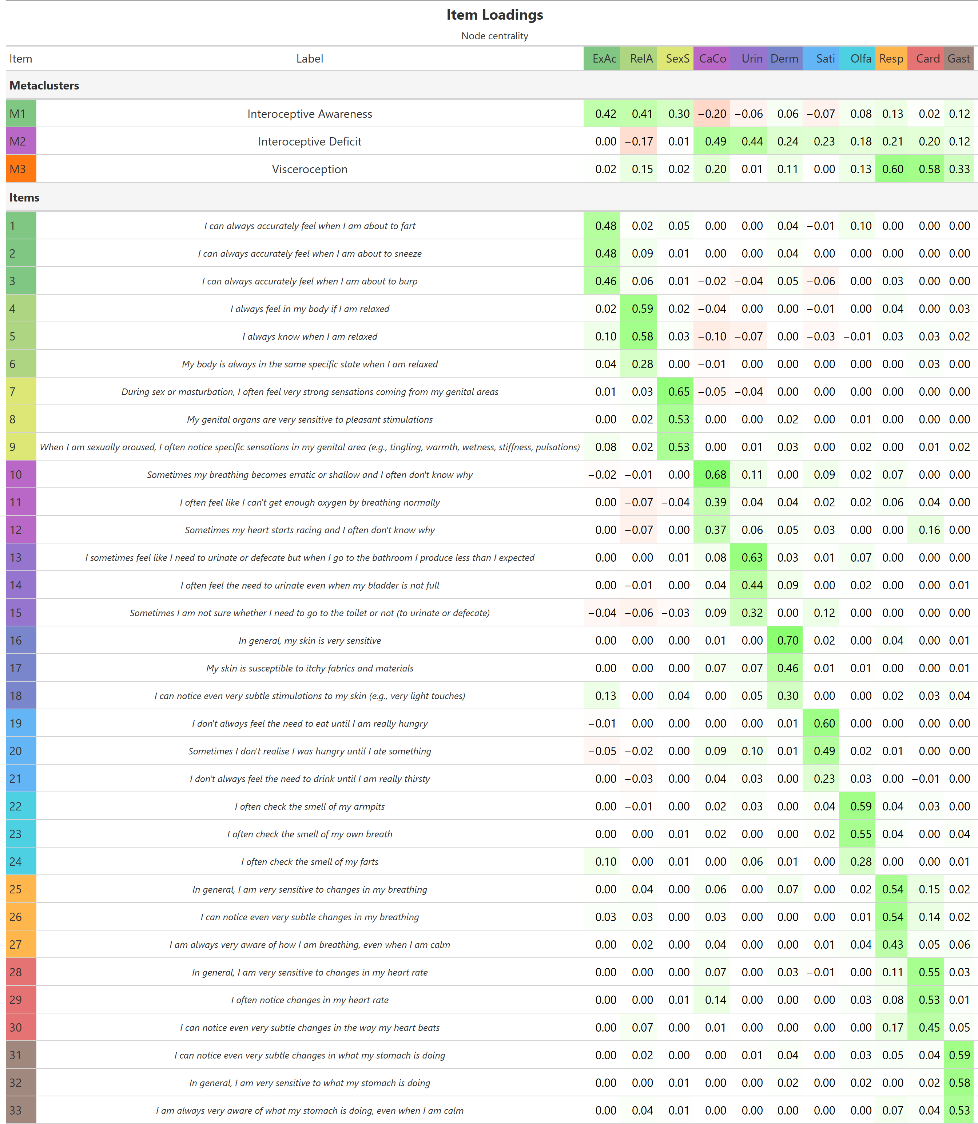

Figure 4
Correlation Matrices between the Mint dimensions (upper-left), and between the Mint and other interoception questionnaires (MAIA, BPQ and IAS; upper-right). The bottom matrix shows the relationships between interoception and other measures included in the study, such as alexithymia (TAS-20), depression and anxiety (PHQ-4), emotion reactivity (ERS), abnormal and dissociative experiences (CEFSA), and Primal World Beliefs. Stars indicate dimensions that have been score-reversed for better in-context interpretation. Correlation coefficients are shown only for significant correlations (p < .001).
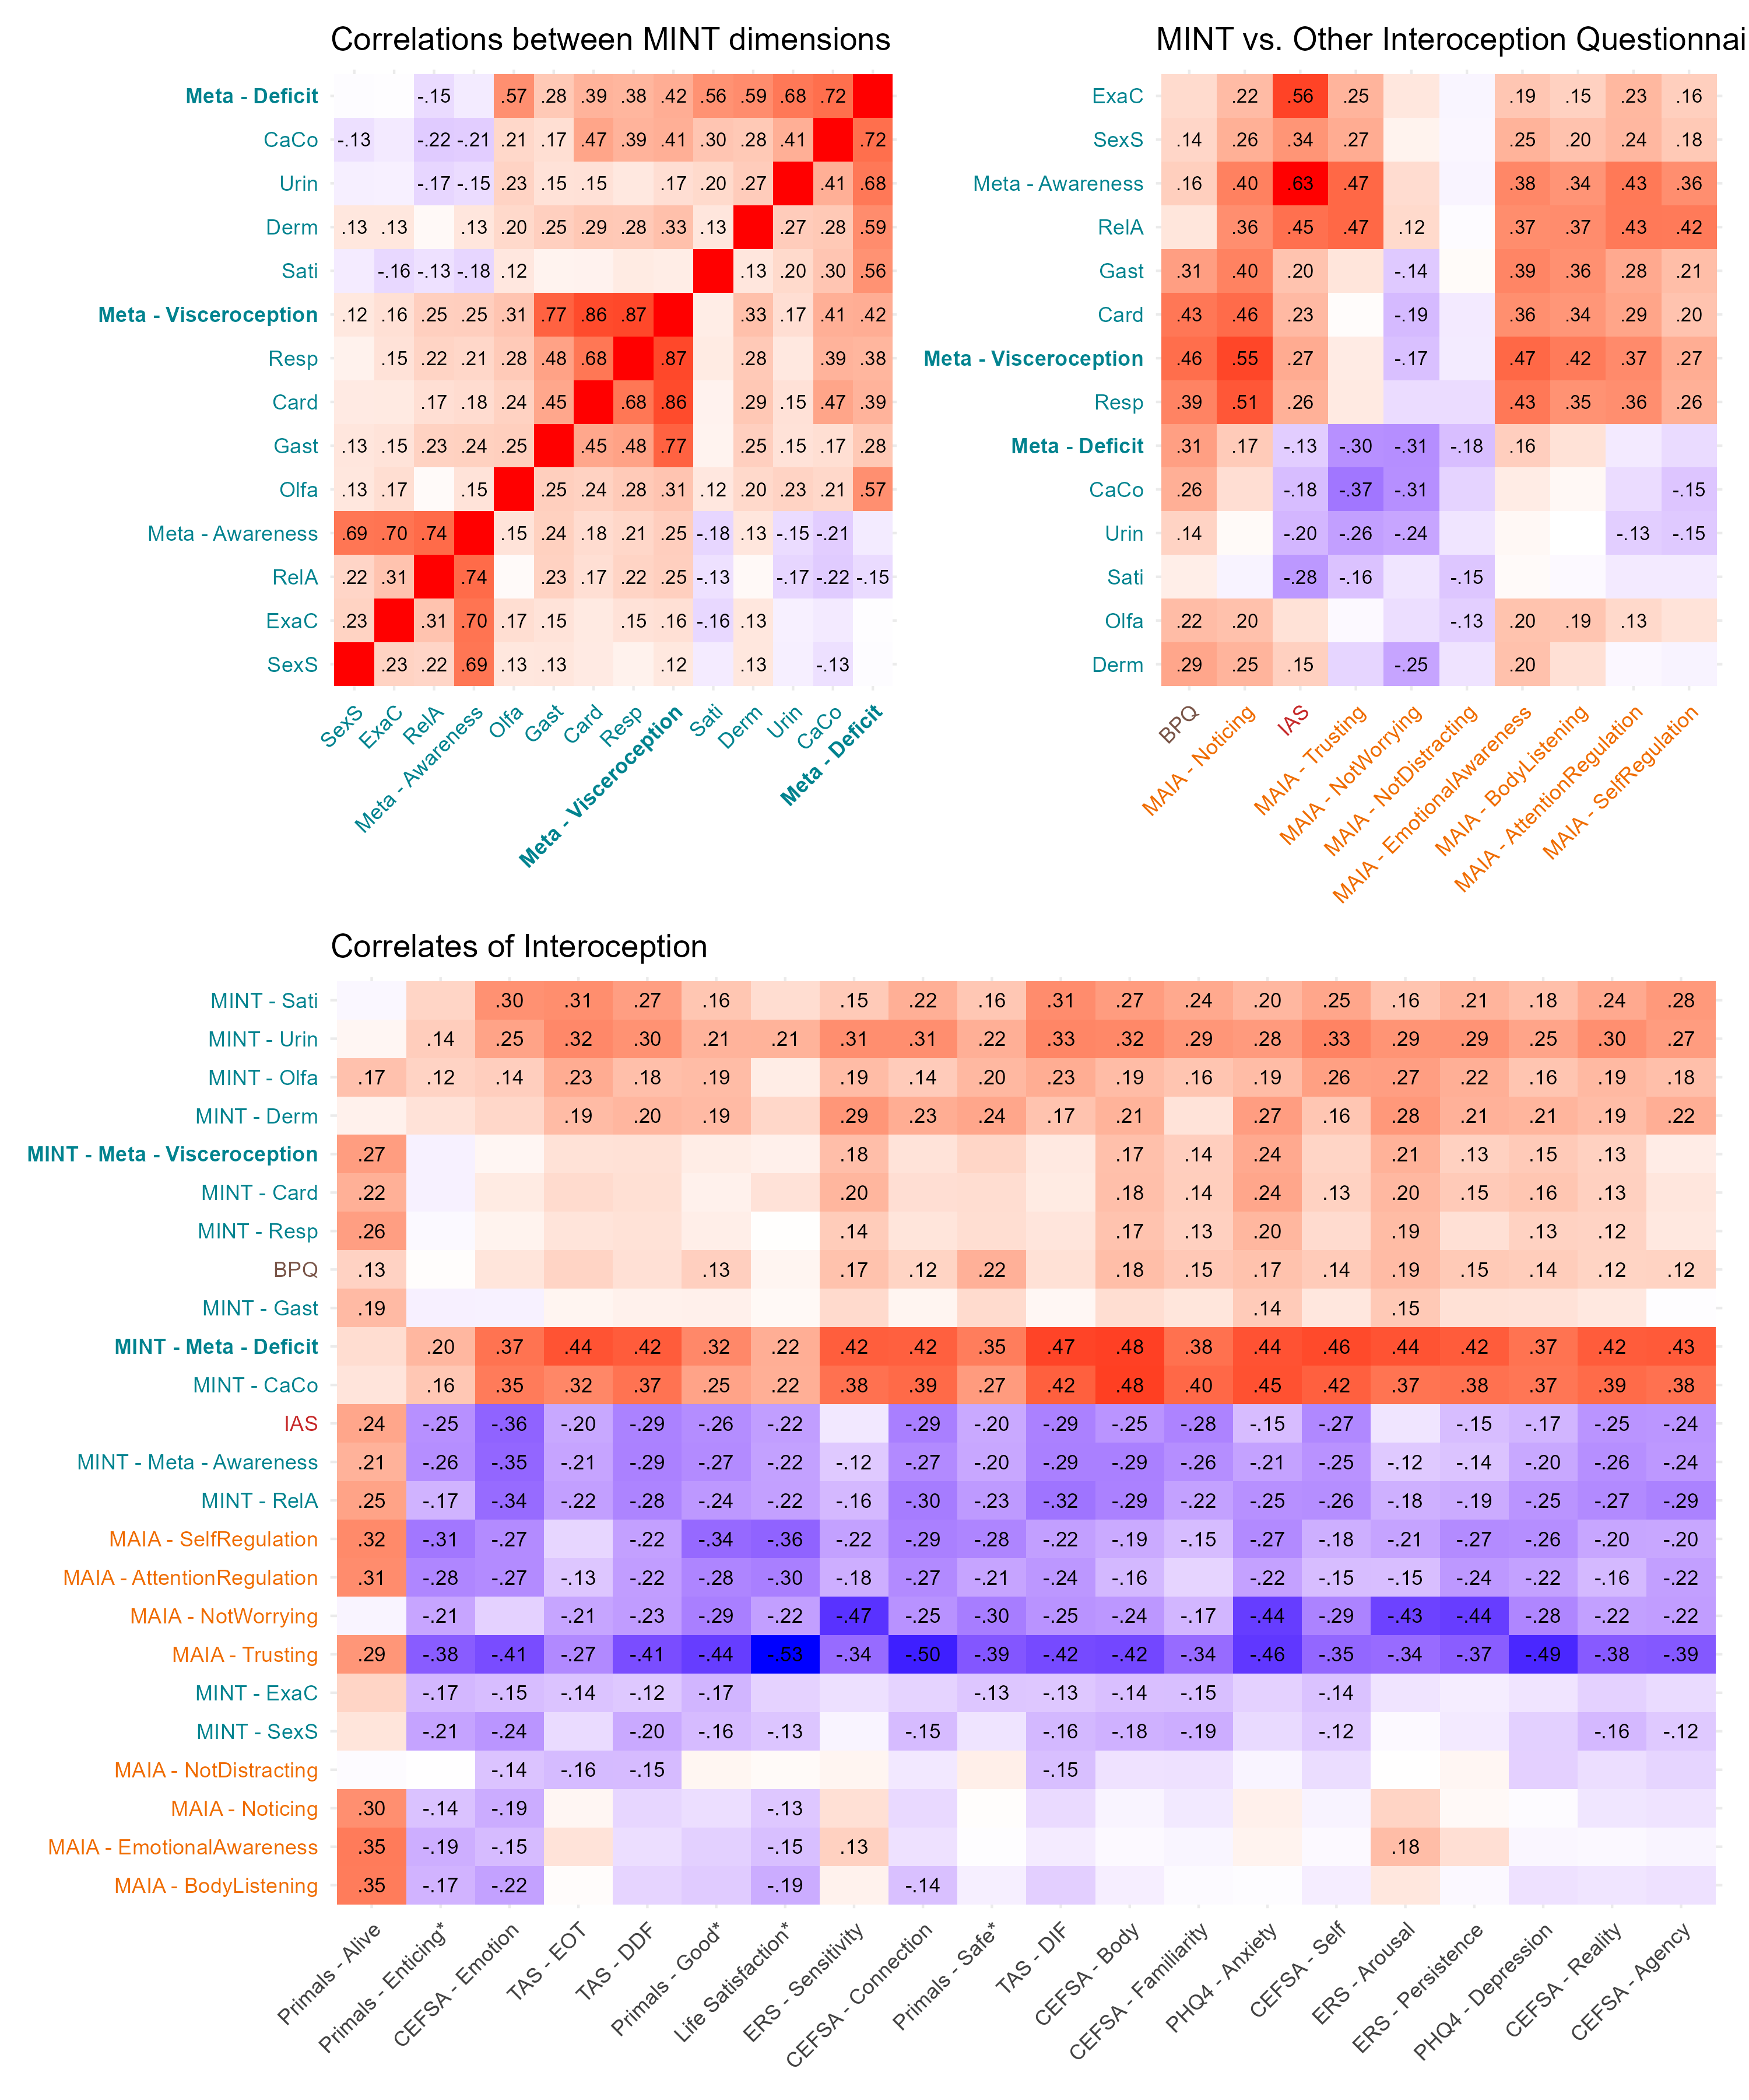

Figure 5
Summary table of the comparison between interoception questionnaires (Mint, MAIA, BPQ and IAS). For various outcomes included the study, we tested the Mint and Non-Mint dimension that had the strongest link (as a unique predictor). Values in parenthesis represents correlation coefficient for continuous variables and log-odds ratios for binary variables (the occurrence of mental and somatic health conditions). We also compared the predictive performance of regression models including multiple predictors, and present their ranking based on raw predictive power (R2) and BIC, which favours more parsimonious models (with less predictors). Green background indicates an advantage for the Mint, while red backgrounds indicate an advantage for another interoception scale. Orange backgrounds indicate an advantage for the MAIA driven by its emotion-regulation dimensions (Trusting and Not-Worrying).
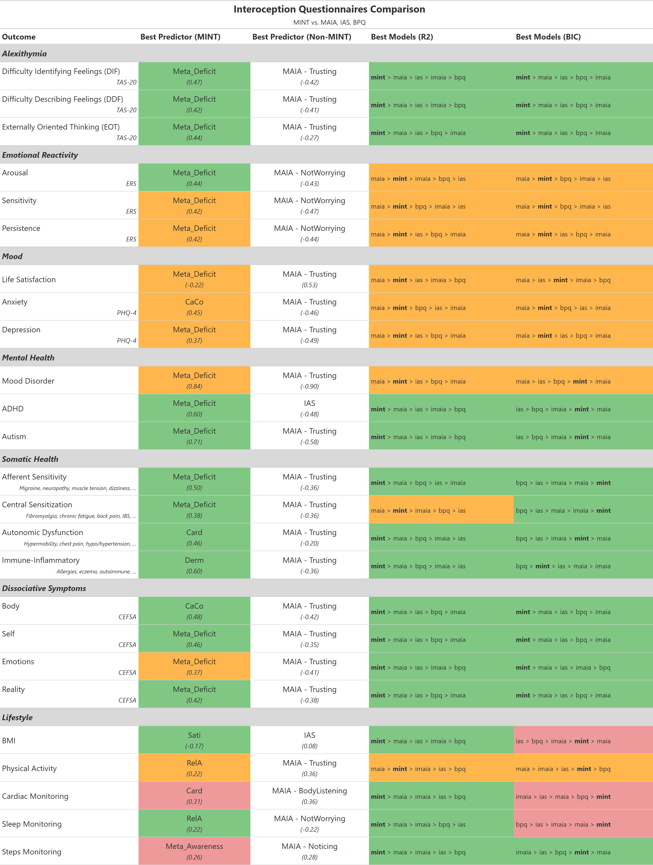

Figure 6
Predictive performance of interoception questionnaires for various self-reported mental health conditions (mood disorders with psychopharmacological treatment, ADHD and ASD) and somatic symptoms. The Receiver Operating Characteristic (ROC) curves are shown for the logistic regression models for various questionnaires and versions. A high Area Under the Curve (AUC) indicates a good discriminative power of the model (i.e., a strong combination of sensitivity and specificity). The Mint scale (in blue-green) consistently outperformed the other interoception scales, with the exception of the MAIA which, driven by its emotion-regulation dimensions (Trusting and Not-worrying), performed better for mood disorders. However, the Mint and MAIA performed comparatively for central sensitization.
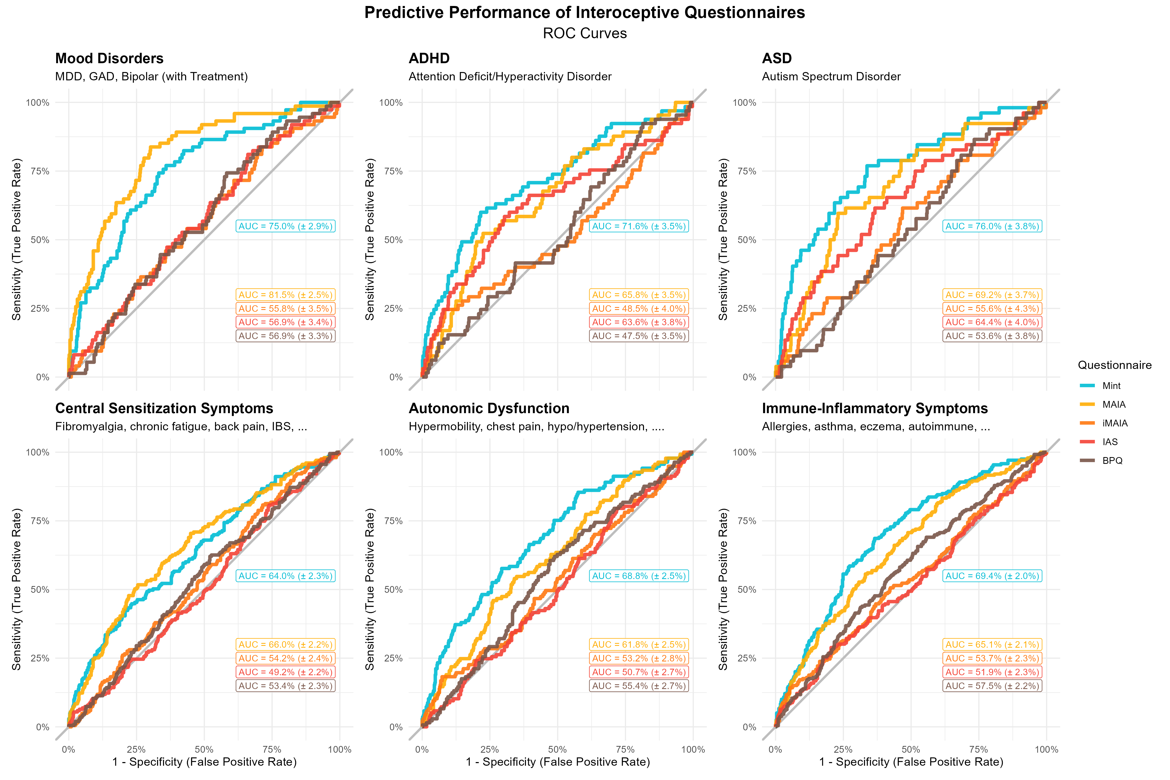

Figure 7
Descriptive statistics and gender differences across MINT clusters. For each cluster, mean scores and standard deviations are reported separately by gender (excluding participants identifying as “Other”), alongside independent-samples t-test results and corresponding Cohen’s d effect sizes.
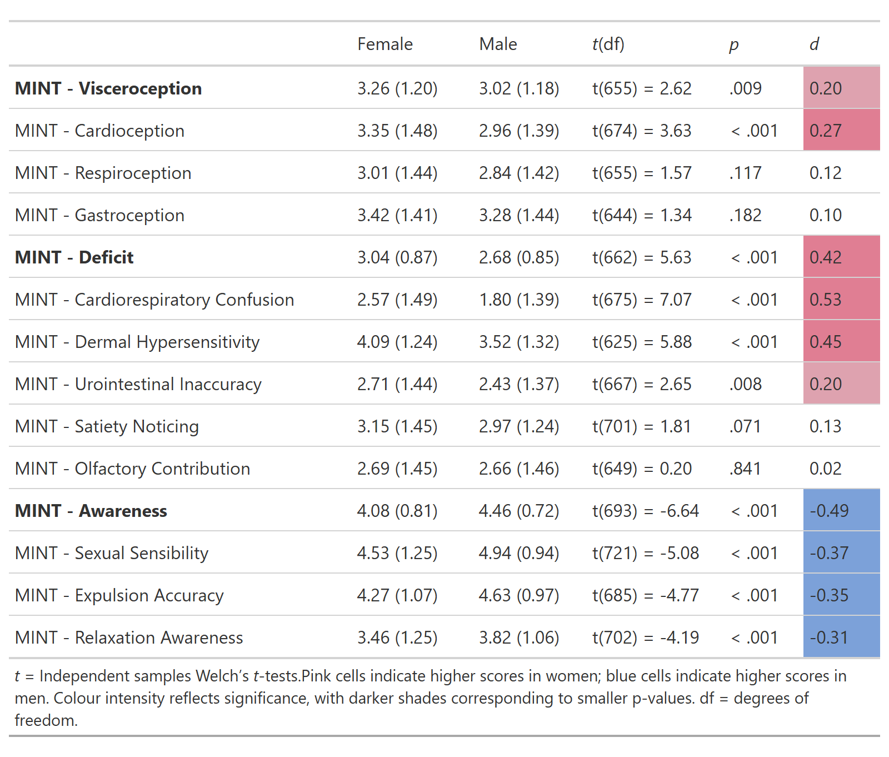

See original items at “MASKED FOR REVIEW”
The experiment can be tested by following the link on “MASKED FOR REVIEW”

