Review
We thank the Associate Editor and Reviewers for their thoughtful and constructive feedback on our revised manuscript. We are glad that the efforts made during the previous revision were well received, and we have carefully addressed all remaining comments in this further revision.
All changes are indicated in bold throughout the manuscript and are detailed below.

Associate Editor

As associate editor, my primary reservation involves the overall length of the submission. The paper contains a series of artificial breaks that would reduce the length if removed, but the text continues to exceed the 30 page limit set in guidelines for ASSESSMENT (i.e., 30 pages of text excluding Title Page, Abstract, Tables, Figures, Footnotes and Reference list). While the submission is well written and the response to feedback provided in the initial round of reviews was excellent, portions of the text could be streamlined to bring the paper more in line with parameters set by the journal.

We thank the associate editor for the acknowledgement and the positive feedback for our revised manuscript and we acknowledge the need for a shorter length. In particular, we have now removed artificial breaks throughout the revised manuscript and streamlined several sections.
We have now removed artificial breaks throughout the revised manuscript and streamlined several sections: Specifically, we condensed the Introduction (line 102, 132-133) , merged ethics statements into their respective participant paragraphs (189-190, 380-381), merged several Study 1 paragraphs, condensed the Study 1 Discussion (347-351), condensed the Study 2 Lifestyle measures section (379-381), condensed the Study 2 Results (lines 529-532, 547-558), condensed the Study 2 Discussion (638-659), and removed a duplicate sentence from the Limitations and the Item Generation sections.
We have made a significant reduction in the overall page count from 35 pages (excluding Title Page, Abstract, Tables, Figures, Footnotes and Reference list) to 31 pages, which we hope will be sufficient.

From my own read, the hanging set of measures listed on pg. 6 could be presented more efficiently.

We have now addressed this (see lines 71-76).

Discussion 1 and Discussion 2 may be additional targets for possible streamlining.

We have now addressed this by condensing the Study 1 Discussion (see lines 347-351) and the Study 2 Discussion from four paragraphs to two (see lines 638-659).

Further, sections involving the introduction and analysis of Mint variations could be removed entirely given that short-form versions are not addressed in the Introduction or discussed in the Discussion.

We agree that the Mint variants are an area worth removing given their little impact on the overall paper. We have now excluded them from the manuscript and from figures 6 and 7. A brief mention has been retained a sentence in the Limitations section (lines 690-692), noting that preliminary analyses of abbreviated Mint versions point to a worthwhile formal validation in future work.

I would also ask that you review the text carefully for language tying psychometric characteristics to physical instruments as opposed to features of the interpretation and use of scores. This is a technical issue but an important one that dovetails with comments by Reviewer 2.

We believe we have now resolved this issue by reframing psychometric properties to the scores and not the scale in itself. The following changes were made throughout the manuscript:
Line 132-133: “..version of the Mint against the established interoception questionnaires, demonstrating that Mint scores have a robust structure and predictive validity for a range of clinically-relevant outcomes.”
Line 136-137: "…refining it into a scale yielding psychometrically robust scores."
Line 355-356: "Study 2 then sought to examine the psychometric properties of Mint scores…"
Line 360: "…we assessed the criterion validity of Mint scores…"
Lines 503-504: "The convergent validity of scores from the final set of items was assessed…"
Line 665: "Mint scores are psychometrically robust, reflecting a stable, hierarchical structure…"
Line 729-730: "…providing a structurally coherent, nuanced measure whose scores demonstrate strong convergent and criterion validity…"
Figure 1 caption: "…suggesting that Mint scores are robust to different presentation conditions…"
Figure 2 caption: "Score reliability at the item level can be quantified…"

Again, I appreciate the level of responsiveness to input from the initial review. I believe that the paper merits publication and is likely to make a positive contribution to the field. I am happy to move forward with potential acceptance pending the submission of a streamlined document that addresses remaining issues raised by reviewers. I will handle the review of final edits myself to help streamline the process.

We sincerely thank the associate editor for the positive feedback and the recognition of our work and the possibility that our paper will make a positive contribution to the field.

Reviewer 1

Comments to the Author
First, I would like to thank the authors for the revisions that they have made on this manuscript. I believe that the current manuscript is notably stronger and clearer than the initial version. In particular, I’m appreciative of the amount of effort the authors put into reanalysis based on my initial comments. In general, the authors have been quite responsive to my comments.

I do have two remaining (very) minor comments regarding the interpretations of the predictive performance of mental health outcomes (page 33) after the requested revisions. I also have one comment about the reporting of gender differences in response to my comment 7. I believe these comments can be addressed in the copy editing stage and do not require additional review.

1.With the inclusion of bootstrapped CIs, the MINT and MAIA predict central sensitization symptoms equivalently (i.e., there isn’t evidence that MAIA out-predicts MINT in this domain anymore).

We have now addressed this in the caption of Figure 6 and in the text.
Lines 628-629: "…with the exception of Central Sensitization, where the Mint and MAIA performed comparatively."
-> SAME
2. The figure in the updated draft does not include the CIs that are included in the figure present in the response to reviewers document. Please make sure that the updated figure 6 is in the final manuscript.

Instead of the CIs, our previous response mentions, derives and includes a unique index of uncertainty, the SE, that we included in the figure, that in our opinion offers a more compact view of uncertainty and avoids bloating the figure legend (and the 2 indices are formally equivalent).

3. The results presented in figure 7 currently suggest that reported significance levels accompany effect size estimates (Cohen’s d) rather than statistical tests which is somewhat misleading. Please report the corresponding test statistics, degrees of freedom, and exact p-values in addition to the estimated effect size. Apologies if this feels pedantic but I do believe these details are important.

We have now addressed this by adding the aforementioned statistics to Figure 7. For each of the 14 Mint clusters, the figure now reports mean scores and standard deviations separately by gender, alongside independent-samples Welch's t-test statistics in the form t(df), exact p-values, and Cohen's d effect sizes.
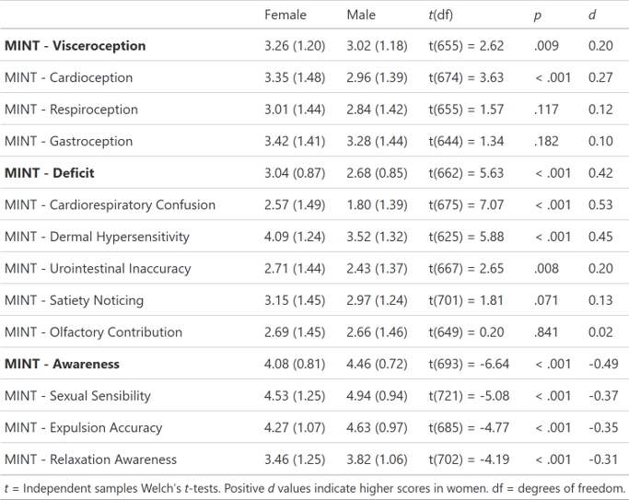

Reviewer 2

Comments to the Author
The authors present a series of studies that introduce the development and validation of the Multimodal Interoception Questionnaire (Mint scale) for measuring interoception. Strengths of the manuscript include the use of two samples to develop and validate the measure, and a strong focus on modeling the context and full range of modalities to extend and improve upon existing interoception measures. The authors clearly invested considerable time responding to the Editor and Reviewers’ comments. My only minor comment is that some instances of boosterism language (e.g., “cutting-edge”) remain. Otherwise, I have no further comments or suggestions.

We have now removed all boosterism language, in particular any mention of "cutting-edge" and "novel" throughout the manuscript.
Line 117-118: "…refined using psychometric network analysis."
Line 173-174: "…reduced using psychometric network-based techniques…"
Line 235: "…using Unique Variable Analysis (UVA, Christensen et al., 2023), a principled method derived from network psychometrics."
Line 334: "The resulting hierarchical structure offers interpretable insights into self-reported interoception…"
Abstract: “..we further assessed the structure of the Mint in an independent sample...”

