

Core questionnaires: item list
Study: MINT questionnaire validation follow-up
Version: 2, 7 October 2026
The three questionnaires of the core set, as participants see them, one questionnaire per page: the short introduction shown before each, the instruction shown above every item, the response scale and every item, followed by an example of the feedback participants are shown once they finish it. Items are shown one per screen, in a random order. The demographic questions and the brief trait scales that complete the core set are listed in the full item list at https://realitybendinglab.com/TestYourself/docs/ (“Content” slide).

Multidimensional Interoceptive Traits questionnaire (MINT)
Makowski et al. · 33 items and 1 attention check
INTRODUCTION
Let's talk about your body.
The next questions are about your body and what you feel going on inside it: your breathing, your heartbeat, your stomach, your genitals, your skin. What you notice, how clearly you notice it and how easily you can tell what it means.
Some of these are blunt, and a few may feel odd to be asked, but they are all important: how people sense their own body can say a lot about them.
Think of what is actually true of you, not with what sounds right.

Instruction above each item: Answer the following question based on how accurately the statement describes you in general
Response scale: Each participant is randomly assigned one of three response formats, all scored 0 to 6: seven circles numbered 0 to 6; seven circles labelled −3 to +3; or a continuous slider with no numbers. All three run from “Disagree” to “Agree”.
1 | I can always accurately feel when I am about to fart
2 | I can always accurately feel when I am about to sneeze
3 | I can always accurately feel when I am about to burp
4 | I always feel in my body if I am relaxed
5 | I always know when I am relaxed
6 | My body is always in the same specific state when I am relaxed
7 | During sex or masturbation, I often feel very strong sensations coming from my genital areas
8 | My genital organs are very sensitive to pleasant stimulations
9 | When I am sexually aroused, I often notice specific sensations in my genital area (e.g., tingling, warmth, wetness, stiffness, pulsations)
10 | Sometimes my breathing becomes erratic or shallow and I often don't know why
11 | I often feel like I can't get enough oxygen by breathing normally
12 | Sometimes my heart starts racing and I often don't know why
13 | I sometimes feel like I need to urinate or defecate but when I go to the bathroom I produce less than I expected
14 | I often feel the need to urinate even when my bladder is not full
15 | Sometimes I am not sure whether I need to go to the toilet or not (to urinate or defecate)
16 | In general, my skin is very sensitive
17 | My skin is susceptible to itchy fabrics and materials
18 | I can notice even very subtle stimulations to my skin (e.g., very light touches)
19 | I don't always feel the need to eat until I am really hungry
20 | Sometimes I don't realise I was hungry until I ate something
21 | I don't always feel the need to drink until I am really thirsty
22 | I often check the smell of my armpits
23 | I often check the smell of my own breath
24 | I often check the smell of my farts
25 | In general, I am very sensitive to changes in my breathing
26 | I can notice even very subtle changes in my breathing
27 | I am always very aware of how I am breathing, even when I am calm
28 | In general, I am very sensitive to changes in my heart rate
29 | I often notice changes in my heart rate
30 | I can notice even very subtle changes in the way my heart beats
31 | I can notice even very subtle changes in what my stomach is doing
32 | In general, I am very sensitive to what my stomach is doing
33 | I am always very aware of what my stomach is doing, even when I am calm
34 | I can always accurately answer to the extreme left on this question to show that I am reading it (attention check)

Example of the feedback shown after this questionnaire
Shown once the MINT is finished: a slice of brain and the organs it reads, drawn from the participant’s three MINT scores, with where each score stands among other people and what it describes.
Drawn here with made-up example scores, exactly as the page draws it.
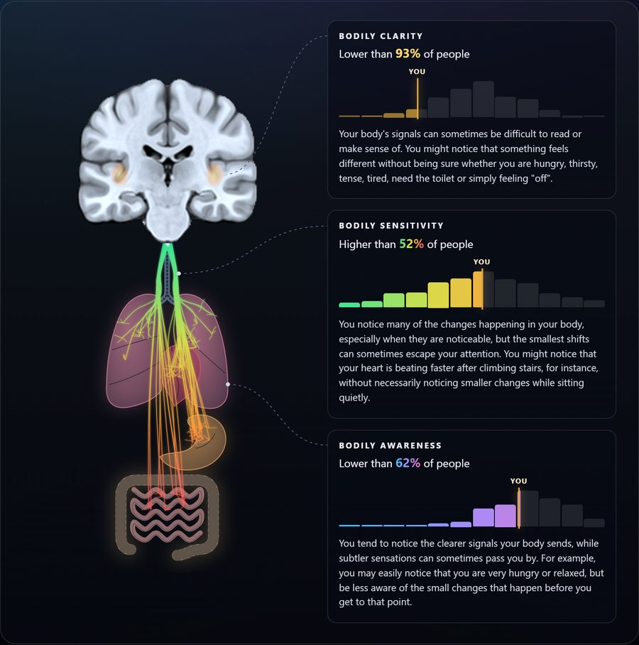

Beliefs about Artificial Intelligence Technology (BAIT)
Makowski et al. · 26 items and 1 attention check
INTRODUCTION
What do you make of the new age we are entering?
The questions that follow are about your relationship with artificial intelligence (AI). What we make of thinking machines tends to say as much about us as it does about them.

Opening questions
1. How knowledgeable do you consider yourself about Artificial Intelligence (AI) technology?
Response: Seven circles numbered 0 to 6, from “Not at all” to “Expert”
2. How well do you understand the way modern AI systems actually work, technically?
For instance, how large language models (LLMs) and generative AI produce the text or images they do.
Response: Seven circles numbered 0 to 6, from “Not at all” to “In detail”
3. How frequently do you use Artificial Intelligence (AI) tools or technologies in your daily life?
This includes tools like ChatGPT, image or art generators and AI assistants.
Response: Never / A few times per month / A few times per week / Once a day / A few times per day / A lot of times every day

Statements
Instruction above each item: Indicate the extent to which you agree with each statement, for AI as it exists today
Response scale: Seven circles numbered 0 to 6, from “Disagree” to “Agree”
1 | Current AI algorithms can generate very realistic images
2 | Images of faces or people generated by AI always contain errors and artifacts
3 | Videos generated by AI have obvious problems that make them easy to spot as fake
4 | Current AI algorithms can generate very realistic videos
5 | Computer-Generated Images (CGI) are capable of perfectly imitating reality
6 | Technology allows the creation of environments that seem just as real as reality
7 | AI assistants can write texts that are indistinguishable from those written by humans
8 | Documents and paragraphs written by AI usually read differently compared to Human productions
9 | AI is dangerous
10 | I am worried about future uses of AI
11 | AI is exciting
12 | Much of society will benefit from a future full of AI
13 | I can easily distinguish between real and AI-generated images
14 | I am bad at telling if images are real or AI-generated
15 | I often find it challenging to differentiate between AI-generated and human-written text
16 | I can accurately detect subtle differences between AI from human-created content
17 | Human creators bring a unique perspective that AI cannot replicate
18 | AI-generated art can sometimes surpass human creativity and artistic value
19 | AI-generated content often feels impersonal compared to human-generated media
20 | AI-generated content tends to be more interesting and engaging than human-generated content
21 | Human-made art evokes stronger emotional responses than AI-generated art
22 | I am more likely to appreciate content when I know it is created by humans rather than AI
23 | I am more likely to trust content when I know it is created by a human rather than AI
24 | I can show that I am Human and not an AI by answering all the way to the right (attention check)

Example of the feedback shown after this questionnaire
Shown once the BAIT is finished: the robot that stands for how the participant pictures AI, which of four kinds of AI picture their answers are nearest, and the other three for comparison.
Drawn here with made-up example scores, exactly as the page draws it.
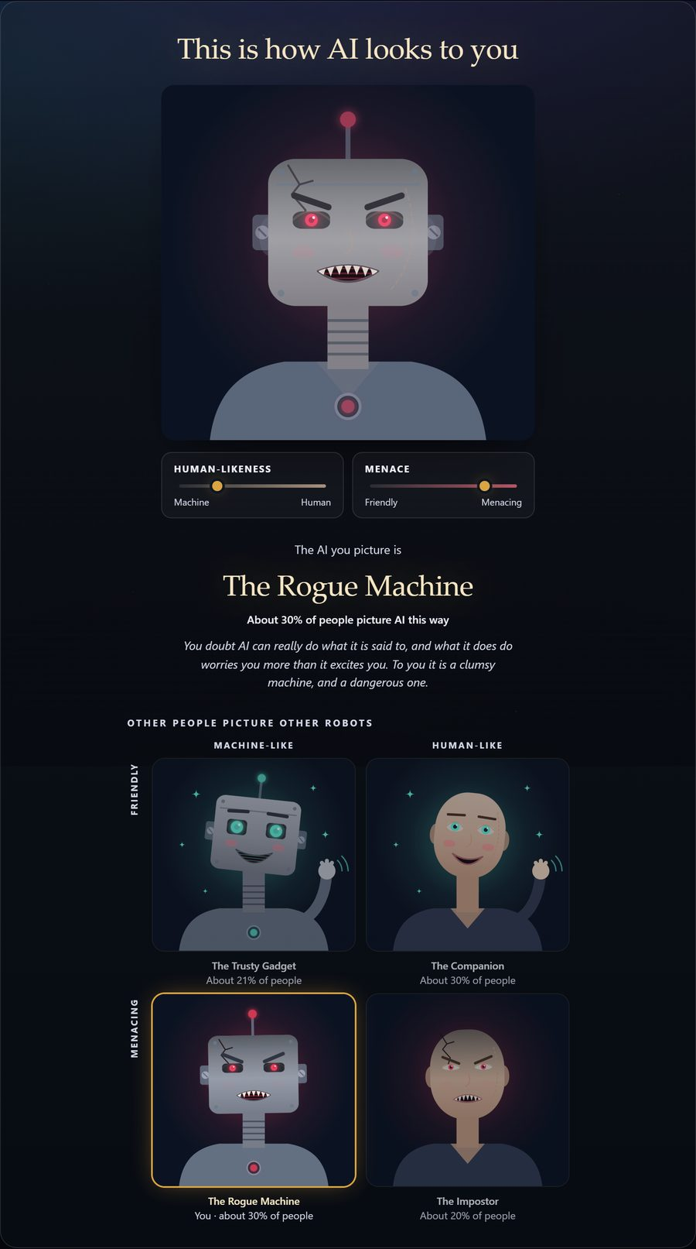

HiTOP Brief Report (HiTOP-BR)
Simms et al., 2026 · 45 items and 1 attention check
INTRODUCTION
The last year.
The questions about your mood were about the past couple of weeks. These widen the frame to the last twelve months. They ask about the kinds of experience psychology has spent a century sorting into diagnoses. Here they are asked as dimensions instead: not whether you have something, but how much of it has been true of you.
Some statements will describe you well and some not at all. Every one of them describes somebody, and most describe more people than would admit to it.
Think of the times in the last twelve months when a statement applied to you, and say how well it described you then.

Instruction above each item: Consider whether there have been significant times during the last 12 months during which this statement applied to you, and choose the option that best describes how well it described you during that period.
Response scale: Not at all / A little / Moderately / A lot
1 | I found it easy to deceive others
2 | I deserved special treatment
3 | I saw things that were not really there
4 | My fantasies felt very real to me
5 | I liked having power
6 | I felt something was wrong with my body
7 | When I had the chance, I chose to be alone rather than with other people
8 | My moods were intense and unpredictable
9 | My mind was flooded with troubling images of a bad experience
10 | I had pains in several parts of my body
11 | I felt like I was outside of my body
12 | I was happiest when I was alone
13 | I found it easy to manipulate others
14 | I was bothered by several bodily symptoms (e.g., headache, fatigue or stomach problems) for which there was no clear or sufficient medical explanation
15 | I had trouble planning and keeping to schedules
16 | I lost things that I needed
17 | I was frustrated with having to convince others I had a real illness
18 | Even when I was very careful, I worried whether I had done something correctly
19 | Reading articles about disease made me worry about my health
20 | I paid my bills late or missed other important deadlines
21 | I could feel changes in my body
22 | I was disgusted with myself
23 | I felt on guard and on edge
24 | I was a messy person
25 | I did things to get others to notice me
26 | I noticed small changes to how my body feels
27 | Things went best when I told others what to do
28 | I heard things that no one else could hear
29 | I was never on time
30 | I had no interest in romantic relationships
31 | Romantic relationships seemed like a hassle to me
32 | I said things without thinking
33 | People told me I was coldhearted
34 | I made decisions quickly without thinking them through
35 | I quit tasks that became too challenging
36 | I had a hard time asserting myself to others
37 | I felt that I did not want to be in a close relationship
38 | I had trouble telling whether something really happened or I just imagined it
39 | I felt that things around me were not real
40 | I liked attracting the attention of others
41 | I was afraid that I might suffer from a serious illness
42 | I thought a lot about death
43 | I bought much more than I needed
44 | I was overwhelmed by anxiety
45 | I expected to get treated better than others
46 | I read each of these statements carefully, and will answer "A lot" to this one (attention check)

Example of the feedback shown after this questionnaire
Shown once the HiTOP-BR is finished: the participant’s last year drawn as a hill to climb, from three of its spectra and the PHQ-4 (asked just before it; listed in the full item list). It shows no score, percentile or ranking, only the shape of the hill, and two other hills for comparison.
Drawn here with made-up example scores, exactly as the page draws it.
