RealityGrid Steerering Application User Manual

Mark Riding 18/08/03

Acknowledgements

The RealityGrid Steerer is mainly the work of Sue Ramsden, with some further enhancements by Mark Riding. The steerer is built using the RealityGrid Steering API, by Andrew Porter.

Introduction

The RealityGrid Steerer is a generic user interface for performing computational steering on (computational) jobs which have been built to support the RealityGrid Steering API. This document aims to give new users an overview of how to use the steerer, and to explain the functionality which it offers.

Starting the Steerer

Run the steering application by executing the command ‘steerer’ at the command prompt, assuming that appropriate paths have been set up. You will be presented with a simple start-up screen:

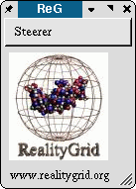
Steerer startup screen

The Steerer menu

The Steerer menu has four options:
- Local Attach attach to a local steerable job, communicated with by means of a polled local shared resource. Shortcut Ctrl+A
- Grid Attach attach to a steerable job located on ‘any’ machine, communicated with by means of a Globus or SOAP interface. Shortcut Ctrl+G
- Set Polling Interval Set how often the application polls the computational job. Shortcut Ctrl+P
- Quit Quits the application. Shortcut Ctrl+G

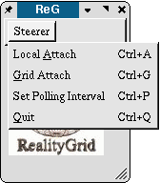
Steerer menu

Attaching to a steerable job

Selecting Local Attach from the Steerer menu will take you straight to the main RealityGrid Steerer window. Selecting Grid Attach will bring up a small dialog box first:

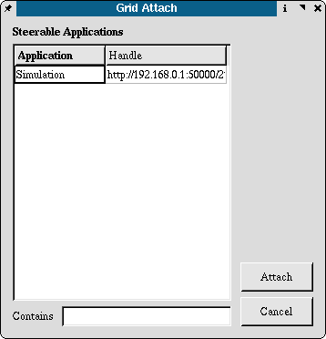
Grid Attach dialog

The dialog lists available RealityGrid SGS applications and addresses in a table. By selecting an entry in the table and clicking on the Attach button, a Steerer is created for the chosen application.
Entries in the Handle column in the table are fully editable.

Using the Steerer

The Main Window

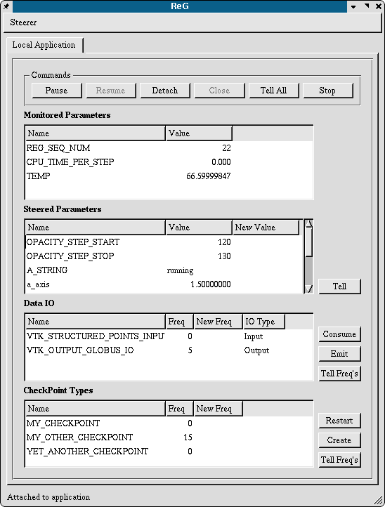
Steerer Main Window

The Main Window is split into five conceptual sections:
- Control Buttons
- Monitored Parameters
- Steered Parameters
- Data IO
- CheckPoint Types

Control Buttons

The Control Buttons panel manages overall control of the steerable job’s state. Different buttons will be greyed out and unavailable depending on a job’s state; for instance, jobs that are not running cannot be stopped.
- Pause button pauses a running job
- Resume button causes a paused job to resume
- Stop button ends the job
- Detach button detaches the steerer from the job, leaving the job running
- Close button closes the main window of the steerer, returning to the startup screen
- Tell All button causes the steerer to pass any user updated parameters to the job, see Steered Parameters section, below

Monitored Parameters

The Monitored Parameters table lists parameters which are exposed by the steerable job, but are not themselves directly steerable. An example of a monitored parameter for a simulation job might be time per simulation step. Such a parameter is changed only by the computational job itself, not the user.

The Steerer allows graphs to be drawn of monitored parameters. By right clicking on a monitored parameter, a context menu appears allowing the user to select a ‘Draw History Graph’ option.

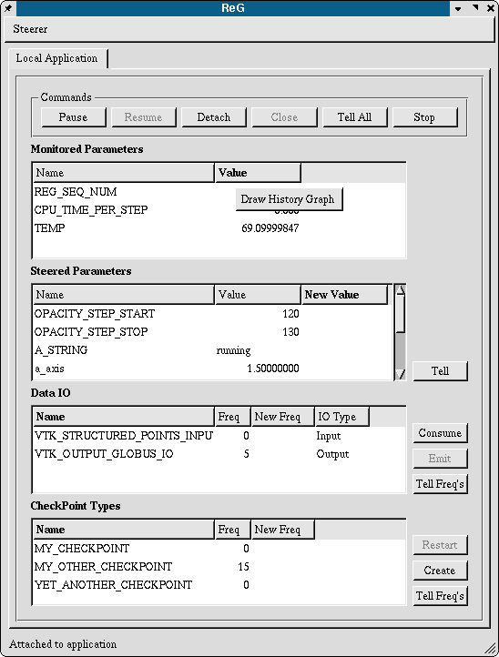
Draw History Graph context menu option

Parameter History Graphs

Selecting the Draw History Graph option from the context menu causes a new window to appear, containing a simple 2D line plot of the selected parameter’s history.

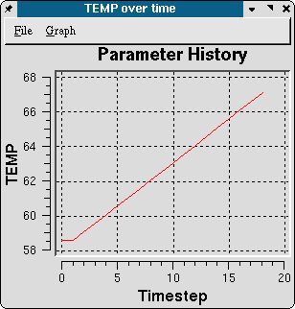
Parameter History Graph

There are two menu’s available in this window, the File menu, and the Graph menu.

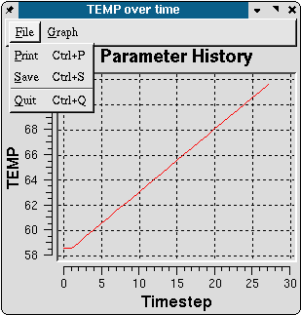
Parameter History Graph: File menu

The File menu has three options:
- Print causes a print-out of the image portion of the window to occur. Shortcut Ctrl+P
- Save saves the image portion of the window to disk. Shortcut Ctrl+S
- Quit closes the window. Shortcut Ctrl+Q

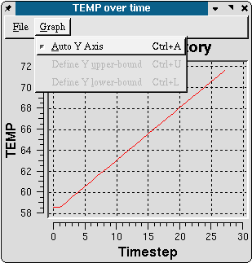
Parameter History Graph: Graph menu

The Graph menu also has 3 options:
- Auto Y Axis allows the application to automatically determine the extents of the y-axis. This menu item toggles on and off. Shortcut Ctrl+A
- Define Y upper-bound if Auto Y axis is not selected, this menu item becomes available. By selecting it, a dialog appears (see below) allowing you to enter an upper bounds for the Y axis of your choosing. If Auto Y Axis is reselected, then this value is ignored. Shortcut Ctrl+U
- Define Y lower-bound as ‘Define Y upper-bound’, but for the lower bound. Shortcut Ctrl+L

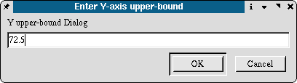
Y axis upper-bound dialog

Steered Parameters

The Steered Parameters list box contains a list of all steerable parameters exposed by the current job. The first column ‘Name’ lists the names of each of the parameters, the second ‘Value’ shows the current value for each parameter, and the third ‘New Value’ allows you to enter new parameters. Holding the mouse over an entry in the third column brings up a tool tip showing the minimum and maximum allowable values for that parameter. Clicking in an entry in the ‘New Value’ column allows a new value to be entered.

New values are only propagated to the running job when the ‘Tell’ button is clicked. When this happens the entries in the ‘Value’ column are updated to reflect the new values, and any entries in the ‘New Value’ column are cleared. This action is also performed if you click on the ‘Tell All’ button in the Commands button panel.

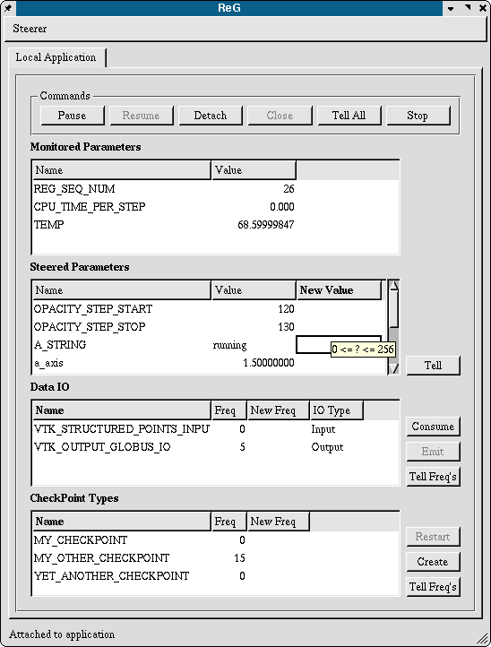
Steered Parameters tool tip

Data IO

The Data IO table lists all data input and output paths available to the current job. The ‘Name’ column lists the name of each data item, the ‘Freq’ column lists how often each data item is written or read (in time steps), the ‘New Freq’ column allows you to specify a new frequency for each item, and the ‘IO Type’ column indicates whether the data item is an input or an output. Each individual entry is either an input or an output, not both. As with the steered parameters table, updates made are not propagated to the current job until either the ‘Tell Freq’s’ button , or the ‘Tell All’ button in the Commands button panel is clicked.

You can manually force a data import or export, in addition to the automatic events. To do so, select an entry from the table, and click on the ‘Consume’ or ‘Emit’ button at the right of the table. Only one of the buttons will be available for each entry, depending on whether it is a data input or output.

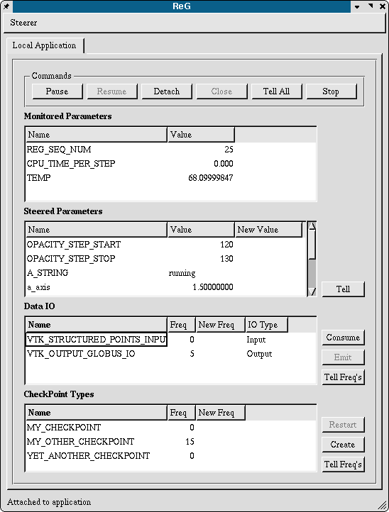
Main Window Data IO Table selection

CheckPoint Types

The CheckPoint Types table lists a job’s checkpoint types; that is the number of types of checkpoint that the running job can take. There can be many instances (checkpoints) of each checkpoint type, and a job may expose several checkpoint types, which differ in the parameters and data values they record. The majority of jobs will only need a single checkpoint type.

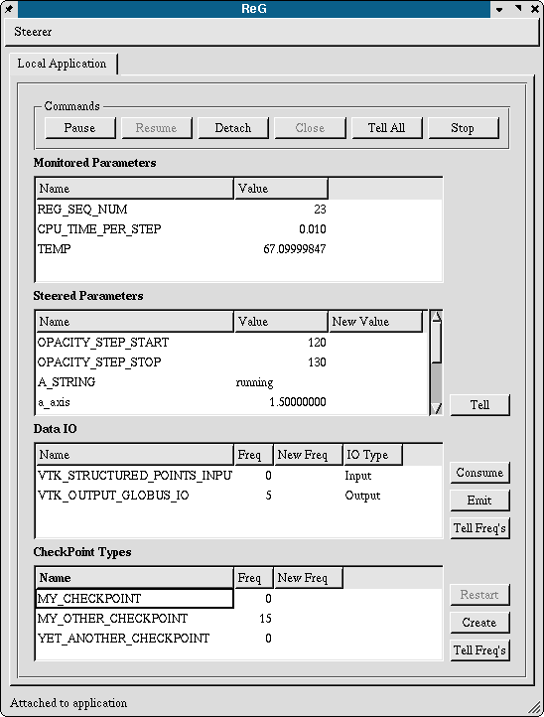
Main Window CheckPoint Type selection

The ‘Name’ column lists the names of each checkpoint type, the ‘Freq’ column lists the frequency with which checkpoint are automatically taken (in time steps), and the editable ‘New Freq’ column allows you to enter new values for a checkpoint’s frequency. As with the Steered Parameter values, new frequency values are only propagated to the running job when either the ‘Tell Freq’s’ button or the ‘Tell All’ button in the Commands button panel is pressed.

Checkpoints (checkpoint type instances) can be created or restarted by means of the ‘Create’ and ‘Restart’ buttons to the right of the main table. These buttons will be greyed out and unavailable by default, only becoming active if a single checkpoint type has been selected which is creatable in the case of the ‘Create’ button, and has pre-existing checkpoint instances in the case of the ‘Restart’ button.

After clicking on the Create button for a valid checkpoint type, a checkpoint instance for the selected checkpoint type will be transparently taken. >is there a response from the app? – there should be<

After clicking on the Restart button for a valid checkpoint type, a dialog is presented listing all the checkpoint instances for that type. You can select a checkpoint instance from the list, and restart it by clicking on the ‘Restart’ button. Clicking on ‘Cancel’ quits the dialog without doing anything.

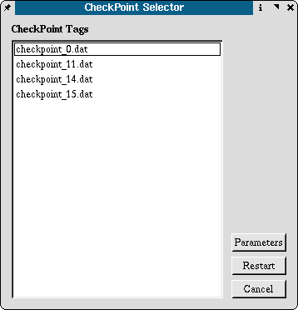
CheckPoint Selector dialog

In order to help differentiate between checkpoint instances, it is possible to inspect the parameters of each by clicking on the ‘Parameters’ button. This brings up another dialog, which lists the checkpoint instance’s parameters and their values at the time the checkpoint was taken. It is possible to have several Checkpoint Parameters Table dialog’s open at the same time, so that different checkpoint instances can be compared and contrasted.
Again, clicking on the ‘Cancel’ button closes the dialog.

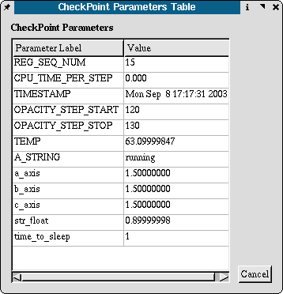
CheckPoint Parameters Table dialog

Index

A
Attach · 2
C
CheckPoint Types · 11
Control Buttons · 5
D
Data IO · 10
I
Introduction · 1
M
Monitored Parameters · 6
P
Parameter History Graph · 6
S
Starting the Steerer · 2
Steered Parameters · 9

