The RealityGrid Steering Grid Service.

Andrew Porter, Manchester Computing.

16th July 2003.

Introduction

This document describes the RealityGrid Steering Grid Service (SGS) – what it is, how to install it and how to use it.

Hosting Environment

The current implementation of the SGS is in Perl and uses the OGSI::Lite hosting environment created by M Mckeown. Although the Container will run under Perl 5.8, it is strongly recommended that Perl 5.6 be used as there are issues with sockets under 5.8.

The hosting environment and the SGS itself are available via CVS:

export CVS_RSH=ssh
export CVSROOT=:ext:<your_username>@bert.mvc.mcc.ac.uk:/usr/local/cvs

cvs co –P OGSI-Lite

In the OGSI-Lite directory created by this command there is an extensive README file giving details on the launching and use of the Container.

Use Case

For the purposes of this document we will consider a grid application consisting of two components; a simulation and a visualisation. The simulation periodically produces data sets which are passed to the visualisation component. Each component has an associated grid-service (GS) interface provided by a separate SGS process, as shown in Figure 1.
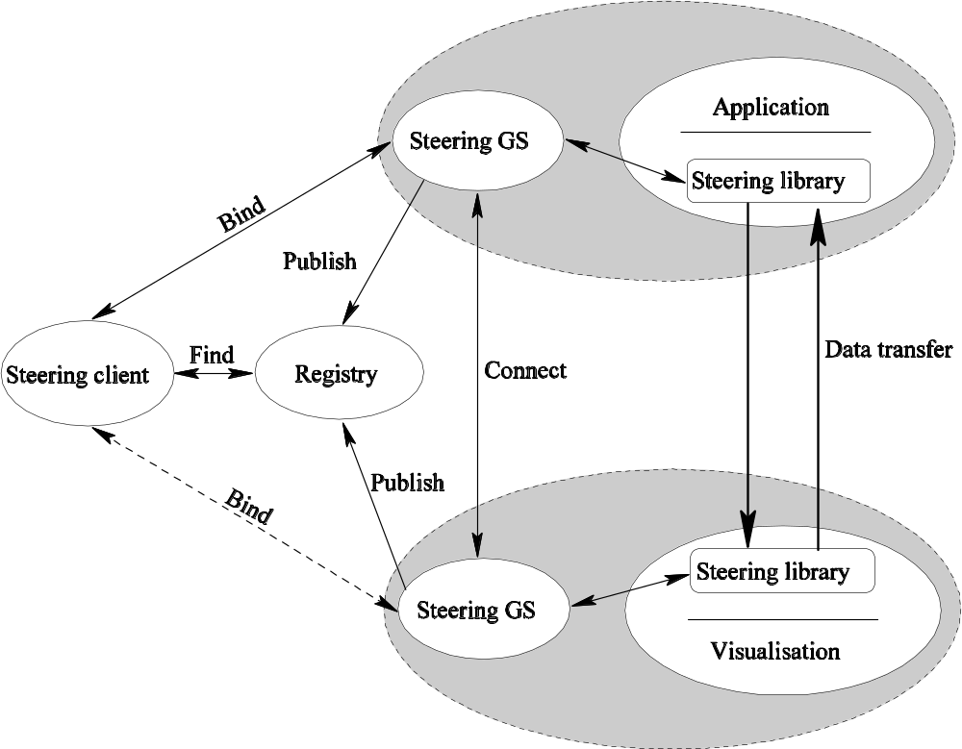
Figure 1: Architecture of example use case.
The grid application has an associated registry grid service that contains details of all of its constituent components. This allows another service (such as a steering client) to dynamically discover which components are steerable and how to contact them. It also facilitates the boot strapping of a sockets-based connection between the simulation and visualisation for the purpose of transmitting data.

In the next section we describe the steps required to construct this example grid application.

Launch Sequence – simulation component

This section assumes that you have the Perl hosting environment (referred to as a Container) up and running and its address is <container_address>. It also assumes that you have a simulation that has been ‘steering enabled’ and built against the RealityGrid steering library.

The basic sequence of steps that must be performed to launch the simulation is as follows:

- Create Registry factory GS
- Use factory to create Registry GS
- Create SGS factory GS
- Use factory to create SGS
- Register SGS with Registry
- Launch simulation and pass it address of SGS

This sequence is illustrated more fully in Figure 2. Once the simulation is up and running, it supplies the SGS with details of what commands it supports, what steerable parameters it has etc. This information is then available via the standard Grid Service method findServiceData.

We will now describe each of these steps in more detail:

Create Registry factory GS

This presents a bit of a chicken-and-egg scenario – what should create a factory? The standard way of doing this is an http ‘get’ command. In this case therefore, one does:

get <container_address>ServiceGroupRegistration/factory

On successful execution of this command, one is returned a Grid Service Handle (GSH) for the factory. This will look something like <container_address><long sequence of digits> and is the address that one uses to contact the service.

Create Registry GS

This is done by calling the standard CreateService method of the factory service we created in the first step. This method takes one argument, the ogsi:terminationTime of the requested service. Using the Perl SOAP::Lite package this would be done as follows:

my $func = “CreateService”;
my $result = SOAP::Lite
->uri(“factory”)
->proxy(“$ServiceGroupRegistration_factory_GSH”)
->$func(“<ogsi:terminationTime after =\”infinity\”/>”);

The CreateService method returns a locator and a termination time for the new grid service. The locator must be parsed in order to obtain the GSH for the newly-created SGS.
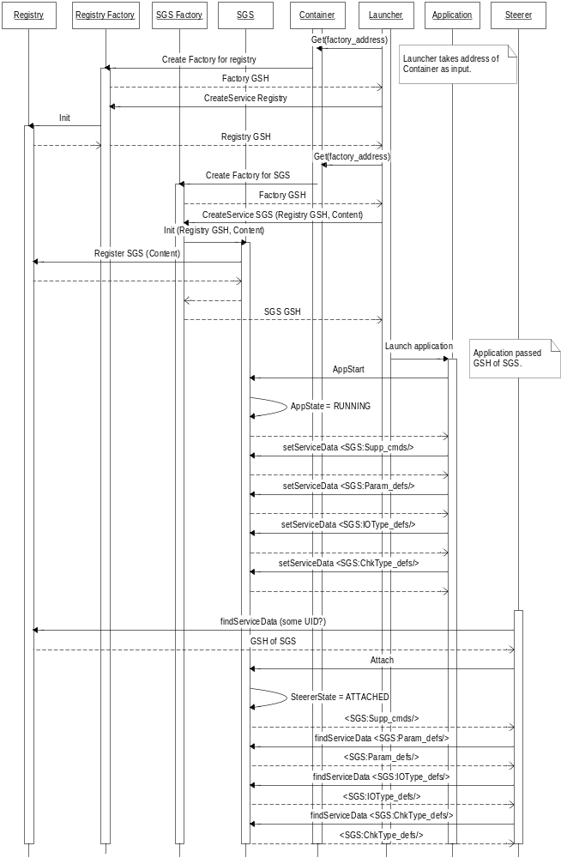
Figure 2: Sequence diagram showing simulation start-up.
Create SGS factory GS & Create SGS

These two steps are basically a repeat of the two just described with SGS replacing ServiceGroupRegistration.

Register SGS with Registry

This is achieved by calling the add method of the ServiceGroupRegistration service. In SOAP::Lite this looks like:

my $location = <<EOF;
<ogsi:locator>
<ogsi:handle>$sgs_GSH</ogsi:handle>
</ogsi:locator>
EOF

my $content = “Simulation”;
my $timeToLive = “<ogsi:terminationTime after=\”infinity\”/>”;
my $func = “add”;
my $result = SOAP::Lite
->uri(“ServiceGroupRegistration”)
->proxy(“$ServiceGroupRegistration_GSH”)
->$func($location, $content, $timeToLive);

The add method returns a locator and termination time for the resulting service entry (each entry in a ServiceGroupRegistration is itself a GS).

Launch simulation and pass it address of SGS

The address of the SGS (its GSH) is passed to the simulation by setting the REG_SGS_ADDRESS environment variable before starting the executable.

Launch Sequence – visualisation component

Once the simulation component (consisting of the application and associated SGS) is up and running, we can add our visualisation component to the grid application. The steps for doing this are as follows:

- Query the registry for the Grid Service Handle of the simulation SGS
- Query the SGS to discover what IOTypes it has
- Choose one or more suitable IOTypes to be used as input to the visualisation
- Create SGS factory GS (or possibly use existing factory service)
- Create SGS for visualisation component
- Register this SGS with Registry
- Initialise SGS with info. on selected data source(s)
- Launch visualisation and pass it address of its SGS
- Visualisation component connects to selected source when Register_IOTypes called

This sequence is illustrated more fully in Figure 3. As before, we now treat each of these steps in more detail.

Query the registry for the Grid Service Handle of the application SGS

We use the standard findServiceData method for this. In SOAP::Lite this is done as follows:

my $func = “findServiceData”;
my $sgs_list = SOAP::Lite
->uri(“ServiceGroupRegistration”)
->proxy(“$registry_GSH”)
->$func(“<ogsi:queryByServiceDataNames names=\”ogsi:entry\”/>”)
->result;

This query returns an xml document containing the handles and ‘content’ (supplied by us as an argument to the add method) of each service registered.

Query the SGS to discover what IOTypes it has

Again, we use the findServiceData method to do this – calling it for the GS with the GSH we obtained in the first step. The query string for this step is:
<ogsi:queryByServiceDataNames names=\”SGS:IOType_defs\”/>.
This returns an XML document containing the definitions of the various IOTypes that the simulation has registered.

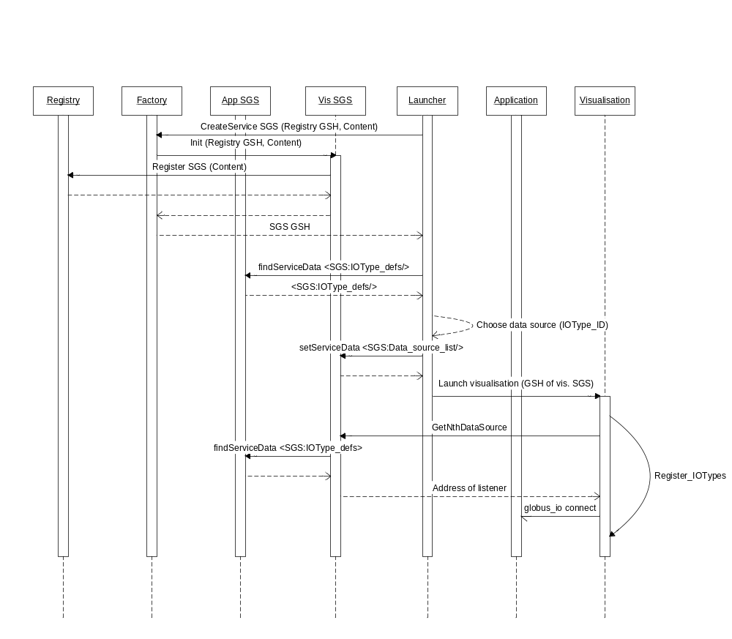
Figure 3: Launching sequence for visualisation component.
Choose one or more suitable IOType(s) to be used as input to the visualisation

It is up to us to parse the document obtained in the previous step to find those IOTypes that are for output and match our requirements – maybe by giving the user a list of the labels associated with these IOTypes and letting them choose at deployment time. (This assumes that the labels act as Unique Identifiers for the IOTypes.)

Create SGS factory GS, create SGS for visualisation component & register this SGS with Registry

These three steps are essentially identical to those performed in launching the SGS associated with the simulation. The only difference is likely to be the ‘content’ specified when registering the service as this needs to identify the component as being some sort of visualisation (e.g. “vtk 4.2 volume visualiser”).

Initialise SGS with info. on selected data source(s)

For this we call the setServiceData method of our visualisation’s SGS and set its <SGS:Data_source_list> service data. In SOAP::Lite this can be done as follows:

my $dataSources = “<SGS:Data_source_list>
<SGS:Data_source>
<SGS:Source_GSH>“ . $GSH_of_sim_SGS . “</SGS:Source_GSH>
<SGS:Source_label>“ . $Chosen_IOType_label . “</SGS:Source_label>
</SGS:Data_source>
</SGS:Data_source_list>”;

my $func = “setServiceData”;
my $arg = "<ogsi:setByServiceDataNames>".$dataSources.
"</ogsi:setByServiceDataNames>";

my $result = SOAP::Lite
->uri(“SGS”)
->proxy(“$vis_SGS_GSH”)
->$func(“$arg”);

Launch visualisation and pass it address of its SGS

As with the simulation, this is done by setting the REG_SGS_ADDRESS environment variable prior to running the executable.

Visualisation component connects to selected source when Register_IOTypes called

The visualisation component must be built against the RealityGrid steering library and use its support for data sample consumption. When the call to Register_IOTypes is made, the library queries the SGS for the SGS:Data_source_list service data. Each successive IOType that is registered is mapped to successive entries in this list. Each entry contains the GSH for the SGS of the data source and the label of the IOType to use from that source. The visualisation SGS queries the specified SGS for the definition of that IOType and can thus discover how to connect to it (in the case of globus_io this requires a hostname and port).

Steering Protocol

The SGS makes use of both standard GS methods (such as setServiceData) and steering-specific methods in allowing a client to perform steering actions. The steering-specifc methods are summarised in the state diagram of the SGS which is shown in Figure 4.

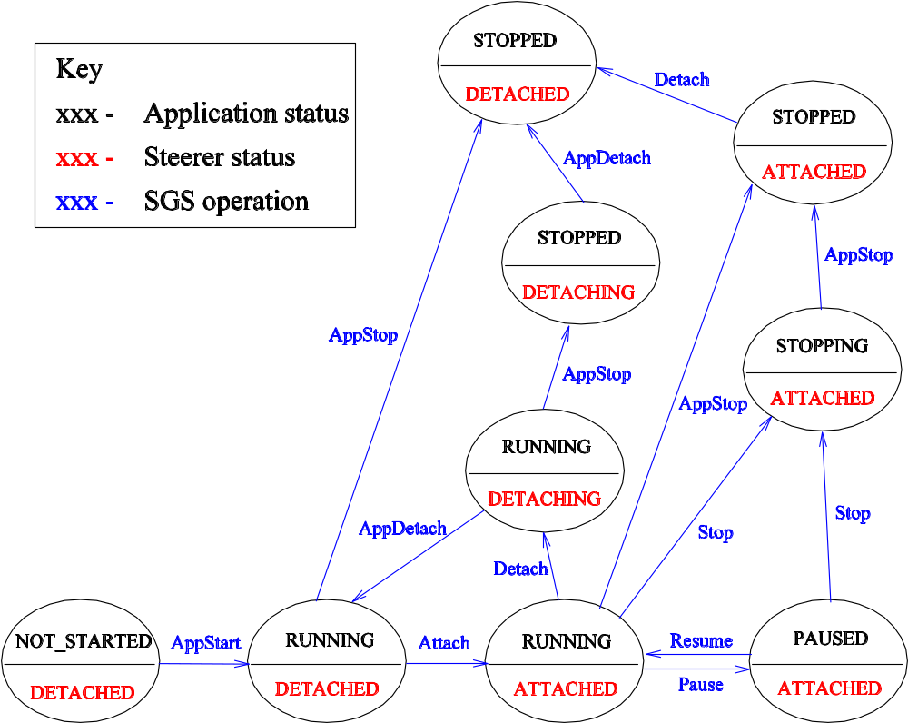
Figure 4: State diagram for the SGS.

Those methods beginning “App” are intended to be called by the simulation/visualisation program. All of the remainder are intended to be called by a steering client and take no arguments.

Methods supported by the Steering Grid Service

SGS-specific Client-side methods

Attach

If successful, returns an xml document containing the steering commands that the application supports. This document will be of the form:

<SGS:Supported_cmds>
<ReG_steer_message>
-
-
</ReG_steer_message>
</SGS:Supported_cmds>

i.e. it consists of a standard RealityGrid steering message (conforming to the http://www.realitygrid.org/xml/steering schema) wrapped by tags identifying which service-data element of the SGS it comes from.

If unsuccessful (e.g. if another steering client is already attached), returns “SGS_ERROR”.

Detach

Instructs the simulation that the steerer has detached. Simulation should call AppDetach to confirm.
Returns “SGS_SUCCESS” on successful completion, “SGS_FAILURE” otherwise.

GetNotifications

Returns a (space-delimited) list of the names of the service data elements that have changed since the last call of this method. Is then up to the client to get their new values using findServiceData. Intended for monitoring of e.g. simulation state (running, stopped etc.).

This method is a stop-gap – we should really be using the official grid service mechanisms for notification.

GetNthDataSource

Intended for use by visualisation components. Takes an integer argument (i.e. N) and returns the end-point of that data source. Currently this is globus_io specific and is of the form: hostname:address.

GetStatus

Returns the next status message emitted by the simulation or an empty string if no new status message is available. The status message is an XML document conforming to the RealityGrid steering schema.

Pause

Instructs the simulation to Pause. Returns “SGS_SUCCESS” or “SGS_FAILURE”. The latter may occur if the simulation’s state is not “RUNNING” (see Figure 4).

PutControl

Send a control message to the simulation. This message is an XML document conforming to the RealityGrid steering schema. Returns “SGS_SUCCESS” on successful completion, “SGS_FAILURE” otherwise (which may indicate that the SGS has run out of free buffers in which to store control messages).

Resume

Instruct a paused simulation to resume execution. Returns “SGS_SUCCESS” or “SGS_FAILURE”. The latter will occur if the simulation is not already paused.

Stop

Instruct a simulation to stop executing. Returns “SGS_SUCCESS” or “SGS_FAILURE”.

Generic grid-service methods

Destroy

Destroy the SGS. Only to be used for clean-up – no checking is done on the state of any attached steering client or simulation.

findServiceData

Query the grid service to find the content of the specified service data element(s). See the OGSI specification.

setServiceData

Set the content of the specified service data element(s). See the OGSI specification.

Internal methods – called by the process for which the SGS is the interface

AppStart

Called to signal the SGS that the simulation (or visualisation) is now running/available to be steered.

AppStop

Called to signal the SGS that the simulation is no-longer available to be steered.

AppDetach

Called by the steered component to confirm receipt of a Detach command.

GetControl

Used to get the next control message from the steering client. Returns an XML document conforming to the RealityGrid steering schema or an empty string (if no message available).

PutStatus

Used to send a status message to an attached steering client. Again, the message is an XML document conforming to the RealityGrid steering schema.

Strictly speaking it is therefore also a Grid Service Reference but the Perl hosting environment does not differentiate between a reference and a handle.

