Computational Steering in RealityGrid

DRAFT 0.5

August 16, 2002

Stephen Pickles, Robin Pinning, Andrew Porter¹, Graham Riley, Rupert Ford, Ken Mayes², David Snelling³, Jim Stanton ⁴, Steven Kenny ⁵, Shantenu Jha⁶.

1. Manchester Computing, University of Manchester
2. CNC, Department of Computer Science, University of Manchester
3. Fujitsu Laboratories of Europe
4. Department of Computing, Imperial College
5. Department of Mathematical Sciences, Loughborough University
6. Queen Mary, University of London

1. Background Assumptions and General Considerations

RealityGrid partners have prior experience of computational steering in various frameworks [Love, DIVE, Stanton]. The Cactus project [Cactus] and Brodlie [GRASPARC, COVISA] have also done notable work in this field.

Computational Steering in RealityGrid will be within a grid-enabled component framework [Mayer1, Mayer2], the details of which are currently under development.

Application scientists have pre-existing codes (hereafter referred to as simulations), which are to be made steerable. These codes are written in Fortran, C, C++ or a mixture of these, and can be compiled using standards-compliant Fortran90 and C/C++ compilers. These codes will in general be parallel, but it is desirable to avoid assuming or prescribing any particular paradigm (e.g. message passing or shared memory) or harness (e.g. MPI, PVM, SHMEM).

We assume that the simulation may be considered as a single component. We hope that this does not preclude future finer-grained componentisation within the simulation itself.

We assume that the logical structure within the simulation is such that there exists a point (breakpoint) within a larger control loop at which it is feasible to insert new functionality intended to
- accept a change to one or more of the parameters of the simulation (steerable parameters);
- emit a consistent representation of the current state of both the steerable parameters and other variables (monitored quantities);
- emit a consistent representation (provisionally called outsample) of part of the system being simulated that may be required by a downstream component (eg. a visualisation system or another simulation).
We would also like to assume that it is feasible, at the same point in the control loop, to
- output a consistent representation of the system (checkpoint) containing sufficient information to enable a subsequent restart of the simulation from its current state. This is likely to include all fundamental (as opposed to derived) physical fields, any required auxiliary fields (which might not be physically meaningful) and other variables such as simulation parameters and state of the random number generator;
- (in the case that the steered component is itself downstream of another component), to accept a sample emitted by an upstream component (provisionally called insample).

As our immediate concern is with making simulations steerable, we have chosen language that reflects that pre-occupation. However, it is our expectation that the above will easily generalise to other components. An example is a visualisation component that consumes outsamples emitted by an upstream simulation component – it should be possible to steer the visualisation within the same framework. In particular, it will be important to monitor quantities such as the rate at which insamples are consumed by a visualisation or renderer component in order to throttle back the rate at which upstream outsamples are emitted – it is not possible to buffer such a data stream indefinitely.

It is undesirable to require a wholesale re-factoring of the simulation in order to make it steerable. At the same time, we want generic solutions that can be re-used across a wide range of application codes. These considerations lead us to prefer a library-based approach.

During the course of the RealityGrid project, we will see changes to the implementation of computational steering (e.g. from file-based to communication-based steering) as well as evolution of the component framework itself. It is highly desirable to minimise the need to alter the application source code in the face of such changes. We therefore insist that the API seen by the application and implemented by the library makes no reference to any details of the underlying implementation. The application should not be aware of whether files or sockets are involved. Thus implementation-neutral terms like “emit” should be preferred to terms like “write”.

It is desirable to discourage a bifurcation of steerable and non-steerable versions of the application source code. It is also desirable to be able to validate the results of a steerable binary against a non-steerable binary. These considerations lead us to recommend that provision be made for a null form of the library that provides the necessary backwards compatibility.

It is desirable to mandate a common set of control commands that every steerable application will be required to respect (or at least recognise), along with standard status information that every steerable application is required to emit for the benefit of the steerer. By doing this we make it possible to develop, as separate components, generic steering controls that can manage any RealityGrid-compliant steerable application, providing real added value. For example, a generic steerer could conceivably provide facilities such as pause/resume, attach/detach, logging, checkpoint management, windback and replay.

At the same time, it is expected that the set of steerable parameters and monitored quantities (collectively known as user parameters) will vary from application to application. The co-operation of the application code will be required to carry out the mapping of user parameters passed though the steering library onto the internal variables of the application, and also to perform the reverse mapping.

2. Functionality

We note that the existing file-based steering framework [Love] does not explicitly provide the functionality emit_status. We however see this as a key ingredient of a comprehensive steering framework.

Figure 1 shows one possible steering configuration within the strawman architecture [Pickles]. In this diagram, deployed components are represented as shaded elipses and arrows represent data flow. This data may consist of commands, parameter values or large sets of simulation data. Solid arrows indicate data flow that can be controlled by the steering application. Dashed arrows refer to data flow that is independent of steering.

In this picture, a simulation is pushing data to a downstream component (in this case, a visualization component) and both are being steered by a single steering component. The architecture should allow for the complete absence of the steering component as far as one or both of the others are concerned. It should also be noted that while this picture shows a data-push model, it is equally possible that a data-pull model could be used.

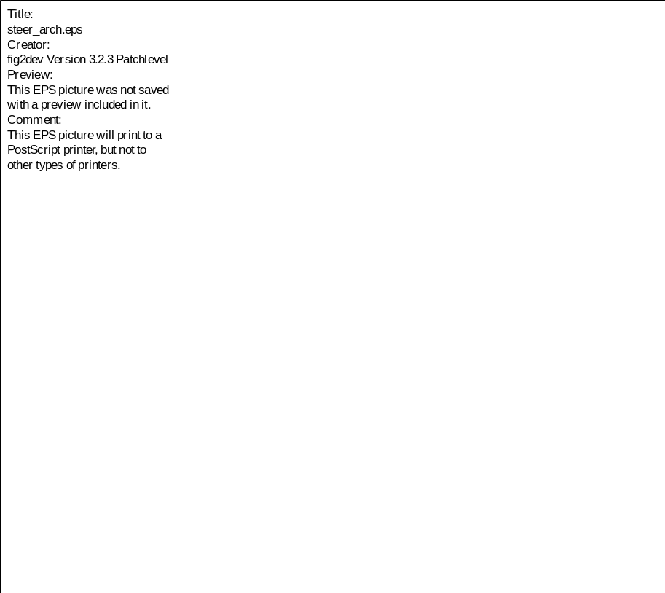
Figure 1: Steering within the strawman architecture. For a description of symbols see the text.

3. An API for Computational Steering

3.1 General

It is assumed that the control and status links will involve the exchange of small quantities of data. For cases where the steerable 'parameter' is a large array of data, it will be treated as a form of 'sample_data' with the steering application issuing instructions for it to be emitted and consumed as required.

The routine specifications given below are in C with the aim being to establish what information needs to be supplied to each routine and in what form. The API itself will provide FORTRAN, C and C++ bindings. For F90, the routine names will be those specified below (albeit in lower-case) with “_f” appended. All of the routines will be F90 subroutines and hence their return value is passed back to the caller by an additional ‘status’ argument (c.f. MPI).

All routines will provide integer return values with a return value of zero indicating success and a return value of unity indicating failure. (These quantities will be defined in a header file as REG_SUCCESS and REG_FAILURE, respectively, c.f. MPI.) Routines may use this return value to specify more detailed information on the nature of the success/failure – see individual interface specifications for details. All return values utilised by one or more of the steering routines are listed in Appendix B.

3.2 Null functionality of library

The library must incorporate a null form so that an application code that incorporates calls to the steering API will work efficiently in the absence of a steering utility. The simplest solution to this seems to be the use of a global flag with a check made on its value at the start of each routine in the steering API. A routine will be provided to allow the user to set this flag:

void Steering_enable(const int EnableSteer).

The default value of this flag will be FALSE (it may also be possible to set it using information supplied by the framework during initialisation of the component).

This functionality overlaps with that required for the situation where the simulation initially runs without steering but a steering application subsequently connects to it. In this case, it will be necessary to check for a requested connection each time Steering_control is called. This is distinct from the situation where the application scientist knows a priori that no steering will be available and hence does not wish to waste time checking for it. It therefore seems sensible to provide a second flag, used when steering is enabled, to indicate whether or not an active connection to a steering application exists.

3.3 Feedback from downstream components

As indicated in Figure 1, it will be necessary for downstream components that consume sample data to be able to report their status to the sources of the sample data. This overlaps with the area of performance monitoring since it gives the upstream component the ability to identify situations where a downstream component is unable to keep up. A possible way of dealing with this (as indicated in this API) is to reduce the frequency with which the upstream component emits sample data. A more sophisticated and framework-based approach would be to look for ways of dynamically improving the performance of the downstream component where possible.

4. Top-level simulation-side routines

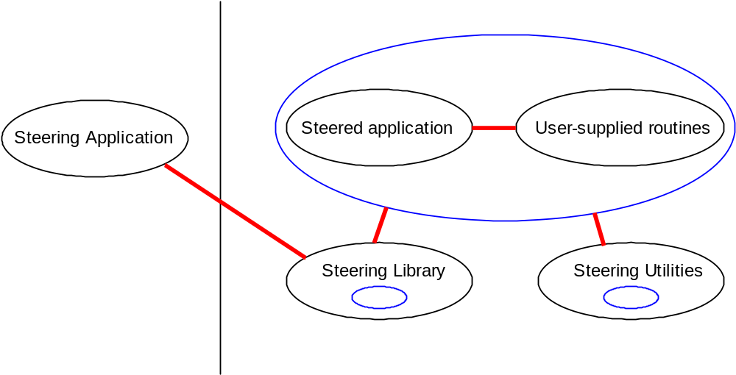
Figure 2: Architecture of a steered application and associated steerer.

The following routines in the API will directly concern the application scientist:

int Steering_initialize(int NumSupportedCmds,
int *SupportedCmds)

IN NumSupportedCmds No. of steering commands supported, int
IN SupportedCmds Array of supported commands, array of ints
RETURNS REG_SUCCESS, REG_FAILURE
Construct connection to steering application if available. Specifies which steering commands (pre-defined in a header file) the simulation supports.

int Register_IOTypes( int NumTypes,
char* *IOLabel,
int *IOType)

IN NumTypes No. of IO types to register, integer
IN IOLabel Unique label for each IOType, array of char*
OUT IOType Identifier of registered IO type, array of int
RETURNS REG_SUCCESS, REG_FAILURE
In order to enable the generic steering application to control the emission and consumption of different types of sample data and checkpoint, the steered application must register the different sample-data/checkpoint types that it supports. IOType is then used as the identifier of this sample/checkpoint type. This routine is cumulative in its operation in that the IOTypes passed to it are appended to the internal list of any IOTypes registered in previous calls.
It is assumed that the mapping from IOLabel to a Grid source/sink is performed using the component framework.

int Register_params( int NumParams,
char* *ParamLabels,
int *ParamSteerable,
void **ParamPtrs,
int *ParamTypes)

IN NumParams Number of params to register, int
IN ParamLabels Label for each parameter, array of char*
IN ParamSteerable 1 if parameter steerable, array of int
IN ParamPtrs Pointer to parameter value, array of void*
IN ParamTypes Datatype of parameter, array of integers
RETURNS REG_SUCCESS, REG_FAILURE
Register the provided list of parameters with the library. The labels must be unique as they will be used to identify individual parameters. The ParamSteerable array identifies whether each parameter is steerable or not. Since the quantities being registered with the steering library are pointers, it is a requirement that the variables to which they refer remain in scope through multiple Steering_control calls (i.e. until Steering_finalize is called).

This routine may be called more than once and at any time (whether or not Steering_initialize has successfully initiated a connection with a steering application). The assumption here is that the library’s internal tables of parameters will remain unchanged by the (dis)connection of a steering application.

Multiple calls to this routine have a cumulative effect. i.e. Every successful call to this routine results in the addition of the specified parameters to the table of registered parameters within the library.

When called from C, the pointers in ParamPtrs may be to variables of different types. The type of each pointer will be specified by the ParamTypes array using some coding scheme in which integers refer to different types. (This coding scheme will be defined within header files, c.f. MPI.)

int Unregister_params( int NumParams,
char **ParamLabels)

IN NumParams No. of parameters to unregister, integer
IN ParamLabels Labels of params to unregister, array of char*
RETURNS REG_SUCCESS, REG_FAILURE
Removes the steered parameters (identified by the labels in SteerParamLabels) from the steering library such that their values will no longer be reported to the steering application or adjusted from within the library.
int Steering_control(int SeqNum,
int *NumSteerParams,
char* *SteerParamLabels,
int *NumSteerCommands,
int *SteerCommands)

IN SeqNum Indicator of application’s progress, int
OUT NumSteerParams No. of modified steering params, int
OUT SteerParamLabels Labels of modified params, array of char*
OUT NumSteerCommands No. of commands returned to application, int
OUT SteerCommands List of steering commands, array of int
RETURNS REG_SUCCESS, REG_FAILURE
This routine will be called at the breakpoint referred to in the background assumptions described earlier.

It will:
- check for and allow a steerer to connect if simulation not already being steered;
- retrieve the (new) values of the steerable parameters from the steering application and update the associated simulation variables via the pointers supplied at their registration;
- retrieve any commands from the steering application – those that must be handled by the application itself are returned as a list (encoded as integers) in SteerCommands. It is the application’s responsibility to deal with these commands in the order in which they occur in the list;
- report the current values of all registered monitoring parameters to the steering application.

It will recognise and handle (internally) the following pre-defined commands:

- set_sample_emit_frequency;
- set_sample_consume_frequency;
- detach (issued when steerer wants to end steering session).

This list may be altered without changing the API itself.

As an aid to the application programmer, the returned list of labels identifies which of the steering parameters have been changed by the steering application. (The values themselves will have been updated using the pointers previously registered with the library.)

The commands that the application may be expected to support are:
- Stop;
- Pause/resume;
- Emit a checkpoint (of type IOType);
- Consume a checkpoint (of type IOType);
- Emit sample data (of type IOType);
- Consume sample data (of type IOType).

In the case of the ‘pause’ command, the library will provide a routine that supplies the necessary functionality, Steering_pause(). However, the application programmer is also free to provide their own routine, should they need to take actions while the simulation is paused (as may be the case with an experiment). Any ‘pause’ routine must periodically call Steering_control(…) in order to check for a ‘resume’ command.

int Emit_start ( int IOType,
int SeqNum,
int *IOHandle)

IN IOType Which registered IOType to emit, integer
IN SeqNum Indication of application’s progress, integer
OUT IOHandle Handle of opened IO channel, integer
int Consume_start (int IOType, int *IOHandle)
IN IOType Which registered IOType to consume, integer
OUT IOHandle Handle of opened IO channel, REG_IOHandleType
RETURN REG_SUCCESS, REG_FAILURE

Effectively, a call to 'open' some sort of I/O channel, which could be a file or a connection to another component – an implementation decision. The channel to open is identified by IOType, which must have been obtained from a prior call to Register_IO_type. It is assumed that Emit/Consume_data_slice can determine the destination associated with this particular type of checkpoint/sample data, e.g. by interrogating the component framework.

These routines are to be called on one thread only.

int Emit_stop(int *IOHandle)
int Consume_stop(int *IOHandle)

INOUT IOHandle Handle of IO channel to close, integer
RETURNS REG_SUCCESS, REG_FAILURE

Signal the end of the emission (or consumption) of the sample or checkpoint referred to by IOHandle. The value held by IOHandle is not a valid handle once this call has completed. These routines should be called by the same, single, thread that made the corresponding call to Emit/Consume_start.

int Emit_data_slice (int IOHandle,
int DataType,
int Count,
void *pData)

IN IOHandle IO channel to use for emission, integer
IN DataType Type of data to emit (int, float etc.), integer
IN Count No. of elements in array to emit, integer
IN pData Ptr. to array to emit, array of void*
RETURNS Routine not yet implemented
This will wrap the low-level I/O necessary for emitting the sample data (e.g. to filestore or to another component, depending on the implementation) or for checkpointing. It should be called on the same thread that called Emit_start.

The application programmer is responsible for collecting sample/checkpoint data (in portions if necessary) and passing it to this routine. They are also responsible for reconstructing/identifying it in the downstream component. An example of the proposed usage of this routine is given in the next section.

IOHandle is the handle returned by a prior call to Emit_start.

int Consume_data_slice( int IOHandle,
int *DataType,
int *Count,
void **pData)

IN IOHandle IO channel to use for consumption, integer
OUT DataType Data type of data being consumed, integer
OUT Count No. of data items consumed, integer
OUT pData Ptr. to array containing consumed data, array void*
RETURNS Routine not yet implemented
Wraps the low-level IO for receiving sample data from another component or for consuming a checkpoint. IOHandle is obtained from a call to Consume_start and thus identifies the type of sample/checkpoint data being consumed. As well as the return values of REG_SUCCESS and REG_FAILURE, this routine may also return REG_EOD when no more data of the requested sample type is available.
This routine must be called on the same thread that called Consume_start.

int Steering_finalize()
RETURNS REG_SUCCESS, REG_FAILURE
Close the connection to the steering application. Clears the internal library tables of registered parameters and sample-data/checkpoint types. Reverts steering library to the state it had prior to original call to Steering_initialize. Application cannot be steered following this call (unless a further call to Steering_initialize is made).

int Steering_pause( int *NumSteerParams,
char **SteerParamLabels,
int *NumCommands,
int *SteerCommands);

OUT NumSteerParams No. of parameters edited by steerer, integer
OUT SteerParamLabels Labels of those params, array of char*
OUT NumCommands No. of commands sent by steerer, integer
OUT SteerCommands Commands sent by steerer, array of integer
RETURNS REG_SUCCESS, REG_FAILURE
Intended to be called by the application in response to a 'pause' command from the steerer. Blocks until a 'resume' or 'stop' command is received. Returns all commands that immediately followed a 'resume' command as well as the labels of any parameters edited in that particular message. (Parameters can be edited while the application is paused because this routine continually calls Consume_control until it receives 'resume' or 'stop'.)

Example usage of Emit_data_slice

An example of the structure of an 'Emit_sample' routine, to be written by the application scientist (and therefore could in fact be called anything they like), is given below. This routine is called by the application in response to instructions returned by Steering_control. It is assumed that the MPI process of rank 0 is the process that calls Steering_initialize, Steering_control, etc.

int Emit_sample(int IOType, int SeqNum
<, + any other required arguments >){

int irank;
int count;
int nprocs;
int *data_ptr;
REG_SampleHandleType SampleHandle;

MPI_Comm_rank(MPI_COMM_WORLD, &irank);
MPI_Comm_size(MPI_COMM_WORLD, &nprocs);

if(irank == 0){

/* IOType corresponds to a previously registered sample
type */
Emit_start(IOType, SeqNum, &SampleHandle);
}

for(iproc=0; iproc<nprocs; iproc++){

MPI_Barrier(MPI_COMM_WORLD);

if(irank != 0 && irank == iproc){

/* Some code to get data_ptr and the quantity of data
(count) goes here... */

MPI_Send(&count, 1, MPI_INT, 0, Some_Tag, MPI_COMM_WORLD);
MPI_Send(data_ptr, count, MPI_DOUBLE, 0, Some_Tag,
MPI_COMM_WORLD);
}
else if(irank == 0){

/* Collect data on master process and then emit it... */

if(iproc != 0){

MPI_Recv(&count, 1, MPI_INT, iproc, MPI_ANY_TAG,
MPI_COMM_WORLD, &status);

/* Allocate memory if required */

MPI_Recv(pdata, count, MPI_DOUBLE, iproc, MPI_ANY_TAG,
MPI_COMM_WORLD, &status);
}
else{

/* Some code to get pdata and quantity of data (count)
on process 0 goes here */
}

Emit_data_slice(sampleHandle, REG_STR_DOUBLE, count,
pdata);
}

}

if(irank == 0){
Emit_stop(sampleHandle);
}

return 0;
}

5. Specification of routines for the steering-application side

These routines are intended to support whoever writes the steering application.

int Steerer_initialize();
RETURNS REG_SUCCESS, REG_FAILURE
Initialise the internal tables etc. used by the steering library on the steering application side. Must be called before all other steering-library routines.

int Steerer_finalize();
RETURNS REG_SUCCESS
Cleans up the internal tables etc. Must be called after all steering activity is complete.

int Sim_attach(REG_SimIDType SimID,
int *SimHandle)

IN SimID ID of sim. to attach to, REG_SimIDType
OUT SimHandle Handle of simulation, integer
RETURNS REG_SUCCESS, REG_FAILURE, REG_MEM_FAIL
Attach to the specified simulation. Returns SimHandle for use in future calls (since the steering application may be steering more than one component).

The way in which to specify the simulation to attach to is currently unknown - presumably this will depend upon the component framework.

int Sim_detach(int *SimHandle)

INOUT SimHandle Handle of simulation from which to detach, integer
RETURNS REG_SUCCESS
Detaches from the specified simulation and cleans up associated table entries and communication infrastructure. SimHandle will not be valid following the call.

int Delete_sim_table_entry(int *SimHandle);

INOUT SimHandle Handle of sim. to delete, int
RETURNS REG_SUCCESS, REG_FAILURE
Deletes all data associated with the simulation with handle SimHandle. Used when a simulation detaches. Supplied as separate interface because also required when simulation decides to detach.

int Consume_param_defs( int SimHandle)

IN SimHandle Simul’n from which to recv param definitions, int
RETURNS REG_SUCCESS, REG_FAILURE
Consume the parameter definitions emitted by the steered application. The internal table of parameters is updated ready for querying (e.g. in order to update the GUI).

int Consume_IOType_defs(int SimHandle)

IN SimHandle Handle of sim. from which to consume IOType defs, int.
RETURNS REG_SUCCESS, REG_FAILURE
Consume the IOType descriptions emitted by the steered application. These descriptions provide information to be displayed on the GUI in order to allow the user to request sample data/checkpoints to be emitted and consumed.

int Get_next_message(int *SimHandle,
REG_MsgType *msg_type);

OUT SimHandle Handle of sim. that emitted message, integer.
OUT msg_type Type of message received, REG_MsgType.
RETURNS REG_SUCCESS
Looks for the next message from any attached simulations. If it finds one then it returns the handle of the originating simulation and the type of message. If it fails to find a message then it returns REG_FAILURE.

int Emit_control( int SimHandle,
int NumCommands,
int *SysCommands)

IN SimHandle Handle of sim’n to send control data to, int
IN NumCommands No. of commands to send, integer
IN SysCommands Commands to send to sim’n, array of int
RETURNS REG_SUCCESS, REG_FAILURE
Transfer the steering commands and any new values for the steerable parameters (i.e. those altered since the last call of this routine) to the simulation. SimHandle identifies the simulation concerned as it is conceivable that we could be steering more than one component.

int Consume_status(int SimHandle,
int *SeqNum,
int *NumCommands,
int *SysCommands)

IN SimHandle Sim’n from which to consume status, int
OUT SeqNum Measure of progress of sim’n, integer
The following variables list any commands sent to the steerer from the application (e.g. ‘detach’).
OUT NumCommands No. of system commands recvd, integer
OUT SysCommands List of system commands recvd, array of int
RETURNS REG_SUCCESS, REG_FAILURE, REG_MEM_FAIL
Retrieve the status of the simulation being steered, along with any commands that the simulation has sent to the steerer (e.g. notification that it has finished).

Any parameter values received by this routine are automatically used to update the internal library table of parameters.

int Get_param_number(int sim_handle,
int steerable,
int *num_params);

IN sim_handle Specify which simulation entry to query, integer
IN steerable Specify whether steerable (1) or monitored (0), int
OUT num_params The no. of <steerable> params registered, int
RETURNS REG_SUCCESS, REG_FAILURE
Gets the number of <steerable> parameters associated with the simulation with handle sim_handle. i.e. if steerable==TRUE then this returns the number of steerable parameters that the simulation has.

int Get_param_values(int sim_handle,
int steerable,
int num_params,
int *handles,
char* *labels,
char* *vals);

IN sim_handle Sim. handle for which to retrieve param. vals, int
IN steerable Whether to get steerable (1) or monitored (0), int
IN num_params No. of param vals to get, integer
OUT handles List of handles of params, array of int
OUT labels List of param labels, array of char*
OUT vals List of param vals as strings, array of char*
RETURNS REG_SUCCESS, REG_FAILURE
Gets the first num_params, steerable parameters associated with the simulation with handle sim_handle. Returns the handles, labels and values (as strings) of these parameters. handles, labels and vals must all point to chunks of memory large enough to receive num_params entries.

int Set_param_values(int sim_handle,
int num_params,
int *handles,
char* *vals)
IN sim_handle Handle of sim. whose params to update, int
IN num_params No. of params to update, int
IN handles List of param handles, array of int
IN vals List of associated vals as strings, array of char*
RETURNS REG_SUCCESS, REG_FAILURE
Sets the values of the parameters with the specified handles for the simulation with handle sim_handle. Causes internal flags to be set to indicate that these parameter values have changed.

int Get_iotype_number( int sim_handle,
int *num_iotypes)

IN sim_handle Handle of sim. table entry to query, int
OUT num_iotypes No. of IO types registered, integer
RETURNS REG_SUCCESS, REG_FAILURE

Gets the number of IO types associated with the simulation with handle sim_handle.

int Get_iotypes( int sim_handle,
int num_iotypes,
int *handles,
char* *labels)

IN sim_handle Handle of sim. to get IO types for, int
IN num_iotypes No. of IO types to retrieve, int
OUT handles List of handles of IO types, array of int
OUT labels List of labels of IO types, array of char*
RETURNS REG_SUCCESS, REG_FAILURE

Gets the first num_iotypes IO types associated with the simulation with hand sim_handle. Returns the handle and label associated with each IO type.

int Dump_sim_table();
RETURNS REG_SUCCESS, REG_FAILURE
A debugging routine - writes the complete contents of the internal table holding information on all connected simulations to ./sim_table.txt

6. References

[Cactus] http://www.cactuscode.org/index.html.

[Chin] A Use Case for the LB3D Simulation Code, J. Chin, S. Jha, J. Harting, RealityGrid internal document, May 2002.

[COVISA] Collaborative Visualization, Jason Wood, Helen Wright and Ken Brodlie, Proceedings of IEEE Visualization 97, 253-259, 1997.

[DIVE] DIVE: Distributed Interface to Visualisation Environment, EPCC-SS96-12, Bálint Joó.

[GRASPARC] GRASPARC – A Problem Solving Environment Integrating Computation and Visualization, K. Brodlie et al.

[Love] P. J. Love and J. M. R. Martin, Steering High-Performance Parallel Programs, A Case Study, Comm. Process Arch. 2000, 99, edited by P. H. Welch and A. W. P. Bakkers.

[Mayer1] Component Programming Model, Anthony Mayer, presentation delivered at RealityGrid CS Meeting 15 May 2002.

[Mayer2] Meaning and Behaviour in Grid Orientated Components and Appendix: RealityGrid Examples, Anthony Mayer et al.

[Pickles] Architecture presented by Stephen Pickles at the RealityGrid CS Meeting, 11th April 2002

[Stanton] Collaborative Scientific Visualisation Within a Grid Enabled Component Framework, J. Stanton, S. Newhouse, J. Darlington, 2002.

[Visit] Visit – a Visualization Interface Toolkit, Version 1.0, T. Eickermann and W. Frings, 2000.

Appendix A: F90 bindings for the application-side routines

In the following, where a routine argument is an array, the routine should be passed the first element. The KIND parameters, REG_SP_KIND and REG_DP_KIND are defined in reg_steer_f90.inc and correspond to KIND(1) and KIND(1.0D0), respectively. The directory mini_app_f90 in the distribution contains an example of a very simple steerable ‘simulation’ written in F90.

SUBROUTINE steering_enable_f(EnableSteer)

IN EnableSteer Flag to enable/disable steering (1 or reg_true to
enable), INTEGER (KIND=REG_SP_KIND)

SUBROUTINE steering_initialize_f(NumSupportedCmds, SupportedCmds,
Status)

IN NumSupportedCmds Number of supported cmds, INTEGER
(KIND=REG_SP_KIND)
IN SupportedCmds List of supported cmds, array of INTEGER
(KIND=REG_SP_KIND)
OUT Status Routine return status, INTEGER
(KIND=REG_SP_KIND)

SUBROUTINE steering_finalize_f(status)

OUT Status Routine return status, INTEGER (KIND=REG_SP_KIND)

SUBROUTINE register_iotypes_f(NumTypes, IOLabel, IOType, Status)

IN NumTypes No. of types to register, INTEGER (KIND=REG_SP_KIND)
IN IOLabel List of associated labels, array of CHARACTER
IN IOType List of associated handles, array of INTEGER
OUT Status Return status, INTEGER (KIND=REG_SP_KIND)

SUBROUTINE register_params_f(NumParams, ParamLabels, ParamSteerable,
ParamPtrs, ParamTypes, Status)

IN NumParams No. of params to register, INTEGER
(KIND=REG_SP_KIND)
IN ParamLabels Label of each param, array of CHARACTER
IN ParamSteerable Whether each param steerable (1 or reg_true),
array of INTEGER (KIND=REG_SP_KIND)
IN ParamPtrs ptr to each sim. variable, array of REAL or
INTEGER (KIND=REG_SP_KIND or REG_DP_KIND)
IN ParamTypes Type of each parameter, array of INTEGER
(KIND=REG_SP_KIND)
OUT Status Routine’s return status, INTEGER
(KIND=REG_SP_KIND)

Note that if the parameter to be registered is a string then steering_char_to_ptr_f must be called first in order to retrieve a pointer to the string, returned as an integer. This integer should then be supplied in the normal way to register_params_f with ParamTypes set to REG_CHAR.
Since F90 uses call by reference, the ParamPtrs variable supplied to this routine need only be the variable that is to be registered. The underlying C library is then able to retrieve a pointer to this variable.

SUBROUTINE consume_start_f(IOType, IOHandle, Status)

IN IOType Type of IO channel to open, INTEGER (KIND=REG_SP_KIND)
OUT IOHandle Handle by which to refer to this channel, INTEGER
(KIND=REG_SP_KIND)
OUT Status Routine return status, INTEGER (KIND=REG_SP_KIND)

SUBROUTINE consume_stop_f(IOHandle, Status)

IN IOHandle Handle of IO channel to close, INTEGER
(KIND=REG_SP_KIND)
OUT Status Return status of routine, INTEGER (KIND=REG_SP_KIND)

SUBROUTINE steering_control_f(SeqNum, NumSteerParams,
SteerParamLabels, NumSteerCommands,
SteerCommands, Status)

IN SeqNum Current seq. no. of simulation, INTEGER
(KIND=REG_SP_KIND)
OUT NumSteerParams No. of params modified by steerer, INTEGER
(KIND=REG_SP_KIND)
OUT SteerParamLabels Labels of modified params, array of CHARACTER
OUT NumSteerCommands No. of commands sent by steerer, INTEGER
(KIND=REG_SP_KIND)
OUT SteerCommands List of commands, array of INTEGER
(KIND=REG_SP_KIND)
OUT Status Routine return status, INTEGER
(KIND=REG_SP_KIND)

SUBROUTINE steering_pause_f( NumSteerParams, SteerParamLabels),
NumCommands, SteerCommands, Status)

OUT NumSteerParams No. of params modified by steerer, INTEGER
(KIND=REG_SP_KIND)
OUT SteerParamLabels Labels of modified params, array of CHARACTER
OUT NumSteerCommands No. of commands sent by steerer, INTEGER
(KIND=REG_SP_KIND)
OUT SteerCommands List of commands, array of INTEGER
(KIND=REG_SP_KIND)
OUT Status Routine return status, INTEGER
(KIND=REG_SP_KIND)

SUBROUTINE steering_char_to_ptr_f(string, ptr)

IN string String for which to retrieve pointer, CHARACTER;
OUT ptr ‘Pointer’ to string to be passed to register_params_f,
INTEGER (KIND=REG_DP_KIND)

This routine must be called prior to calling register_params for a string in order to obtain the pointer that will be registered.

Appendix A: Specification of application-side lower-level routines

These routines are not formally part of the specification. This part of the document should be viewed as preliminary material for discussion between implementers.

The following routines underlie the API but are not intended to be visible to or used by the application scientists. As such, it should be possible to modify their interfaces and implementation without altering the application codes that use the steering API.

int Emit_param_defs()

Pass all of the registered parameters to the steerer so that it can display them. Compare Consume_param_defs in section 5.

int Emit_IOType_defs()

Emit the labels and associated IOType handles for all registered IO types. Compare Consume_IOType_defs in section 5.

int Consume_control( int *NumCommands,
int *SysCommands,
int *NumSteerParams,
int *SteerParamHandles,
char* *SteerParamLabels)

OUT NumCommands Number of commands received, integer
OUT SysCommands List of commands received, array of int
OUT NumSteerParams Number of steerable params received, int
OUT SteerParamHandles List of param handles received, array of int
OUT SteerParamLabels List of param labels received, array of char*

Retrieves any system commands and steerable-parameter values from the steering application. Parameter values are automatically updated via the pointers stored in the internal tables – lists of associated handles and labels are passed back in order that the application may be informed of which variables have been updated.

int Emit_status( int SeqNum,
int NumParams,
int *ParamHandles,
int NumCommands,
int *SysCommands,)

IN SeqNum Indication of simulation progress, integer
IN NumParams No. of monitored params, integer
IN ParamHandles List of monitored param handles, array of int
IN NumCommands Number of commands to emit, integer
IN SysCommands List of commands to emit, array of integer

Emit a status report to be consumed by the steerer. NumParams and ParamHandles are intended to allow us to tell the steerer what we just received from it but this is not currently implemented. NumCommands and SysCommands are intended for the same purpose but are also used to send commands such as 'finish' (when sim. has finished) back to the steerer.

This routine could itself add extra information to the data passed back to the steering application such as the amount of cpu time remaining.

int Consume_ack(int IOType)

IN IOType, IO channel on which to consume acknowledgement, integer

Check for an acknowledgement from whichever component has consumed the last sample data of this type (i.e. check that it is ready for another data set).

int Emit_ack(int IOType)

IN IOType, IO channel on which to emit acknowledgement, integer

Emit an acknowledgement to the component from which the last sample data of type IOType was obtained to signal that this component is ready for more data.

int Generate_status_filename(char* filename)

IN filename, Root from which to generate filename, char*

Generate a filename (for a status message) from supplied root and internally-generated index.

int Detach_from_steerer()

Take down connection with steerer and clean-up table entries.

int Update_ptr_value(param_entry *param)

IN param, Param entry containing ptr to update, param_entry

Update the value of the variable pointed to by the pointer associated with the supplied param_entry.

int Get_ptr_value(param_entry *param)

IN param, Param entry whose value to update, param_entry

Update the 'value' field of the param_entry by retrieving the value of the variable pointed to by the pointer associated with the entry.

Appendix B: Return values

These will be defined in a header file and will have the following values:

Return label | Value
REG_SUCCESS | 0
REG_FAILURE | 1
REG_EOD | 2
REG_MEM_FAIL | 3

Appendix C: Dataflow

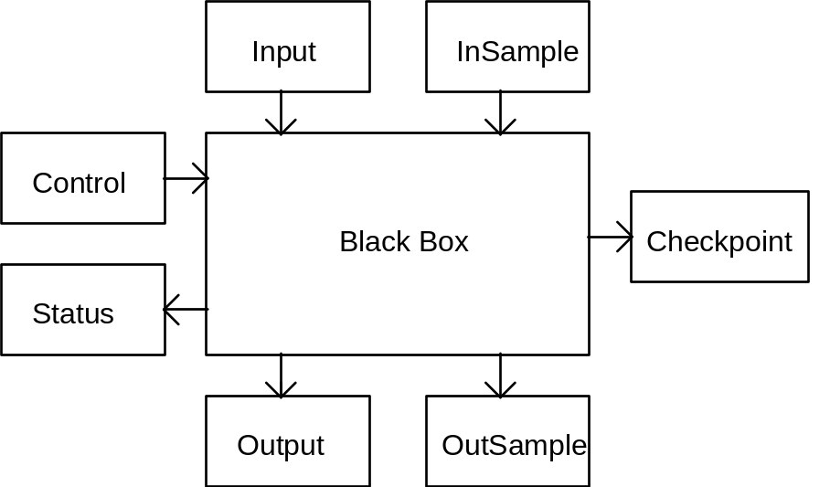

Dataflow connections of a steered simulation (black box).

- Simulation Application
  - Including (arbitrarily complex) runtime.
  - Configured and advertised by the site.
- Basic Simulation
  - Input Data (File) at start
  - Output Data (File) at end
- Steerable Simulation
  - Control and InSample consumed periodically
  - Status and OutSample created periodically
- Checkpoint
  - Checkpoint File created on request

