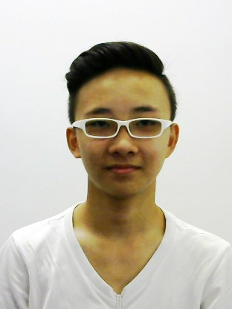

Name: Chua Guo Jun

Age:19

Gender: Male

Nationality: Singaporean

Contact: +65 9477 7953

Email: Chuaguojun@yahoo.com.sg

Address: West Coast Drive, Singapore 120508

**Personal Description**

I am very good at Info-comm Technology (IT) and I am a very fast and efficient learner. I can pick up and process new knowledge and skills at a relatively fast speed, and I believe that is one of my unique propositions. At the same time, if I am weak at doing something, I will not give up easily but persevere on as I believe that if I practise hard enough, I will be able to perfect the things I do. I have faith in myself and I am a confident individual who strives to bring out the best in himself.  
  
**Work Experience**  
Sushi Tei (2017 - Present)  
Responsibilities:

* Service Waiter
* Cashier
* Customer service
* Runner (Kitchen)

**Education**  
Higher Nitec (IT System & Network), April 2019 - Present  
*Institute of Technical Education (College West)*

* Sep 2019
* Computer Maintenance and Operating System: A
* Networking Technology: B
* GPA:3.5

Nitec (Networking & System Administration), January 2017 - December 2018  
*Institute of Technical Education (College West)*

* Jun 2017
* IT Essentials and PC Support
* Internet Fundamentals and Applications
* Essentials of Java Programming
* Dec 2017
  + Network Essentials
  + Server Essentials
  + Fundamentals of HTML5
* Jun 2018
  + Info-comm Project
* Dec 2018
  + Internetworking Technology: B
  + Server Administration: B
  + Software Applications Essentials: B

GCE ‘N’ Level, 2016  
*Tanglin Secondary School*

* Aggregate: ELMAB3: 9
* Volleyball School Team Captain 2013-2015
* House Captain 2015-2016
* Class Chairman 2015-2016

**Other Contribution**

* Services and Enrichment Programmes 2017: Certificate of Accomplishment
* Youth Expedition Project to Musekee, Chiang Mai, December 2019
* Silver Info-comm Fiesta 2019: Certificate of Appreciation
* Taman Jurong MakeFest 2019

**Other Achievement**

* CDC & CCC award 2019
* Data Analytics Competition 2019
* Joint ITE-Oracle Certificate in Essentials of Java Programming 2017
* Edusave Good Progress Award (GPA) 2018
* CCNA Routing and Switching: Introduction to Networks (2018)
* IT Essentials (2017)
* Introduction to Cybersecurity (2019)

**Personal Interests**

My interests and activities usually revolve around sports, especially volleyball and badminton. I enjoyed playing sports as it is a very good form of leisure entertainment. To relax myself in stress situations, I would tune in to music and watch my favourite Korean dramas. Furthermore, I enjoy watching cyber security documentaries that revolve around the importance of cyber security and hacking. Lastly, I love participating in community services as a form of contribution to the community and to enhance my personal experience.