Creativity Studies on the Reactable online community
Assessing the validity of distributed creativity models in an online community of creators

UPF MASTER THESIS / 2013
Supervisor
Dr. Sergi Jorda (Music Technology Group - MTG)

DEPARTMENT OF INFORMATION AND COMMUNICATION TECHNOLOGIES


ii
Acknowledgments
I wish to thank my supervisor Sergi for making this project possible through his tireless support, patience and interest in exploring whatever strange theory I was trying to get into. I would also like to thank everyone from the Reactable systems team, for providing me with the data for such a fascinating system to study, and to Thodoris, Marcos, Mathieu and Andres for their assistance and promptness to resolve any doubts I had. Thanks to Lucas for his interest and critical thinking.
My thoughts go out to my family and friends from CSIM, hoping I will share more of the excitement and passion for the systems that we shape and shape us.

iii

Abstract
The current thesis presents a creativity study of the online community built around the Reactable mobile application. By exploring the relationship between social exposure and creative production patterns as suggested by various frameworks for fostering distributed creativity, we assessed the validity of said models in the context of an online community of creators, by looking at predictors for both social influence and psychological creativity. We report on the Reactable community specificities and on how it shines light on contemporary cultural practices on the Internet for creators intending to showcase their work and create network bonds with their peers. Users's work that rely on previous work tends to be more appreciated, spread more, although their psychological creativity score is not significantly different.
Keywords : Reactable, online communities of creators, distributed creativity, autopoiesis systems, mobile music production,

v

Index
Abstract............................................................................................................................... v
1. Introduction......................................................................................................................1
  - Problem Statement.............................................................................................1
  - State of the Art...................................................................................................2
a) Psychological view..................................................................................2
b) Distributed creativity...............................................................................3
c) Online communities.................................................................................3
d) Online communities of creators...............................................................4
e) Autopoietic systems.................................................................................5
  - An introduction to the Reactable.......................................................................8

2. System Architecture.........................................................................................................9
2.1 Reactable Mobile...............................................................................................9
2.2 Reactable Community......................................................................................10
2.3 The systems......................................................................................................11
2.4 Data retrieval....................................................................................................11
  - Preliminary analysis.........................................................................................13
a) Field interacting with persons................................................................13
b) Domain interacting with persons...........................................................14
c) Field interacting with the domain..........................................................15
3. Methods..........................................................................................................................16
3.1 Objectives and hypothesis................................................................................16
  - Operationalization of the variables..................................................................16
a) Originality..............................................................................................16
b) Elaboration.............................................................................................17
c) Divergent thinking score........................................................................18
d) Confounding variables...........................................................................19
4. Results............................................................................................................................20
5. Discussion and conclusion.............................................................................................22
References..........................................................................................................................24
Appendix............................................................................................................................28
a) Result tables.......................................................................................................28
b Rails application for retrieving data and computing creativity scores................31

vi
1. INTRODUCTION
1.1 Problem Statement
In an era where boundaries between producers and consumers of culture are becoming everyday blurrier, and the transmission of culture has become equally important as its production, the case for creativity in a distributed context is inevitable. With the Internet and the emergence of distributed creativity, notions of authorship, copyright and fixity of cultural artifacts are questioned. Cultures of participation are a very active field of investigation, mostly driven by innovative business research in the knowledge economy trying to make the best out of this new economic paradigm (Fischer 2005, Faraj et al. 2011, Florida 2002).
On the other hand, creativity studies, although more than 60 years old already, still suffer from lack of a clear definition for what is creativity, and its assessment is still at an early stage. There is no real consensus over what class of entity is being studied, and psychological and social approaches emphasize different, apparently irreconcilable aspects of creativity (Klausnen 2010). Creatology (Iba 2010) proposes a new way to looking at creativity using autopoietic systems theory (Luhmann 1984, Maturana & Varela 1980), adding a third element to the equation, the creative system. Using systems theory, non-original creations are creative as long as they contribute to the autopoiesis of the creative system by successive discoveries.
Assuming systems exist, we studied the coupling of sociological, psychological and creative systems in a distributed setting where creators share, download, rate, remix and get inspired by others creations. The domain, supported by the constant creation of new tables that spread and are exoised through the Reactable Community website, gives hints to users as to what possibilities the application offers, and how to make music in order to be established within the field. The Reactable community offers a unique opportunity to study the systems because of the detail and amount of data available on psychological, sociological and creative behaviors of its members. We analyzed patterns of individual creative behavior, social behavior, and transmission of knowledge on the platform to find out what may be driving the autopoiesis of the reactable social and creative systems.

1.2 State of the Art
a) Psychological view
Boden defines creativity by its chief attributes as “the ability to come up with ideas or artefacts that are new, surprising and valuable”. (Boden, 2004). Creativity is generally associated with self-determination, intrinsic motivation and mastery (Amabile 1998, Csikszentmihalyi 1996, Robinson 2001, Nickerson 2009) in goal-oriented contexts such as education or the workplace. As the result of a heuristic process, where the goal is not necessarily clear every step of the way (Amabile 1996), it is best facilitated by providing a nurturing environment, where small rewards coming from the work produced maintain intrinsic motivation, and the right amount of challenge is matched with the right amount of skills to maintain flow (Csikszentmihalyi 1996). The creative process is about a specific use of associative memory. It is sometimes equated in the litterature with divergent thinking (Guilford, 1967). The Torrance Tests of Creative Thinking, based on Guilford's theory, originally involved simple tests were scored on four scales. fluency, flexibility, originality and elaboration. They are criteria of creative thinking and not of a creative product. In that sense, they are not necessarily predictors of an eminently creative product, but rather taken as evidence of a creative process, which is the tendency to come up with multiple answers to a set problem. Boden emphasizes the need for exploration and transformation of conceptual spaces in people's minds (Boden, 2004). Gabora's Honing theory (2009) explains that by describing the creative process as the process by which worldviews tend to resolve states of potentiality through self-organized transformation. As the worldview self-modifies through the interaction of the idea with newly generated contexts, new associations are made and insight is eventually triggered when the percolation threshold is reached in the graph of ideas and associations. Then a more analytical approach is needed, following a search and select heuristic where the smarts is not in the generation but in the selection of ideas. It is coherent with Wallas's widely accepted 4 phase model of the creative process (Wallas, 1926), preparation and incubation corresponding to the first stage, illumination to the moment the percolation threshold is reached, verification being essentially a search and select process.
Although mostly studied as the internal cognitive process of an individual as seen previously, creativity is generally recognized to be widely dependant on social acceptance. Klausnen raises the difficulty of dealing with a response-dependent phenomenon (Klausnen, 2010), where realist and anti-realist views are opposed. Either the creative person, process or product is creative independently of how it is experienced by a social circle, or it is not. Both views do not allow to determine where creativity is achieved. According to Csikszenmihalyi (1999), there is no way to separate the reaction of society from the person's contribution. When studying eminent individuals, some common traits that have been found include access to the field and support from a specialized community or individual (Gardner, 1993; Csikszenmihalyi, 1996). But for ones who made an unprecedented contribution to human culture, where the success of a meme is indistinguishable from its acceptance, creative thinking is not a guarantee of a historical achievement. P-creativity (Boden, 2004) is an idea that’s new to the person who comes up with it. Many other people may have had that idea before, but if a new idea is H-creative, that means that no-one else has had it before. To Boden, h-creativity is a special instance of p-creativity.

b) Distributed creativity
Csikszentmihalyi, on the other hand, describes it more in terms of its effect, saying that creativity is “when a person, using the symbols of a given domain, such as music, engineering, business or mathematics, has a new idea or sees a new pattern, and when this novelty is selected by the appropriate field for inclusion into the relevant domain”. (Csikszentmihalyi, 1996) Through the 1990s, a second wave of creativity research pursued the idea that creativity is embedded in social groups, that creative products emerge from collaborative networks. (Farrell, 2001; Paulus & Nijstad, 2003, Sawyer, 2003 and 2009). Distributed cognition (Hutchins, 1995) is generally studied as a phenomenon emerging within a group sharing a common objective, i.e. producing a unique end-result, and where more often than not its participants share the same physical space. Similarly, drawing from debates on philosophy of the mind and how to account for the supervenience of mind that can't be explained by the activity of individual neurons only, Sawyer (2003) argues for non reductionist individualism, saying that although social events supervene on the individual level, they can also be the cause of individual events. Distributed creativity (Sawyer and DeZutter, 2009) is the view that in a creative process involving various individuals, that generates a creative product needs not be determined by the contribution of each participant. Fischer et al. (2005) state that the role of the individual in creativity is highly overrated, and that it is the combined efforts of the society that are the true source of creativity. Opposing the Division of Labor approach to collaboration (Levy & Murnane, 2004), where the collective outcome is equal to the sum of individual efforts, social creativity is a matter of emergent interactions and meanings, where the collective outcome is superior to the sum of individual efforts. To bring social creativity alive, Fischer continues, “cultures of participation need to be fostered and supported with socio-technical environments that allow stakeholders to act as designers, contributors, and decision makers in personally meaningful activities.” Meta-design is supposed to allow individual to be naturally creative by promoting commitment of all stakeholders who freely and fluidly associate with several fairly autonomous groups. It is committed to emphasize personal motivation through self-determination.
c) Online communities
Based on analyses of several online platform such as Wikipedia and Flickr, The reader-to-leader framework (Preece & Schneidermann, 2009) describes how to motivate social participation in online communities by the identification with successive involvment patterns, starting with venturing in, browsing, reading (reader), then rating, posting, uploading (contributor), developping relationships, working together (collaborator), and finally promoting participation and mentoring novices (leader). Online leaders typically contribute to the largest number of comments and are the most active. A design feature that promotes contributions is visibility to the author and community, possibly with the contributor being identified by a login name. This visibility offers contributors recognition that adds to their social presence online, which has been observed to motivate tagging (Ames and Naaman, 2007; Nov et al. 2008) or editing contributions (Nov 2007), in turn, creating a growing reputation (Farzan et al., 2008). Typically leaders, although representing a small minority of the platforms population, contribute to most of the platforms content (Ortega et al. 2008). Thus, acknowledging, recognizing, and rewarding contributions and, in so doing, enabling the contributors to stand out (Hemetsberger 2001; Kollock 1999; Huffaker 2007) are variables thought to encourage online contributions by some scholars (Kollock 1999; Lampel and Bhalla 2007; Kolbitsch and Maurer 2006). These principles are reminiscent to Free and open-source software philosophies, but also seem to inherit from a traditional organizational view of creativity. The organizations associated tended to situate their members within strong organizational relationships that might not exist in massive decentralized or informal , non-goal oriented creative communities. Many members of the organizations favored in traditional creativity research share a similar past, in the sense that they have similar backgrounds (e.g., collegiate degrees and professional knowledge). (Pace et al, 2013) They promote a sort of “organized self organization” which is quite different from the functioning of truly grassroots FLOSS initiatives, where a continuous absorption of the developers practice by the periphery is necessary in order for the project to live on, but without initial planning whatsoever. (Rullani and Haefliger 2013).

d) Online communities of creators
The fairly recent emergence of the Online Communities of Creators (OCOCs) (Sylvan 2007) would then seem to offer a more appropriate model for the Reactable online community. In OCOCs, the core activity revolves around personal creations. Three main abilities characterize such platforms: the ability to share creations, the ability to comment on and discuss each other's work, and the ability to associate particular contributions with the people who make them. Examples of OCOCs include Flickr, Minecraft, Youtube or the community around the Scratch programming language (Sylvan, 2010). Studying OCOCs, Sylvan mapped specific behaviors of participants to Roger's (1995) five stages of adoption of innovations: awareness, interest, evaluation, trial and adoption, which also easily map to Preece and Schneiderman's reader-to-leader framework (2009). Her focus being on learning, she studied how users influence and reuse one another's work and how this contributed to children's learning and integration in the community using social network analysis. Project Influence and Social Influence received differentiated treatment, one being operationalized as number of downloads for every project, the other as betweenness centrality (Freeman, 1977). Both were found to be positively correlated, although reactions to appropriation of code from other users received mixed reactions, from anger to assentment. In another study of the Scratch community, Monroy-Hernández and Hill (2010) discovered that a positive attitude when remixing projects or framing community guidelines seemed to assure a more reliable functioning. From a more organizational approach again, in a comparative study of two OCOCs for music remixing (although the study simply refers to them as online communities), one firm-led (nin.com), the other community-led (ccmixter.com) Jarvenpaa & Lang (2011) found that, the power boundary, more open ended, with a clear reuse arborescence and a lower emphasis on identity in ccmixter permitted a higher generative capacity. They refer to the tension between control and growth, that allows stronger creativity, as West and O’mahony claim (2008) although they provide no evidence for it. According to Pace et al (2013), in their study of Etsy, a craft and arts online community, it seems principles from the reader-to-leader framework (Preece and Schneidermann, 2009) can also be applied OCOCs, as long as they are supporting the open-ended nature of such platforms (Luther and Bruckman, 2008).

e) Autopoietic systems
Recent years have seen a reappraisal of autopoietic systems theory to analyse knowledge collaboration in a distributed setting (Hall & Nousala 2007), (Mingers & White 2010)(Vines & Hall 2007) and in open-source communities (Pankowska 2011). Originally developped by biologists Maturana and Varela (1980), autopoiesis is the theory of living organisms as self-sustaining sustaining systems owing to an inner network of reactions that constantly re-generate all of the autopoietic unit's components. It is a functional description primarily intended for small organisms such as cells not centered on DNA, RNA and replication but rather on the continuous transformation that maintains the autopoietic unit : the living unit is open from the physical point of view (matter and energy are exchanged with the environment), but operationally closed (the network of transformations is physically contained within/maintains the boundary).
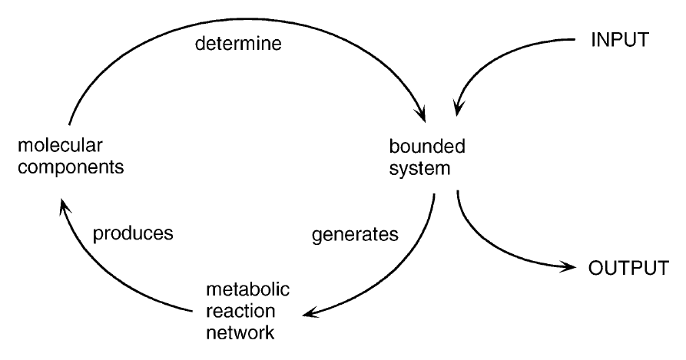
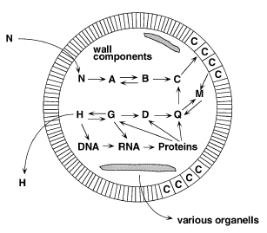
Fig.1 The chemical autopoiesis of cellular life as a self-maintaining factory. Matter and energy flow in an out of the cell, but it is operationally closed

To the authors great surprise, Luhmnann (1984) constructed an entire field based on social autopoiesis. The idea of autopoietic systems is the theory of social systems understood as systems of communication that reproduce all their necessary, specific structures within their own self-referential closed processes. Maturana argued very vocally against the convoluted appropriation of the term, because it presupposes the autonomy of communication from actual persons. Autopoiesis only applies to networks of processes that reproduce themselves, but communications are reproduced by humans. As such, humans are merely an input to the social and not elements of it. The social system has no boundary like a cell has a membrane or a dog has skin. Again, what defines the system is its operational closure, ie its functioning, which is in our case defined by the information architecture of the reactable community.

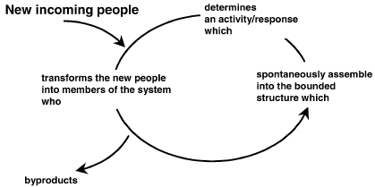
Fig.2 The autopoiesis of social systems. People provide matter and energy as input/output to the system.

Iba (2010) built an autopoietic Creative systems theory of creativity, based on his interpretation of Luhman's Autopoietic systems theory (1984) and with a clear nod to Csikszenmihalyi's influential systems approach (1999). It is based on the coupling of sociological, psychological and creative systems. The creative system's autopoiesis is the result of the succession of momentary elements, creative sparks (Sawyer 2006), that act within the boundary of the system. Each discovery is the synthesis of an idea, an association, and a finding. Ideas come from self-reference of the system, an association is made with an hetero-reference to the system's environment through a discovery media, and a finding is a new momentary element of the system. A creative spark is not necessarily novel or useful, but each creative spark participates to the autopoiesis of the creative system.

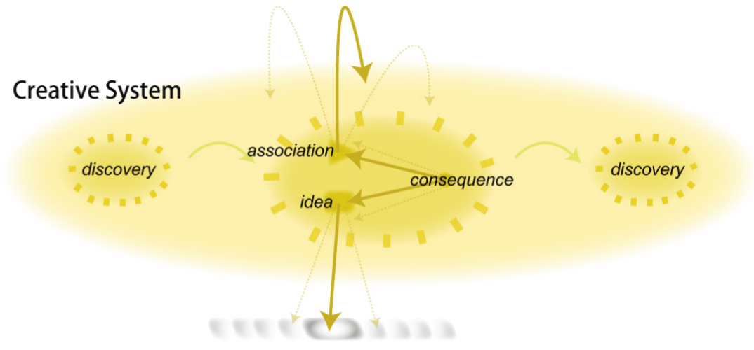
Fig.3 A discovery is constituted of an association with a reference to the system itself, an idea from a reference to the system's environment, that create a new discovery : a consequence (Iba 2009)

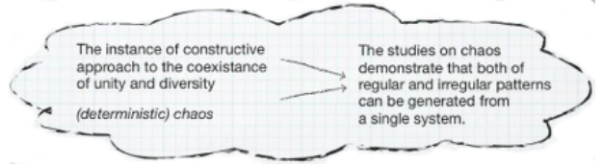
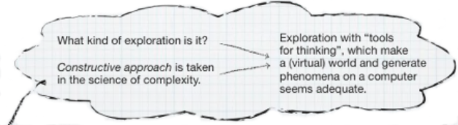

Fig.4 part of the sequence of 3 discoveries within a creative process.(Iba 2010)

Within this framework, a creative act is one that particpates to the creative system, and so re-invention is also creative. Of course creativity lies on associations (hetero-references) with the creative system's environment, thus the need for coupling of psychic and social systems. Since the systems are operationally closed, the systems are inaccessible to one another. They need a communication medium. Iba (2010) proposes pattern languages as this medium.

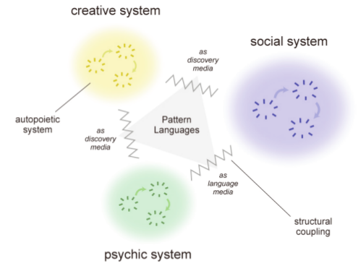
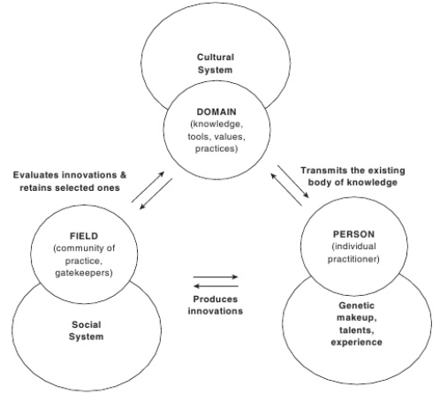
Fig. 5 The interaction of person, field and domain, (Csikszenmihalyi 1999) and the coupling of psychic, creative and social systems (Iba 2009)

Finally, the theory considers creativity not a feature of individuals or society only, but rather of the creative system. As long as there is creation, there is creativity by the creative system, but it constantly needs input (persons that make new discoveries) to maintain its autopoiesis. From now on we will refer to the psychic, social and creative systems as person, field, and domain using Csikszenmihalyi's terminology.
1.3 An introduction to the Reactable
The reacTable is a musical instrument whose design is motivated by a concept rather than a technology. Reactable players use Dynamic Patching (Kaltenbrunner et al., 2004), reminiscent of data flow programming paradigm, to connect sound generators and sound processors to flow control units or other sound processing units. It provides a predefined set of rules regarding what objects can send data to another depending on the type of the objects involved. Audio generators can't combine with one another, audio effects can be chained, and controllers can send data to any object. Using these simple metaphors, it allows for a good balance between exploration and production, and while giving considerable amount of information to collaborators, is considered to foster group flow (Laney et al. 2010) . At its core, it is a collaborative instrument, designed for remote or on-site collaboration (Kaltenbrunner et al., 2006). Inspired by Barbosa and Kaltenbrunner's Public sound objects (2002) amongst others, which allowed real-time music performance over the Internet for anyone to join, it also aimed to be an accessible instrument, and has been used as a subject of study with autistic children (Villafuerte, 2011) and special learning groups. Jorda's early research (1999) was exploring how the Internet, then an emerging technology, was about to challenge notions of authorship and copyright. At the time, full-duplex communication was preferred over half-duplex. Later, studies of tabletop interfaces (Jorda 2005) put emphasis on the potential for multi-user and multi-process music-making offered by digital instruments as well as on the flexibility of interface layouts and strategies of collaboration by distributing the controls (Fiebrink et al. 2009). This led to the characterization of the reacTable as a device for sharing control instead of a device for sharing data.
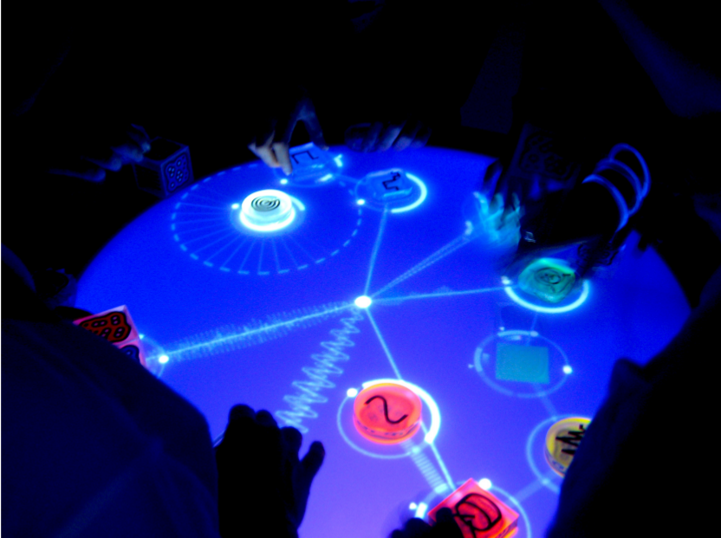
Fig.6 The Reactable shown to the audience of Sónar A Coruña 2010.

2. System Architecture
2.1 Reactable Mobile
Developped by the spin-off academic company, the first version of the Reactable mobile application was launched at the end of 2010. It inherits its design principles from the tabletop Reactable. In order to make music, users build patches connecting tangibles, the physical objects associated with signal processing units. Objects are connected to one another using drag-and-drop gestures, by putting them next to another. Then the objects parameters are modified using tap-drag gestures to emulate the rotation of the cubes, or using touch menus on the periphery of the object as in the original Reactable.
A table is a static definition of the objects used : their type, their position, and parameters. The Dynamic Patching algorithm determines the objects connections according to their position and types . The software can also receive sound input from the device microphone, accelerometer input, and prerecorded audio samples, all controlled through their dedicated tangibles shown on screen. In order to create a full song, one must play the instrument by changing the tangibles connections and parameters over time. A performance of a table can be recorded and played back by the application. Also, the app allows to record audio from a performance.
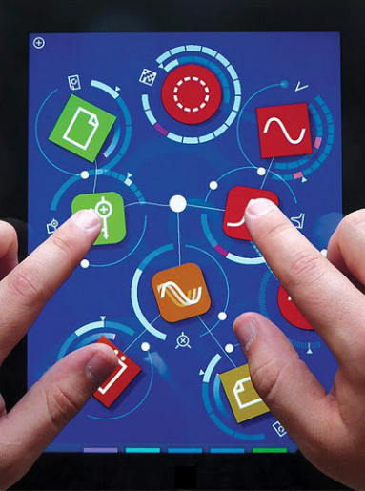
Fig.7 The reactable mobile application. Reactable Website.

2.2 The Reactable community
When the Reactable mobile app was launched, reactable and reactable mobile users were able to exchange and share their tables via the dedicated forum. Between July 2010 and March 2012, where the Reactable community website was launched, a little less than a hundred tables were exchanged, still ranking amongst the most popular today.
Reactable mobile users, once they are happy with their creation, can create a profile on the Reactable community, and upload tables, and related performances, tracks (song recordings) and videos to the platform. There, they can download others creations to play back and play with on their own devices, talk to one another through comments on uploads, and give likes to the ones they particularly enjoy.
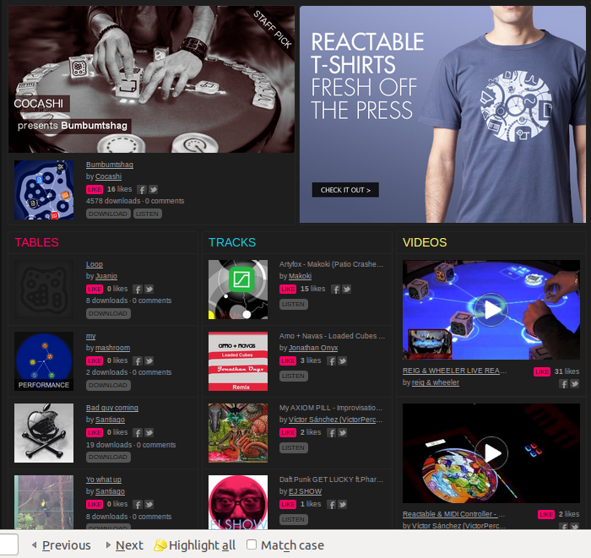

Fig 8. Screen capture of the main page of the Reactable community website.

2.3 The systems
We will now describe the functioning of the coupling of psychic, social and creative systems around the Reactable mobile application and Reactable community according to Csikszenmihalyi's (1999) systems framework.
Persons interacting with the reactable mobile application interface try to make sense of the pattern language it provides, actively and interactively engaging with it as a discovery medium for musical creation. They produce for and transmit the existing body of music, the domain or creative system, by uploading their music that can be re-enacted by the application using samples, associations between tangibles and their parameters, and performances. But their online activity and choices making music are influenced by others activity and choices, using hints from the community. The Reactable community is a language medium for persons to interact through communication (comments and online activity) with the field or sociological system, that evaluates tables with likes and downloads, affects their visibility and retains selected ones for the domain. As such, it is a discovery medium for the creative system, selecting the most successful memes, again using the pattern language of samples, associations between tangibles and their parameters.

-The Reactable community, through comments and online behavior, is a language medium for persons to interact with the field
-The Reactable mobile application, by means of audio files, tangibles, parameters, and gestures, is a discovery medium for the domain to interact with the persons.
-The Reactable community, by selecting tables based on success according to likes and downloads, is also a discovery medium, for the field to interact with the domain.

2.4 Data Retrieval
The data we will be studying first came in two separate bulks. We are using a dump from the SQL database of the Reactable community website from June 11^{th,}, 2013 and a collection of all the tables uploaded to the platform as zip files.
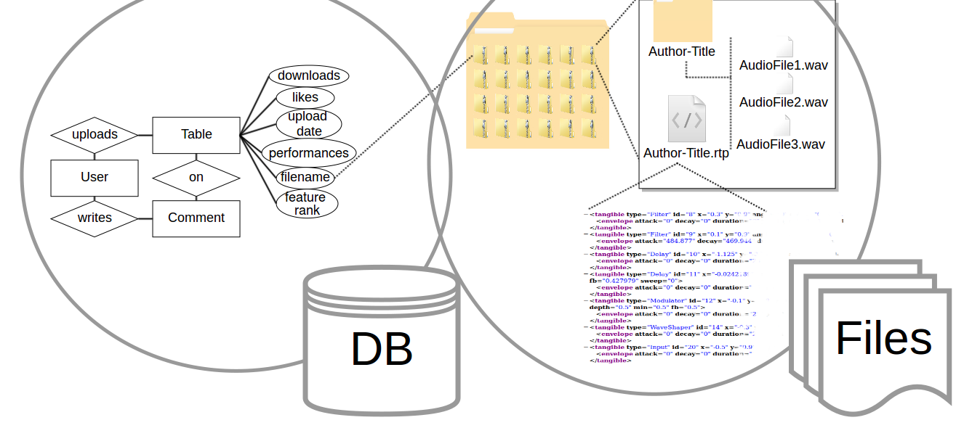
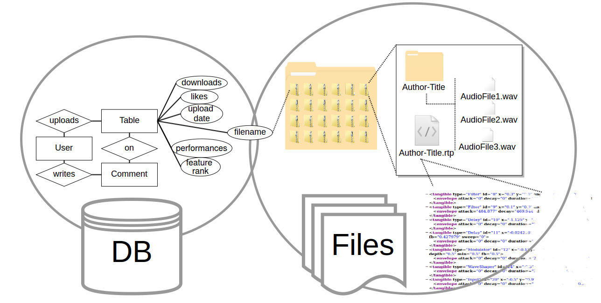
Fig. 9 Data used for the analyses

The database contains information about users, their tables, songs, videos, links to their social networks, comments they left, likes they gave and so on. As of June 11th, the Reactable community has 14293 registered users. The second part is a 22GB folder containing all 3169 tables packaged as zip files. Those packages contain information about the tangibles used and their parameters in the XML format (.rtp file), the samples used (.wav files) , and a transcription of a performance (.rtperf file) if one was recorded. They define the standard data format that is used to exchange one's creation (.rtz files). In order to study correlations between the aforementioned systems, we needed a unified data model. We then created 2 new data models, samples and tangibles, in which we store information about what objects and what samples were used.

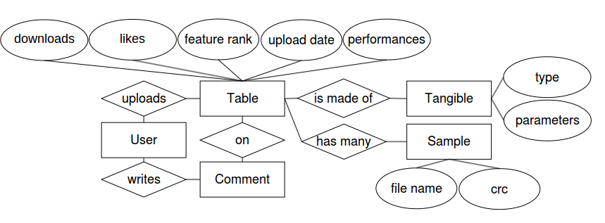
Fig.10 The unified data model, with its most relevant attributes
A Ruby on Rails application was built for this purpose : in order to retrieve data in a format exploitable by SPSS, a new field was added to existing tables, and a Rails query corresponding to the variable to retrieve was created. For instance, in order to be able to calculate the correlation between elaboration and likes, the field “defaults” was added to the table “tangibles”, and a Rails function parsed the zip file for each table to count the ratio of default values for its parameters. Once the “defaults” field for each tangible is filled, a simple SQL query can return comma separated values (.csv file) for the number of likes a table received and the ratio of defaults parameters it has. The ruby code for the operations performed can be found in appendix b)

2.5 Preliminary analysis
We will go here through basic statistics to give a glimpse of what is going on in the Reactable community.
a) Field interacting with persons
Quite few comments are exchanged on the platform. 97% of registered users never wrote any comment, and 38% of these comments were made on one's own table. Very few comments were written about tables uploaded on the forum. When the Reactable community was launched, a contest was organized to kickstart it, and an unprecedented peak in activity was recorded. The contest, organized between June and July 2012 offered a Reactable live! instrument (the tabletop version of Reactable), after the 20 tables with most likes were judged by a jury of musicians with international fame, based on their creativity and skills. Unfortunately, they had to deal with cheating from many users creating fake accounts to get more likes, which was facilitated by the fact likes only have a receiver, not a giver. A general feeling of mistrust between members of the community seemed to appear. Still, the winners showed skill and creativity using the application and received almost unanimous positive feedback from the community.
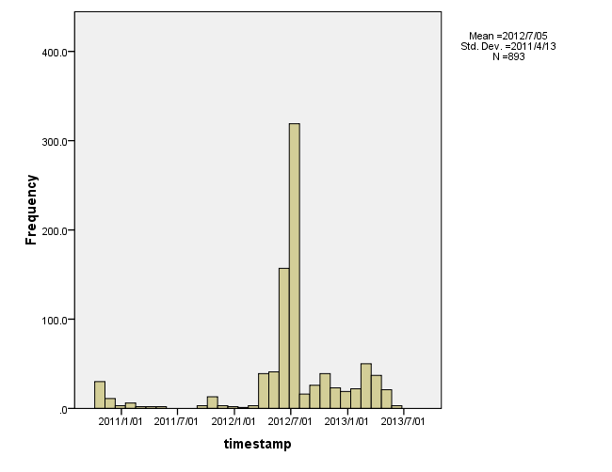
Fig.11 Number of comments on the platform over time. Comments written before March 2012 come from the Reactable forum, that was replaced then by the Reactable Community
b) Domain interacting with persons
There is a steady, heavy flow of tables shared and downloaded on the platform, which gives the user a considerable amount of creations to get inspired from. Since its inception, tables were downloaded more than 1640000 times, which is an average of 518 downloads per table. Nonetheless, the distribution of downloads is extremely skewed: 88% of the tables received less than 518 downloads, which means a minority of tables is likely to have a disproportionate influence on other users. Downloads are mostly “blind” : very few tables (6,7%) are uploaded along with an audio recording, so users most of the time users don't have the possibility to listen to a table before it is loaded in the application. And since most tables are uploaded without a performance (70%), the static structure of tables ie the objects and samples used, their parameters and how they are connected is more immediately accessible than how the table can or is meant to be played. Table reuse is considerable : 19% of the tables uploaded were created from downloading and modifying another table, and reuse count goes up to 5 successive “sparks”. Looking for samples is likely to be an important drive for downloads. Tables usually make a heavy use of the loop tangible, and so far 16800 samples are used in all the tables, many of which are actually the same audio file. We estimated the number of distinct samples used on the platform to 3900, which means every audio file is on average used 4 times. Out of the 80% tables that use samples, only 20% are not using samples taken from another table. Samples are then the most used discovery medium for individuals' psychological systems. But it is completely independent from creative use of the pattern language of tangibles, because, unless the same table is reused, a sample from another table is generally accessed from a browser that only references the original table by its name. This way, the user is unable to build on top of previous work, and given an incentive to reuse the sample “as is”, instead of finding a new or creative use for it.
c) Domain interacting with field
As stated before, users and tables are given visibility according to the downloads and likes they received, and whether they were featured by Reactable to showcase the possibilities offered by the application. To discover new material from the community, users need to browse through the following categories, ordered by the following criteria (colored is default).

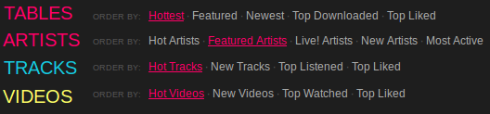
Fig. 12 Search filters for browsing tables, artists, tracks and videos on the platform
For all elements, “Hot” is calculated as a combination of likes and downloads from tables of the last 2 weeks. In order to find new interesting material and contribute to the ongoing autopoiesis of the creative system, users need to skim through pages of new songs either trusting the “Hot” algorithm, or downloading new tables and hoping to find something interesting. Remixing, while possibly driving the activity of the community, are not credited publicly, although appearing in the rtp file. Same goes for sample reuse. As such, creative activity is not directly a discovery medium for the domain, but mostly through the “self-fulfilling prophecies” of downloads and likes which, although not completely unrelated to creativity, is mediated by a process that doesn't allow for a great generative capacity. No proper community effort is driving the creative system, meaning, it is not through selection and contribution that tables get passed along, but through an algorithm that reflects appreciation and newness of finished work that emphasizes the individual's supposedly eminent personality. While persons conducting creative processes can be creative in this context, our argument is that the most creative persons (ie, whose contribution to the domain is most important) won't actually be those relying most on (internal) creative processes.

3. Methods
3.1 Objectives and hypothesis
According to the previous observations, we assimilate the creative behavior of Reactable community to be mostly that of “egoboosters” (Iba et al. 2009). The information architecture and flows of information it supports is the evidence. Since there is “social creativity” as long as there is creation to be evaluated and transmitted through a field, our objective is to prove that in this context it does not need “psychological creativity”, because creative activity keeps feeding the domain with the energy of newcomers spontaneously acting according to the following paadigm “upload, get downloads by people who didn't listen to your music, try to get as many downloads as possible, and disappear until you upload a new table”. Our hypothesis is then that :

H. People that rely on table reuse are potentially more creative in the sense that they contribute more to the domain

3.2 Operationalization of the variables
a) Originality
The originality of a person's production will be evaluated on the basis of the originality of the objects it is using on a table. Each table will then be assigned an originality score, calculated by the following formula :

originality = for each tangible in table, sum(count of occurrences of tangible in database)/number of tangibles in table.

The statistical rareness of a tangibles was established by counting every single occurrence of the (object type, object subtype) pair. For instance, using a “Loop” object with the “loop” subtype is extremely common, but using the “Loop” object with the “oneshot” subtype is very rare.
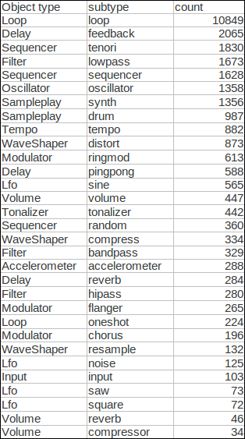
Fig. 13 Frequency distribution of every tangible type and subtype combination

b) Elaboration
The elaboration of a table will be measured looking at how many parameters were tweaked for each object. Every parameter of an object that is different from the default for that object will be counted, then divided by the total number of parameters for that object.

elaboration = number of tweaked parameters / total number of parameters available for chosen objects

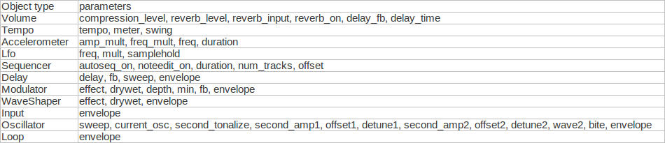
Fig. 14 Every parameter taken into account, by object type

Parameters taken into account include parameters accessible by rotating the tangible (except for filter and input), parameters only accessible via tangible menu, and envelope as one single parameter. Parameters not taken into account include sequencer object sequences, tonalizer object scales and sampleplay object instruments, and if the oscillator tangible wave was hand-drawn.
The elaboration score of a user will be the average elaboration score of its tables. Following is a frequency distribution of the ratio of default settings per table giving an overview of the uses of the community.

c) Divergent thinking score
Divergent thinking is calculated as an average of elaboration and originality.
Divergent thinking score = (Elaboration score + Originality score)/2

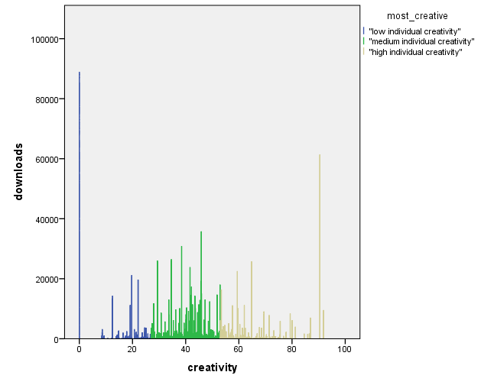
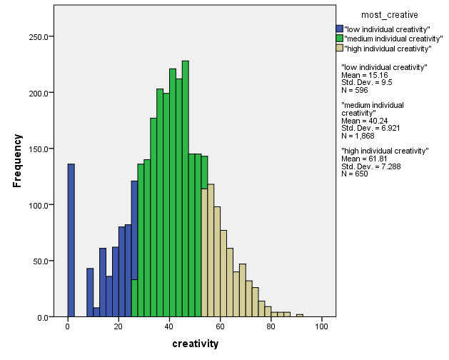
Fig. 15 p-creativity score with 20-60-80% cumulative frequencies. Medium p-creativity gets most downloads, but the distribution of downloads over creativity doesn't allow for significant comparison of medians across groups.
d) Confounding variables
Various parameters might get undesirable side effects an ought to be discarded. Because we are studying the community, tables originating from the forum (created prior to April 2012) will not be taken into account. Accordingly, tables that participated in the contest that kickstarted the community will be discarded. Featured tables will also be reserved a separate treatment, being in a special position given by the company.
Another possible confounding factor when looking at downloads is time. The older a table is, the more likely it is to have received more downloads. Nonetheless, after two weeks, tables cease to appear as “hot”, and time should be a lot less relevant factor. Unfortunately, an analysis of how downloads normaly evolve over time is not possible unless several database dumps are used

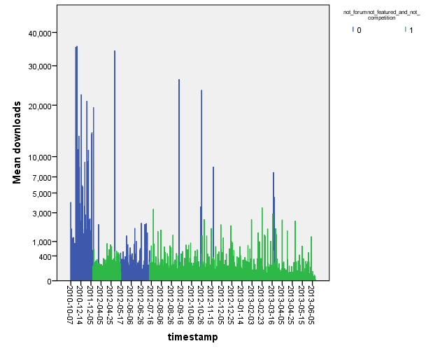
Fig.16 Mean downloads by upload date. Green data is regular uploads, blue is for forum, competition and featured users

4. Results
We compared the creativity score computed as an average of originality and elaboration scores. None of the computed scores followed a normal distribution, so non-parametric tests were used.
H. People that rely on table reuse are potentially more creative in the sense that they contribute more to the domain
While reuse of tables is unrelated to divergent thinking score, tables that come from other tables tend to be more appreciated and to spread more than those that don't. See appendix a) for detail on tests.
A Mann-Whitney U test was run to determine if there were differences in divergeng thinking score between tables relying on reuse and those that don't. Distributions of the divergent thinking score were similar, as assessed by visual inspection. Median divergent thinking scores for reuse were not statistically significantly different, U = 702,830; z = -.791; p = .429
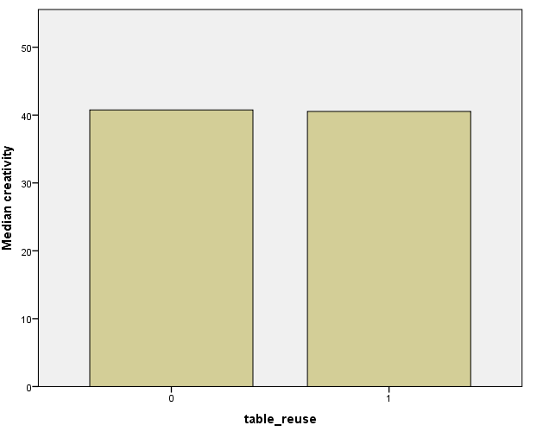
Fig.17 Comparison of median p-creativity score across reuse groups
A Mann-Whitney U test was run to determine if there were differences in appreciation between tables relying on reuse and those that don't. Distributions of the appreciation score were similar, as assessed by visual inspection. Median appreciation for reuse (0.044298) and original(0.0027624) scores were significantly different, U = 16,940; z=1.726; p = 0.084
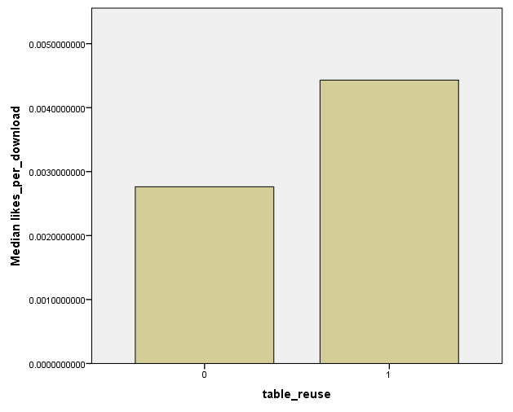
Fig.18 Median likes per download across reuse groups.
A Mann-Whitney U test was run to determine if there were differences in spread between tables relying on reuse and those that don't. Distributions of the downloads were similar, as assessed by visual inspection. Median downloads for reuse (119) and original (108) scores were significantly different, U = 770,307; z=1.571; p = .116
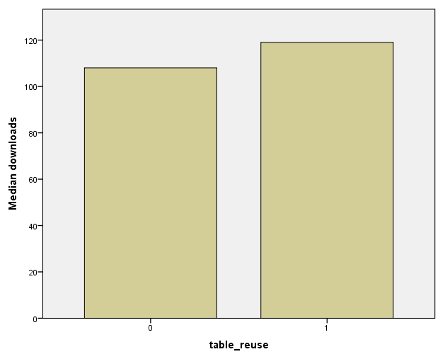
Fig.19 Median downloads across table_reuse groups

5. Discussion and conclusion
The results found are encouraging. We might have expected superior divergent thinking score for tables coming from several iterations since possibly more options are explored when several persons are involved in the creation. The results matched our hypothesis : tables that came from other tables receive significantly more likes per download, even given that those same tables receive more downloads. This is the sign of a superior recognition of the appropriateness of the production when several people are involved, and thus of a superior creativity, that can not be explained only by the sum of the individual creativities involved. Unless tables that have ascent were put forward by featuring, exposure from the forum or from the competition, which should be verified, the table that rely on reuse are genuinely creative : they contribute to the domain (they are spread) relying more than other tables to appreciation from their peers than on the self-fulfilling prophecy of downloads. Everything happens as if reusing a table, successive users were successfully leaving a cognitive trace in the domain, which made somehow the table more valuable in a way that can't be measured by p-creativity. Unfortunately it is not possible to know what chain of tables were involved in the reuse. It seems, according to figure 15 that tables with average creativity get the most downloads. At least that's what the distribution seems to look like. If that is so, then once again this is remarkable because the superior amount of downloads can not be explained by individuals creative ability. Many additional factors should be taken into account and their influence carefully studied. The amount of data available allows for many factors individual and interactional influence to be studied. Whether one or several performances were uploaded, audio files,
It is remarkably useful that reactable tables can only be downloaded, evaluated and shared by reactable mobile users, because if maintains the operational closure of the system. Nobody outside the system can participate in the inner working of the system, except of course the systems designers. By changing the community architecture from a user or conversation-centered (Community of Practice) community to a content-centered (OCOC), the information architects at Reactable systems changed the chain of functional activity that feeds the community. Reactable forum users are significantly more divergent thinking types. It is assumed that this is because, as 'beta' users they are most likely to be experienced and then more proactive, as opposed to novice users that rely more on their impression of what others do. But these users interacted using a forum, which is arguably more adapted to open-source communities.
Difficulties and future work.
The artifact around 0% creativity is due to the algorithm chosen. Coincidentally, ordinary objects as loops only have 1 parameter, so tables using only this type of object get polarized score. Some extra parameters should be added to smooth out the distribution of p-creativity and so also allow for comparing groups across the distribution. A flexibility criteria should be added, and the p-creativity criteria should be then an attribute of users instead of tables. This should allow to unveil more creativity patterns easily. The influence of the presence of performances, artworks, or tracks associated to tables could be studied.
It is important in our opinion to stress the fact that the present study is actually quite agnostic regarding musical practice. We are not really, or at least not directly looking at musical creativity. At no point any assumption was made about the musicality of the productions made. As a study on pattern languages, the approach used could really well be adopted for very distinct domains. Then, of course, the creativity is not in the objects used, but in their dynamic associations over time. We started exploring the possibility of looking at what connections were made through hardlinks, but the amount of missing data is simply too high for the data to be significant. The complexity of the dynamic patching algorithm did not allow it to be replicated for the purpose of our study, but we envision exciting possibilities for creativity studies where statistics are made about what different kind of dynamic associations are made between objects, to assess the exploration and transformation of conceptual spaces. On a more distributed creativity focus, we would like to hope for the possibility of using network dynamics studies for creativity, not merely linking users as is usually made when studying platforms such as wikipedia, but literally linking ideas, and observe the unfolding of the autopoiesis of the creative system through observable distributed creative practices that can be enacted by the design of the appropriate system.

References
Amabile, T. M. (1998). "How to kill creativity". Harvard Business Review
Amabile, T. M. (1996). Creativity in context. Boulder, CO: Westview.
Ames, M. and M. Naaman. (2007) “Why we tag: motivations for annotation in mobile and online media,” in Proceedings of 25th Annual ACM Conference on Human Factors in Computing Systems.
Barbosa, A.; Kaltenbrunner, M. 2002. “Public Sound Objects: A shared musical space on the web” – Proceedings of International Conference on Web Delivering of Music (WEDELMUSIC 2002) - IEEE Computer Society Press, Darmstadt, Germany (doi:10.1109/WDM.2002.1176188).
Boden, Margaret (2004). The Creative Mind: Myths and Mechanisms, Second Edition. Sphere Books.
Csikszentmihalyi, M. (1996) Creativity : Flow And The Psychology Of Discovery And Invention. HarperCollinsPublishers, New York, 1996.
Csikszentmihalyi (1999). A Systems Perspective on Creativity. Handbook of Creativity. Cambridge, UK: Cambridge University Press.

Csikszentmihalyi, M. (2012). "The importance of challenge for the enjoyment of intrinsically motivated, goal-directed activities.". Personality and Social Psychology Bulletin.
Farrell, M. P. (2001). Collaborative circles: Friendship dynamics and creative work. Chicago: University of Chicago Press.
Fiebrink, R.; Morris, D.; Morris, M. R (2009), “Dynamic mapping of physical controls for tabletop groupware,” in Proceedings of the 27th international conference on Human factors in computing systems (CHI ’09), pp. 471–480, ACM
Fischer, G.; Giaccardi, E.; Eden, H.;, Sugimoto, M.; Ye, Y; (2005). Beyond binary choices: Integrating individual and social creativity. International Journal of Human- Computer Studies, 63:482–512
Florida, R. (2002). The Rise of the Creative Class: And How It's Transforming Work, Leisure, Community and Everyday Life, Basic Books.
Freeman, Linton (1977). "A set of measures of centrality based on betweenness". Sociometry 40: 35–41.
Gabora, L. & Aerts, D. (2009). A model of the emergence and evolution of integrated worldviews. Journal of Mathematical Psychology, 53, 434-451.
Gabora, L., Firouzi, H. (2012). Society functions best with an intermediate level of creativity. Proceedings of the Annual Meeting of the Cognitive Science Society (pp. 1578-1583). August 1-4, Sapporo Japan.
Gloor, P. (2006). Swarm Creativity: Competitive Advantage Through Collaborative Innovation Networks: Oxford University Press
Guilford, J. P. (1967). The Nature of Human Intelligence.
Hall, W.P., Nousala, S. 2007. Facilitating the emergence of an ICT cluster. ICE 2007 - 13th International Conference on Concurrent Enterprising – "Concurrent (Collaborative) Innovation", Sophia-Antipolis, France, 4-6 , June 2007
Hemetsberger, A. (2001) “Fostering cooperation on the Internet: Social exchange processes in innovative virtual consumer communities,” in Annual Conference of the Association for Consumer Research (ACR), Austin, Texas.
Hutchins, E. (1995) Cognition in the wild. Cambridge, MA: MIT Press.
Iba, T., Nemoto, K., Peters, B., Gloor, P.A., 2010. Analyzing the creative editing behavior of Wikipedia editors: Through dynamic social network analysis. Procedia-Social and Behavioral Sciences 2, 6441–6456.
Jarvenpaa, S.L., Lang, K.R., 2011. Boundary Management in Online Communities: Case Studies of the Nine Inch Nails and ccMixter Music Remix Sites. Long Range Planning 44, 440–457.
John-Steiner, V. (2000). Creative collaboration. New York: Oxford University Press
Jordà, S. (1999). Faust music on line: An approach to real-time collective composition on the internet. Leonardo Music Journal, 9, 5-12.
Jordà, S. (2005). "Multi-user instruments: models, examples and promises." Proceedings of the 2005 conference on New interfaces for musical expression. National University of Singapore.
Kaltenbrunner, M., Jorda, S., Geiger, G., Alonso, M., 2006. The reactable*: A collaborative musical instrument, in: Enabling Technologies: Infrastructure for Collaborative Enterprises, 2006. WETICE’06. 15th IEEE International Workshops On. pp. 406–411.
Kaltenbrunner, M.; Geiger, G.; Jorda, S. (2004) Dynamic Patches for Live Musical Performance. In Proceedings of the 4th Conference on New Interfaces for Musical Expression (NIME04), Hamamatsu, Japan
Laney, R., Dobbyn, C., Xambó, A., Schirosa, M., Miell, D., Littleton, K., Dalton, N., 2010. Issues and techniques for collaborative music making on multi-touch surfaces.
Levy, F., & Murnane, R. (2004). The new division of labor: How computer are creating the next job market. New York: Russell Sage Foundation.
Lauritzen, G., Salomo, S. (2012),. THE COMMUNITY BOUNDARY DE-PARADOXIFYED.
Luhmann, N. (1984). Soziale Systeme: Grundriß einer allgemeinen Theorie, Frankfurt: Suhrkamp. (English translation: Social Systems, John Bednarz Jr., Dirk Baecker (translator), Stanford: Stanford University Press, 1995)
Luther, K. and Bruckman, A. (2008) Leadership in online creative collaboration. Proc. of CSCW ’08. ACM Press, 343-352
Maturana, H. R. & Varela, F. J. (1980). Autopoiesis and Cognition: The realization of The Living, Dordrecht: D. Reidel Publishing Company.
Mingers, J., White, L., 2010. A review of the recent contribution of systems thinking to operational research and management science. European Journal of Operational Research 207, 1147–1161.
Monroy-Hernández, A., Hill, B.M., 2010. Cooperation and attribution in an online community of young creators. Computer 469–470.
Nickerson, R. S. (1999). "Enhancing creativity". In R. J. Sternberg. Handbook of Creativity. Cambridge University Press.
Nov, O. (2007) “What motivates Wikipedians?” Communications of the ACM (50) 11, pp. 60-64.
Nov, O., M. Naaman, and C. Ye. (2008) “What drives content tagging: The case of photos on Flickr,” in Proceedings of 26th Annual ACM Conference on Human Factors in Computing Systems, pp. 1097-1100.
Ortega, F., J.M. Gonzalez-Barahona, and R. Gregorio (2008) “On the inequality of contributions to Wikipedia,” in Proceedings of 41st Annual Hawaii International Conference on System Sciences. Piscataway, NJ: IEEE Press.
Paulus, P. B., & Nijstad, B. A. (2003). Group creativity: Innovation through collaboration. New York: Oxford University Press.
Pink, D.H. (2006). A Whole New Mind: Why Right-Brainers Will Rule the Future, Update edition, Riverhead Trade.
Preece, J. and B. Shneiderman (2009) “The Reader-to-Leader Framework: Motivating Technology-Mediated Social Participation,” AIS Transactions on Human-Computer Interaction, (1) 1, pp. 13-32Pankowska, M., 2011. Autopoiesis and Open Access Repositories, International Journal for e-Learning Security (IJeLS), Volume 1, Issues 1/2, March/June 2011
Robinson, Ken. (2001) Out of our minds : Learning to Be Creative. Wiley & Sons, Incorporated, John
Rogers, E. M. 1995. Diffusion of Innovations (3rd ed.). New York, NY: The Free Press.
Rullani, F., Haefliger, S., 2013. The periphery on stage: The intra-organizational dynamics in online communities of creation. Research Policy 42, 941–953.
SALGANIK , M.J; DUNCAN J.W. (2008), Leading the Herd Astray: An Experimental Study of Self-fulfilling Prophecies in an Artificial Cultural Market, Social Psychology Quarterly 2008, Vol. 71, No. 4, 338–355
Sawyer, K. (2003) Nonreductive Individualism Part II Social Causation. Philosophy of the Social Sciences 33 (2):203-224
Sawyer, R.K., DeZutter, S., 2009. Distributed creativity: How collective creations emerge from collaboration. Psychology of Aesthetics, Creativity, and the Arts 3, 81–92.
Schumacher, P.S., The Autopoiesis of Architecture: A New Framework for Architecture, J.Wiley and Sons, Chichester, 2011
Søren Harnow Klausen (2010): The Notion of Creativity Revisited: A Philosophical Perspective on Creativity Research, Creativity Research Journal, 22:4, 347-360
Sternberg, R. J. (Ed.). (1999). Handbook of creativity. Cambridge, UK: Cambridge University Press.
Sylvan, E., 2010. Predicting influence in an online community of creators, in: Proceedings of the SIGCHI Conference on Human Factors in Computing Systems. pp. 1913–1916.
Sylvan, E., The sharing of Wonderful Ideas: Influence and Interaction in Online Communities of Creators [WWW Document], n.d. URL http://web.media.mit.edu/~sylvan/SylvanDissertation2007.pdf (accessed 7.1.13).
Tyler Pace, Katie O’Donnell, Natalie DeWitt, Shaowen Bardzell, Jeffrey Bardzell (2013) From Organizational to Community Creativity: Paragon Leadership & Creativity Stories at Etsy
Villafuerte Bazán, L. (2011) Acquisition of Joint Attention and Social Abilities through music Tangible User Interface: children with Autism Spectrum Condition and the Reactable experience, CSIM Master Thesis
Vines, R., Hall, W., Naismith, L., 2007. Exploring the foundations of organisational knowledge: an emergent synthesis grounded in thinking related to evolutionary biology, in: actKM Conference, Australian National University, Canberra.
Wallas, G. (1926) The Art of Thought. Harcourt, Brace and World, New York, NY

Appendix
a) Result tables
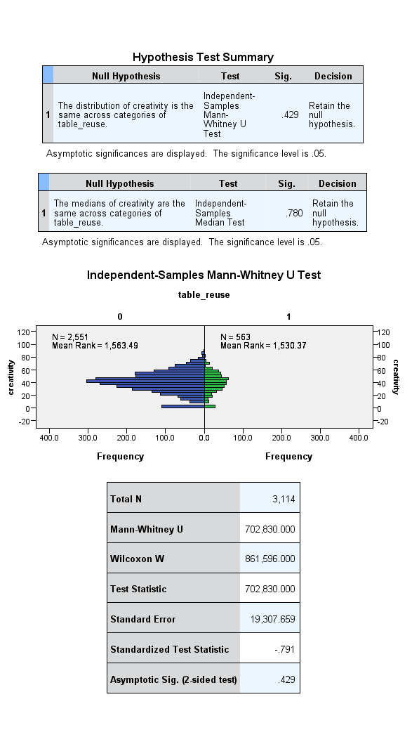
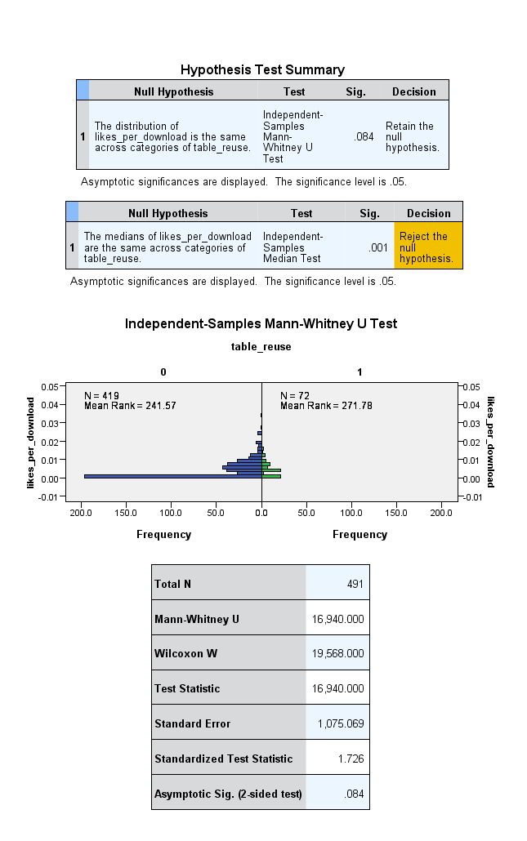
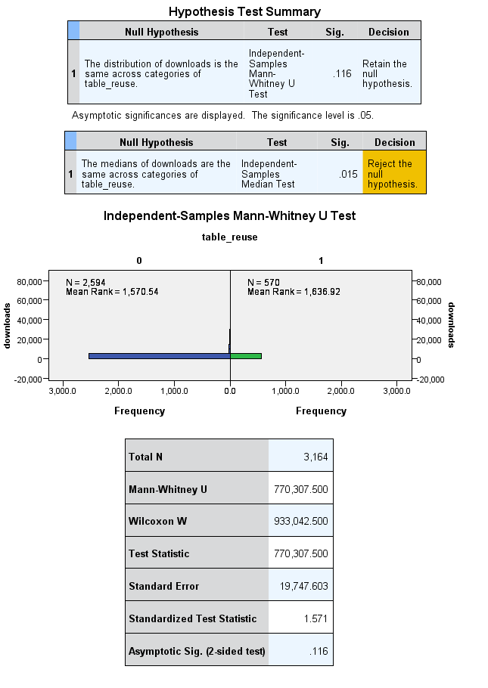
b) Rails application for retrieving data and computing creativity scores
the following function parses zip files to store information on tangibles. It is given to clarify the algorithm used to perform the computation

def get_tangibles
uploads_path = "/home/polpo/reactable/June11db/uploads/"
files = p Dir.entries(uploads_path).sort!.map{|f| (f.split("._").second.nil?)?f:f.split('._').second}
files.each do |f|
table = nil
zip_file = nil
if f.split(".").last == "rtz"
begin
zip_file = Zip::ZipFile.open uploads_path + f #open it
table = Table.find_by_reactable_file f
rescue
end
if zip_file && table
zip_file.each_entry do |e|
if e.name.split('.').last == "rtp" #look for rtp file
begin
xml = Nokogiri::XML(e.get_input_stream.read) #returns a nokogiri-parsable stream
result = xml.xpath("//tangible") #get tangible nodes
create_tangibles result, table
break
rescue
end
end
end
end
end
end
end
This function creates a new entry for given a nokogiri query result, and the corresponding table
def create_tangibles (result, table)
default_settings={:Volume=>{:compression_level=>"0", :reverb_level=>"0", :reverb_input=>"0", :reverb_on=>"0", :delay_fb=>"0", :delay_time=>"0.7"},
:Tempo=>{:tempo=>"128", :meter=>"4", :swing=>"0"},
:Accelerometer=>{:amp_mult=>"1", :freq_mult=>"1", :freq=>"12", :duration=> "0.75"},
:LFO=>{:freq=>"5", :mult=>"0", :samplehold=>"1"},
:Sequencer=>{:autoseq_on=>"0", :noteedit_on=>"0", :duration=>"0.75", :num_tracks=>"6", :offset=>"0"},
:Delay=>{:delay=>"0.66", :fb=>"0.5", :sweep=>"0"},
:Modulator=>{:effect=>"0.5", :drywet=>"0.5", :depth=>"0.5", :min=>"0.5", :fb=>"0.5"},
:WaveShaper=>{:effect=>"0.5", :drywet=>"0.5"},
:Input=>{:amp=>"0"},
:Oscillator=>{:sweep=>"0", :current_osc=>"0", :second_tonalize=>"0", :second_amp1=>"0", :offset1=>"0", :detune1=>"0", :wave1=>"0", :second_amp2=>"0", :offset2=>"0", :detune2=>"0", :wave2=>"0", :bite=>"0"},
}

result.each do |r| #for each tangible node, create tangibles and store hardlinks
node_type = r.xpath('@type').to_s
locals = String.new
#hardlinks = Array.new
if node_type != "Output" && r.xpath('@docked').to_s != '1' #if not an output and not docked
defaults = 0
if default_settings.has_key? node_type.to_sym
default_settings[node_type.to_sym].each do |s|
if (r.xpath("@"+s[0].to_s).to_s == s[1]) #test whether s corresponds to a default value
defaults+=1
end
end
end
defaults = default_envelope r, defaults
if (Tangible.find_by_local_and_table_id r.xpath('@id').to_s, table.id).nil?
t=Tangible.create(:tangible_type => node_type, :subtype => r.xpath('@subtype').to_s, :table_id => table.id, :defaults => defaults, :local => r.xpath('@id').to_s)
end
r.xpath("//tangible[@id="+t.local.to_s+"]/*[@to>-1]").each do |h|
locals+=h.xpath("@to").to_s+","
end
# hardlinks[t.id.to_s.to_sym] = locals[0..locals.length-2] unless locals.empty? #gives association between tangible id and locals hardlinked to
locals.clear
end
end
=begin if !hardlinks.empty?
hardlinks.each do |h| #find by
Tangible.find(h[0]).update_attribute :hardlink_to, h[1].split(",").map{|l| Tangible.find_by_local_and_table_id(l, table.id).id}.join(",")
end
hardlinks.clear #clear values for current rtp
end
=end
end
The following function tests whether the envelope used for the current object is the default for that object
def default_envelope (r, defaults)
default_envelopes = {
:default => {:attack=>"0", :decay=>"0", :duration=>"25", :points_x=>"0,0,0,0.2,1", :points_y=>"0,1,1,1,0", :release=>"20"},
:filter_8 => {:attack=>"0", :decay=>"0", :duration=>"0", :points_x=>"0,0,0,1,1", :points_y=>"0,1,0.5,0.5,0", :release=>"0"},
:filter_9 => {:attack=>"484.877", :decay=>"469.944",:duration=>"1193", :points_x=>"0,0.406256,0.8,1,1", :points_y=>"0,1,0.5,0.5,0", :release=>"0"},
:oscillator_47 => {:attack=>"0", :decay=>"500", :duration=>"600", :points_x=>"0,0,0.8,1,1", :points_y=>"0,1,0,0,0", :release=>"0"}
}

if ["10", "11", "12", "14", "20", "24", "29", "34", "39", "46"].include? r.xpath("@id").to_s
default_envelopes[:default].each do |e|
if (r.xpath("//tangible[@id =" + r.xpath("@id").to_s + "]/envelope")).xpath("@"+e[0].to_s).to_s != e[1]
return defaults #if found a value different from defaults, return defaults count unchanged
end
end
return defaults + 1 #if all values are default, increment defaults count by one
elsif (r.xpath '@id').to_s == "8"
default_envelopes[:filter_8].each do |e|
if (r.xpath("//tangible[@id =" + r.xpath("@id").to_s + "]/envelope")).xpath("@"+e[0].to_s).to_s != e[1]
return defaults
end
end
return defaults + 1 #if all values are default, increment defaults count by one
elsif (r.xpath '@id').to_s == "9"
default_envelopes[:filter_9].each do |e|
if (r.xpath("//tangible[@id =" + r.xpath("@id").to_s + "]/envelope")).xpath("@"+e[0].to_s).to_s != e[1]
return defaults
end
end
return defaults + 1 #if all values are default, increment defaults count by one
elsif (r.xpath '@id').to_s == "47"
default_envelopes[:oscillator_47].each do |e|
if (r.xpath("//tangible[@id =" + r.xpath("@id").to_s + "]/envelope")).xpath("@"+e[0].to_s).to_s != e[1]
return defaults
end
end
return defaults + 1 #if all values are default, increment defaults count by one
else #if object none of those with envelope settings, return defaults count as is
return defaults
end
end
This function computes the elaboration score for a table (at this stage it is a defaults_ratio, so, it's an unelaboration score)
def compute_defaults_ratio
default_settings={:Volume=>6,
:Tempo=>3,
:Accelerometer=>4,
:LFO=>3,
:Sequencer=>5,
:Delay=>4,
:Modulator=>6,
:WaveShaper=>3,
:Oscillator=>13,
:Filter=>1,
:Loop=>1,
:Input=>1
}
#no sampleplay, no tonalizer, which means

Table.all.each do |t|
defaults=0
params=0
t.tangibles.each do |ta|
if !(default_settings[ta.tangible_type.to_s.to_sym]).nil? #if the tangible is part of those studied
params+=default_settings[ta.tangible_type.to_s.to_sym] #count how many parameters could have been tweaked
defaults+=ta.defaults #count how many parameters were tweaked
end
end

if params != 0
t.update_attribute(:defaults_ratio,defaults.to_f/params.to_f)
end

end
end

This function calculates the originality score of tables. At this stage, it is not a ratio since it doesn't take into account the possible scores, so it is merely an originality score

def originality #computes originality
type_subtype_probability = {
:Volume_compressor=>34,
:Volume_reverb=>46,
:LFO_square=>72,
:LFO_saw=>73,
:Input_input=>103,
:LFO_noise=>125,
:WaveShaper_resample=>132,
:Modulator_chorus=>196,
:Loop_oneshot=>224,
:Modulator_flanger=>265,
:Filter_hipass=>280,
:Delay_reverb=>284,
:Accelerometer_accelerometer=>288,
:Filter_bandpass=>329,
:WaveShaper_compress=>334,
:Sequencer_random=>360,
:Tonalizer_tonalizer=>442,
:Volume_volume=>447,
:LFO_sine=>565,
:Delay_pingpong=>588,
:Modulator_ringmod=>613,
:WaveShaper_distort=>873,
:Tempo_tempo=>882,
:Sampleplay_drum=>987,
:Sampleplay_synth=>1356,
:Oscillator_oscillator=>1358,
:Sequencer_sequencer=>1628,
:Filter_lowpass=>1673,
:Sequencer_tenori=>1830,
:Delay_feedback=>2065,
:Loop_loop=>10849
}

=begin
probability of tenori = 1362 / 21270
probability of loop = 7996/21270

overall originality = 1 - probability of tenori + 1 - probability of loop
= t.tangibles.count*(1-(type_probability[tenori]+type_probability[loop])/21270)
=end

#total = 21270
Table.all.each do |t|
probability = 0.0
tangibles_count = 0
t.tangibles.each do |ta|
if ta.tangible_type == "Oscillator"
probability += 1358
tangibles_count +=1
else
probability += type_subtype_probability[[ta.tangible_type, ta.subtype].join("_").to_sym]
tangibles_count +=1
end
end
if probability > 0
t.update_attribute(:originality, probability/tangibles_count)
end
end
end

This function computes the originality score for all tables

def compute_creativity
Table.all.each do |t|
#creativity = ((1 - defaults_ratio) + ((max unoriginality - unoriginality)*100/(max unoriginality - min unoriginality))/2
begin
t.update_attribute :creativity, (((1-t.defaults_ratio)*100) + ((10849 - t.originality)*100/10701))/2
rescue
end
end
end

