Hellbringer

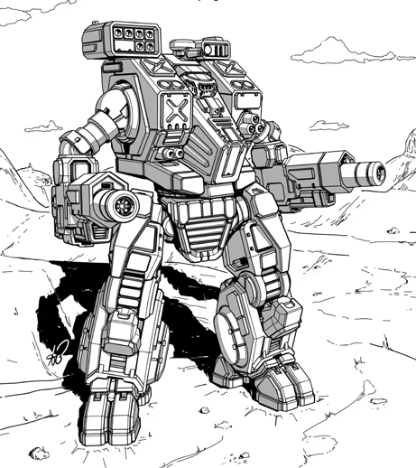
Origin: Aslan Clans
IFF Type: II-RAINMAKER Veteran

Hull: +0
Sys: +3
Agi: +1
Eng: +0

HP: 12 (2)
Armor: 1
Evasion: 10
E-Def: 10
Speed: 3
Size: 1
Heat Cap: 8 (2)
Save T: 12
Sensors: 15

Name | Mnt | Range | Acc | Dmg | Special
Ten-Thousand Arrow Hwacha | M | 20 | +4 | 5Ex | Reliable 2, Knockback 1, Multi 2
Lounging Moon Blade | M | (2) | +4 (+X) | 6En

Systems and Traits
Endless Rain of Heavenly Javelins: Quick Action – Fire 6 seeking rockets at targeted locations, next character to enter that area takes 6K
Huntsman: When locked on gain Smart, Seeking, and AP
Lightning Reflexes: On a 5+ Heavy/Superheavy weapons automatically miss
Limitless: Overcharge always gains 1d6 heat

