LEGIONNAIRE

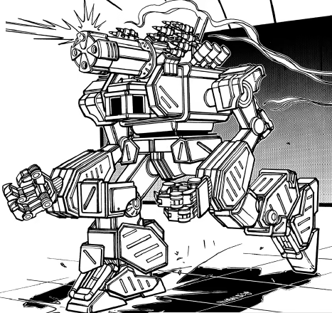
Origin: Florian
IFF Type: II-SENTINEL

Hull: +2
Sys: +1
Agi: +1
Eng: +1

HP: 16
Armor: 1
Evasion: 8
E-Def: 8
Speed: 5
Size: 1
Heat Cap: 6
Save T: 10
Sensors: 10

Name | Mnt | Range | Acc | Dmg | Special
“Streetsweeper” CQB | M | 5 (3) | +1 | 6K
Gladius Blade | M | (1) | +2 | 4K
Micromissile Array | Aux | 10 | +1 | 1d6K | Seeking, Limited 2

Systems and Traits
Eye of Midnight: Quick Action – Becomes slowed but can overwatch every turn
Guardian: Grants hard cover to allies
Bodyguard: Trait, Protocol – Designate a ward within 5, can overwatch anyone attacking ward as a reaction

