Locust LCT-1V

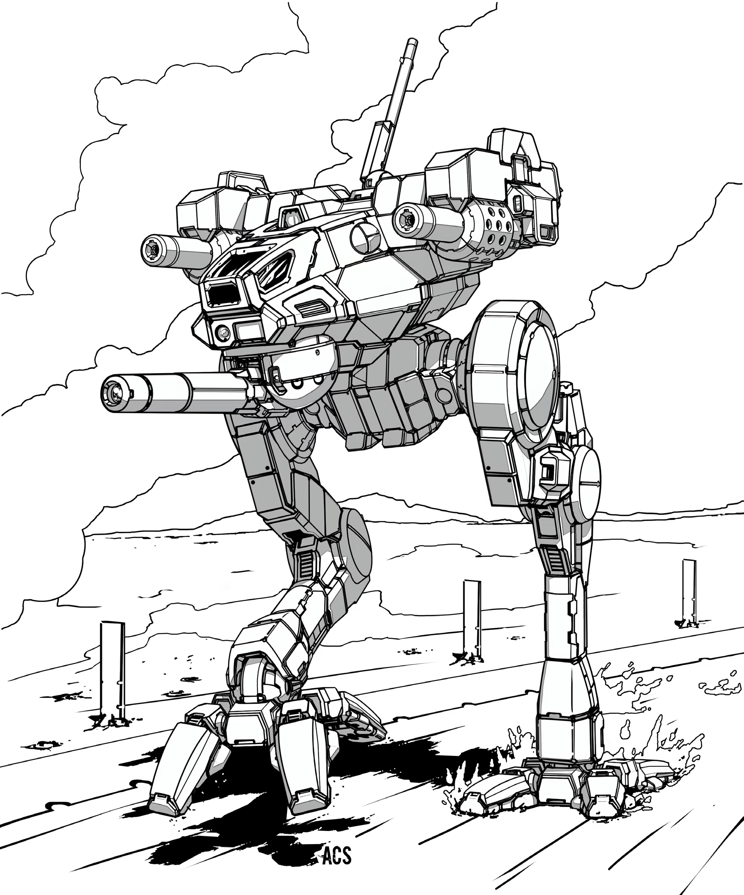
Origin: Florian
IFF Type: SNIPER Grunt VI

Hull: -2
Sys: +1
Agi: +1
Eng: +1

HP: ~1
Armor: 0
Evasion: 10
E-Def: 8
Speed: 4
Size: 1
Heat Cap: 1
Save T: 11
Sensors: 15

Name | Mnt | Range | Acc | Dmg | Special
Florian Sabot Rifle | SH | 25 | +2 (+XX) | 10K | AP, Ordinance, Loading
Browning MG | Aux | 6 | +0 | 1d3K

Systems and Traits
Sniper’s Mark: Full Action – Rifle shots deal 1 structure damage instead of normal damage, unless target finds cover
Climber: Grapple hook to ascend vertical surfaces

