RLA In Honor of Count FornicE

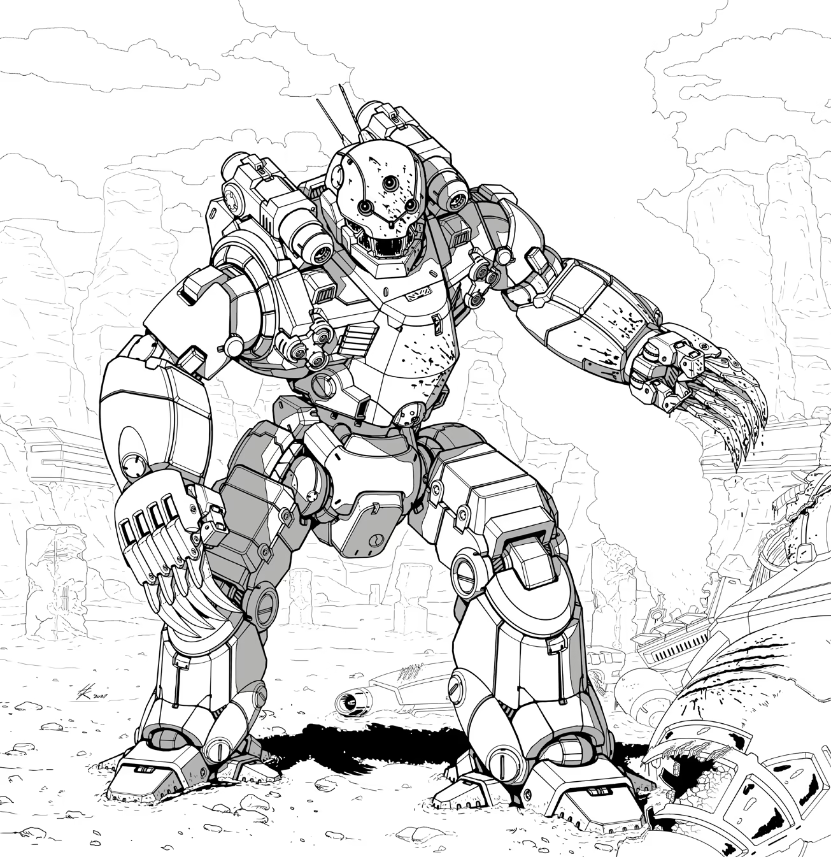
Origin: Order of Lod
IFF Type: I-ACE.2 Grunt VI

Hull: -2
Sys: +1
Agi: +3
Eng: +0

HP: 1
Armor: 0
Evasion: 12
E-Def: 8
Speed: 5
Size: 1
Heat Cap: 8
Save T: 10
Sensors: 10

Name | Mnt | Range | Acc | Dmg | Special
Titanium Claws | M | (1) | +1 | 5K
Micromissile Array | Aux | 10 | +1 | 3K | Seeking,Smart,Limited 2

Systems and Traits
Flight System – Can fly when moving or boosting
Barrel Roll – Reaction, Recharge 5+: Cause attack to miss and move 6 spaces

