RLA In Honor of Duke Thaw

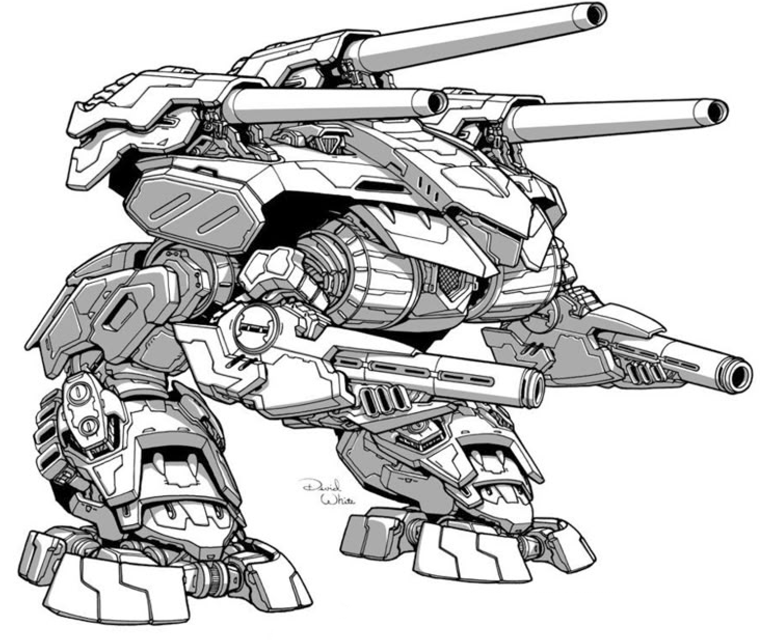
Origin: Order of Lod
IFF Type: II-BOMBARD Elite

Hull: +1
Sys: +2
Agi: -1
Eng: +3

HP: 13 (2)
Armor: 0
Evasion: 8
E-Def: 14
Speed: 2
Size: 2
Heat Cap: 8 (2)
Save T: 13
Sensors: 15

Name | Mnt | Range | Acc | Dmg | Special
3 x Bombard Canon | SH | 25 | +4 (-1) | 9K | AoE 2,Arcing,Ordinance, Loading
2 x Turbolaser | M | 8 | +3 | 4E | Reliable 1

Systems and Traits
Siege Armor – Resistant to all damage from attacks outside range 3
Earthshaker Shell – Recharge 6+, increase AoE to 3 and targets must Hull save or be knocked prone
Voice of Authority – Once per round can use reaction to give ally reroll on attack

