RLA In Honor of Monarch Leandra

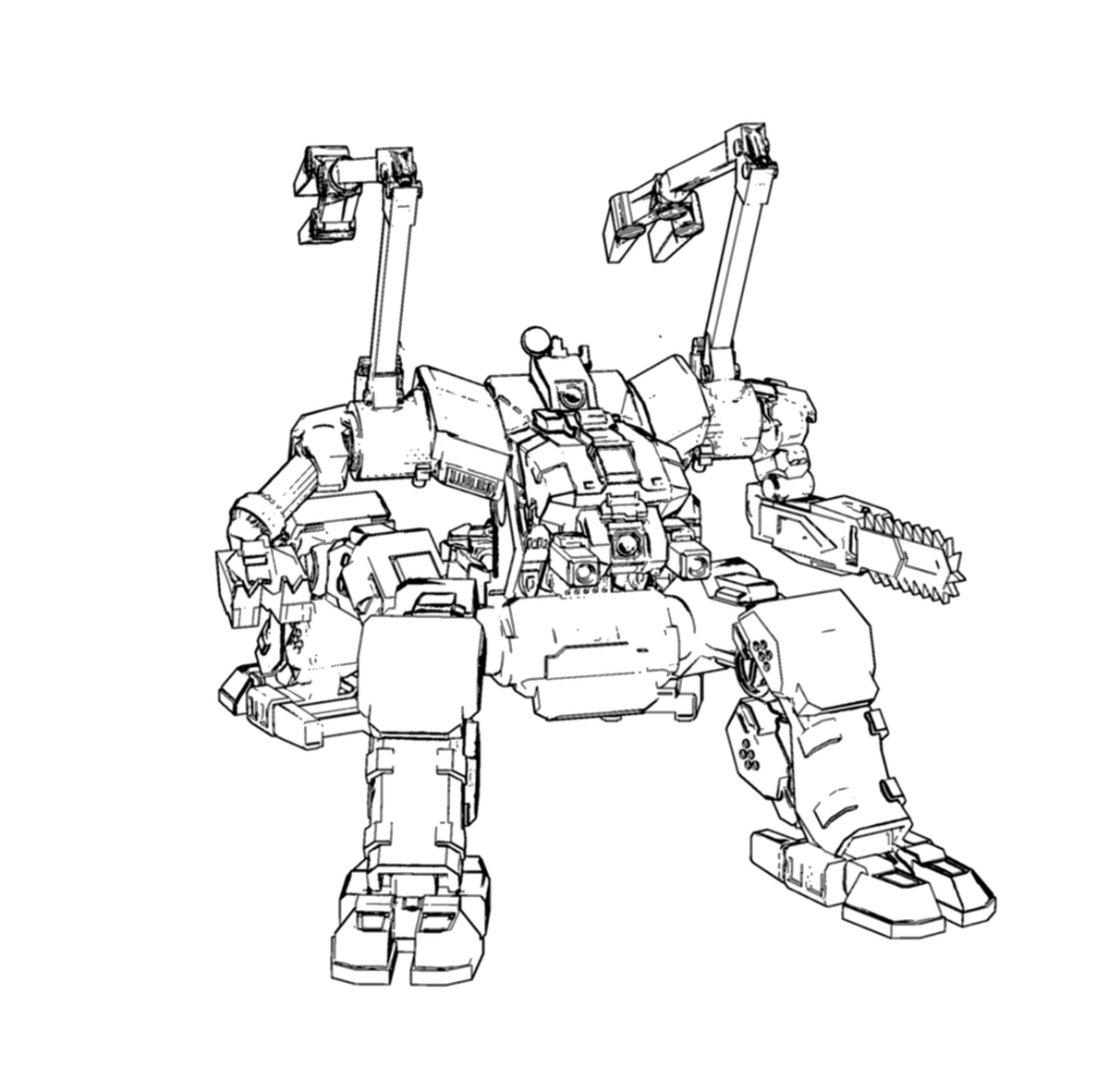
Origin: Order of Lod
IFF Type: II-SUPPORT.2

Hull: +1
Sys: +1
Agi: -1
Eng: +4

HP: 18
Armor: 1
Evasion: 10
E-Def: 10
Speed: 4
Size: 2
Heat Cap: 8
Save T: 12
Sensors: 10

Name | Mnt | Range | Acc | Dmg | Special
Claws and Cutter | M | (1) | -1 | 4K

Systems and Traits
Sealant Gun – Quick, extinguish ignited allies or slow enemies who fail a Hull save
Coordination Field – Adjacent allies roll saves and skill checks twice and take the better
Shield Projector – Full, Tech, One ally within 15 gains 5 Overshield

