The Jormungundr

Origin: Harrison Armory – Mithril Branch
IFF Type: HA TOKUGAWA
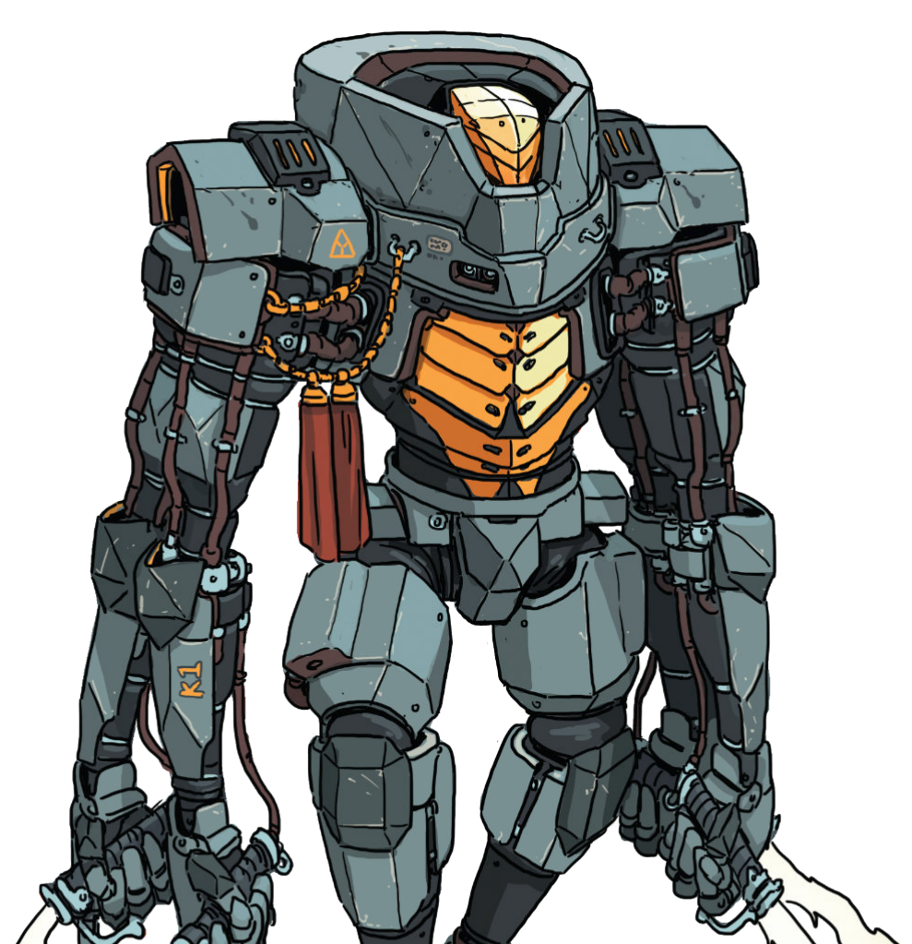
Hull: +2
Sys: +0
Agi: +2
Eng: +1

HP: 12 (4)
Armor: 1
Evasion: 10
E-Def: 6
Speed: 5
Size: 1
Heat Cap: 9
Save T: 11
Sensors: 10

Name | Mnt | Range | Acc | Dmg | Special
2 x Torch | M | (1) | +2 | 1d6E+3B | 2 SelfHeat, Overkill
Annihilator | M | 5 (3) | +2 | 1d3+2E | 2 SelfHeat, AP, Multiattack

Systems and Traits
LUCIFER-NHP
Deep Well Heat Sink

