Hole Puncher

Origin: Marrakesh?
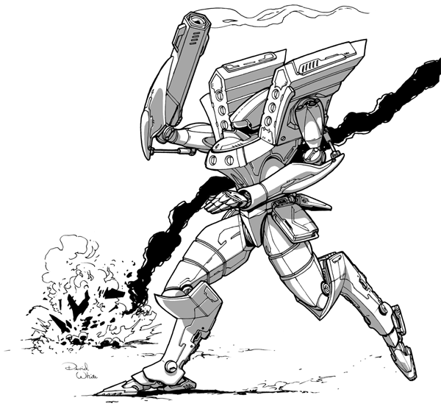
IFF Type: I-SPECTRE

Hull: -2
Sys: +1
Agi: +3
Eng: +0

HP: 10
Armor: 0
Evasion: 10
E-Def: 8
Speed: 4
Size: 1
Heat Cap: 7
Save T: 10
Sensors: 5

Name | Mnt | Range | Acc | Dmg | Special
Monosword | M | (3) | +2 | 5K
Showstopper Rifle | M | 10 | +2 | 3E | Reliable 2

Systems and Traits
Opportunity - +1 Accuracy against targets who are engaged
Deadly – 1d6 damage on critical hit
Optical Cloak – Can become Invisibile
Prowl – Quick, Move and become Hidden
Weakness Analyzer – Gain 1 extra Accuracy when using Lock On

