Automated PV Lifecycle Assessment (LCA) Tool
  - Thesis Presentation & Future Roadmap Report

1. Executive Summary
This project addresses a critical data transparency gap in the photovoltaic (PV) industry. While Environmental Product Declarations (EPDs) exist, they are currently locked in static, unstructured PDF formats, making large-scale comparison and sustainable procurement impossible. I have developed a Python-based data pipeline and an interactive Decision Support Tool (Web App) that automates the extraction, normalization, and visualization of EPD data. This empowers stakeholders to make data-driven decisions based on true Carbon Intensity (gCO2e/kWh) rather than just manufacturing footprint.

2. The Problem Statement
Why does this tool need to exist?
Data Silos: Critical environmental data is trapped in unstructured PDF documents scattered across various program operators.
Incomparable Units: Manufacturers report data differently (per module vs. per Watt vs. per m2), making direct apple-to-apple comparisons manually impossible.
Static Analysis: Current procurement decisions often ignore operational lifespan and degradation, which are critical for true 'cradle-to-grave' impact.
Greenwashing Risk: Without a standardized way to audit data quality, incomplete EPDs can falsely appear superior.

3. The Solution: PV LCA Decision Tool
I have built a comprehensive solution consisting of a data normalization engine and an interactive dashboard.
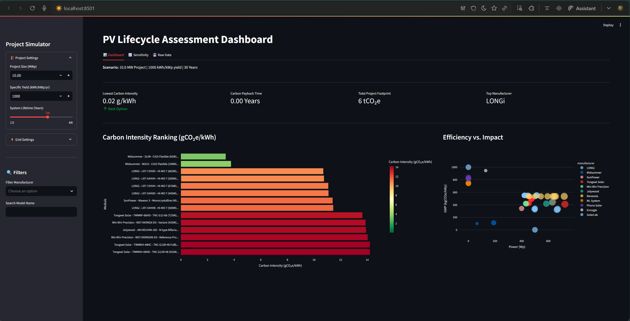
Figure 1: Comprehensive view of the Dashboard, showing the sidebar controls, main metrics (KPIs), and the Carbon Intensity ranking chart

3.1 Key Features
- Project Simulator: Unlike static lists, the tool simulates specific project contexts (Location Yield, Lifetime) to calculate real-world impact.
- Dynamic Metrics: Calculates Carbon Intensity (gCO2e/kWh) and Carbon Payback Time (CPT) in real-time.
- Quality Assurance: An automated 'Star Rating' system assesses data reliability, directly combating greenwashing.
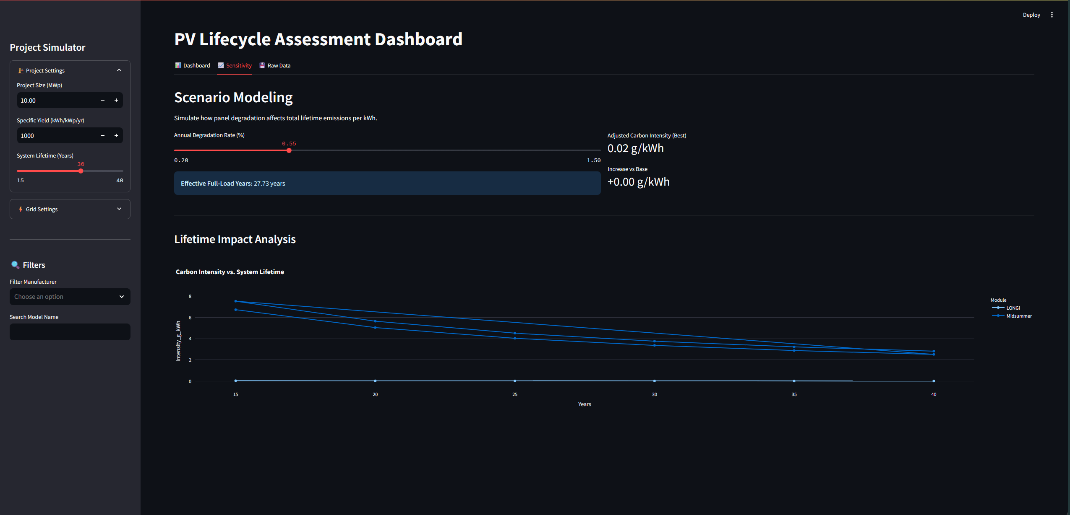
Figure 2: Sensitivity Analysis tab modeling the impact of degradation rates on the effective full-load years and adjusted carbon intensity

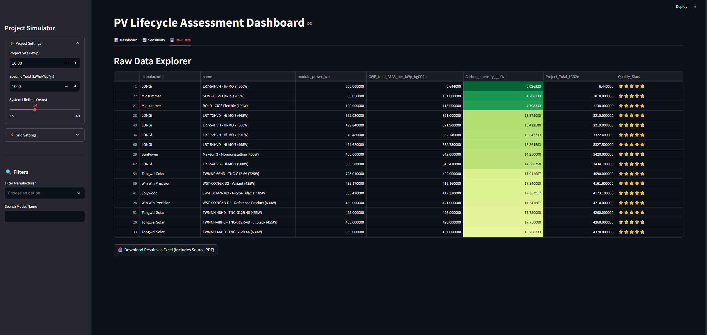
Figure 3: Raw Data Explorer tab displaying the full dataset with sorting capabilities and the Excel export function.

4. Industry Use Cases

Use Case A: Solar Developers & EPCs
Scenario: A developer needs to build a 50 MW plant in Southern Spain.
Solution: The tool identifies that while Glass-Glass modules have higher initial carbon, their lower degradation results in a 15% lower lifetime carbon intensity in high-irradiance climates.

Use Case B: Policy Makers & Public Procurement
Scenario: A government wants to set a carbon cap for new solar tenders.
Solution: The tool provides a benchmark for 'average' vs. 'best-in-class' carbon intensity to set realistic regulatory thresholds.

5. Future Roadmap: Agentic AI Automation
The current pipeline relies on manual CSV entry. The next phase introduces Agentic AI to fully automate the lifecycle from 'PDF Discovery' to 'Database Update'.

Phase 3: The "Autonomous EPD Hunter"
I propose a stack using n8n (Orchestrator), OpenAI GPT-4o (Intelligence), and Pinecone (Vector DB).
- The Scout (Search Agent): Triggers weekly to scrape EPD registries and identify valid PDF links for 'Photovoltaic Modules'.
- The Reader (Extraction Agent): Downloads PDFs and uses Vision-Language Models (GPT-4o) to extract unstructured data like GWP, Efficiency, and Dimensions into JSON.
- The Analyst (Normalization Agent): Applies the logic built in Phase 1 to convert mixed units into standard Wp metrics.
- The Publisher (Deployment Agent): Commits clean data to the GitHub repository and notifies stakeholders via Slack/Email.
Impact: This shift reduces data maintenance time by 99% and ensures the database grows automatically as new products are released.

6. Conclusion
This project transforms static, opaque environmental documents into a dynamic, transparent decision-making engine. By combining rigorous LCA methodology with modern web technology, I have built a tool that doesn't just show data it interprets it for real-world impact. The transition to an Agentic AI pipeline will secure this tool's position as a scalable, industry-leading standard for sustainable solar procurement.

