1195 VFD Usage Guide v0.2

目前在1195上有關VFD的操作, 是由VFD controller IP, 透過serial interface來操作VFD driver IC (例如Princeton PT6311), 來達到VFD display與key scanning

VFD driver 分為三部份
1. kernel driver : 存取VFD controller register 與interrupt handling
(linux-kernel/arch/arm/mach-rtk119x/driver/rtk_vfd.c)
2. low level user space driver : 控制 VFD controller與VFD driver IC
(phoenix/system/src/platform_lib/VFD/TOPPRO_TP6311.cpp)
- high level user space driver : user需根據不同應用而自行設計
(phoenix/system/src/platform_lib/VFD/FUTABA_11BT236.cpp)

一般來說, 使用者僅需了解low level user space driver的interface, 並且設計自己的high level user space driver即可.

（一）kernel driver
經由make menuconfig, 在以下路徑選取support Realtek VFD driver
System Type -> Realtek Platform Driver -> VFD driver

此kernel driver會建立三個device node
"/dev/venus_vfdo"
"/dev/venus_vfd_wrctl"
"/dev/venus_vfd_keypad"
low level user space driver即可透過這三個device node 操作vfd display與read keypad/switch status

(二) low level user space driver
請參考vfd_l.h, interface為class VFD_Controller, 實做在TOPPRO_TP6311.cpp,
在此文件中僅列出VFD display的low level user space driver interface, key scanning interface尚未列出, 將在後續文件補上.

- Constructor : VFD_Controller(int digit, unsigned char pulseWidth = 14);
Initial VFD driver IC, initial display ram, set dimming quality
Parameters:
int digit, configure how many digits you what on VFD,
EX: TP6311 could support different display mode, from 8 digit-20 segment to 16 digit- 12 segment

unsigned char pulseWidth configure how the dimming quality you what on VFD, EX: TP6311 could support
1/16 ~ 14/16 (pulseWidth 0 = display off, 1 = 1/16,…,14=14/16)

- Destructor : ~VFD_Controller();
Disable VFD driver IC
- unsigned char m_DisplayRAM[48];
Display ram buffer

- void InitDisplayRAM(void);
Initial display ram

- void UpdateDisplayRAM(void);
Trigger DisplayUpdater to update display ram and dimming quality

- void UpdateLED(void);
After using LEDOn or LEDoff, the UpdateLED() will trigger spi transaction to update LED

- void LEDOn(char ledNum);
Enable LED status without real spi transaction,
Parameters:
char ledNum EX : TP6311 support LED port 1~5, bit 0 corresponds LED1 display, bit 1 corresponds LED2
display and so forth.

- void LEDOff(char ledNum);
Disable LED status without real spi transaction,
Parameters:
char ledNum EX : TP6311 support LED port 1~5, bit 0 corresponds LED1 display, bit 1 corresponds LED2
display and so forth.

- void NodeOn(unsigned char digit, unsigned char segment);
enable specific segment in specific digit with real spi transaction,
Parameters:
unsigned char digit, specific which digit
unsigned char segment enable specific segment in this digit

- void NodeOff(unsigned char digit, unsigned char segment);
disable specific segment in specific digit with real spi transaction,
Parameters:
unsigned char digit, specific which digit
unsigned char segment disable specific segment in this digit

sNodeOn and sNodeOff modify DisplayRAM only, without real spi transaction (silent)
- void sNodeOn(unsigned char digit, unsigned char segment);
Enable specific segment in specific digit without real spi transaction,
Parameters:
unsigned char digit, specific which digit
unsigned char segment enable specific segment in this digit

- void sNodeOff(unsigned char digit, unsigned char segment);
Disable specific segment in specific digit without real spi transaction,
Parameters:
unsigned char digit, specific which digit
unsigned char segment disable specific segment in this digit

setDimmingQuality modify m_dimmingQuality only, without real spi transaction (silent)
- static void setDimmingQuality(unsigned char pulseWidth);
Update dimming quality without real spi transaction, and will be updated until the UpdateDisplayRAM is called.

例如在 PT6311, Digit與segment 對應到DisplayRAM address的對照如下
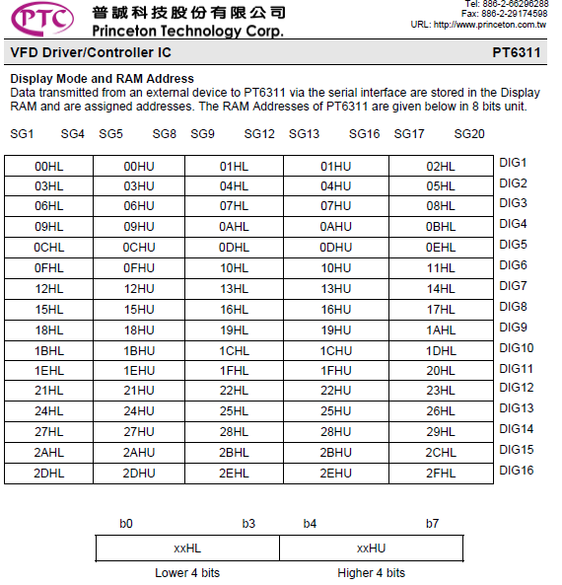

- inline bool IsUpdateComplete(void)
Check whether the display ram is updated

AutoRead control
- void disableAutoRead(void);
Disable keypad and switch auto read
- void enableAutoRead(void);
Enable keypad and switch auto read

(三) high level user space driver
您可以依照產品需求, 透過包裝low level user space driver interface, 客製化自己的high level user space driver
您可以參考 FUTABA_11BT236.cpp

#include "VFD_l.h"

void VenusVFD_init(void )
{
VFD_Controller_init(11, 14); // 11 digits, dimming quality 14/16
}

bool showTime(time_t timestamp)
{
struct tm TM;
char message[10];

printf(" showTime\n");
sNodeOn(6, 16);
localtime_r(&timestamp, &TM);
sprintf(message, " %02d%02d ", TM.tm_hour, TM.tm_min);
printf("[%s] %s %d showTime\n",__FILE__,__FUNCTION__,__LINE__);
show_msg(message);
return true;
}

bool show_msg(char *msg)
{
int length, i;
unsigned char startAddr;

length = strlen(msg);
if(length > 9 )
length = 9;

for(i=0;i<length;i++) {
startAddr = (9-i)*3;
pthread_mutex_lock(&(mem_mutex));
modifyDisplayRAM(m_DisplayRAM, startAddr, msg[i]);
pthread_mutex_unlock(&(mem_mutex));
}
for(;i<9;i++) {
startAddr = (9-i)*3;
pthread_mutex_lock(&(mem_mutex));
modifyDisplayRAM(m_DisplayRAM, startAddr, ' ');
pthread_mutex_unlock(&(mem_mutex));
}
UpdateDisplayRAM();
return true;
}

static void modifyDisplayRAM(unsigned char *base, unsigned char offset, char letter)
{
int i;
int tableIndex;

if(letter>= '0' && letter <= '9')
tableIndex = letter - '0';
else if(letter >= 'A' && letter <= 'Z')
tableIndex = letter - 'A' + 10;
else if(letter >= 'a' && letter <= 'z')
tableIndex = letter - 'a' + 10;
else if(letter == ' ')
tableIndex = 36;
else if(letter == '-')
tableIndex = 37;
else
tableIndex = 38;

for(i=2;i<=8;i++) {
if(letterTable[tableIndex][15-i] == 1)
base[offset] |= (0x1 << (i-1));
else
base[offset] &= (~(0x1 << (i-1)));
}

for(i=9;i<=15;i++) {
if(letterTable[tableIndex][15-i] == 1)
base[offset+1] |= (0x1 << (i-9));
else
base[offset+1] &= (~(0x1 << (i-9)));
}
}

Version | Date | Author | Changes from Previous Revision
0.1 | 2014/04/18 | Victor.hsu | The very first version
0.2 | 2014/11/7 | Victor.hsu | Modify

