
Archery Merit Badge Worksheet

Requirement 1

Name and explain the archery safety rules.

________________________________________________________________________________________________________________________________________________________________________________________________________________________________________________________________________________________________________________________________________________________________________________________________________________________________________________________________________________________________________________________________________________________________________________________________________________________________________________________________________________________________________________________________________________________________________________________________________________________________________________________________________________________________________________________________________________________________________________________________________________________________________________________________________________________________________________________________________________________________________________________________________________________________________________________________________________________________________________________________________________________________________________________________________________________________________________________________________________________________________________________________________________________________________________________________________________________________________________________________________________________________________________________________________________________________________________________________________________________________________________________________________________________________________________________________________________________________________________________________________________________________________________________________________________________________________________________________________________________________________________________________________________________________________________________________________________________________________________________________________________________________________________________________________________________________________________________________________

Requirement 2

Name the part of an arrow.

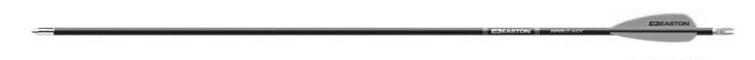

Name the parts of a bow.

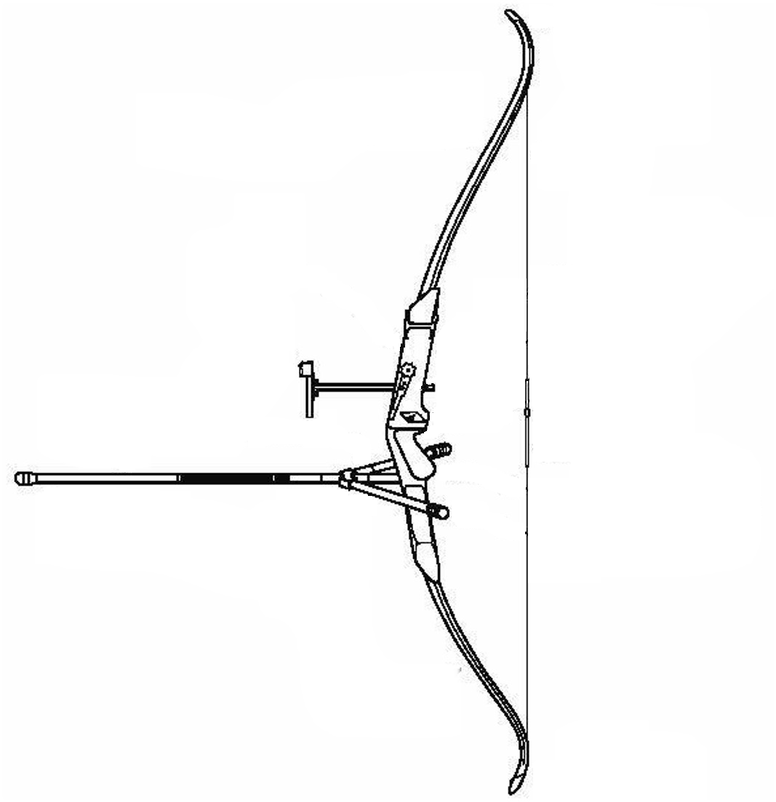
Describe the following accessories:

Arm Guard ____________________________________________________________________________________________________________________________________________________________________________________________________________________________________________________________________________________________________________

Shooting Glove
____________________________________________________________________________________________________________________________________________________________________________________________________________________________________________________________________________________________________________

Finger Tab
____________________________________________________________________________________________________________________________________________________________________________________________________________________________________________________________________________________________________________

Quiver
____________________________________________________________________________________________________________________________________________________________________________________________________________________________________________________________________________________________________________

Requirement 3

Explain the proper care and how to store the bow, bowstrings, and arrows.

 | Explain Proper Care | Explain How to Store
Bow
Bowstrings
Arrows

 Make a bowstring.

 Fletch six arrows:
 Arrow # 1
 Arrow # 2
 Arrow # 3
 Arrow # 4
 Arrow # 5
 Arrow # 6

Requirement 4

Explain the following terms:

Cast
____________________________________________________________________________________________________________________________________________________________________________________________________________________________________________________________________________________________________________________________________

Weight of Bow
____________________________________________________________________________________________________________________________________________________________________________________________________________________________________________________________________________________________________________________________________

Fistmele
____________________________________________________________________________________________________________________________________________________________________________________________________________________________________________________________________________________________________________________________________

Methods of Aiming
____________________________________________________________________________________________________________________________________________________________________________________________________________________________________________________________________________________________________________________________________

Spine
____________________________________________________________________________________________________________________________________________________________________________________________________________________________________________________________________________________________________________________________________

Target
____________________________________________________________________________________________________________________________________________________________________________________________________________________________________________________________________________________________________________________________________

Arrow
____________________________________________________________________________________________________________________________________________________________________________________________________________________________________________________________________________________________________________________________________

Field Arrow
____________________________________________________________________________________________________________________________________________________________________________________________________________________________________________________________________________________________________________________________________

Hunting Arrows
____________________________________________________________________________________________________________________________________________________________________________________________________________________________________________________________________________________________________________________________________

Requirement 5

Shoot with bow and arrow one of the following:

 A field round for 14 targets, and make a score of 60 points.
 A Boy Scout field archery round for 14 targets (56 shots), and make a score of 75 points.
 A junior American round on a standard 48-inch target, and make a score of 250 points.
 A national indoor round for 10 targets, and make a score of 30 points.
 A Chicago round on a standard 16-inch target, and make a score of 250 points.

Date Completed: _______________________

Name of Archery Range Official or Merit Badge Counselor: _______________________________________________

This certify that the scout met the minimum points for Requirement #5 of Archery Merit Badge as checked above.

_____________________________________________________
Signature of Archery Range Official or Merit Badge Counselor

Requirement 6

Explain the difference between field archery and target archery.
____________________________________________________________________________________________________________________________________________________________________________________________________________________________________________________________________________________________________________________________________________________________________________________________________________________________________________________________________________________________________________________________________________________________

Explain the following:

Field Round
________________________________________________________________________________________________________________________________________________________________________________________________________

Hunter’s Round
________________________________________________________________________________________________________________________________________________________________________________________________________

Animal Round
________________________________________________________________________________________________________________________________________________________________________________________________________

Boy Scout Field Archery Round
________________________________________________________________________________________________________________________________________________________________________________________________________

American and Junior American Rounds
________________________________________________________________________________________________________________________________________________________________________________________________________

National Indoor Round
________________________________________________________________________________________________________________________________________________________________________________________________________

Chicago Round
________________________________________________________________________________________________________________________________________________________________________________________________________

