
Bookbinding Merit Badge Worksheet

Requirement 1

Name the different parts of a book.

- __________________________________________________

- __________________________________________________

- __________________________________________________

- __________________________________________________

- __________________________________________________

- __________________________________________________

- __________________________________________________

- __________________________________________________

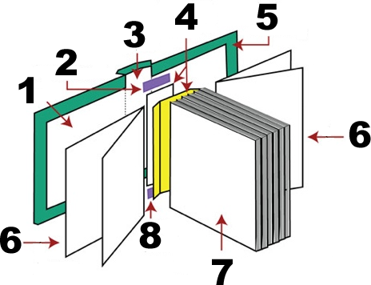

Requirement 2

- Name the different materials used in bookbinding.

____________________________ ____________________________ ____________________________

____________________________ ____________________________ ____________________________

____________________________ ____________________________ ____________________________

____________________________ ____________________________ ____________________________

____________________________ ____________________________ ____________________________

____________________________ ____________________________ ____________________________

- Name some substitute materials used in bookbinding.

____________________________ ____________________________ ____________________________

____________________________ ____________________________ ____________________________

____________________________ ____________________________ ____________________________

____________________________ ____________________________ ____________________________

____________________________ ____________________________ ____________________________

____________________________ ____________________________ ____________________________

- Describe the proper steps in preparing paste:

____________________________________________________________________________________________________

____________________________________________________________________________________________________

____________________________________________________________________________________________________

____________________________________________________________________________________________________

____________________________________________________________________________________________________

____________________________________________________________________________________________________

And explain their uses.

____________________________________________________________________________________________________

____________________________________________________________________________________________________

____________________________________________________________________________________________________

Requirement 3

Name the tools and equipment used in bookbinding, and explain their uses.

TOOLS | EXPLAIN THE USE

EQUIPMENTS | EXPLAIN THE USE

Requirement 4

Descript at least four (4) different stitches used in bookbinding.

STITCHES | DESCRIBE

Requirement 5

Bind or rebind any of the following:

 Sheets of Papers

 Volume of loose magazines or newspapers

 A damaged book

