
Crop Production Merit Badge Worksheet

Requirement 1

Show on a map of the Philippines where the following crops are grown in volume: corn, rice, sorghum, and soybeans.
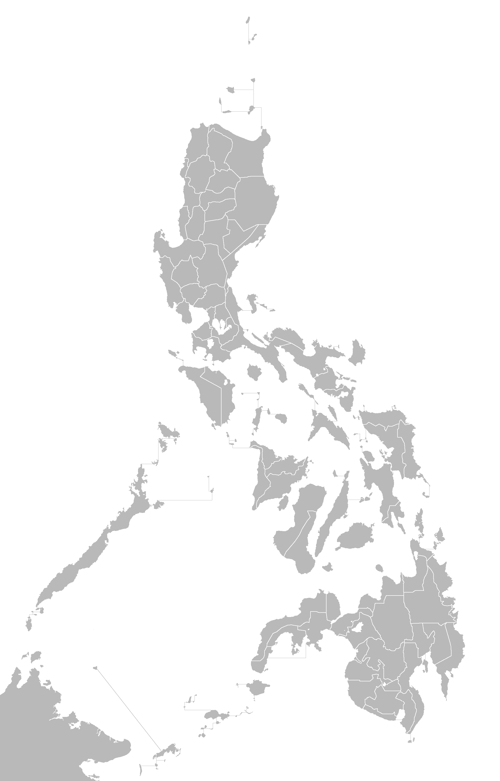
Requirement 2

Grow any of the above crops in an area of not less than 200 square meters (if planted to a standard variety), OR in a smaller plot if planted to an experimental variety (Consult your Merit Badge Counselor before planting).

MERIT BADGE COUNSELOR CONSULTATION

This certifies that the Scout has consulted me, the Merit Badge Counselor, and the I have given the Scout the go ahead to proceed with this requirement with the details below.

VARIETY # 1
Crop to be Planted:  Corn  Rice  Sorghum  Soybeans
Variety to be Planted:  Standard  Experimental
Name of this Variety: __________________________________________________________________________
Location of Area to Plant: ______________________________________________________________________
Size of the Area (in Square Meters): _____________________________

VARIETY # 2
Crop to be Planted:  Corn  Rice  Sorghum  Soybeans
Variety to be Planted:  Standard  Experimental
Name of this Variety: __________________________________________________________________________
Location of Area to Plant: ______________________________________________________________________
Size of the Area (in Square Meters): _____________________________

VARIETY # 3
Crop to be Planted:  Corn  Rice  Sorghum  Soybeans
Variety to be Planted:  Standard  Experimental
Name of this Variety: __________________________________________________________________________
Location of Area to Plant: ______________________________________________________________________
Size of the Area (in Square Meters): _____________________________

VARIETY # 4
Crop to be Planted:  Corn  Rice  Sorghum  Soybeans
Variety to be Planted:  Standard  Experimental
Name of this Variety: __________________________________________________________________________
Location of Area to Plant: ______________________________________________________________________
Size of the Area (in Square Meters): _____________________________

Signature of Merit Badge Counselor: ____________________________________

Date of Consultation: ___________________________

Requirement 3

Keep an accurate and complete record of costs, hours of work, seed and other materials, and yield.

SEED AND MATERIALS RECORD

Date  Purchased | Seed or  Material | Description of Item Purchased | QTY | Unit Price | Item Total

HOURS OF WORK RECORD

Date of  Work | Description of Work Performed | # of  People  (A) | # of Hours  Spent  (B) | Total  Man  Hours  (A x B)

YIELD RECORD

Crop Variety  Planted | Date  Planted | Expected  Yield  (A) | Date  Harvest | Actual  Yield  (B) | Yield  Variance  (B-A)

Requirement 4

Submit your record, with samples of yield, to your Counselor.

COUNSELOR CERTIFICATION

This certifies that I have reviewed the Scouts records in fulfillment of Requirement #3 of the Crop Production Merit Badge and the sample yield.

Signature of Merit Badge Counselor: ____________________________________

Date of Consultation: ___________________________

Describe the relative value of at least three varieties of the crop planted.

# | Crop Variety | Describe the Relative Value
1
2
3

Requirement 5

Describe modern ways of crop farming.

