
Fruit Cultivation Merit Badge Worksheet

Requirement 1

Do the following:

- Point out on a map of the Philippines the regions where ten (10) different varieties of fruits can be found or grown.

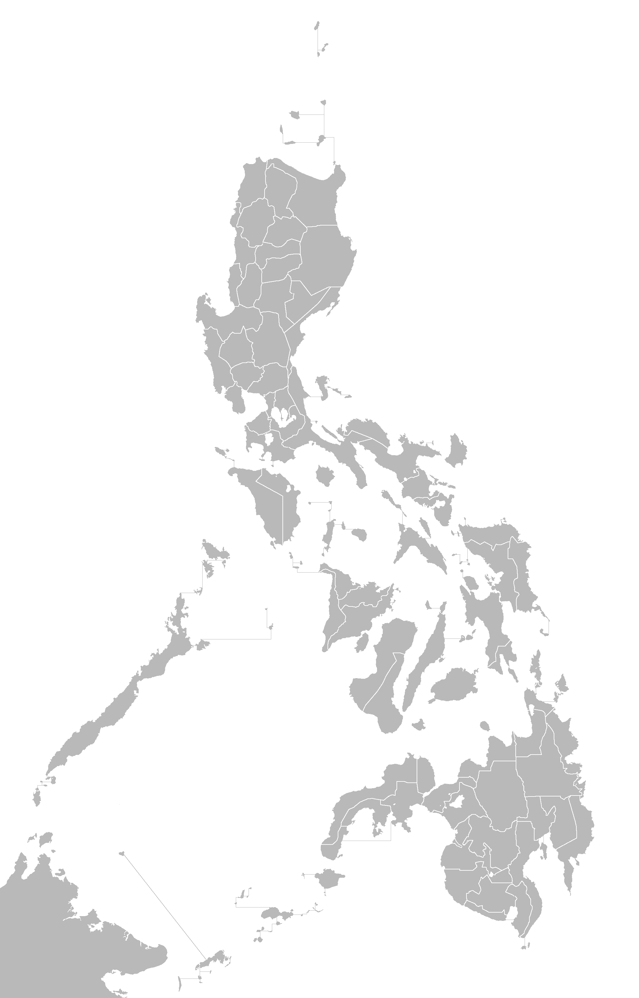

- List the varieties of fruits that can be grown economically where you live.

No # | Fruit Variety
1
2
3
4
5

Requirement 2

Pick a good place in your backyard for a fruit or nut orchard. Make a plan for planting fruits and nuts in this area.

What are you planning to plant?  Fruits  Nuts  Both

Write your plan below. Include dates you expect to start and finish this project. Also include where you plan to acquire the fruit or nut you are planting and how you plan to care for it.

Counselor Approval of Your Plan:

___________________________________________ __________________
Counselor Signature Date
Requirement 3

Take full care of your fruit or nut orchard through a crop season of one (1) year. Keep accurate record of costs, observations, and yields. Describe three (3) of the insect pests most harmful to fruit or nut crops where you live. Name two (2) diseases most harmful. Explain how you would control each without hurting wildlife or destroying useful insects.

COST RECORD

Date | Description of Item Purchased | Unit Cost | QTY or Weight | Total Item Cost

YIELDS

Date | Amount of Yield | Date | Amount of Yield

OBSERVATIONS

Date Observed | Observation Record

INSECT PEST

# | Insect Name | Describe How They Are Harmful | Explain How to Control without Hurting Wildlife and Useful Insect
1
2
3

DISEASES

# | Disease Name | Explain How to Control without Hurting Wildlife and Useful Insect
1
2

