
Horsemanship Merit Badge Worksheet

Requirement 1

Name fifteen (15) parts of a horse.

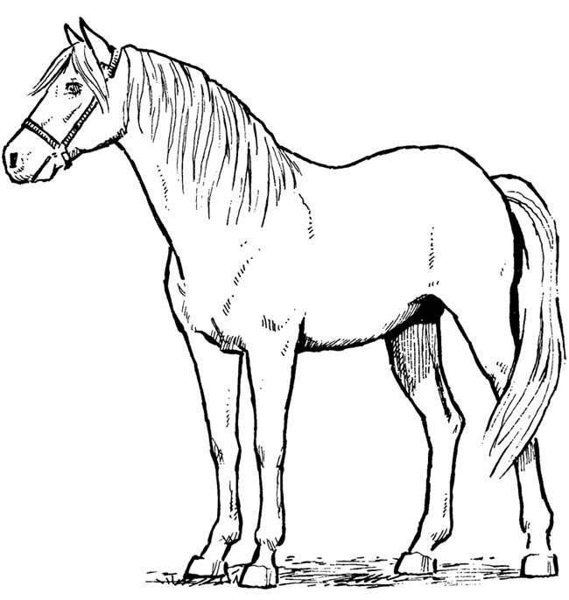

Requirement 2

Name four (4) leading breeds of horses. Explain what each breed is noted for.

Breed of Horse | Noted For

Requirement 3

 Show the care of Saddle

 Show the care of Bridle

Name the main parts of a Saddle and Bridle.

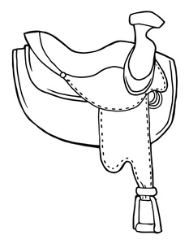
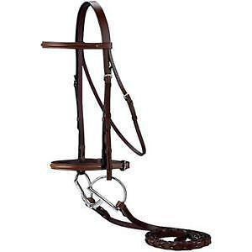

Requirement 4

 Show how to Groom

 Show how to Pick Out Feet

 Show how to Care for Horse After Riding

Requirement 5

Describe the symptoms of colic.

________________________________________________________________________________________________________________________________________________________________________________________________________________________________________________________________________________________________________________________________________________________________________________________________________________________________________________________________________________________________________________________________________________________________________________________________________________________________________________________________________________________________________________________________________________________________________________________________________________________________________________________________________________________________

Describe four (4) other horse diseases.

Disease Name | Describe

Requirement 6

Name three (3) main defects of feet and legs. Explain how to detect them.

Main Defects | Detection

Requirement 7

 Show how to safely approach and rescue a horse from a stall in case of fire.

List down the steps here:

________________________________________________________________________________________________________________________________________________________________________________________________________________________________________________________________________________________________________________________________________________________________________________________________________________________________________________________________________________________________________________________________________________________________________________________________________________________________________________________________________________________________________________________________________________________________________________________________________________________________________________________________________________________________
________________________________________________________________________________________________________________________________________________________________________________________________________________________________________________________________________________________________________________________________________________________________________________________________________________________________________________________________________________________________________________________________________________________________________________________________________________________________________________________________________________________________________________________________________________________________________________________________________________________________________________________________________________________________

Requirement 8

 Ride a horse for a distance of ten (10) kilometers.

