
Insect Study Merit Badge Worksheet

Requirement 1

Tell how insects are different from all other animals.

____________________________________________________________________________________________________________

____________________________________________________________________________________________________________

____________________________________________________________________________________________________________

____________________________________________________________________________________________________________

____________________________________________________________________________________________________________

____________________________________________________________________________________________________________

____________________________________________________________________________________________________________

____________________________________________________________________________________________________________

Show the differences between insects, spiders, and centipedes.

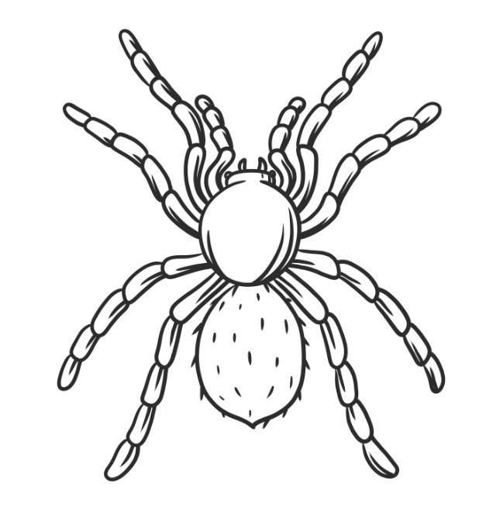 | 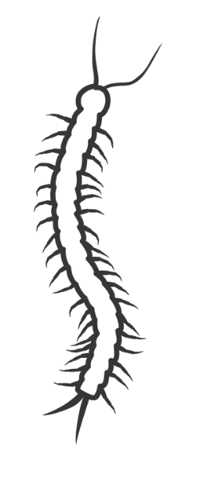

____________________________________________________________________________________________________________

____________________________________________________________________________________________________________

____________________________________________________________________________________________________________

____________________________________________________________________________________________________________

____________________________________________________________________________________________________________
Requirement 2

Point out and name the main parts of an insect.
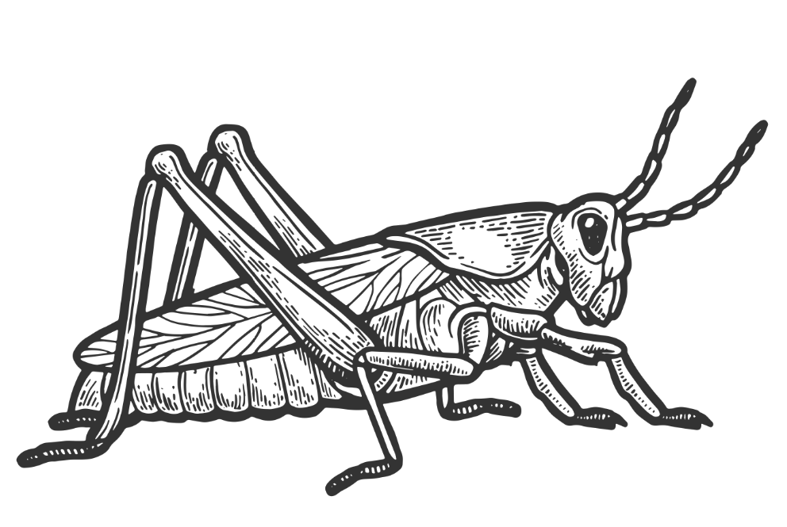

Requirement 3

Collect and mount fifteen (15) different species. Label each one with common and scientific names where possible.

No# | Common Name | Scientific Name
1
2
3
4
5
6
7
8
9
10
11
12
13
14
15

Show your collection to your Troop or Patrol.

Date Shown ___________________________________
Requirement 4

IMPORTANT! Print fifteen (15) Copies of this page and complete one for each insect you have collected.

Tell something about the histories and habits of the fifteen insects collected – where each is likely to be found, what it eats, the different stages of its life; how it sees, hears, smells, feels; and with what plants, animals, birds, and other insects it is associated.

# | Insect Common Name

Where is it likely to be found: ___________________________________________________________________________

What It Eats: _________________________________________________________________________________________

Different Stages of Its Life: ______________________________________________________________________________

____________________________________________________________________________________________________

____________________________________________________________________________________________________

____________________________________________________________________________________________________

____________________________________________________________________________________________________

____________________________________________________________________________________________________

____________________________________________________________________________________________________

____________________________________________________________________________________________________

How it Sees: __________________________________________________________________________________________

How it Hears: _________________________________________________________________________________________

How it Smells: ________________________________________________________________________________________

How it Feels: _________________________________________________________________________________________

What it Associates With:

Plants: _______________________________________________________________________________________

Animals: _____________________________________________________________________________________

Birds: ________________________________________________________________________________________

Other Insects: _________________________________________________________________________________

Requirement 5

Tell how insects fit in the food chains of other insects, fish, birds, and mammals.

____________________________________________________________________________________________________________

____________________________________________________________________________________________________________

____________________________________________________________________________________________________________

____________________________________________________________________________________________________________

____________________________________________________________________________________________________________

____________________________________________________________________________________________________________

____________________________________________________________________________________________________________

____________________________________________________________________________________________________________

____________________________________________________________________________________________________________

____________________________________________________________________________________________________________

____________________________________________________________________________________________________________

____________________________________________________________________________________________________________

____________________________________________________________________________________________________________

____________________________________________________________________________________________________________

____________________________________________________________________________________________________________

____________________________________________________________________________________________________________

Requirement 6

From your insect collection, identify:

- Five (5) species of insects helpful to man. Tell how they are helpful

No# | Insect Common Name | How They Are Helpful
1
2
3
4
5

- Five (5) species of insects harmful to man. Tell how they are harmful.

No# | Insect Common Name | How They Are Harmful
1
2
3
4
5

Requirement 7

Tell things that make social insects different from solitary insects.

____________________________________________________________________________________________________________

____________________________________________________________________________________________________________

____________________________________________________________________________________________________________

____________________________________________________________________________________________________________

____________________________________________________________________________________________________________

____________________________________________________________________________________________________________

____________________________________________________________________________________________________________

____________________________________________________________________________________________________________

____________________________________________________________________________________________________________

____________________________________________________________________________________________________________

____________________________________________________________________________________________________________

____________________________________________________________________________________________________________

____________________________________________________________________________________________________________

____________________________________________________________________________________________________________

____________________________________________________________________________________________________________

____________________________________________________________________________________________________________

Requirement 8

Compare the life histories of a butterfly and a grasshopper.

Butterfly | Grasshopper

Explain how they are different.

____________________________________________________________________________________________________________

____________________________________________________________________________________________________________

____________________________________________________________________________________________________________

____________________________________________________________________________________________________________

____________________________________________________________________________________________________________

____________________________________________________________________________________________________________

____________________________________________________________________________________________________________

____________________________________________________________________________________________________________

Raise a butterfly or a moth from a caterpillar.

Select which one your raised: □ Butterfly □ Moth

