
Weather Merit Badge Worksheet

Requirement 1

List the composition of air, note whether they are constant or variable element, and their function, if any.

Element Function
- ____________ ◻ Constant ◻ Variable ____________________________________________________________________
- ____________ ◻ Constant ◻ Variable ____________________________________________________________________
- ____________ ◻ Constant ◻ Variable ____________________________________________________________________
- ____________ ◻ Constant ◻ Variable ____________________________________________________________________
- ____________ ◻ Constant ◻ Variable ____________________________________________________________________
- ____________ ◻ Constant ◻ Variable ____________________________________________________________________
- ____________ ◻ Constant ◻ Variable ____________________________________________________________________
- ____________ ◻ Constant ◻ Variable ____________________________________________________________________
- ____________ ◻ Constant ◻ Variable ____________________________________________________________________

Requirement 2

Tell how the following are formed:

Moisture _____________________________________________________________________________________________

Fog _________________________________________________________________________________________________

Hail ________________________________________________________________________________________________

Rain ________________________________________________________________________________________________

Snow _______________________________________________________________________________________________

Requirement 3

Explain the electrical and optical phenomena in the air:

Rainbow _____________________________________________________________________________________________

Mirage ______________________________________________________________________________________________

Looming ____________________________________________________________________________________________

Halos _______________________________________________________________________________________________

Lightning ____________________________________________________________________________________________

Thunder _____________________________________________________________________________________________

◻ Describe to your counselor occurrence of these phenomena you’ve seen for yourself

Requirement 4

What is the following equipment used for and how?

Barometer Used for ______________________________________________________________________________

How __________________________________________________________________________________

Thermometer Used for ______________________________________________________________________________

How __________________________________________________________________________________

Anemometer Used for ______________________________________________________________________________

How __________________________________________________________________________________

Hygrometer Used for ______________________________________________________________________________

How __________________________________________________________________________________

Rain Gauge Used for ______________________________________________________________________________

How __________________________________________________________________________________

◻ Make a simple weather vane.

◻ Be conversant with storm/weather signals.

Requirement 5

Do one:

◻ On the back of this page: Write a simple statement on the climate in the Philippines.

- OR -

◻ On the back of this page: Tell the value of weather prediction.

◻ Write a brief account of the Philippine Atmospheric Geophysical and Astronomical Services Administration (PAGASA) – stating what daily, weekly, or monthly publication are prepared and distributed by it.

◻ Be able to interpret the charts and graphs contained in PAGASA publications.

- OR -

◻ Using the table on the next page, keep a daily record for a month of the following: dew or fog in the morning; at a specific hour each day, the direction and force of the wind; the temperature and kinds of clouds (if any) in the sky.

Day | Time  Morning | Dew or  Fog | Time of  Day | Wind  Direction | Wind Speed | Temperature | Clouds
1
2
3
4
5
6
7
8
9
10
11
12
13
14
15
16
17
18
19
20
21
22
23
24
25
26
27
28
29
30
31

Requirement 6

Places where danger from lightning is great: Places where danger from lightning is less:

__________________________________________ __________________________________________
__________________________________________ __________________________________________
__________________________________________ __________________________________________
__________________________________________ __________________________________________
__________________________________________ __________________________________________
__________________________________________ __________________________________________
__________________________________________ __________________________________________

Requirement 7

Using the map of Asia below map the trajectories or paths of typhoons in the Philippines
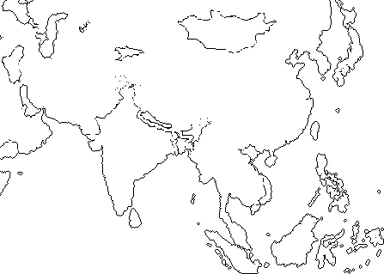

What is the cause and origin of typhoons?
________________________________________________________________________________________________________________________________________________________________________________________________________________________
____________________________________________________________________________________________________________
____________________________________________________________________________________________________________
____________________________________________________________________________________________________________

