
World Brotherhood Merit Badge Worksheet

Requirement 1

Have an elementary knowledge of the geography, history, customs, and characteristics of people of at least three countries other than your own.
Geography History Customs People

Country # 1 _______________________ ◻ ◻ ◻ ◻

Country # 2 _______________________ ◻ ◻ ◻ ◻

Country # 3 _______________________ ◻ ◻ ◻ ◻

Requirement 2

Correspond regularly for a period of not less than one year with a Scout of another country. Write at least six letters and receive at least three replies.

Name of Foreign Scout: _________________________________________________________________________________

Address: _____________________________________________________________________________________________

Date of Letters Sent Date of Letters Received

1. ____________________ 1. ____________________

2. ____________________ 2. ____________________

3. ____________________ 3. ____________________

4. ____________________

5. ____________________

6. ____________________

Requirement 3

◻ Give an informative talk of at least 3-minute duration to the members of your Patrol/Crew/Troop/Outfit on the interest and knowledge gained by corresponding with or visiting a Scout of another country.

Date Delivered: ____________________

Requirement 4

Tell in your own words how the Scouting Movement began: ___________________________________________________________
____________________________________________________________________________________________________________
____________________________________________________________________________________________________________
____________________________________________________________________________________________________________
____________________________________________________________________________________________________________
____________________________________________________________________________________________________________
____________________________________________________________________________________________________________
____________________________________________________________________________________________________________
____________________________________________________________________________________________________________
____________________________________________________________________________________________________________
____________________________________________________________________________________________________________
____________________________________________________________________________________________________________
____________________________________________________________________________________________________________

Identify the five Scouting regions on the world map below.
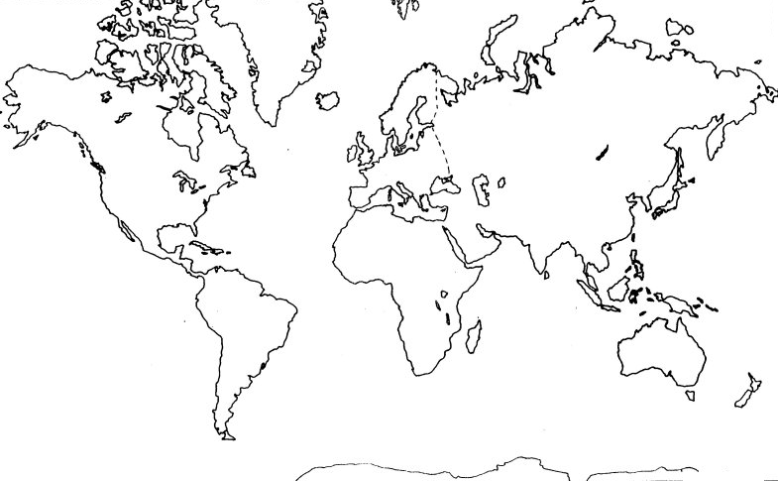

List thirty countries which have Scouting:

1. ________________________ 11. ________________________ 21. ________________________
2. ________________________ 12. ________________________ 22. ________________________
3. ________________________ 13. ________________________ 23. ________________________
4. ________________________ 14. ________________________ 24. ________________________
5. ________________________ 15. ________________________ 25. ________________________
6. ________________________ 16. ________________________ 26. ________________________
7. ________________________ 17. ________________________ 27. ________________________
8. ________________________ 18. ________________________ 28. ________________________
9. ________________________ 19. ________________________ 29. ________________________
10. ________________________ 20. ________________________ 30. ________________________

◻ Describe and demonstrate at least three ways by which Scouts from various countries can recognize each other.

1. ________________________ 2. ________________________ 3. ________________________

Explain the organization and operation of the World Organization of the Scout Movement.

World Scout Conference ________________________________________________________________________________
____________________________________________________________________________________________________
____________________________________________________________________________________________________
____________________________________________________________________________________________________
____________________________________________________________________________________________________
____________________________________________________________________________________________________
____________________________________________________________________________________________________

World Scout Committee ________________________________________________________________________________
____________________________________________________________________________________________________
____________________________________________________________________________________________________
____________________________________________________________________________________________________
____________________________________________________________________________________________________
____________________________________________________________________________________________________
____________________________________________________________________________________________________

World Scout Bureau ___________________________________________________________________________________
____________________________________________________________________________________________________
____________________________________________________________________________________________________
____________________________________________________________________________________________________
____________________________________________________________________________________________________
____________________________________________________________________________________________________
____________________________________________________________________________________________________

Requirement 5

Do any three of the following:

Draw the flag of the United Nations and at least twelve member countries. Label your drawing.

- OR -

◻ Read the Preamble of the Charter of the United Nation.

Use the space below to outline in your own words the purpose of the United Nations Organization as set forth in Chapter 1 of its Charter.

- OR -

Describe the work of the specialized agencies of the United Nations.

International Labor Organization (ILO) ___________________________________________________________________________
____________________________________________________________________________________________________________
____________________________________________________________________________________________________________
____________________________________________________________________________________________________________

Food and Agriculture Organization of the United Nations (FAO) _______________________________________________________
____________________________________________________________________________________________________________
____________________________________________________________________________________________________________
____________________________________________________________________________________________________________

United Nations Educational, Scientific, and Cultural Organization (UNESCO) ____________________________________________
____________________________________________________________________________________________________________
____________________________________________________________________________________________________________
____________________________________________________________________________________________________________

World Health Organization (WHO) _______________________________________________________________________________
____________________________________________________________________________________________________________
____________________________________________________________________________________________________________
____________________________________________________________________________________________________________

- OR -

◻ Read the Universal Declaration of Human Rights.

List at least five rights directly related to you and your family:

- _____________________________________________________
- _____________________________________________________
- _____________________________________________________
- _____________________________________________________
- _____________________________________________________

Requirement 6

Do any three of the following:

◻ Take part in some practical activity of an international character such as the collection or distribution of relief supplies OR the reception and entertainment of visitors from overseas OR assist in a project of a non-partisan organization to promote world brotherhood.

◻ Relate briefly to the members of your Patrol/Crew/Troop/Outfit the history of Scouting in three member countries of the World Organization of the Scout Movement. Draw their Scout Emblems below and label the country.

◻ Keep an album or scrapbook for at least one year depicting activities of another country.

◻ Camp at least five days with Scouts from another country either on locally or in a foreign country. Log your daily activities and impressions below. Show you have a fair understanding of the culture, customs, and characteristics of the Scouts you camped with.

Day 1 ______________________________________________________________________________________
______________________________________________________________________________________
______________________________________________________________________________________
______________________________________________________________________________________
______________________________________________________________________________________

Day 2 ______________________________________________________________________________________
______________________________________________________________________________________
______________________________________________________________________________________
______________________________________________________________________________________
______________________________________________________________________________________

Day 3 ______________________________________________________________________________________
______________________________________________________________________________________
______________________________________________________________________________________
______________________________________________________________________________________
______________________________________________________________________________________

Day 4 ______________________________________________________________________________________
______________________________________________________________________________________
______________________________________________________________________________________
______________________________________________________________________________________
______________________________________________________________________________________

Day 5 ______________________________________________________________________________________
______________________________________________________________________________________
______________________________________________________________________________________
______________________________________________________________________________________
______________________________________________________________________________________

◻ Carry on a conversation with another person in a foreign language for at least five minutes.

Translate at least 100 words of that language given by your counselor. Use the back portion of this page if necessary.

