# A yellow and blue compass AI-generated content may be incorrect.Navigation

Worksheet by the Merit Badge Center, Philippines

**Last Updated: August 20, 2025**

This worksheet was created to assist Scouts with their merit badge work. The worksheet does not replace the actual merit badge counseling process. A certified merit badge counselor for the badge must still certify your completion of each requirement and the merit badge. If a requirement says that you must take an action using words such as “discuss”, “show”, “tell”, “explain”, “demonstrate”, “identify”, etc. that is what you must do. **Merit badge counselors may not require the use of this worksheet or any similar material**. No one may add, subtract, or modify the official requirements for the merit badge as prescribed by the Boy Scouts of the Philippines.

Scout’s Name: ___________________________________________ Unit: _________________________

## Requirement 1. Do the following:

## 1a. Discuss with your Outfit/Troop the cardinal and sub-cardinal points. Identify the landmarks located in each direction based on your home as a point of reference.

Discuss with your Outfit/Troop.

_____________________________________ _______________

Unit Leader’s Signature Date

Draw landmarks in each cardinal and sub-cardinal direction based on your home as point of reference.

|  |
| --- |
|  |

## 1b. Identify and explain the parts and functions of the compass.

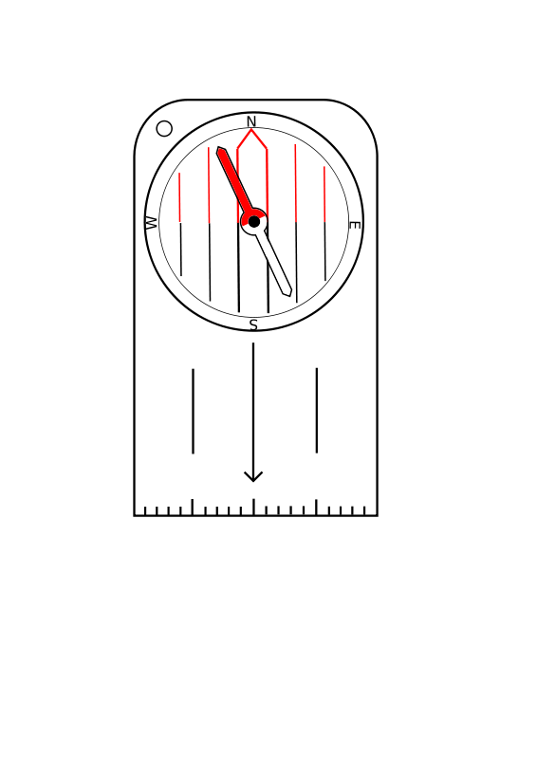

Have your Merit Badge Counselor certify that you have completed this requirement.

________________________________ _____________

Merit Badge Counselor’s Signature Date

## 1c. Demonstrate the proper use of a compass.

Have your Merit Badge Counselor certify that you have completed this requirement.

________________________________ _____________

Merit Badge Counselor’s Signature Date

## Requirement 2. Demonstrate first aid procedure for the following types of injuries that could occur while traveling: blisters, cuts, scrapes, animal/insect bites, heat and cold reactions (sunburn, heatstroke, heat exhaustion, hypothermia), dehydration.

* Blisters
* Cuts
* Scrapes
* Animal/Insect Bites
* Sunburn
* Heatstroke
* Heat Exhaustion
* Hypothermia
* Dehydration

Have your Merit Badge Counselor certify that you have completed this requirement.

________________________________ _____________

Merit Badge Counselor’s Signature Date

## Requirement 3. Do the following:

## 3a. Discuss with your counselor the different types of maps.

|  |
| --- |
|  |
|  |
|  |
|  |
|  |
|  |
|  |
|  |
|  |
|  |
|  |
|  |

Have your Merit Badge Counselor certify that you have completed this requirement.

________________________________ _____________

Merit Badge Counselor’s Signature Date

## 3b. Explain how topographic maps show terrain.

|  |
| --- |
|  |
|  |
|  |
|  |
|  |
|  |
|  |
|  |
|  |
|  |
|  |
|  |

## 3c. Name and point out 10 symbols on a topographic map.

|  |  |
| --- | --- |
| 1. | 6. |
| 2. | 7. |
| 3. | 8. |
| 4. | 9. |
| 5. | 10. |

## 3d. Demonstrate how to measure distances on a map.

Have your Merit Badge Counselor certify that you have completed this requirement.

________________________________ _____________

Merit Badge Counselor’s Signature Date

## 4. Discuss the importance of “Leave No Trace” principles while navigating.

|  |
| --- |
|  |
|  |
|  |
|  |
|  |
|  |
|  |
|  |
|  |
|  |
|  |
|  |
|  |
|  |
|  |
|  |
|  |
|  |
|  |
|  |
|  |
|  |
|  |
|  |
|  |
|  |
|  |
|  |
|  |
|  |

## 5. Do one (1) of the following:

## Demonstrate techniques on how to stay came and focused when lost or facing navigation difficulties.

Have your Merit Badge Counselor certify that you have completed this requirement.

________________________________ _____________

Merit Badge Counselor’s Signature Date

## Conduct a 1-km navigation walk (with approval of your counselor) practicing mindfulness exercises such as deep breathing, and focused attention.

Identify where you plan to do your 1-km navigation walk: __________________________________

Have your Merit Badge Counselor approve where you plan to do your 1-km navigation walk.

________________________________ _____________

Merit Badge Counselor’s Signature Date

Have your Merit Badge Counselor certify that you have completed this requirement.

________________________________ _____________

Merit Badge Counselor’s Signature Date

## 6. Discuss with your counselor how navigation map reading and compass use have influenced different cultures and religions.

|  |
| --- |
|  |
|  |
|  |
|  |
|  |
|  |
|  |
|  |

Have your Merit Badge Counselor certify that you have completed this requirement.

________________________________ _____________

Merit Badge Counselor’s Signature Date