# Tailoring

Worksheet by the Merit Badge Center, Philippines

**Last Updated: March 22, 2021**

This worksheet was created to assist Scouts with their merit badge work. The worksheet does not replace the actual merit badge counseling process. A certified merit badge counselor for the badge must still certify your completion of each requirement and the merit badge. If a requirement says that you must take an action using words such as “discuss”, “show”, “tell”, “explain”, “demonstrate”, “identify”, etc. that is what you must do. **Merit badge counselors may not require the use of this worksheet or any similar material**. No one may add, subtract, or modify the official requirements for the merit badge as prescribed by the Boy Scouts of the Philippines.

Scout’s Name: ___________________________________________ Unit: _________________________

## Requirement 1. Show how to operate, thread, and take care of a sewing machine.

Have your Merit Badge Counselor certify the completion of this requirement.

|  |  |  |
| --- | --- | --- |
| **Requirement** | **Merit Badge Counselor Signature** | **Date** |
| **Operate a Sewing Machine** |  |  |
| **Thread a Sewing Machine** |  |  |
| **Take Care of a Sewing Machine** |  |  |

## Requirement 2. Identify and tell the uses of the following basic tools for tailoring: tape measure, tailor’s square, scissors, tracer, tailor’s chalk.

|  |  |  |
| --- | --- | --- |
| **Tailoring Tool** | **Identified** | **Tell the Use** |
| **Tape Measure** |  |  |
| **Tailor’s Square** |  |  |
| **Scissors** |  |  |
| **Tracer** |  |  |
| **Tailor’s Chalk** |  |  |

## Requirement 3. Name the different parts of a pair of trousers and a casual shirt.

Name the different parts of a pair of trousers.

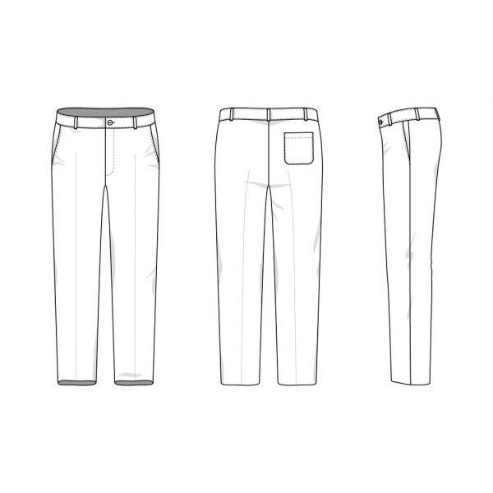

Name the different parts of a casual shirt.

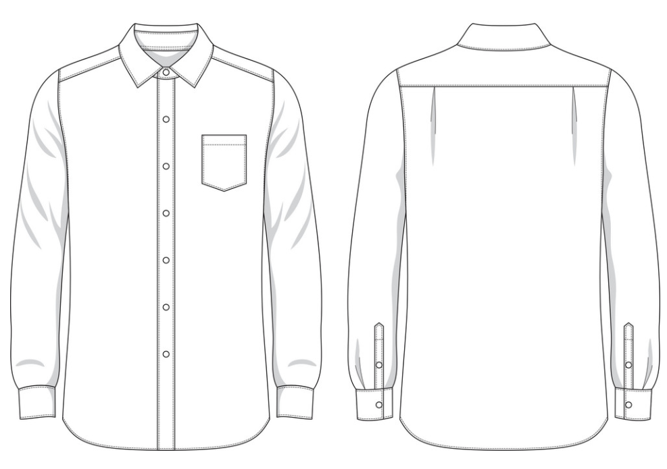

## Requirement 4. Show how to take the measurements for making pajamas and athletic pants. Draft the pattern and make a pair of pajamas or athletic pants.

Show how to take the measurements for making pajamas and athletic pants.

|  |  |
| --- | --- |
| Body Area of Measurement | Measurement |
|  |  |
|  |  |
|  |  |
|  |  |
|  |  |
|  |  |
|  |  |
|  |  |
|  |  |
|  |  |

Have your Merit Badge Counselor certify the completion of this requirement.

___________________________________ _________________

Merit Badge Counselor’s Signature Date

Draft the pattern of a pair of pajamas or athletic pants.

|  |
| --- |
|  |

Make a pair of pajamas or athletic pants, show this to your Merit Badge Counselor.

___________________________________ _________________

Merit Badge Counselor’s Signature Date

## Requirement 5. Explain why certain fabrics should be soaked first in water and drip-dried preparatory to cutting the cloth.

|  |
| --- |
|  |
|  |
|  |
|  |
|  |
|  |
|  |
|  |
|  |
|  |

## Requirement 6. Explain what is sanforized cloth.

|  |
| --- |
|  |
|  |
|  |
|  |
|  |
|  |
|  |
|  |
|  |
|  |

## Requirement 7. Repair or remodel one of the following: worn out collar, too short or too long trousers, tight or loose trouser waistline.

Indicate what you repaired or remodeled: _______________________________________________________

Have your Merit Badge Counselor certify the completion of this requirement.

___________________________________ _________________

Merit Badge Counselor’s Signature Date