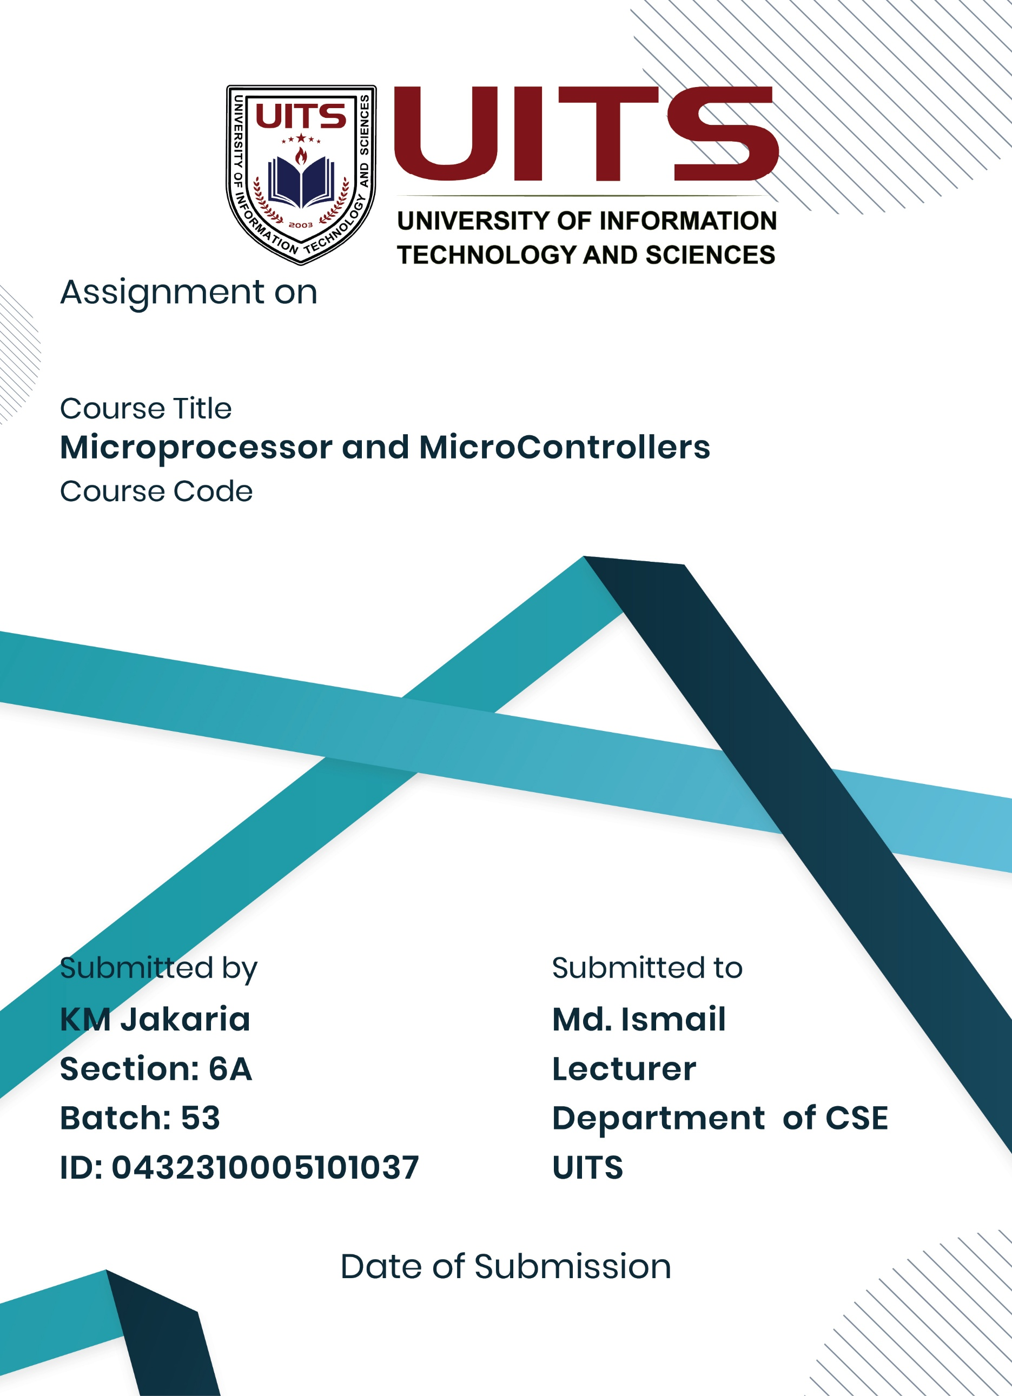
21 Nov, 2025
Lab Project
CSE 360
Experiment Name: Make a Simple Calculator with basic operations like Addition, Subtraction, Multiplication and Division.
Process:
Using 8086 assembly language, this project creates a basic command-line calculator that can be used with the EMU8086 emulator.
One of the four fundamental arithmetic operations is carried out by the calculator once the user enters two integers:

● Addition
● Subtraction
● Multiplication
● Division

Algorithm:
- Start the program.
- Initialize the Data Segment.
- Display a message asking for the first number.
- Call the number-input procedure to store the number.
- Display a message asking for the second number.
- Call the number-input procedure to store the number.
- Show the menu of operations:
- 1 → Addition
- 2 → Subtraction
- 3 → Multiplication
- 4 → Division
- Take the user’s choice as a character input.
- Compare the input with the valid options.
- According to the choice:
- Perform addition → store the result.
- Perform subtraction → store the result.
- Perform multiplication → store the result.
- Perform division → store the result.
- If the choice is invalid, display “Invalid choice!”
- Display “Result:” followed by the computed value.
- End the program.

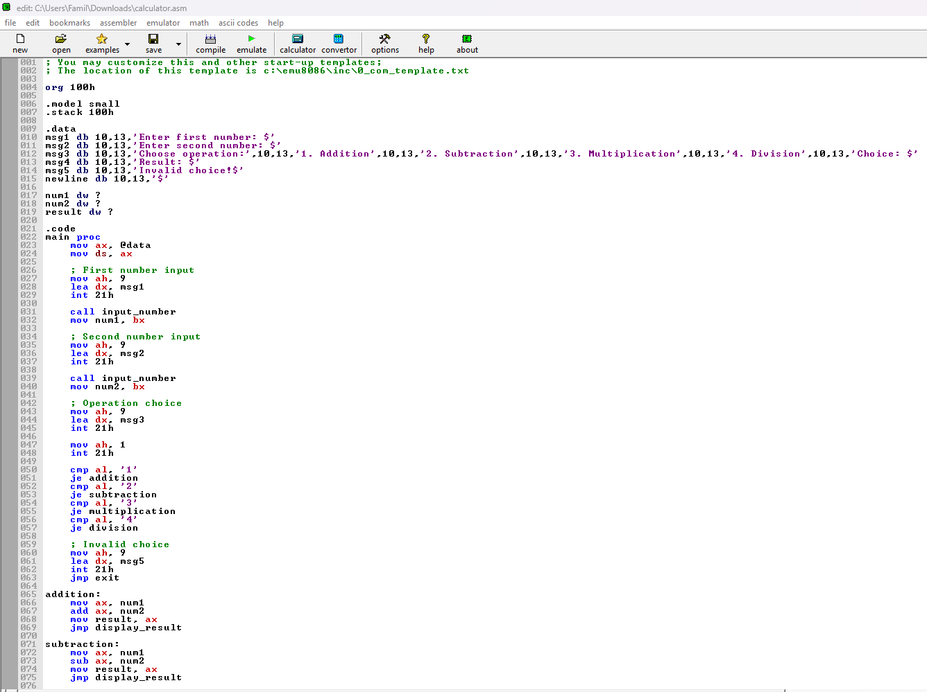
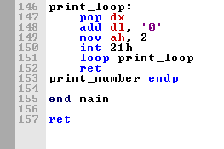
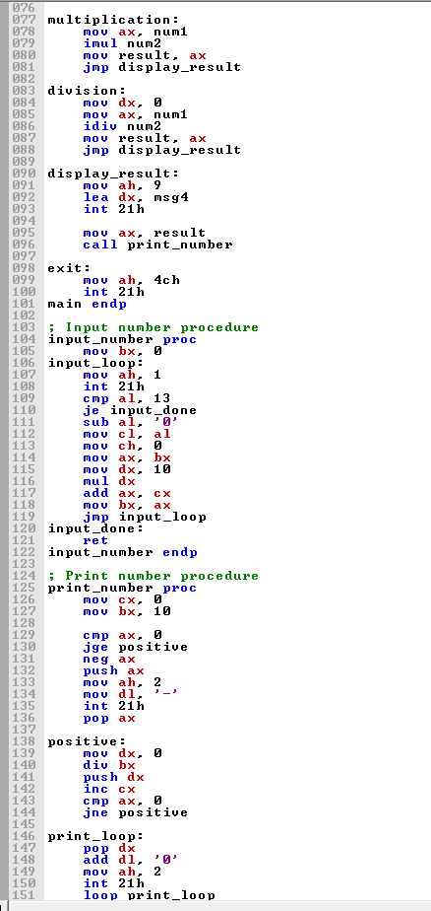
Implementation:
Source Codes:

; You may customize this and other start-up templates;
; The location of this template is c:\emu8086\inc\0_com_template.txt

org 100h

.model small
.stack 100h

.data
msg1 db 10,13,'Enter first number: $'
msg2 db 10,13,'Enter second number: $'
msg3 db 10,13,'Choose operation:',10,13,'1. Addition',10,13,'2. Subtraction',10,13,'3. Multiplication',10,13,'4. Division',10,13,'Choice: $'
msg4 db 10,13,'Result: $'
msg5 db 10,13,'Invalid choice!$'
newline db 10,13,'$'

num1 dw ?
num2 dw ?
result dw ?

.code
main proc
mov ax, @data
mov ds, ax

; First number input
mov ah, 9
lea dx, msg1
int 21h

call input_number
mov num1, bx

; Second number input
mov ah, 9
lea dx, msg2
int 21h

call input_number
mov num2, bx

; Operation choice
mov ah, 9
lea dx, msg3
int 21h

mov ah, 1
int 21h

cmp al, '1'
je addition
cmp al, '2'
je subtraction
cmp al, '3'
je multiplication
cmp al, '4'
je division

; Invalid choice
mov ah, 9
lea dx, msg5
int 21h
jmp exit

addition:
mov ax, num1
add ax, num2
mov result, ax
jmp display_result

subtraction:
mov ax, num1
sub ax, num2
mov result, ax
jmp display_result

multiplication:
mov ax, num1
imul num2
mov result, ax
jmp display_result

division:
mov dx, 0
mov ax, num1
idiv num2
mov result, ax
jmp display_result

display_result:
mov ah, 9
lea dx, msg4
int 21h

mov ax, result
call print_number

exit:
mov ah, 4ch
int 21h
main endp

; Input number procedure
input_number proc
mov bx, 0
input_loop:
mov ah, 1
int 21h
cmp al, 13
je input_done
sub al, '0'
mov cl, al
mov ch, 0
mov ax, bx
mov dx, 10
mul dx
add ax, cx
mov bx, ax
jmp input_loop
input_done:
ret
input_number endp

; Print number procedure
print_number proc
mov cx, 0
mov bx, 10

cmp ax, 0
jge positive
neg ax
push ax
mov ah, 2
mov dl, '-'
int 21h
pop ax

positive:
mov dx, 0
div bx
push dx
inc cx
cmp ax, 0
jne positive

print_loop:
pop dx
add dl, '0'
mov ah, 2
int 21h
loop print_loop
ret
print_number endp

end main

ret

Method:

Taking Input
The program asks the user to enter two numbers.
A custom procedure input_number reads multi-digit numbers by:

  - Taking input one character at time

  - Converting from ASCII to integer

  - Building the final number using multiplication by 10

The result is stored in BX and then saved in num1and num2.

Operation Selection
The user selects one of the operations by pressing:

- Addition

- Subtraction

- Multiplication

- Division

The program reads a single character using int 21h(AH = 1) and matches it with the options using cmp and je.

Performing the Operation
Depending on the choice:

  - Addition: ADD AX, num2

  - Subtraction: SUB AX, num2

  - Multiplication: IMUL num2

  - Division:

    - Clear DX

    - IDIV num2

The result is stored in the variable result.

Result:
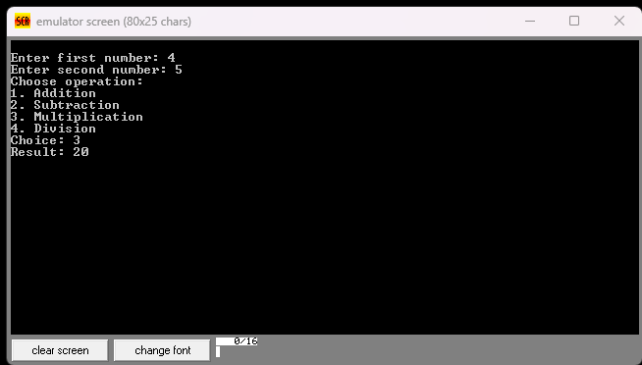
The application displays as like user friendly calculator

Conclusion:
This project effectively illustrates how simple arithmetic operations can be carried out using assembly language.
This calculator application teaches us:

- Using interruptions to handle user input
- Putting multi-digit numeric input into practice
- Using CPU registers to do arithmetic
- Using bespoke processes to display numbers
- Conditional branching in menu-based systems

The project offers a solid basis for comprehending low-level programming ideas and the direct hardware execution of tasks.

