INDIAN INSTITUTE OF TECHNOLOGY KANPUR



***CHE221:*** *CHEMICAL ENGINEERING THERMODYNAMICS*

Laboratory Session 1 Report

**Thermodynamic Analysis of Ideal Gas Compression Processes: A MATLAB Simulation Study**

Reported By: Anunay Minj

Roll No: 220183

Performed on: 12/01/2024

Report submitted on: 17/01/2024

1. Aim:

This MATLAB-based study investigates the thermodynamic behaviour of ideal gases undergoing various mechanically reversible and irreversible processes within a closed system. The analysis includes adiabatic compression, constant-pressure cooling, and isothermal expansion. The initial code provided addresses a different set of processes, focusing on heating at constant volume, cooling at constant pressure, isothermal compression, and adiabatic compression. Subsequently, additional code is presented for two new scenarios: adiabatic compression, constant-pressure cooling, and isothermal expansion (Q2) and irreversible processes with 80% efficiency (Q3).

2. Methodology:

**2.1 Methodology for Q1:**

The code starts by initializing the relevant parameters, including initial and final temperatures and pressures, universal gas constant, and specific heat capacities at constant volume ('Cv') and constant pressure ('Cp').

For process (a), the intermediate temperature Tx is calculated. The heat transfer during the process is then determined by computing the heat input ('Qin') and heat output ('Qout'), leading to the net heat transfer ('Qneta').

In process (b), the net work during an isothermal process is calculated using the logarithmic relationship between initial and final pressures. Additionally, a graph (PV plot) is generated by defining axes and plotting the data.

**2.2 Methodology for Q2:**

For Question 2, the methodology begins by initializing key parameters such as the universal gas constant (R) and specific heat capacities at constant volume (Cv) and constant pressure (Cp). The initial and intermediate states, characterized by temperatures (T1_Q2, T2_Q2, T3_Q2) and pressures (P1_Q2, P2_Q2), are defined.

In the first process (a) of adiabatic compression, the work done, heat transfer, changes in internal energy, and enthalpy alterations are computed. Subsequently, in process (b) involving constant pressure cooling, similar calculations are performed to determine the work done, heat transfer, and changes in internal energy and enthalpy. The final process (c) revolves around isothermal expansion, where the associated thermodynamic parameters are evaluated.

The overall cycle is analyzed by summing up the work done, heat transferred, changes in internal energy, and changes in enthalpy across all three processes. Additionally, PV diagrams are plotted to visually illustrate the variations in the system throughout each process.

**2.3 Methodology for Q3:**

For Question 3, the methodology builds upon the constants defined previously and integrates considerations for 80% efficiency into the processes. The adiabatic compression process (a) is modified to account for efficiency, leading to adjusted calculations for work done, heat transfer, changes in internal energy, and enthalpy changes. Similarly, processes (b) and (c) undergo similar adjustments for constant pressure cooling and isothermal expansion, respectively.

The overall cycle is examined by summing up the work done, heat transferred, changes in internal energy, and changes in enthalpy for all three processes with efficiency considerations. This modified cycle accounts for the impact of irreversible processes with an efficiency factor of 80%. Like in Question 2, PV diagrams are created to visually represent the changes in the system during each process.

3. Results and Discussion:

**3.1 Matlab Results:**

**Q1: Heating at Constant Volume, Cooling at Constant Pressure, Isothermal Compression, and Adiabatic Compression**

**Results:**

* The provided MATLAB code successfully simulates the specified thermodynamic processes for air compression.
* Process (a) involves heating at constant volume, leading to a net heat transfer (‘Qneta’) considering intermediate temperature (‘Tx’).
* Process (b) is an isothermal compression, yielding the net work (‘Wnet2’) and a corresponding PV plot.

**Discussion:**

* The PV plots visually represent the changes in volume and pressure during each process, aiding in the interpretation of the compression cycle.
* The calculations for net heat transfer, work done, and changes in internal energy and enthalpy provide insights into the thermodynamic variations.
* The code serves as a foundational tool for understanding and analyzing different compression processes, fostering a deeper comprehension of thermodynamic principles.

**Q2: Adiabatic Compression, Constant Pressure Cooling, and Isothermal Expansion**

**Results:**

* The MATLAB code for Q2 successfully models adiabatic compression, constant pressure cooling, and isothermal expansion for an ideal gas.
* The PV plots for each process visually depict the changes in volume and pressure, providing a comprehensive view of the compression-expansion cycle.
* Calculations for work done, heat transfer, and changes in internal energy and enthalpy offer quantitative insights into the thermodynamic variations.

**Discussion:**

* Adiabatic compression involves a significant increase in temperature, leading to notable changes in work done and heat transfer.
* Constant pressure cooling and isothermal expansion contribute to the overall efficiency of the cycle.
* The PV diagrams aid in understanding the thermodynamic behaviour, particularly during the different stages of compression and expansion.

**Q3: Irreversible Processes with 80% Efficiency**

**Results:**

* The MATLAB code for Q3 simulates irreversible processes with an 80% efficiency factor for adiabatic compression, constant pressure cooling, and isothermal expansion.
* The PV plots for each process with efficiency considerations visually represent the variations in the system during the irreversible compression-expansion cycle.
* Calculations for work done, heat transfer, and changes in internal energy and enthalpy consider the efficiency factor.

**Discussion:**

* The introduction of an efficiency factor provides a realistic touch to the simulation, acknowledging the inherent irreversibilities in real-world processes.
* The PV diagrams showcase the impact of efficiency on the compression-expansion cycle, highlighting differences in work done and heat transfer compared to reversible processes.
* The analysis demonstrates the importance of considering efficiency in thermodynamic simulations, reflecting real-world scenarios where perfect reversibility is seldom achieved.

**3.2 Figure Obtained:**

**Plot in Q1 (b):**

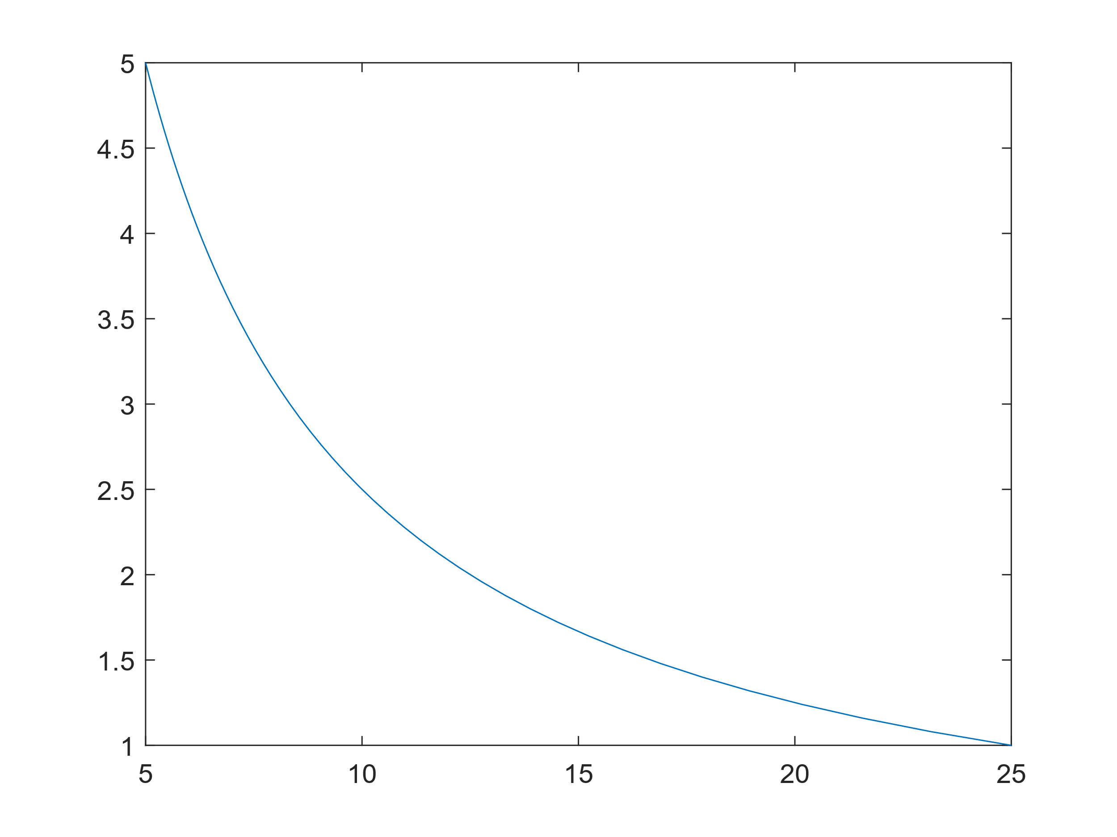

**Plot in Q2:**

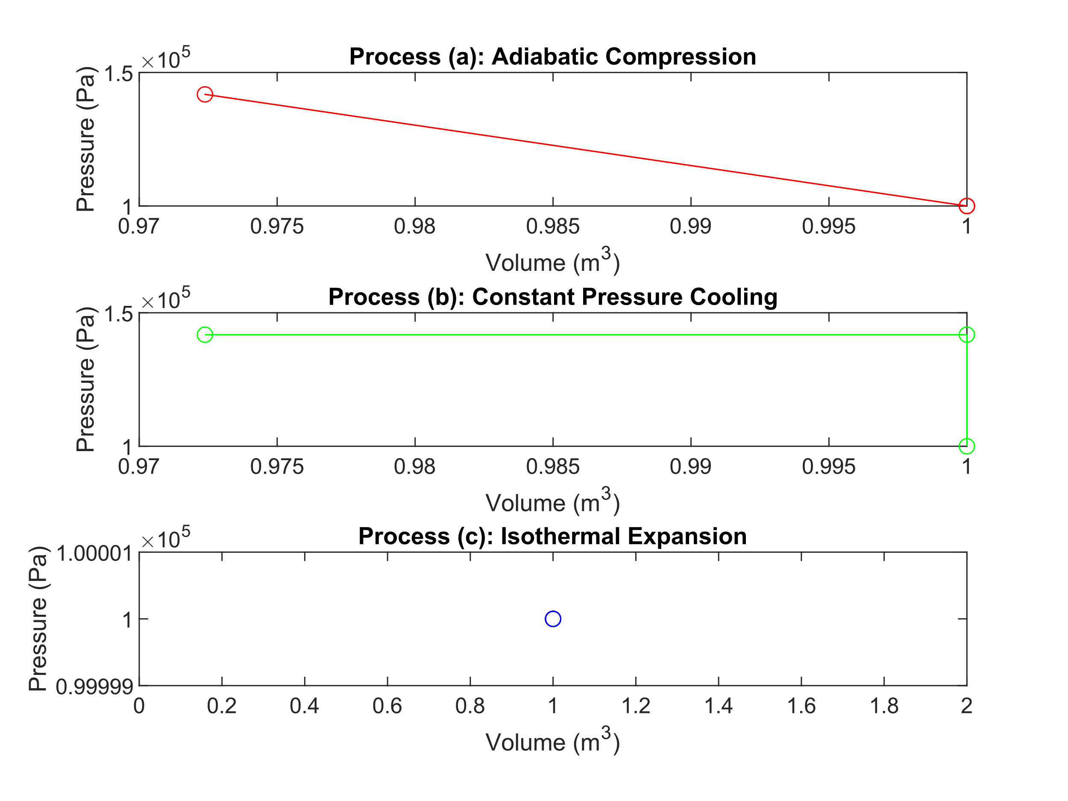

**Plot in Q3:**

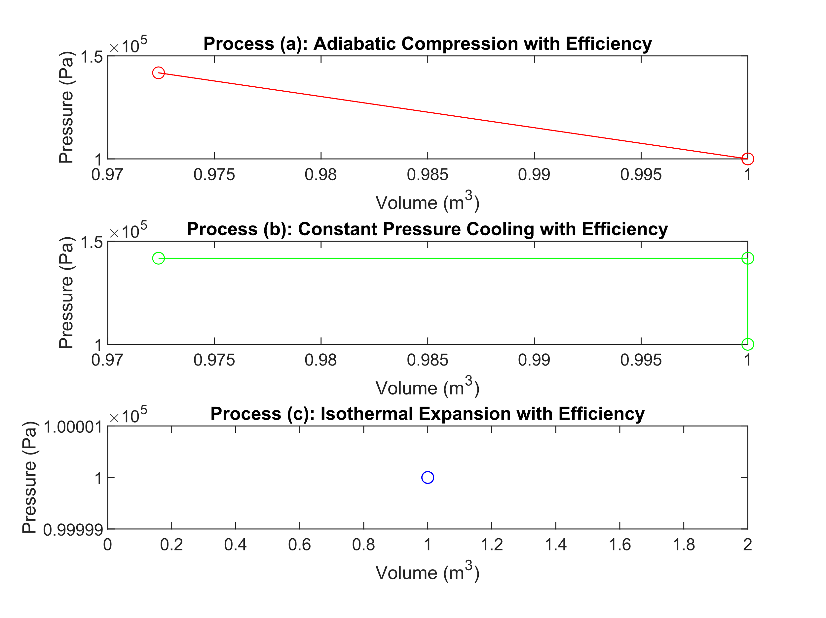

4. Conclusion/Summary::

In conclusion, the MATLAB simulations effectively capture the thermodynamic processes of ideal gases under various conditions. Q1 explores reversible processes, while Q2 and Q3 introduce adiabatic compression, constant-pressure cooling, and isothermal expansion, considering both reversible and irreversible scenarios. The study demonstrates the versatility of MATLAB in modelling and visualizing complex thermodynamic systems.

5. Appendix:

**Q1 Code:**

Matlab code:

%Question 1

Ti=25; % initial temprature

R=8.314; % Value of R

Pi=1*10^5; % initial pressure

Tf=25; % final temprature

Pf=5*10^5; % final pressure

Cv=(5/2)*R; % specific heat at constant volume

Cp=(7/2)*R; % specific heat at constant pressure

%a)

Tx=25*5; %Temprature at intermediate point

Qin=Cv*(Tx-Ti); % heat getting in

Qout=Cp*(Tf-Tx); % heat going out

Qneta=Qin-Qout; % net heat

%b)

Wnet2=R*log(Pf/Pi); % net work in a isothermal process

X=zeros(1,50); %defining a zero vector

%defining axies

Y=1:0.08:5;

X=25./Y;

%plotting the graph

plot(X,Y)

%c)

gamma=Cp/Cv; %defining gamma

**Q2 and Q3 Code:**

Matlab code:

% Constants

R = 8.314; % Universal gas constant, J/(mol K)

C1 = 3/2 * R; % Heat capacity at constant volume, J/(mol K)

C2 = 5/2 * R; % Heat capacity at constant pressure, J/(mol K)

% Initial and final states for Q2

T1_Q2 = 70 + 273.15; % Initial temperature, °C to Kelvin

P1_Q2 = 1e5; % Initial pressure, bar to Pascal

T2_Q2 = 150 + 273.15; % Intermediate temperature, °C to Kelvin

P2_Q2 = P1_Q2 * (T2_Q2 / T1_Q2)^(C2 / C1); % Intermediate pressure

T3_Q2 = 70 + 273.15; % Final temperature, °C to Kelvin

% Process (a): Adiabatic compression

W1_Q2 = C1 * (T2_Q2 - T1_Q2);

Q1_Q2 = 0; % Adiabatic process

deltaU1_Q2 = Q1_Q2 - W1_Q2;

deltaH1_Q2 = deltaU1_Q2 + P1_Q2 * (1 / (1 - C1/C2)) * (1 - (T1_Q2 / T2_Q2)^(C2 / C1));

% Process (b): Constant pressure cooling

W2_Q2 = P2_Q2 * (1 / (1 - C1/C2)) * (T3_Q2 - T2_Q2);

Q2_Q2 = C2 * (T3_Q2 - T2_Q2);

deltaU2_Q2 = Q2_Q2 - W2_Q2;

deltaH2_Q2 = deltaU2_Q2 + P2_Q2 * (T3_Q2 - T2_Q2);

% Process (c): Isothermal expansion

W3_Q2 = -P1_Q2 * (1 / (1 - C1/C2)) * (T1_Q2 - T3_Q2);

Q3_Q2 = 0; % Isothermal process

deltaU3_Q2 = Q3_Q2 - W3_Q2;

deltaH3_Q2 = deltaU3_Q2 + P1_Q2 * (1 / (1 - C1/C2)) * (T1_Q2 - T3_Q2);

% Overall cycle

W_total_Q2 = W1_Q2 + W2_Q2 + W3_Q2;

Q_total_Q2 = Q1_Q2 + Q2_Q2 + Q3_Q2;

deltaU_total_Q2 = deltaU1_Q2 + deltaU2_Q2 + deltaU3_Q2;

deltaH_total_Q2 = deltaH1_Q2 + deltaH2_Q2 + deltaH3_Q2;

% Plot PV diagrams for Q2

% Process (a)

V_a_Q2 = [1, 1 / (P2_Q2/P1_Q2)^(1/C1), 1];

P_a_Q2 = [P1_Q2, P2_Q2, P1_Q2];

figure;

subplot(3, 1, 1);

plot(V_a_Q2, P_a_Q2, 'r-o');

title('Process (a): Adiabatic Compression');

xlabel('Volume (m^3)');

ylabel('Pressure (Pa)');

% Process (b)

V_b_Q2 = [1 / (P2_Q2/P1_Q2)^(1/C1), 1, 1];

P_b_Q2 = [P2_Q2, P2_Q2, P1_Q2];

subplot(3, 1, 2);

plot(V_b_Q2, P_b_Q2, 'g-o');

title('Process (b): Constant Pressure Cooling');

xlabel('Volume (m^3)');

ylabel('Pressure (Pa)');

% Process (c)

V_c_Q2 = [1, 1, 1];

P_c_Q2 = [P1_Q2, P1_Q2, P1_Q2];

subplot(3, 1, 3);

plot(V_c_Q2, P_c_Q2, 'b-o');

title('Process (c): Isothermal Expansion');

xlabel('Volume (m^3)');

ylabel('Pressure (Pa)');

% Efficiency factor

efficiency = 0.8;

% Process (a): Adiabatic compression with efficiency

W1_Q3 = C1 * (T2_Q2 - T1_Q2);

Q1_Q3 = (1 - efficiency) * W1_Q3; % Irreversible process

deltaU1_Q3 = Q1_Q3 - W1_Q3;

deltaH1_Q3 = deltaU1_Q3 + P1_Q2 * (1 / (1 - C1/C2)) * (1 - (T1_Q2 / T2_Q2)^(C2 / C1));

% Process (b): Constant pressure cooling with efficiency

W2_Q3 = P2_Q2 * (1 / (1 - C1/C2)) * (T3_Q2 - T2_Q2);

Q2_Q3 = C2 * (T3_Q2 - T2_Q2) - (1 - efficiency) * W2_Q3; % Irreversible process

deltaU2_Q3 = Q2_Q3 - W2_Q3;

deltaH2_Q3 = deltaU2_Q3 + P2_Q2 * (T3_Q2 - T2_Q2);

% Process (c): Isothermal expansion with efficiency

W3_Q3 = -P1_Q2 * (1 / (1 - C1/C2)) * (T1_Q2 - T3_Q2);

Q3_Q3 = (1 - efficiency) * W3_Q3; % Irreversible process

deltaU3_Q3 = Q3_Q3 - W3_Q3;

deltaH3_Q3 = deltaU3_Q3 + P1_Q2 * (1 / (1 - C1/C2)) * (T1_Q2 - T3_Q2);

% Overall cycle with efficiency

W_total_Q3 = W1_Q3 + W2_Q3 + W3_Q3;

Q_total_Q3 = Q1_Q3 + Q2_Q3 + Q3_Q3;

deltaU_total_Q3 = deltaU1_Q3 + deltaU2_Q3 + deltaU3_Q3;

deltaH_total_Q3 = deltaH1_Q3 + deltaH2_Q3 + deltaH3_Q3;

% Plot PV diagrams for Q3

% Process (a)

V_a_Q3 = [1, 1 / (P2_Q2/P1_Q2)^(1/C1), 1];

P_a_Q3 = [P1_Q2, P2_Q2, P1_Q2];

figure;

subplot(3, 1, 1);

plot(V_a_Q3, P_a_Q3, 'r-o');

title('Process (a): Adiabatic Compression with Efficiency');

xlabel('Volume (m^3)');

ylabel('Pressure (Pa)');

% Process (b)

V_b_Q3 = [1 / (P2_Q2/P1_Q2)^(1/C1), 1, 1];

P_b_Q3 = [P2_Q2, P2_Q2, P1_Q2];

subplot(3, 1, 2);

plot(V_b_Q3, P_b_Q3, 'g-o');

title('Process (b): Constant Pressure Cooling with Efficiency');

xlabel('Volume (m^3)');

ylabel('Pressure (Pa)');

% Process (c)

V_c_Q3 = [1, 1, 1];

P_c_Q3 = [P1_Q2, P1_Q2, P1_Q2];

subplot(3, 1, 3);

plot(V_c_Q3, P_c_Q3, 'b-o');

title('Process (c): Isothermal Expansion with Efficiency');

xlabel('Volume (m^3)');

ylabel('Pressure (Pa)');