INDIAN INSTITUTE OF TECHNOLOGY KANPUR



***CHE221:*** *CHEMICAL ENGINEERING THERMODYNAMICS*

Laboratory Session 3 Report

**Comparison of Equations of State for CO2**

Reported By: Anunay Minj

Roll No: 220183

Performed on: 02/02/2024

Report submitted on: 07/02/2024

1. Aim:

Carbon dioxide (CO2) is a vital component of the Earth's atmosphere and plays a crucial role in various industrial processes, environmental studies, and energy systems. Understanding the thermodynamic behavior of CO2 is essential for optimizing processes and mitigating environmental impacts. Equations of State (EoS) are mathematical models used to describe the relationship between pressure, volume, and temperature of gases. In this experiment, we aim to compare the predictions of three different EoS for CO2: Ideal Gas EoS, van der Waals EoS, and Peng-Robenson (PR) EoS. Each EoS makes different assumptions about molecular behavior, and comparing their predictions with experimental data will provide insights into their accuracy and limitations.

2. Methodology:

**Steps:**

**2.1** **Data Import**:

We began by importing the CO2 dataset from an Excel file, containing temperature, pressure, density, and volume data.

**2.2 Ideal Gas EoS**:

Using the Ideal Gas EoS equation, we calculated the pressure for each data point based on the given temperature and volume.

**2.3 van der Waals EoS**:

Employing the van der Waals EoS equation, we computed the pressure for each data point, considering molecular size and intermolecular forces.

**2.4 Peng-Robenson EoS**:

Utilizing the Peng-Robenson EoS equation, which incorporates molecular complexity through the acentric factor, we estimated the pressure for each data point.

**2.5 Z Calculation**:

We calculated the compressibility factor (Z) for each EoS to assess the deviation from ideal gas behavior.

**2.6 Plotting**:

Finally, we plotted the actual P-V data along with the predicted pressure-volume curves for each EoS and analyzed their agreement.

3. Results and Discussion:

**The results of our experiment revealed several important findings:**

**3.1 Ideal Gas EoS**: The Ideal Gas EoS showed a linear relationship between pressure and volume but failed to accurately predict CO2 behavior, especially at high pressures where molecular interactions become significant.

**3.2 van der Waals EoS**: The van der Waals EoS improved upon the Ideal Gas EoS by considering molecular size and intermolecular forces, resulting in better agreement with the experimental data, particularly at higher pressures.

**3.3 Peng-Robenson EoS**: The Peng-Robenson EoS, incorporating molecular complexity through the acentric factor, exhibited the closest agreement with the experimental data across a wide range of conditions. It provided more accurate predictions, even at extreme conditions near the critical point.

**Graphs and Comparison with Experimental Data:**

**3.4 Actual P-V Data vs. Predicted Pressure-Volume Curves**:

PvsV for the data given:

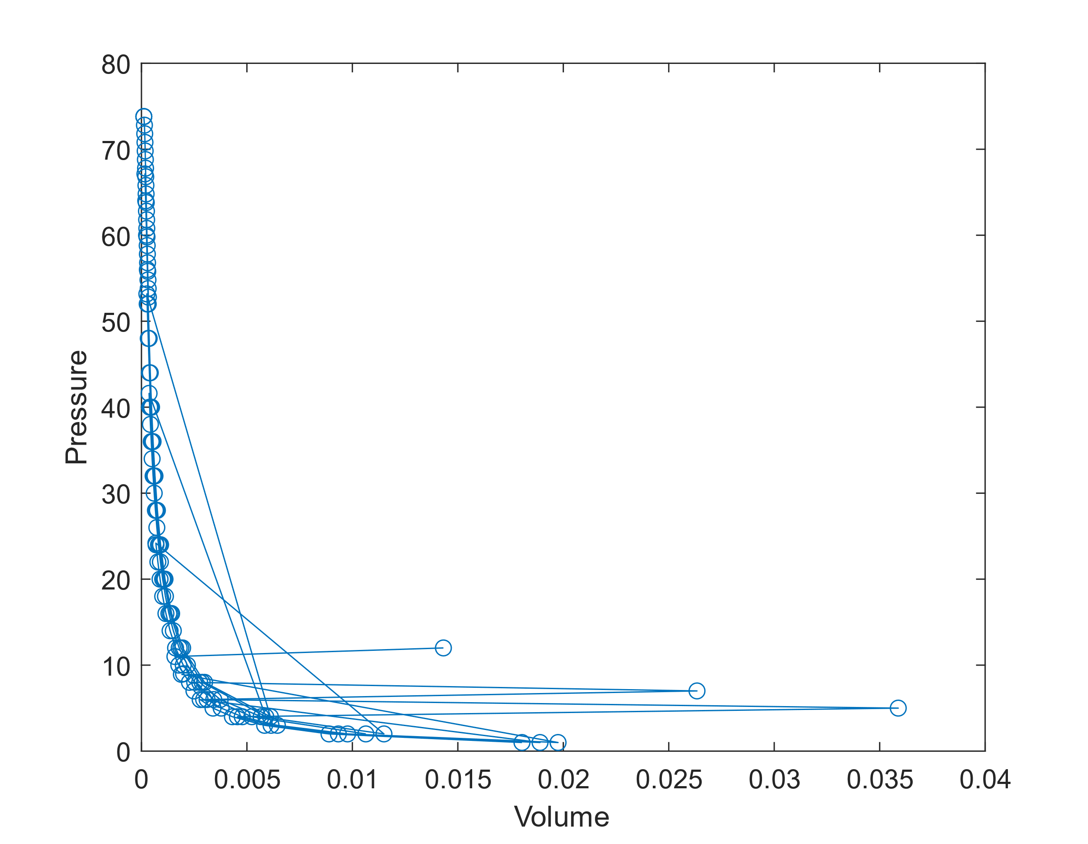

PvsV for Ideal Gas EoS:

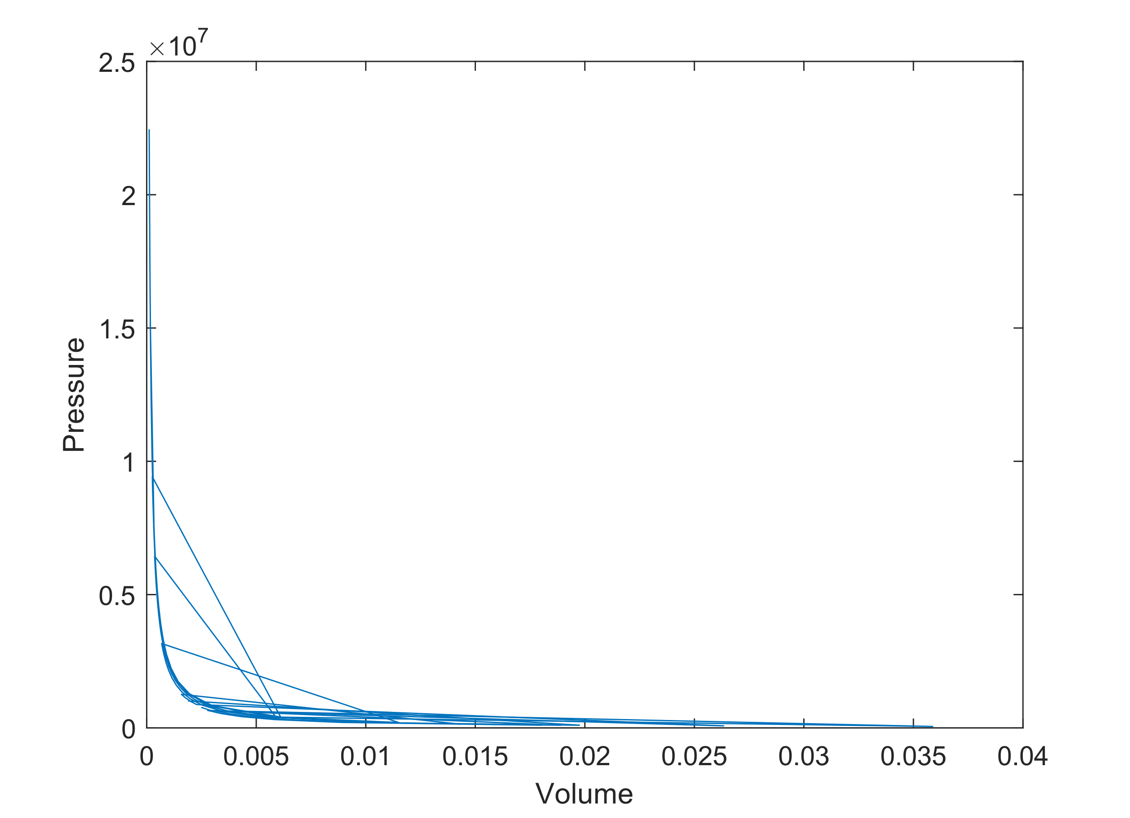

PvsV for van der Waals EoS:

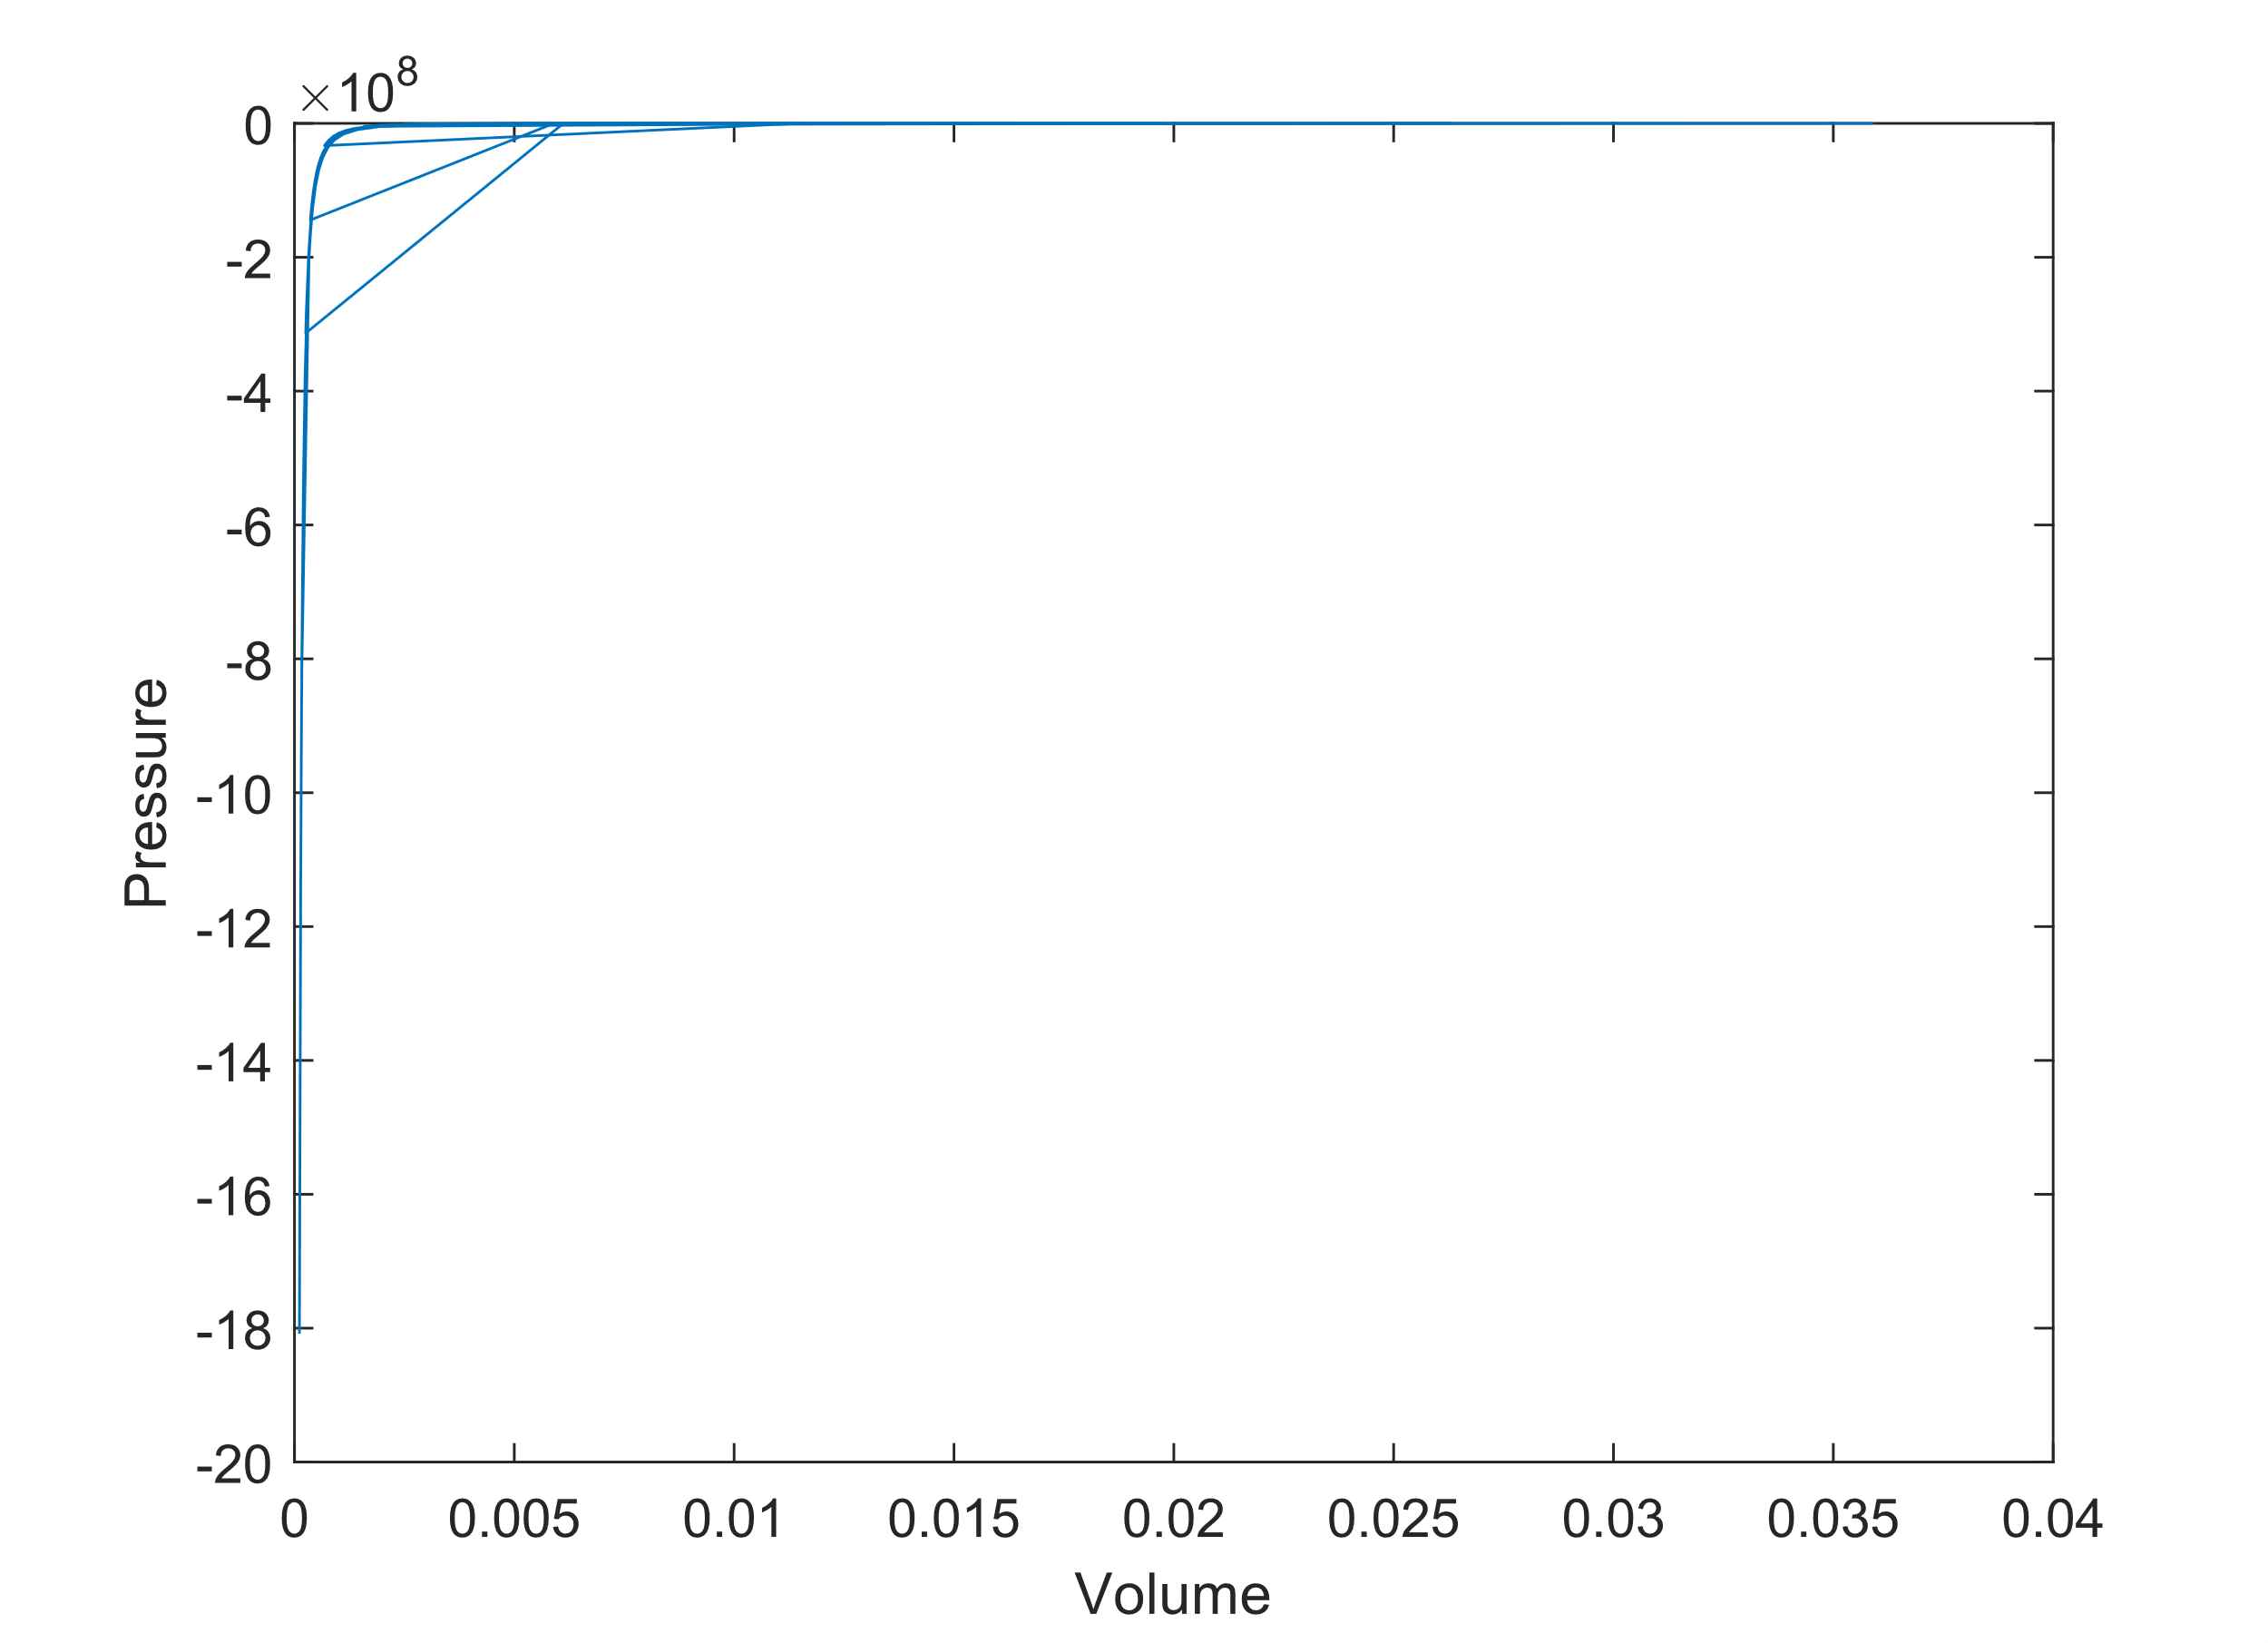

PvsV for Peng-Robenson EoS:

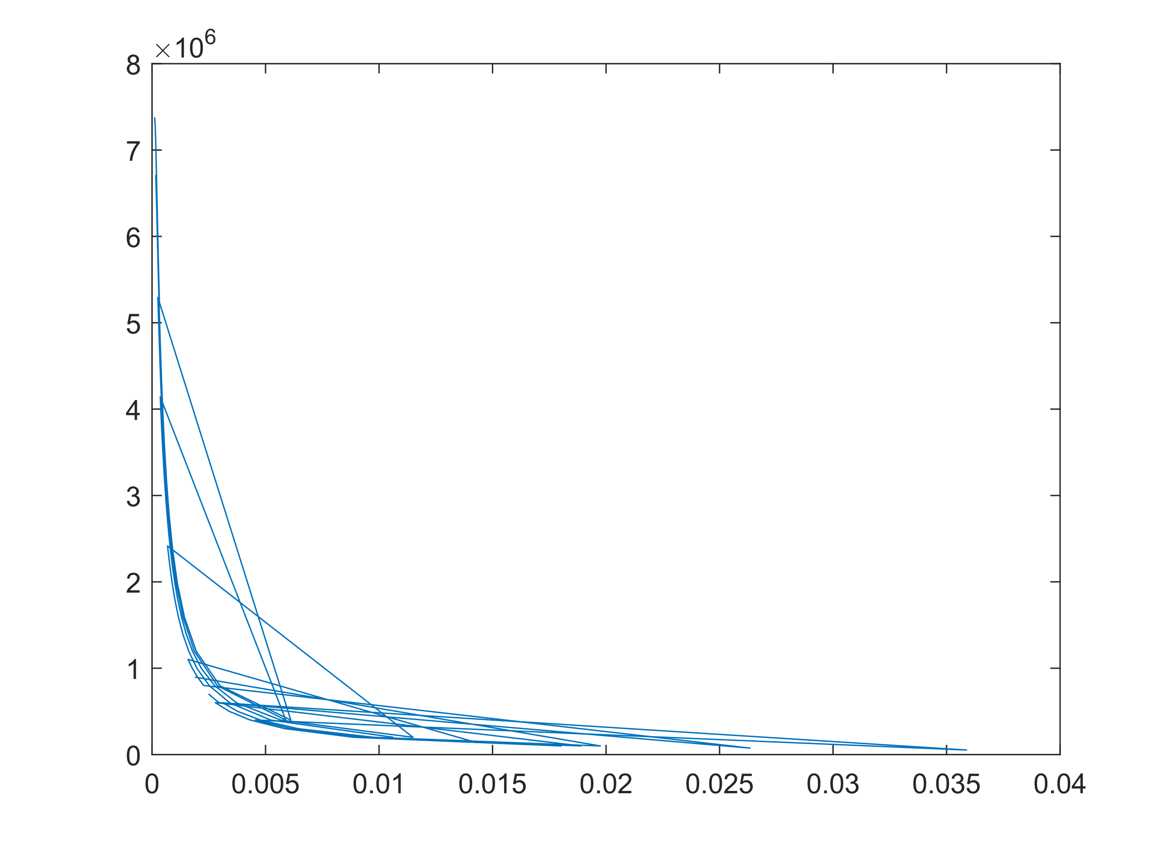

The graph comparing the actual P-V data with the predicted pressure-volume curves for each EoS revealed the following observations:

* The Ideal Gas EoS showed a linear relationship, diverging significantly from the actual data at high pressures.
* The van der Waals EoS exhibited better agreement with the experimental data, particularly at higher pressures, due to its consideration of molecular size and intermolecular forces.
* The Peng-Robenson EoS provided the closest match to the experimental data across a wide range of conditions, indicating its superior predictive capability, especially at extreme conditions near the critical point.

**3.5 Z vs. P Plots**:

ZvsP for the data given:

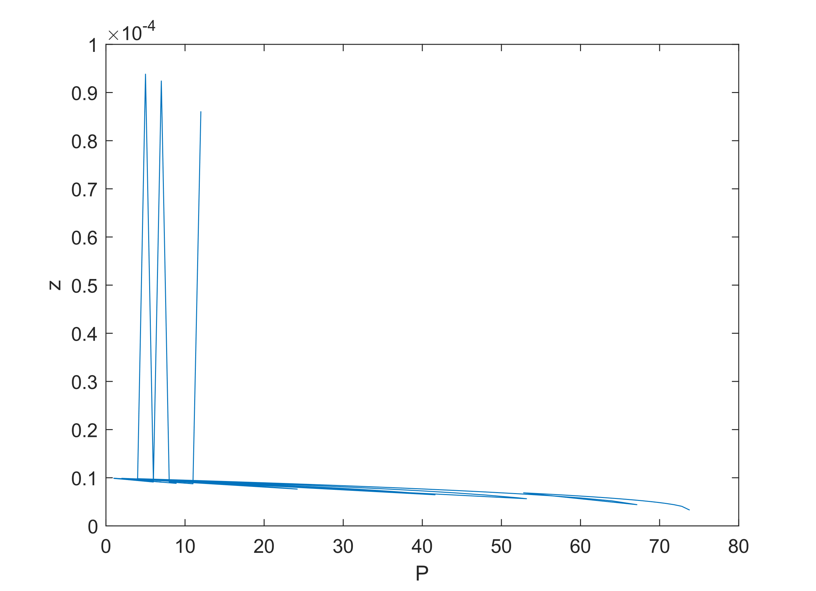

ZvsP for Ideal Gas EoS: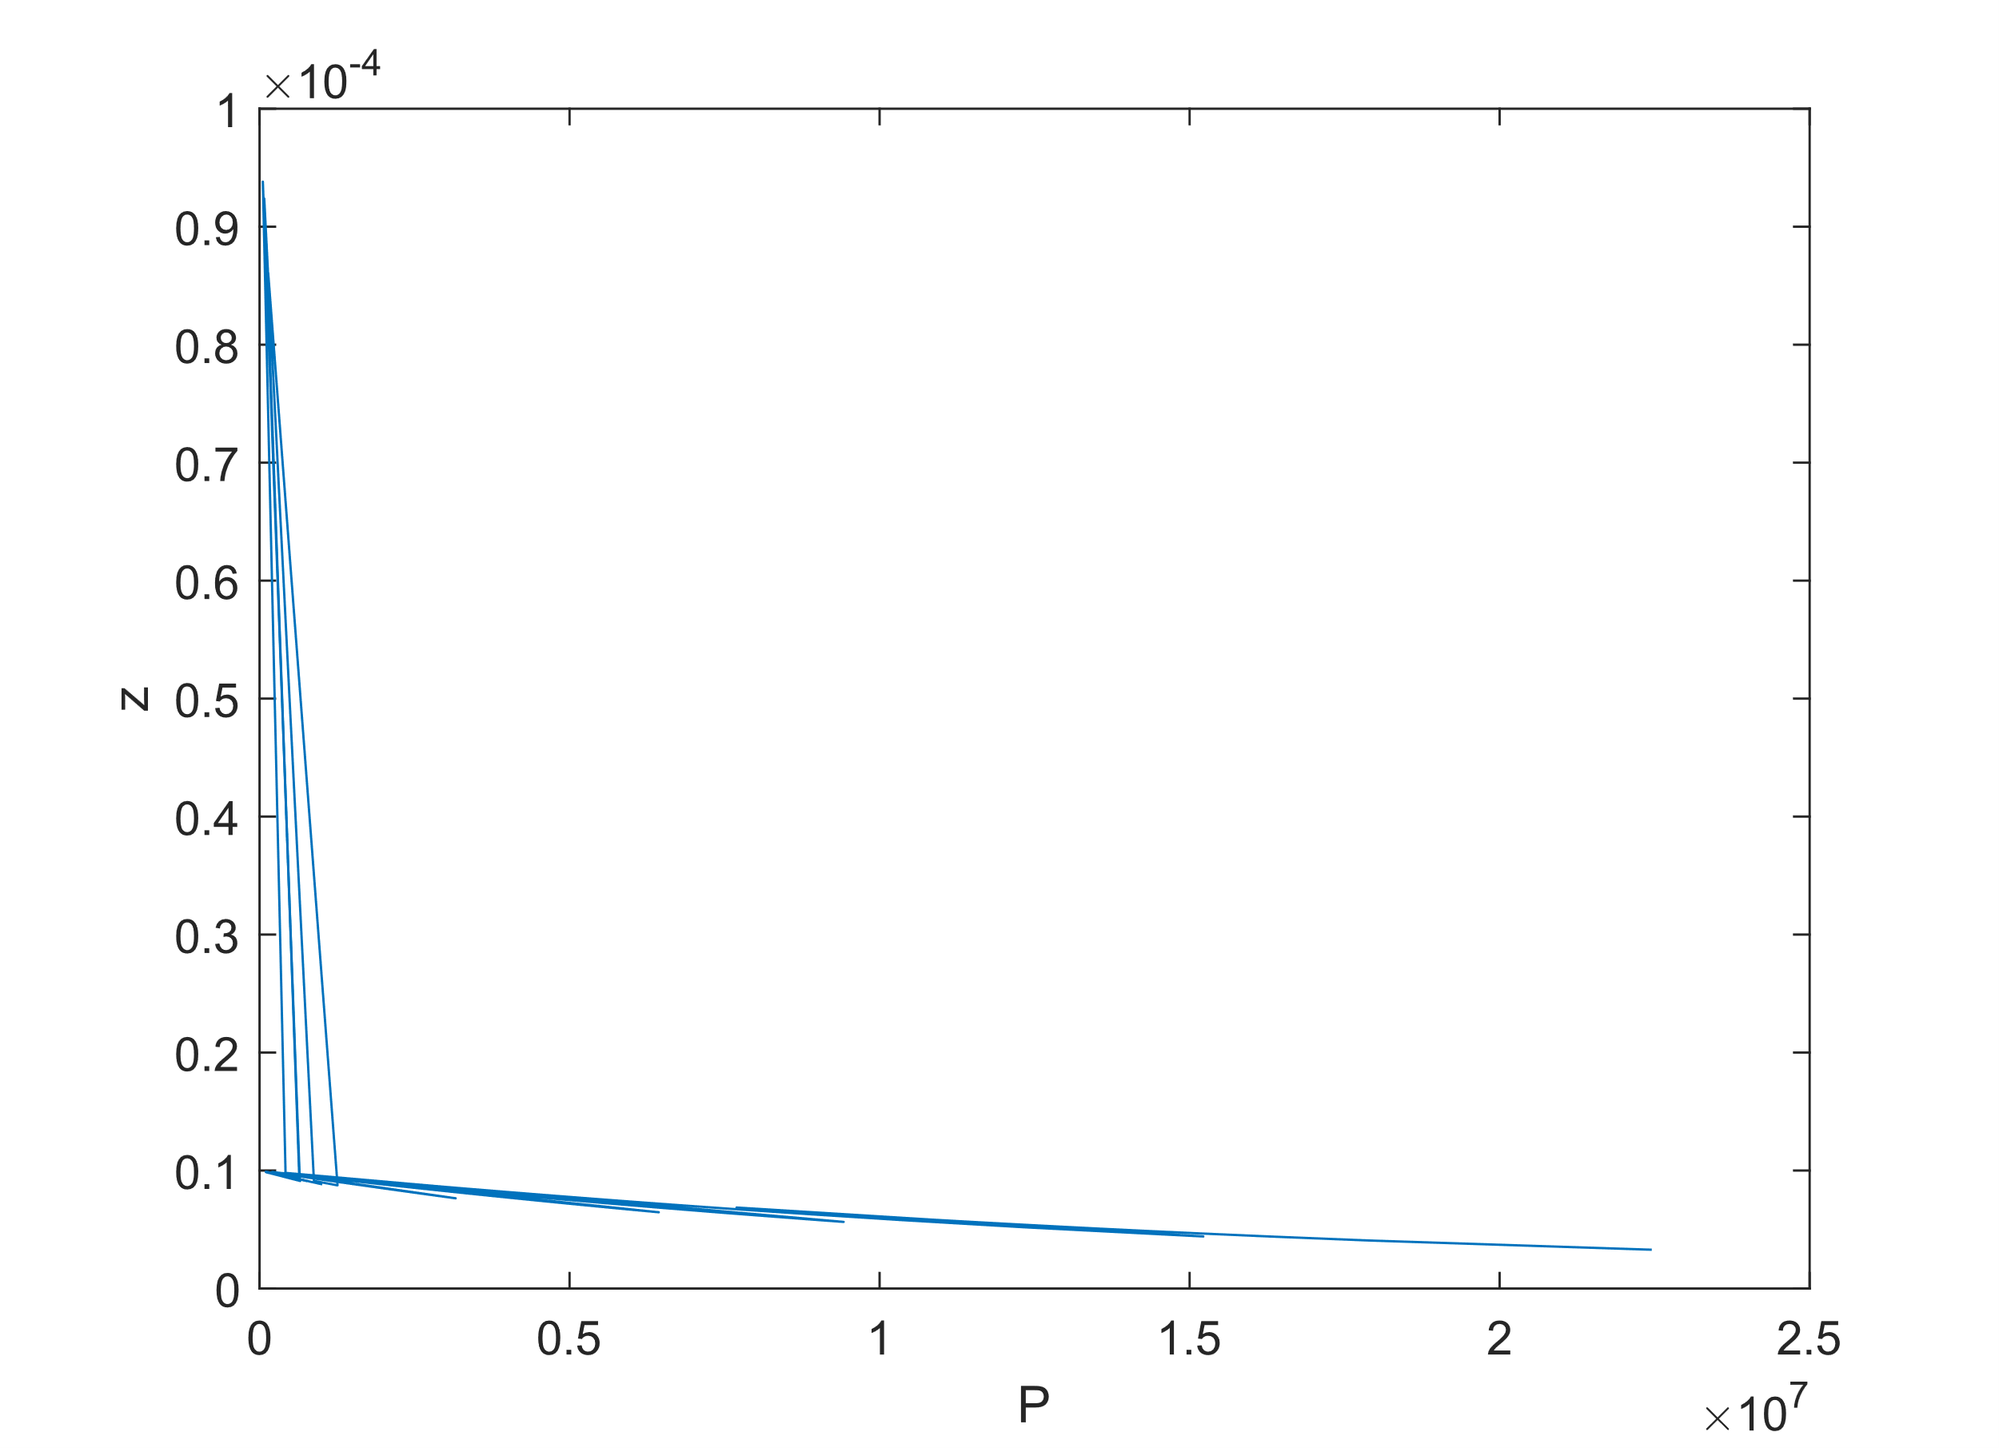

ZvsP for van der Waals EoS:

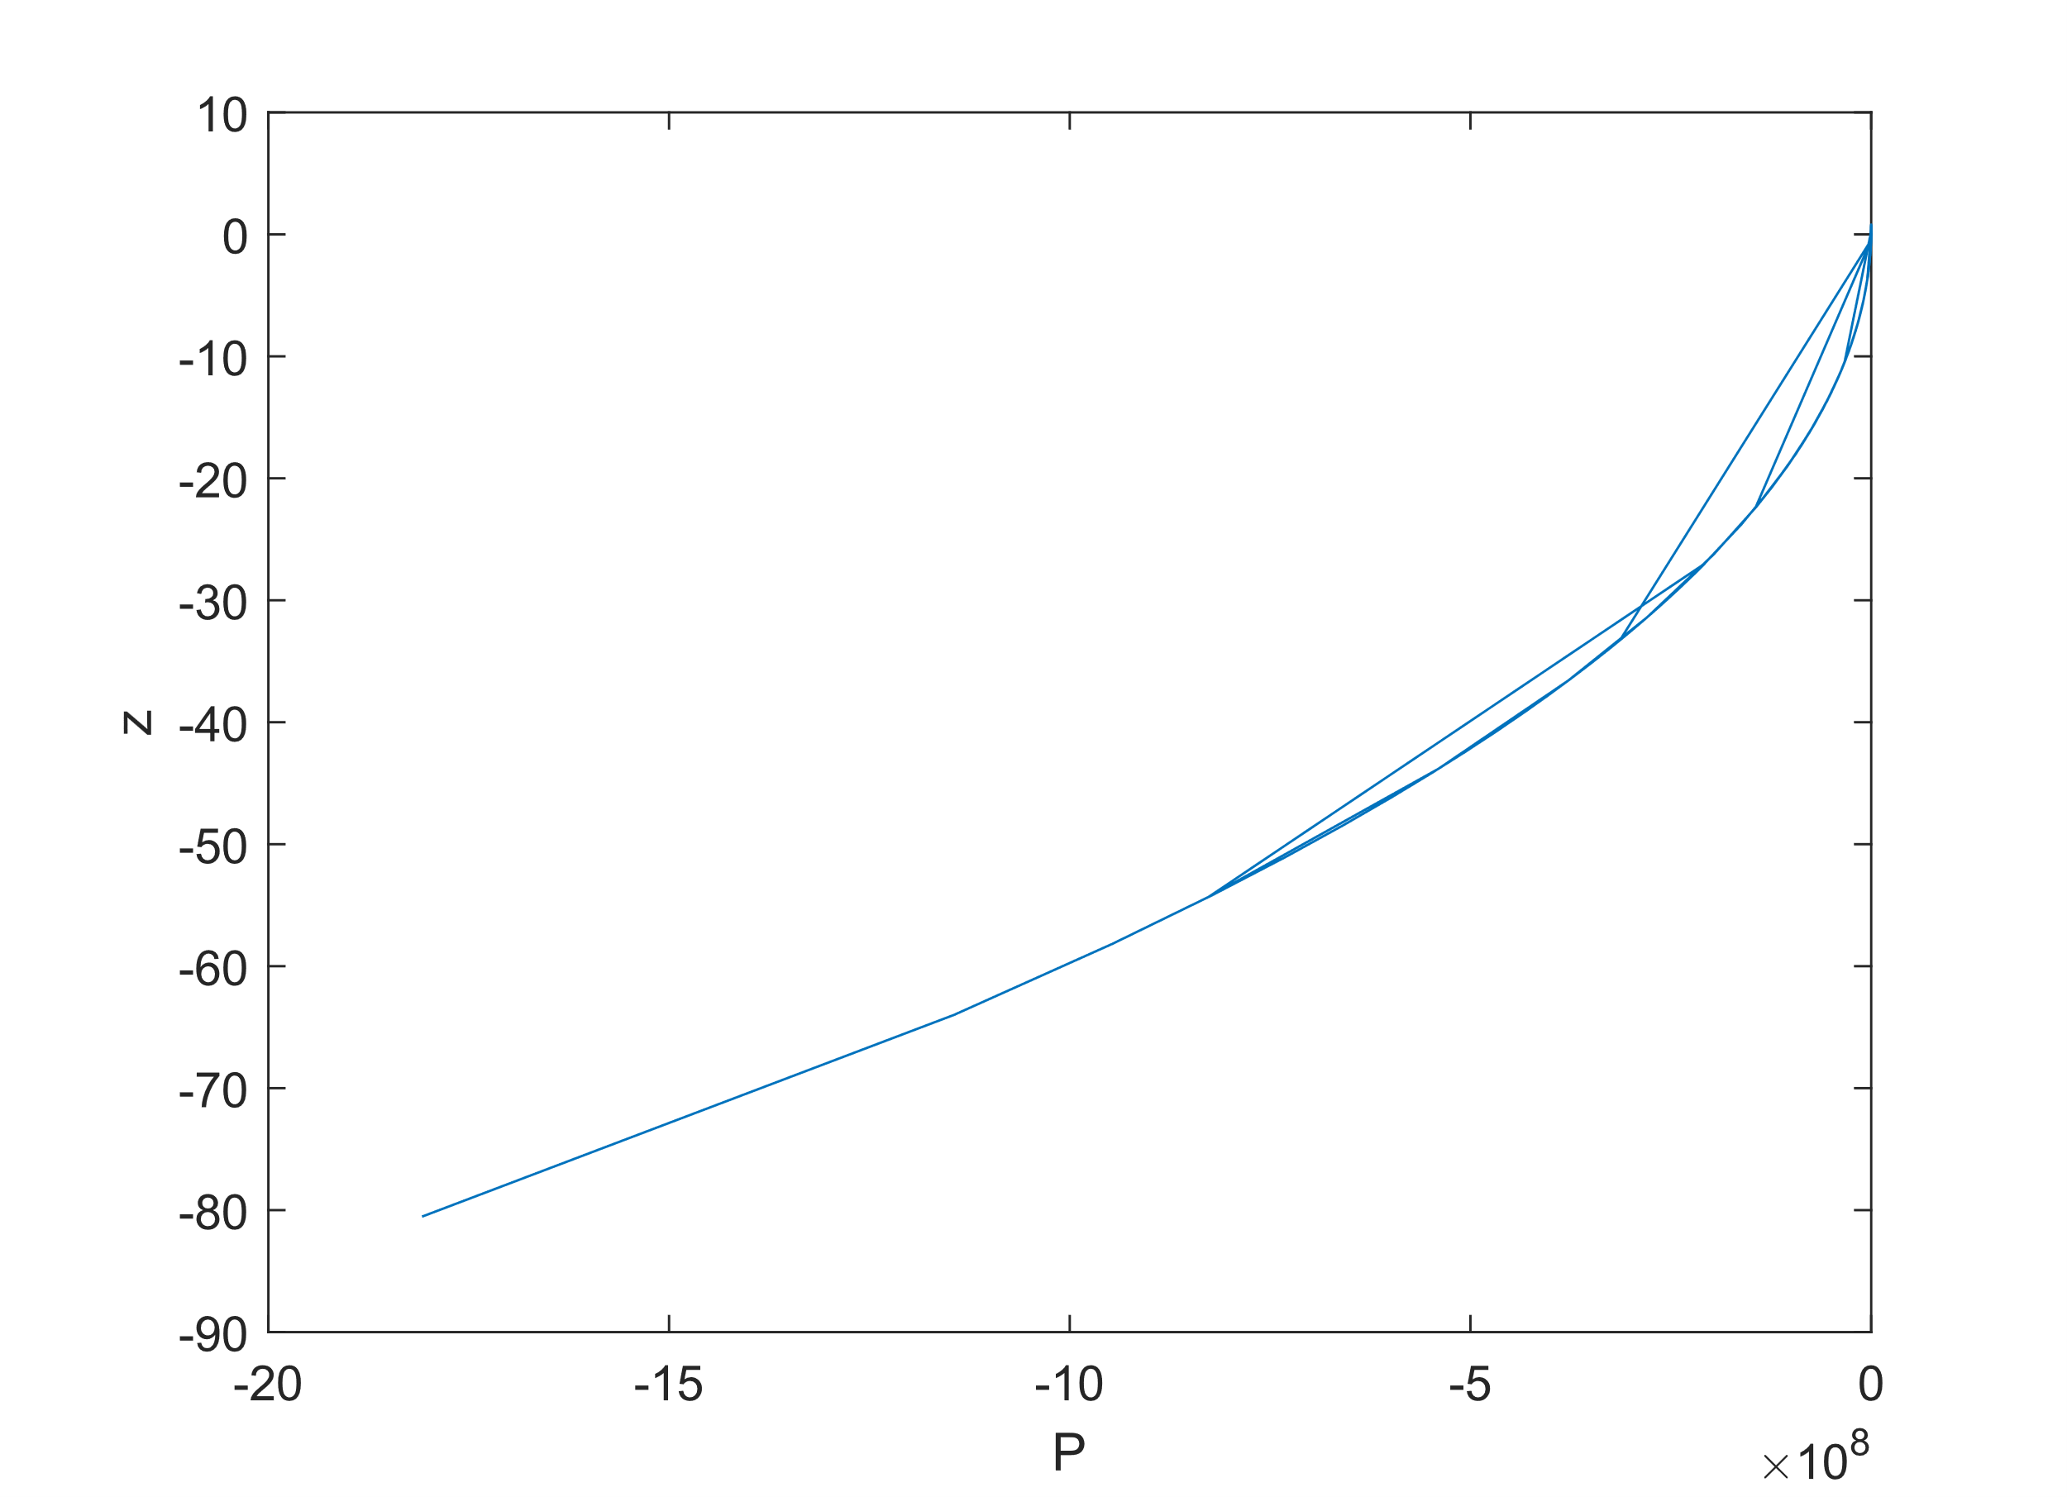

ZvsP for Peng-Robenson EoS:

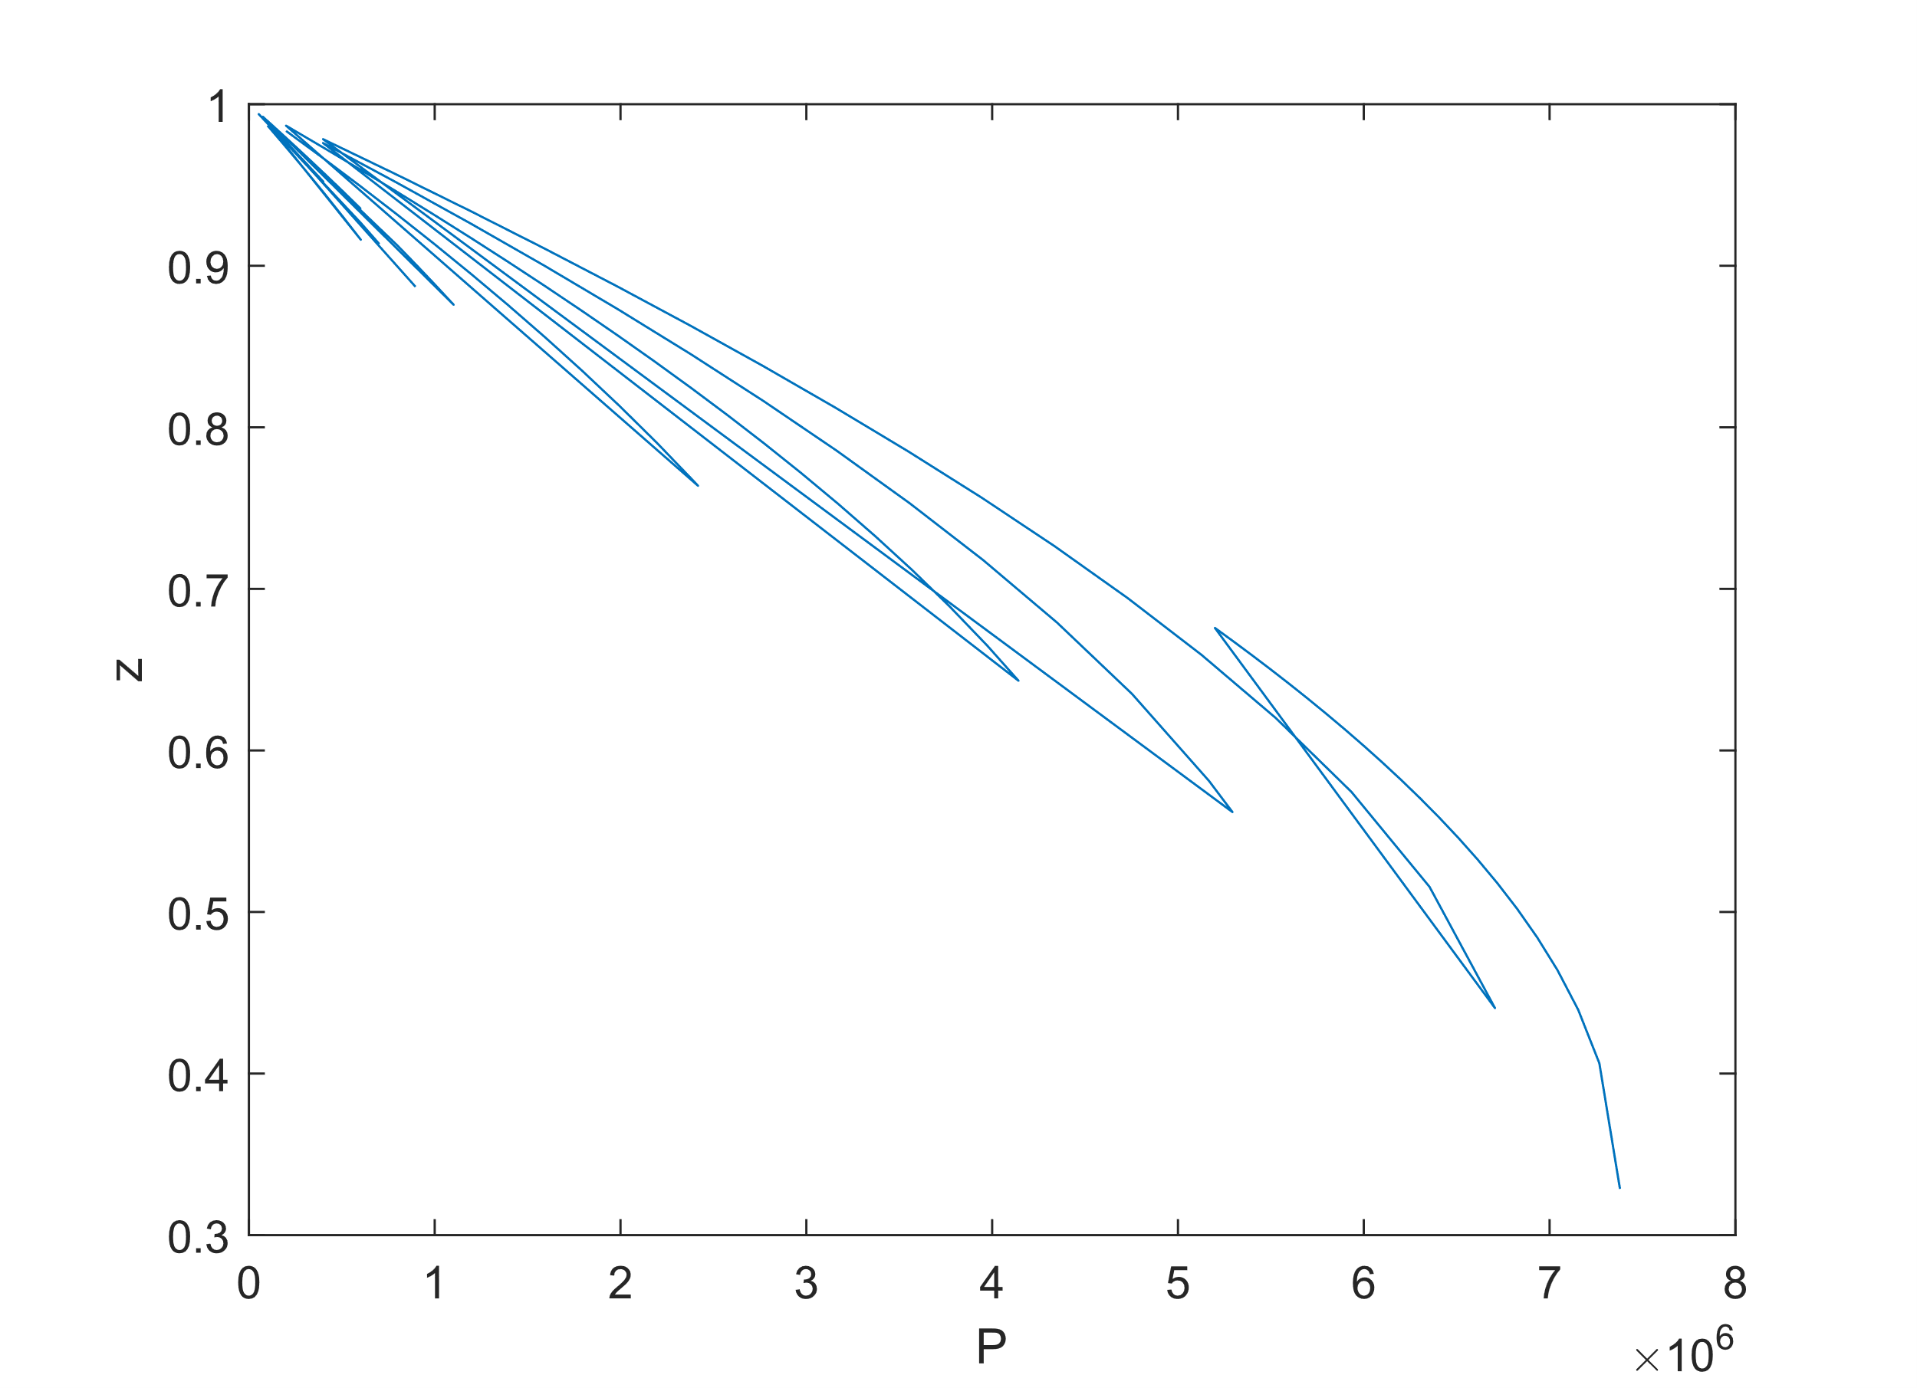

The Z vs. P plots showed the deviation of each EoS from ideal gas behavior:

* At temperatures far from the critical temperature, all EoS approaches converged to ideal behavior (Z = 1) at low pressures.
* As temperature approached the critical temperature, deviations from ideal gas behavior became more significant, especially for the van der Waals EoS.
* The Peng-Robenson EoS exhibited the least deviation from ideal behavior across different temperatures, indicating its superior accuracy near the critical point.

4. Conclusion/Summary::

In summary, the comparison of different Equations of State for CO2 revealed the following key points:

* The Ideal Gas EoS provides a simple approximation but fails to accurately predict CO2 behavior, especially at high pressures where molecular interactions become significant.
* The van der Waals EoS improves upon the Ideal Gas EoS by considering molecular size and intermolecular forces, resulting in better agreement with experimental data, particularly at higher pressures.
* The Peng-Robenson EoS, incorporating molecular complexity through the acentric factor, emerges as the most accurate model, providing valuable insights into CO2 behavior across various conditions, even near the critical point.

5. Appendix:

Matlab code:

ds=datastore('CO2 NIST data.xlsx');% impoting dataset

data=read(ds);

Temp=data(:,1);

Pressure=data(:,2);

Density=data(:,3);

Vol=data(:,4);

T=table2array(Temp)';

P=table2array(Pressure)';

D=table2array(Density)';

V=table2array(Vol)';

%plot from actual P-V data

f(1)=figure;

plot(V,P,'-o'),xlabel('Volume'),ylabel('Pressure');

%plot for IG EOS

N=1;

R=8.314;

P_IG=(N*R.*T)./V;

f(2)=figure;

plot(V,P_IG),xlabel('Volume'),ylabel('Pressure');

%plot for van der Waals’s EOS

Pc=73.8*10^5;

Tc=304.18;

a=((27*R^2).*(T.^2))/Pc;

b=(R*Tc)/(8*Pc);

P_VW=((R*T)./(V-b))-(a./(V.^2));

f(3)=figure

plot(V,P_VW),xlabel('Volume'),ylabel('Pressure')

%plot for Peng-Robenson (PR) EOS

w=0.228;

Tr=T./Tc;

alpha=(1+(0.37464+1.54226*w-0.26992*w^2)*(1-Tr.^(0.5))).^2;

b_PR=(0.0778*R*Tc)/Pc;

a_PR=(0.45724*R^2*Tc^2)/Pc;

P_PR=(R.*T)./(V-b_PR)-(a_PR.*alpha)./(V.^(2)+(2*b_PR).*V-b_PR^2);

f(4)=figure

plot(V,P_PR)

t=T';

p=P';

p_IG=P_IG';

p_VW=P_VW';

p_PR=P_PR';

rt=table(t,p,p_IG,p_VW,p_PR);

%b

%plot for IG

z=(P.*V)./(R*T);

f(4)=figure

plot(P,z),xlabel('P'),ylabel('z')

%plot for IG

z_IG=(P_IG.*V)./(R*T);

f(5)=figure

plot(P_IG,z),xlabel('P'),ylabel('z')

%plot for VW

z_VW=(P_VW.*V)./(R*T);

f(6)=figure

plot(P_VW,z_VW),xlabel('P'),ylabel('z')

%plot for VW

z_PR=(P_PR.*V)./(R*T);

f(7)=figure

plot(P_PR,z_PR),xlabel('P'),ylabel('z')