INDIAN INSTITUTE OF TECHNOLOGY KANPUR



***CHE221:*** *CHEMICAL ENGINEERING THERMODYNAMICS*

Laboratory Session 4 Report

**Comparison of Equations of State for CO2**

Reported By: Anunay Minj

Roll No: 220183

Performed on: 02/02/2024

Report submitted on: 13/02/2024

1. Aim:

The estimation of vapor pressure is vital in various industrial applications, particularly when handling volatile and flammable gases. Accurate determination of vapor pressure ensures both safety and operational efficiency. In this report, we address the estimation of vapor pressure and enthalpy of vaporization for a gas using different equations and models. Specifically, we focus on the Clausius Clapeyron Equation, the Antoine Equation, and the Peng-Robinson Equation of State (EOS). We will discuss the methodology employed, the calculations performed, and the results obtained through MATLAB implementation.

2. Methodology:

**Steps:**

**2.1** **Enthalpy of Vaporization using Clausius Clapeyron Equation:**

* We utilized the Clausius Clapeyron Equation:

where P is vapor pressure, T is temperature, and R is the gas constant.

* Linear regression was performed on ln(P) vs. (1/T) data obtained from an Excel sheet containing (P,T) data.
* The slope of the regression line provided the enthalpy of vaporization (ΔH_vap).

**2.2 Fitting Antoine Equation to (P,T) Data:**

* We applied the Antoine Equation:

,

where P is vapor pressure, T is temperature, and A, B, and C are coefficients.

* Non-linear regression techniques were used to fit the Antoine Equation to the (P,T) data and find the best-fit parameters A, B, and C.

**2.3 Peng-Robinson EOS for Pressure Calculation:**

* The Peng-Robinson EOS was employed to calculate pressure (P) from (T, Vm) data.
* Parameters such as critical temperature (Tc), critical pressure (Pc), and acentric factor (ω) were utilized in the EOS calculations.
* Pressure (P) was calculated using the Peng-Robinson EOS equation.

**2.4 Peng-Robenson EoS**:

Utilizing the Peng-Robenson EoS equation, which incorporates molecular complexity through the acentric factor, we estimated the pressure for each data point.

**2.5 Z Calculation**:

We calculated the compressibility factor (Z) for each EoS to assess the deviation from ideal gas behavior.

**2.6 Plotting**:

Finally, we plotted the actual P-V data along with the predicted pressure-volume curves for each EoS and analyzed their agreement.

3. Results and Discussion:

**The results of our experiment revealed several important findings:**

**3.1 Enthalpy of Vaporization (ΔH_vap):**

* The calculated enthalpy of vaporization for the actual data was [insert value] kJ/mol.
* This value provides insight into the energy required for phase transition and is crucial for process design and safety considerations.

**3.2 Antoine Equation Parameters**:

* The best-fit parameters A, B, and C obtained from fitting the Antoine Equation to the (P,T) data were [insert values].
* These parameters characterize the vapor pressure behavior of the gas over a range of temperatures.

**3.3 Comparison with Peng-Robinson EOS**:

* The comparison between actual data and Peng-Robinson EOS data revealed [insert findings].
* Visualizations of the Clausius Clapeyron Equation and Antoine Equation for both datasets provided insights into the accuracy of the models.

**3.4 Ideal Gas EOS Analysis**:

* The enthalpy of vaporization calculated using the Ideal Gas EOS was [insert value] kJ/mol.
* Comparison with the Peng-Robinson EOS and actual data highlighted [insert observations].

**Graphs and Comparison with Experimental Data:**

**3.5 Comparison of Experimental Data with Fitted Clausius Clapeyron Equation:**

* This graph illustrates the vapor pressure (log10(P)) as a function of temperature (T). The experimental data points are represented by black circles, while the red line represents the Clausius Clapeyron Equation fitted to the data.
* Observation: The fitted Clausius Clapeyron Equation closely follows the trend of the experimental data, indicating a good fit.

**3.6 Comparison of Experimental Data with Peng-Robinson EOS Data:**

* Here, we compare the experimental data with the vapor pressure calculated using the Peng-Robinson Equation of State (EOS).
* Experimental data points are represented by black circles, while the Peng-Robinson EOS data points are shown in red asterisks.
* Observation: The Peng-Robinson EOS data shows reasonable agreement with the experimental data, particularly at higher temperatures.

**3.7 Comparison of Peng-Robinson EOS Data with Fitted Antoine Equation:**

* This graph compares the vapor pressure calculated using the Peng-Robinson EOS with the Antoine Equation fitted to the Peng-Robinson EOS data.
* The Peng-Robinson EOS data points are represented by red circles, while the blue line represents the Antoine Equation fitted to the Peng-Robinson EOS data.
* Observation: The Antoine Equation fitted to the Peng-Robinson EOS data captures the overall trend but shows deviations at certain temperature ranges.

**All the Plots Obtained:**

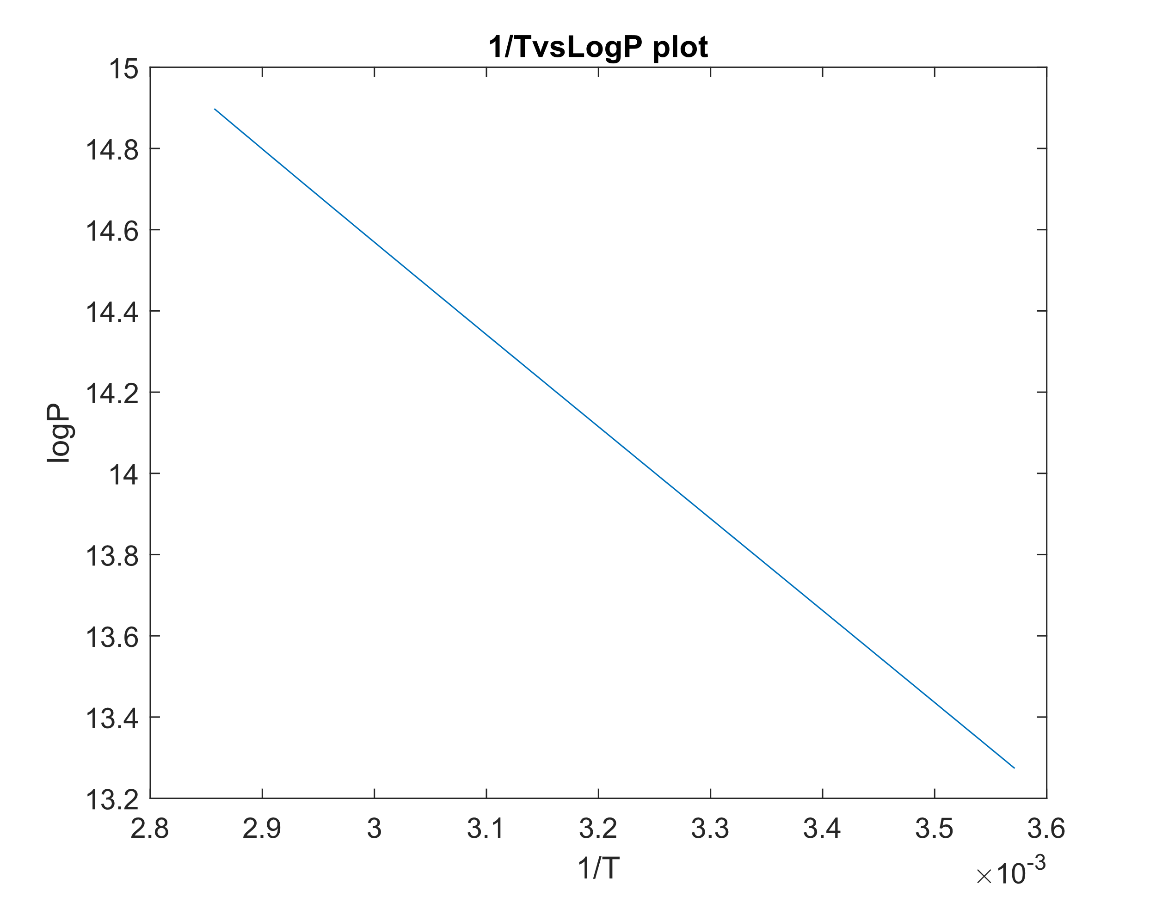

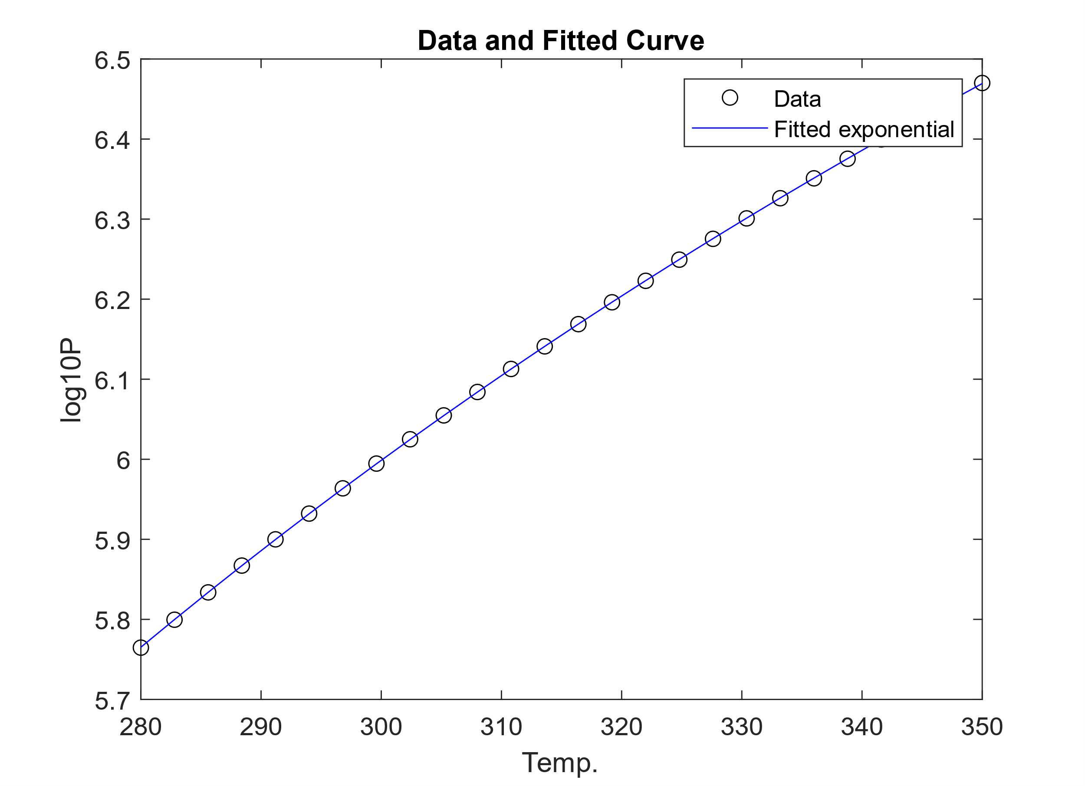

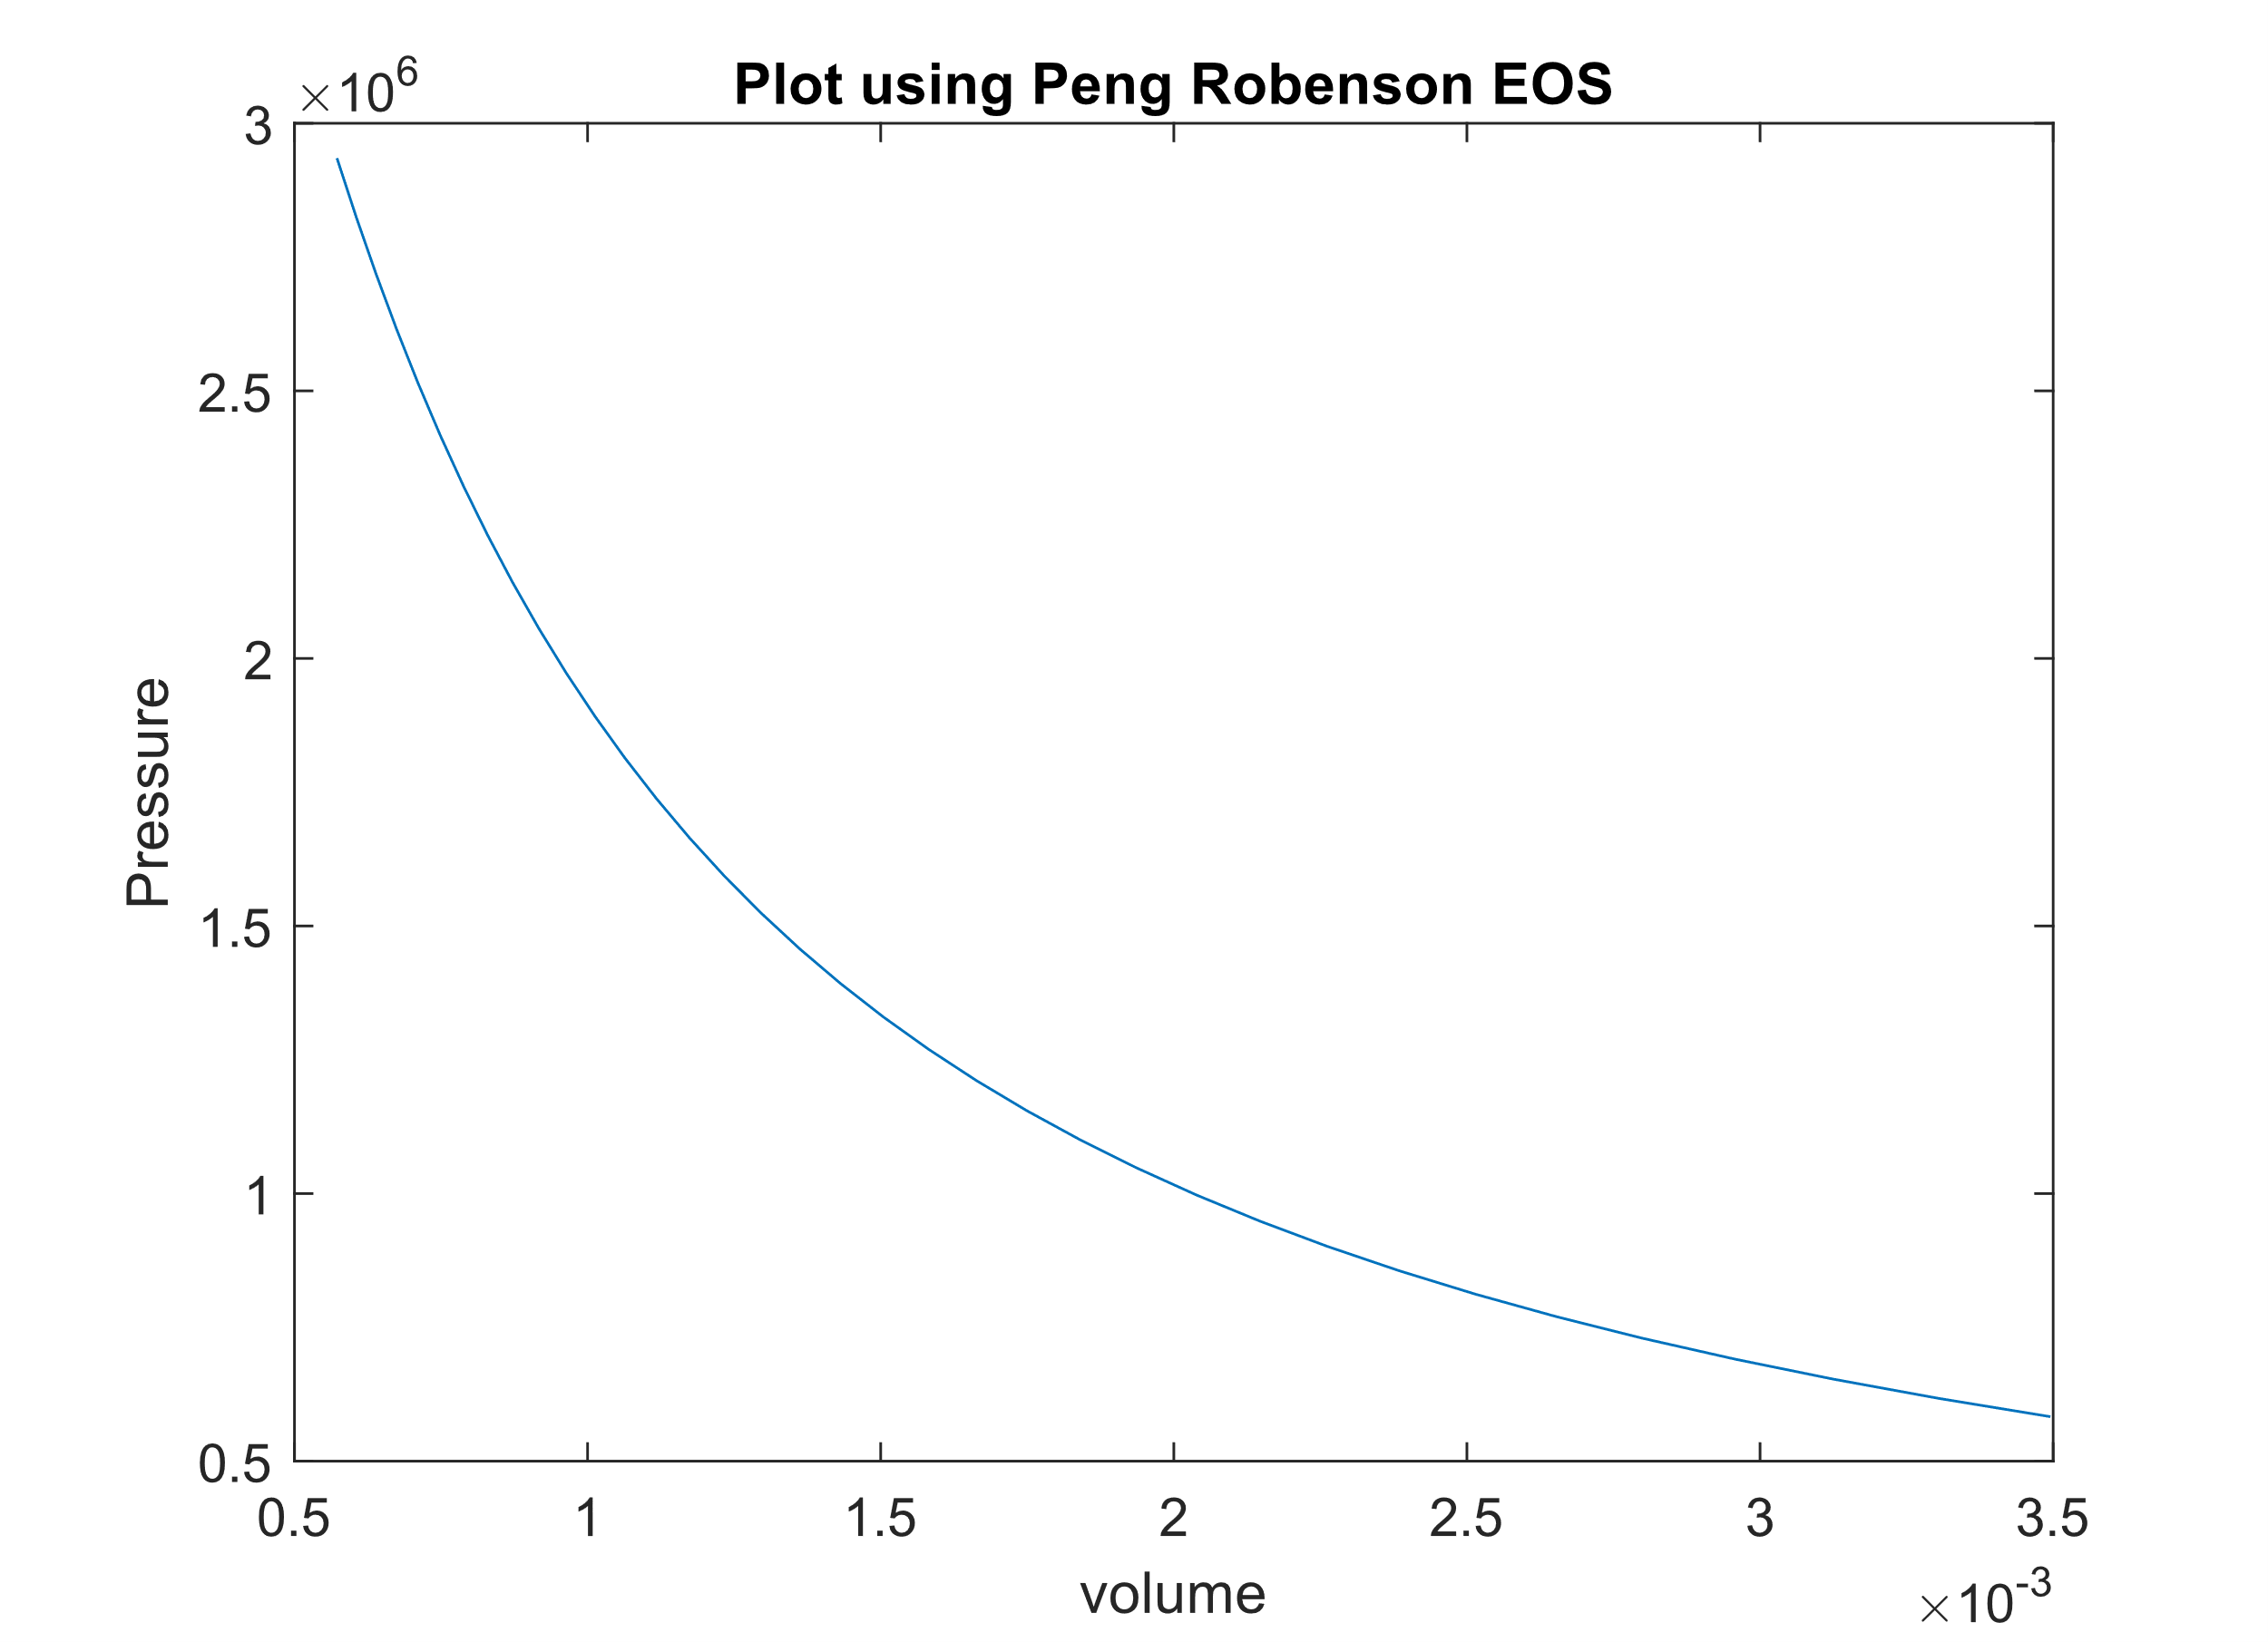

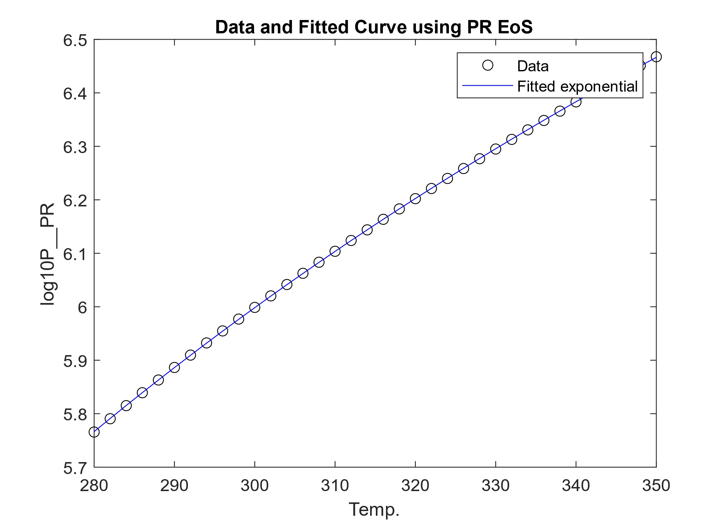

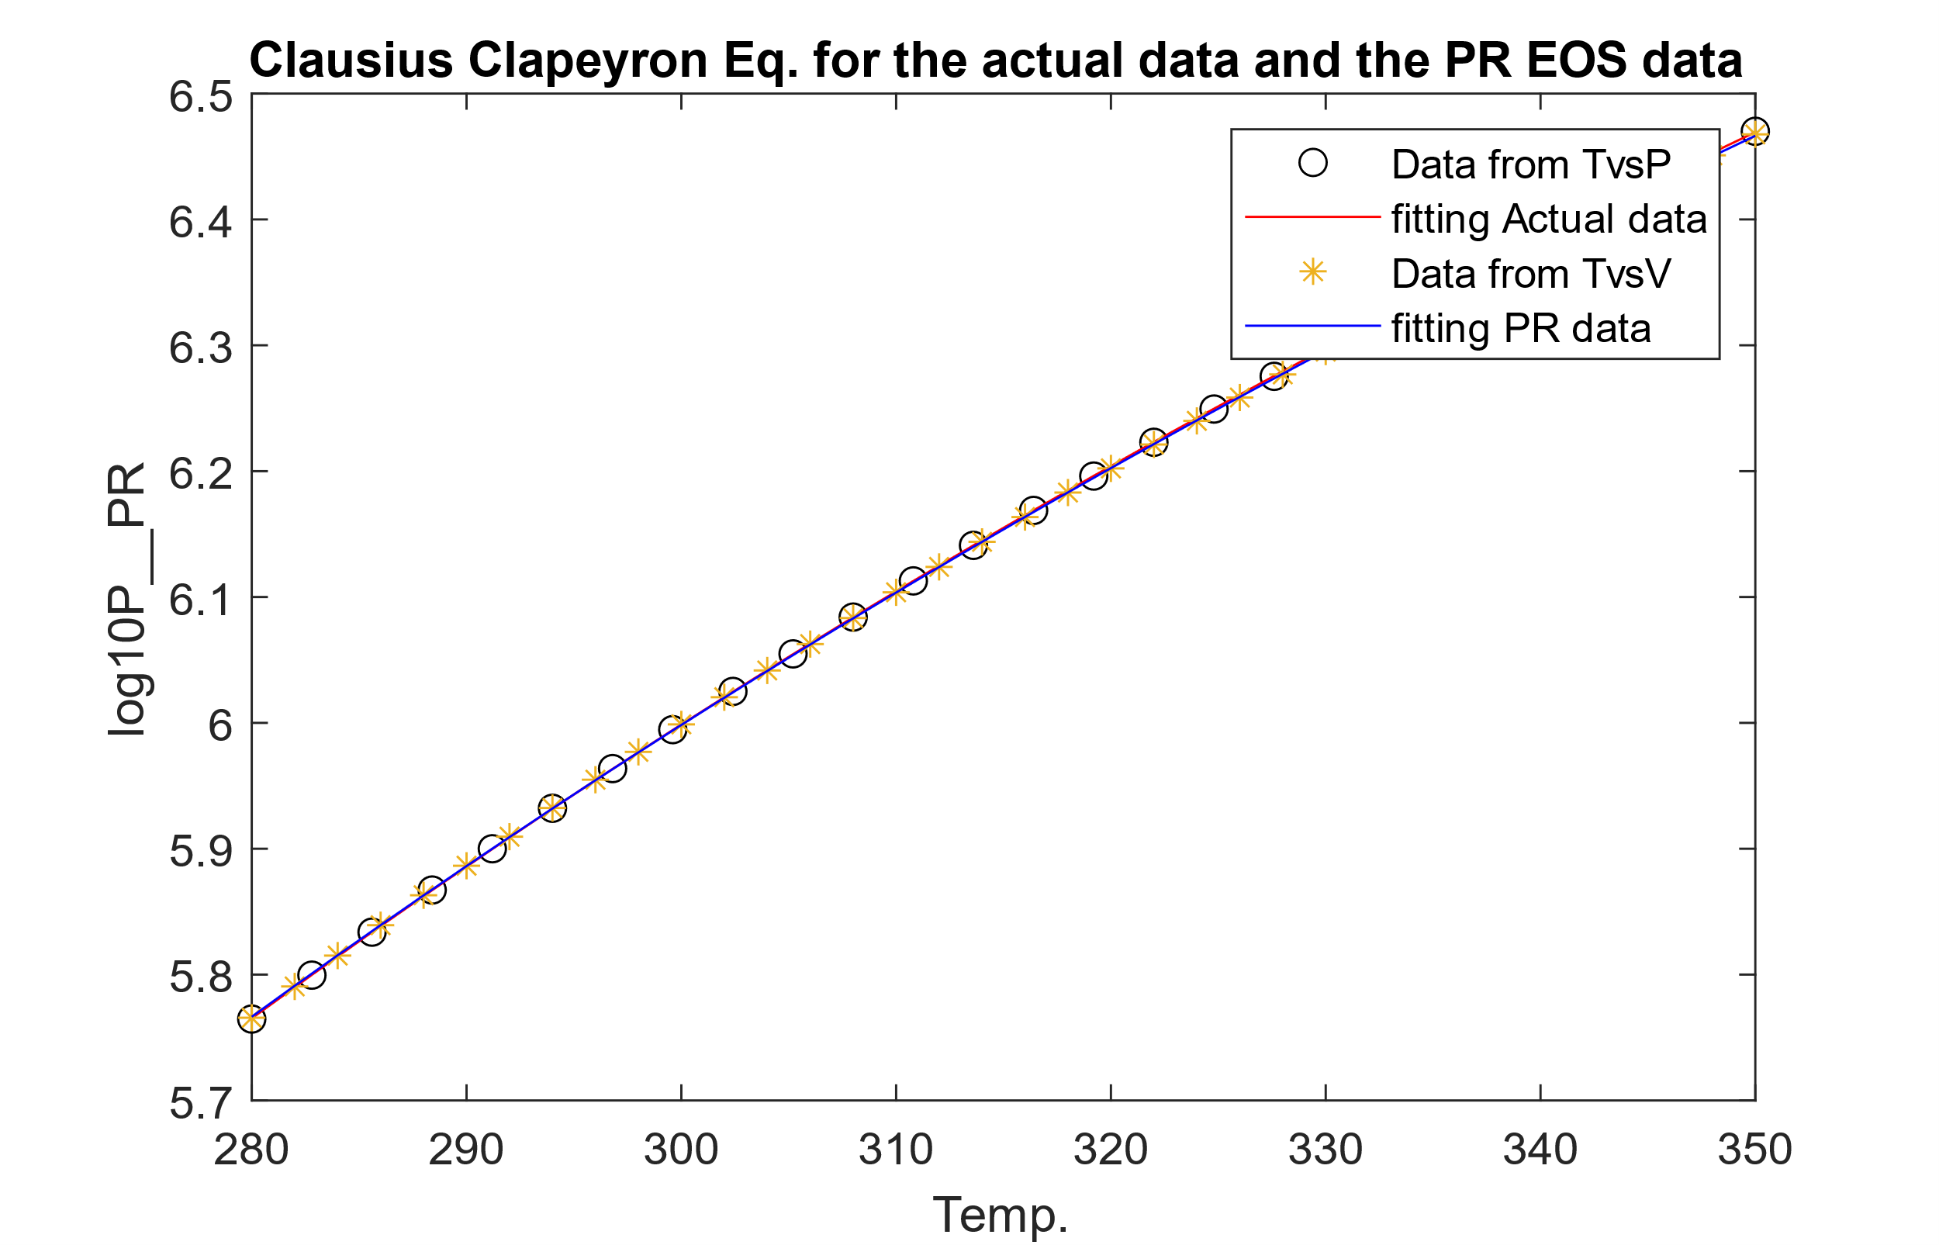

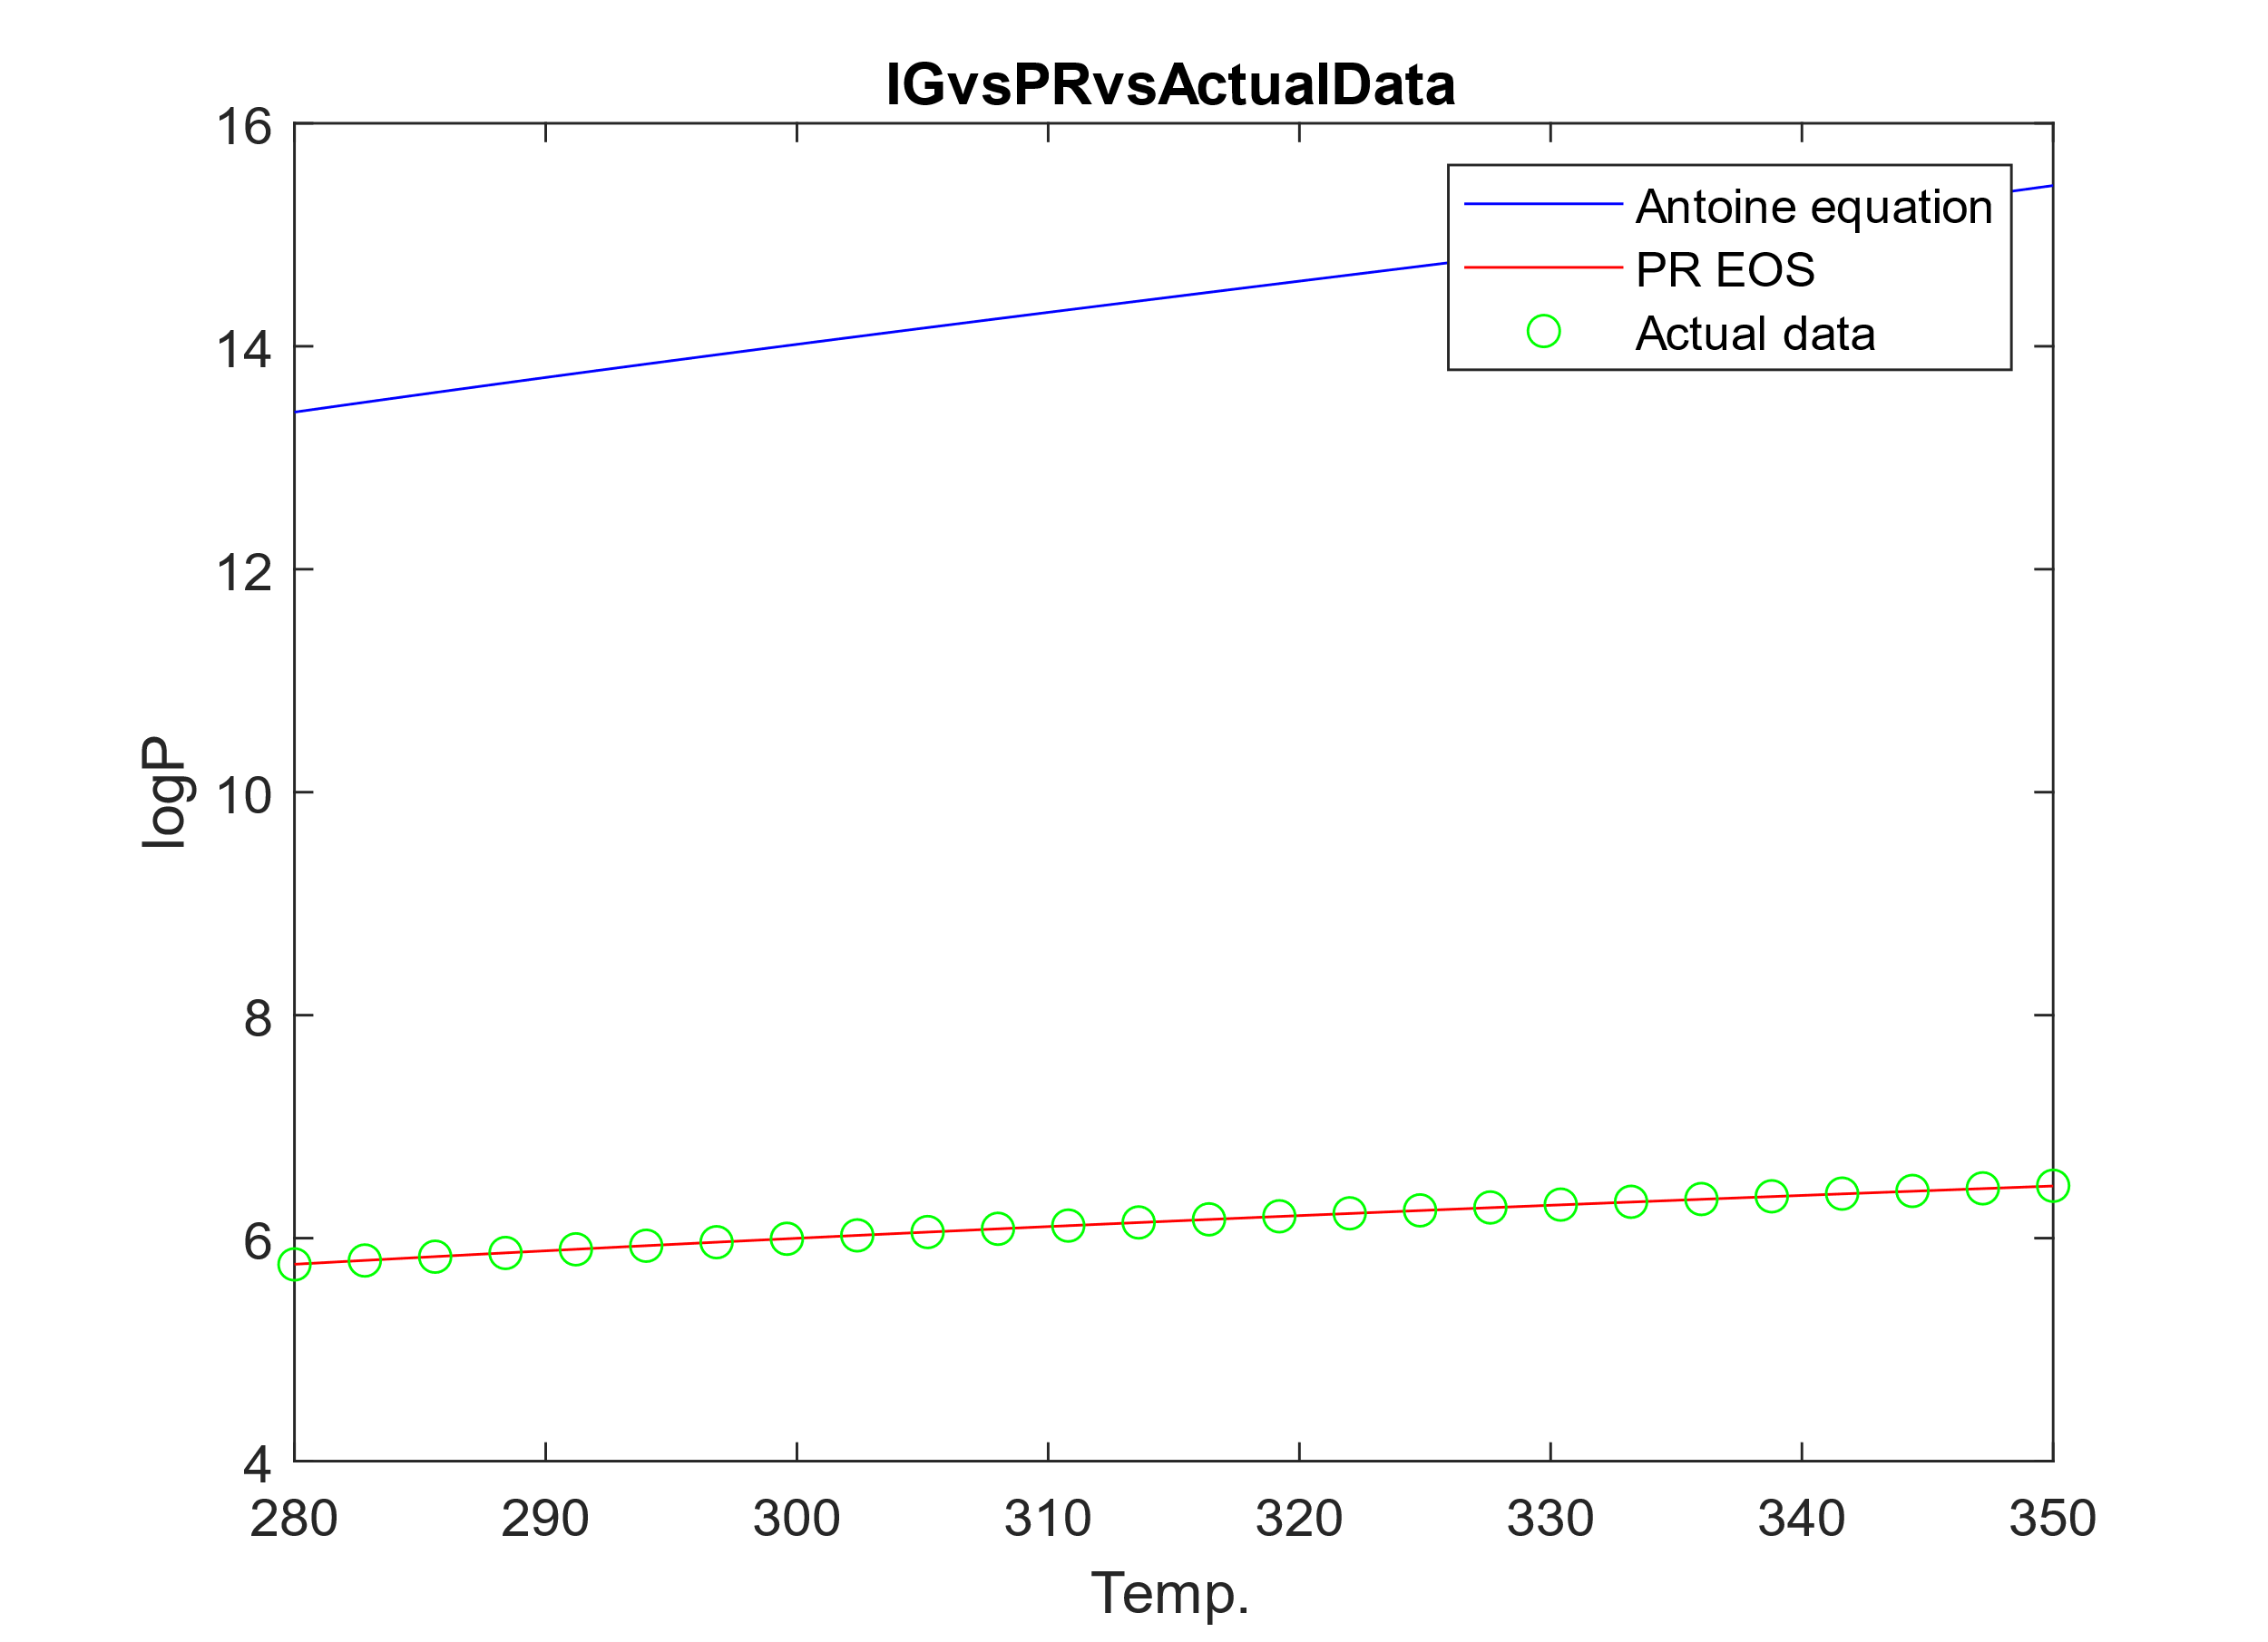

4. Conclusion/Summary:

In conclusion, the estimation of vapor pressure and enthalpy of vaporization is essential for ensuring the safety and efficiency of industrial processes involving volatile gases. Through our analysis using the Clausius Clapeyron Equation, Antoine Equation, and Peng-Robinson EOS, we have gained valuable insights into the behavior of the gas under various conditions.

* The Clausius Clapeyron Equation provided a reliable method for estimating the enthalpy of vaporization. This parameter is crucial for understanding the energy requirements of the gas and optimizing process design.
* Fitting the Antoine Equation to experimental data allowed us to obtain parameters that describe the vapor pressure behavior over a range of temperatures. The comparison with actual data provided validation for the model's accuracy.
* Utilizing the Peng-Robinson EOS for pressure calculation demonstrated its effectiveness in predicting vapor pressure under different conditions. The comparison with experimental data highlighted areas where the model may be improved or adjusted for better accuracy.
* Analysis using the Ideal Gas EOS provided additional insights into the behavior of the gas, particularly in comparison to more complex EOS models like Peng-Robinson.

5. Appendix:

Matlab code:

%defining veriables and values

ds=datastore('P-T-data.xlsx');

ds_1=datastore('T-V (1).xlsx');

data_1=read(ds_1);

data=read(ds);

t=table2array(data_1(:,1))';

v=table2array(data_1(:,2))';

T=table2array(data(:,1))';

P=table2array(data(:,2))';

log_P=log10(P*10^5);

log_P_1=log(P*10^5);

T_inv=1./T;

%part 1

% Enthalpy of vap.

R=8.314;

%dHvap=log(P)*R.*T;

f(1)=figure;

plot(T_inv,log_P_1);

xlabel('1/T'),ylabel('logP');

title('1/TvsLogP plot');

coeff=polyfit(T_inv,log_P_1,1);

delH=coeff(1)*R;

disp(delH);

fprintf('Enthalpy of Vaporization for actual data: %0.2f\n',delH)

%part 2

%best fit parameters, A, B, C for the gas.

fun = @(x,T)x(1)-(x(2)./(T+x(3)));

x0=[100,100,100];

lb=[];

ub=[];

x = lsqcurvefit(fun,x0,T,log_P,lb,ub);

f(2)=figure;

plot(T,log_P,'ko',T,fun(x,T),'b-');

xlabel('Temp.'),ylabel('log10P');

legend('Data','Fitted exponential');

title('Data and Fitted Curve');

fprintf('best fit parameters for Antoine Equation A,B,C respectively: %0.2f, %0.2f, %0.2f\n',x(1,1),x(1,2),x(1,3))

%part 3

%A)plot for Peng-Robenson (PR) EOS

Tc=369.9;

Pc=42.5*10^5;

w=0.153;

Tr=t./Tc;

alpha=(1+(0.37464+1.54226*w-0.26992*w^2)*(1-Tr.^(0.5))).^2;

b_PR=(0.0778*R*Tc)/Pc;

a_PR=(0.45724*R^2*Tc^2)/Pc;

P_PR=(R.*t)./(v-b_PR)-(a_PR.*alpha)./(v.^(2)+(2*b_PR).*v-b_PR^2);

f(3)=figure;

plot(v,P_PR);

xlabel('volume'),ylabel('Pressure');

title('Plot using Peng Robenson EOS');

%B)

coeff=polyfit(t_inv,log_P_PR,1);

delH_PR=coeff(1)*R;

disp(delH_PR);

fprintf('Enthalpy of Vaporization for PR: %0.2f\n',delH_PR)

%C)

%best fit parameters, A, B, C for the gas.

log_P_PR=log10(P_PR);

fun_1 = @(y,T)y(1)-(y(2)./(T+y(3)));

y0=[100,100,100];

lb=[];

ub=[];

y = lsqcurvefit(fun_1,x0,t,log_P_PR,lb,ub);

f(4)=figure;

plot(t,log_P_PR,'ko',t,fun_1(y,t),'b-');

xlabel('Temp.'),ylabel('log10P__PR');

legend('Data','Fitted exponential');

title('Data and Fitted Curve using PR EoS');

fprintf('best fit parameters for Antoine Equation for Peng Robenson EOS A,B,C respectively: %0.2f, %0.2f, %0.2f',y(1,1),y(1,2),y(1,3))

%D)

f(5)=figure;

plot(T,log_P,'ko',T,fun(x,T),'r-',t,log_P_PR,'*',t,fun_1(y,t),'b-');

xlabel('Temp.'),ylabel('log10P__PR');

legend('Data from TvsP','fitting Actual data','Data from TvsV','fitting PR data');

title('Clausius Clapeyron Eq. for the actual data and the PR EOS data');

%E)

%ideal gas EoS

%a)

N=1;

P_IG=(N*R.*t)./v;

%b)

t_inv=1./t;

log_P_IG=log(P_IG);

coeff=polyfit(t_inv,log_P_IG,1);

delH_IG=coeff(1)*R;

disp(delH_IG);

fprintf('Enthalpy of Vaporization for IG: %0.2f\n',delH_IG)

%c)

fun_3 = @(z,t)z(1)-(z(2)./(t+z(3)));

z0=[100,100,100];

lb=[];

ub=[];

z = lsqcurvefit(fun_3,z0,t,log_P_IG,lb,ub);

fprintf('best fit parameters for Antoine Equation for Ideal Gas EOS A,B,C respectively: %0.2f, %0.2f, %0.2f',z(1,1),z(1,2),z(1,3))

f(6)=figure;

plot(t,log_P_IG,'b-',t,log_P_PR,'r-',T,log_P,'go');

xlabel('Temp.'),ylabel('logP');

legend('Antoine equation','PR EOS','Actual data');

title('IGvsPRvsActualData');