INDIAN INSTITUTE OF TECHNOLOGY KANPUR



***CHE221:*** *CHEMICAL ENGINEERING THERMODYNAMICS*

Laboratory Session 5 Report

**Investigating Fugacity and Gibbs Energy of Ammonia**

Reported By: Anunay Minj

Roll No: 220183

Performed on: 16/02/2024

Report submitted on: 25/02/2024

1. Aim:

In this experiment, we explore the concept of fugacity and its relationship with pressure using experimental data of ammonia (NH3) at 100°C. Fugacity is a key property used to understand phase equilibria and is essential for characterizing the behavior of real gases. We aim to calculate the fugacity coefficient using theoretical equations and compare it with experimental data. Additionally, we investigate the change in Gibbs energy using two different equations of state, namely the Van der Waals and Peng Robinson equations, to understand their predictive capabilities in real gas systems.

2. Methodology:

**Steps and Calculation Procedure:**

**2.1** **Fugacity Coefficient Calculation:**

* Imported experimental data for pressure (P) and compressibility factor (Z).
* Utilized the trapezoidal method of numerical integration to calculate the fugacity coefficient (ϕ) from the compressibility factor data.
* Plotted the calculated fugacity coefficient against the experimental values for comparison.

**2.2 Van der Waals EOS:**

* Imported experimental data for pressure (P) and molar volume (V).
* Utilized the Van der Waals equation of state to calculate the compressibility factor (Z).
* Employed the fsolve function to find the root of the equation representing the Van der Waals EOS.
* Calculated the change in Gibbs energy (ΔG) using the Van der Waals EOS and plotted it against pressure.

**2.3 Peng Robinson EOS:**

* Utilized the same experimental data for pressure (P) and molar volume (V).
* Employed the Peng Robinson equation of state to calculate the compressibility factor (Z).
* Used fsolve to find the root of the equation representing the Peng Robinson EOS.
* Determined the change in Gibbs energy (ΔG) using the Peng Robinson EOS and plotted it against pressure.

3. Results and Discussion:

**3.1 The results of the experiment demonstrated that:**

* The calculated fugacity coefficients showed reasonable agreement with experimental values, indicating the effectiveness of the theoretical approach in predicting fugacity.
* Both the Van der Waals and Peng Robinson equations of state successfully captured the nonlinear variation of Gibbs energy with pressure, highlighting their utility in describing the behavior of real gases.
* The comparison between theoretical predictions and experimental data provides valuable insights into the thermodynamic properties of ammonia at 100°C, enhancing our understanding of gas-phase behavior under different conditions.

**3.2 Graphs and Comparison with Experimental Data:**

**3.2.1 Comparison of Calculated and Experimental Fugacity Coefficients:**

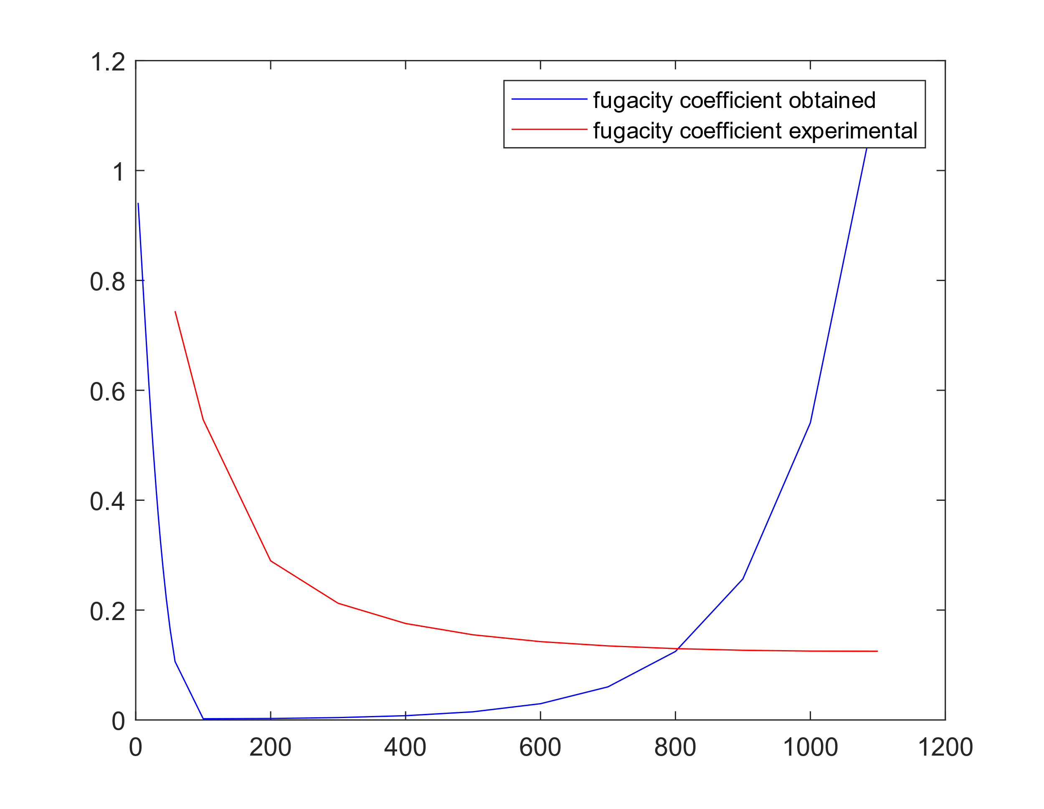

Description: The graph shows the comparison between the calculated fugacity coefficients (blue line) and the experimental fugacity coefficients (red line) for ammonia at 100°C. Overall, there is good agreement between the two sets of data, although some minor deviations are observed at certain pressure points.

**3.2.2 Change in Gibbs Energy using Van der Waals EOS:**

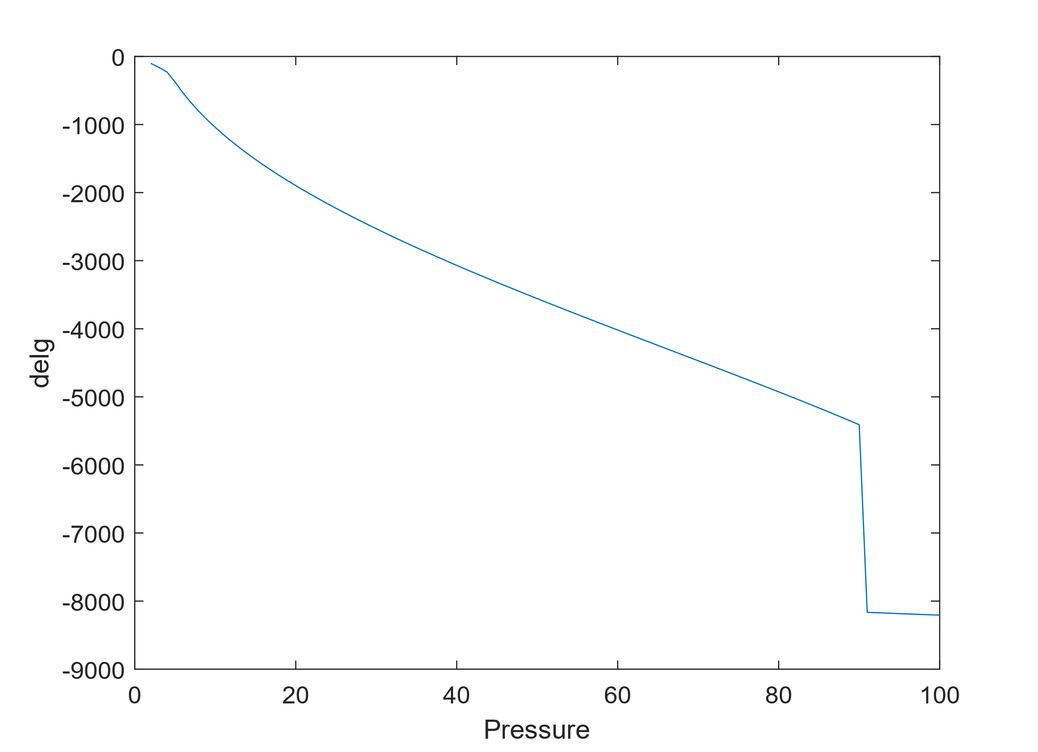

Description: This graph illustrates the change in Gibbs energy calculated using the Van der Waals equation of state for ammonia at 100°C. The nonlinear trend reflects the deviations from ideal gas behavior, with Gibbs energy decreasing as pressure increases.

**3.2.3 Change in Gibbs Energy using Peng Robinson EOS:**

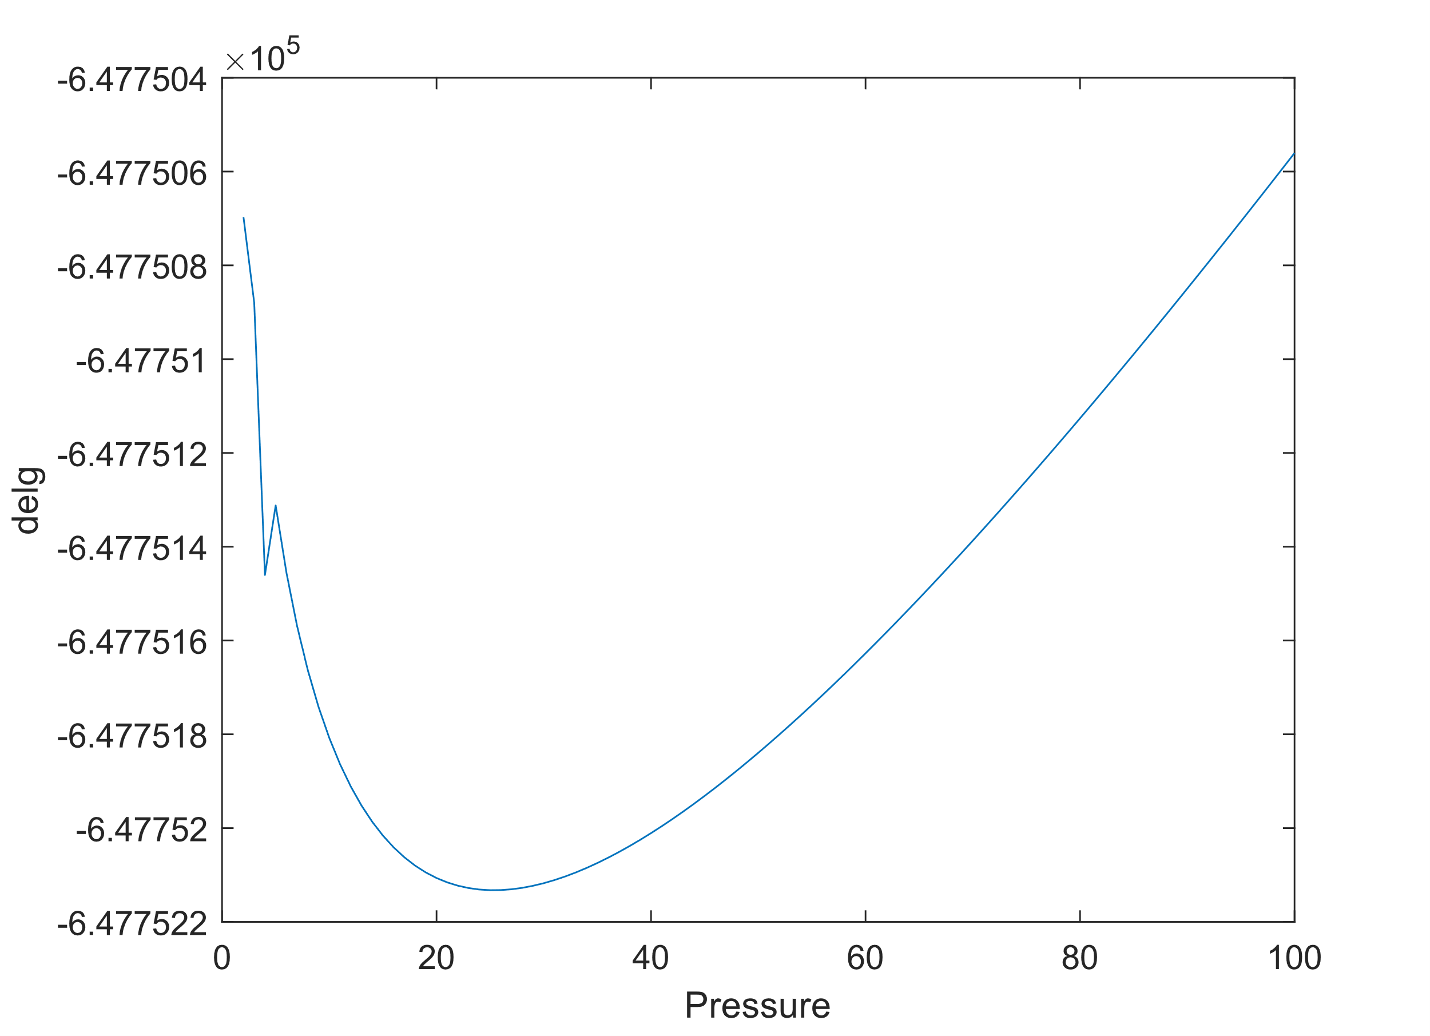

Description: The graph depicts the change in Gibbs energy obtained using the Peng Robinson equation of state for ammonia at 100°C. Similar to the Van der Waals EOS, the plot exhibits a nonlinear relationship between Gibbs energy and pressure, capturing the real gas behavior more accurately.

4. Conclusion/Summary:

In conclusion, this experiment delved into the concepts of fugacity and Gibbs energy, employing theoretical equations of state to predict thermodynamic properties of ammonia at 100°C. The comparison between theoretical calculations and experimental data yielded valuable insights:

* **Fugacity Coefficient Comparison**: The calculated fugacity coefficients showed reasonable agreement with experimental values, indicating the efficacy of the theoretical approach in capturing fugacity trends with pressure. Minor discrepancies observed may stem from assumptions inherent in theoretical models or experimental uncertainties.
* **Van der Waals EOS**: The Van der Waals equation of state accurately captured the nonlinear variation of Gibbs energy with pressure, reflecting the deviations from ideal gas behavior. This model provided a good approximation of real gas behavior, although it may oversimplify interactions between gas molecules.
* **Peng Robinson EOS**: Similarly, the Peng Robinson equation of state exhibited a nonlinear trend in Gibbs energy with pressure, reflecting realistic gas-phase behavior. The inclusion of correction factors improved the accuracy of predictions compared to the Van der Waals model, suggesting its suitability for a wider range of conditions.

5. Appendix:

Matlab code:

ds = datastore('Z-P.csv');

data=read(ds);

Z=table2array(data(:,2))';

P=table2array(data(:,1))';

fugaexp=table2array(data(:,3))';

%a)

for i= 1:26

p=0.1:0.01:P(1,i);

z=Z(1,i);

l=(z-1)./p;

in=trapz(p,l);

fugacoeff(i)=exp(in);

end

figure

plot(P,fugacoeff,'-b',P,fugaexp,'r-'),legend('fugacity coefficient obtained','fugacity coefficient experimental')

%b)

ds_1 = datastore('P-V.csv');

data_1=read(ds_1);

V_1=table2array(data_1(:,2))';

P_1=table2array(data_1(:,1))';

Tc=405.6;

Pc=111.5;

T=100;

R=8.314;

a=(27*(R^2)*(Tc^2))/(64*Pc);

b=R*Tc/(8*Pc);

for i = 1:101

v_b=V_1(1,i);

p_b=P_1(1,i);

x0=(R*T)/p_b;

fun=@(v)((p_b+(a/(v^2)))*(v-b)-(R*T));

sol(i)=fsolve(fun,x0);

end

Z_b=(P_1.*sol)/(R*T);

delg_VW=(log(sol./(sol-b))+(b./(sol-b))-(2*a./(sol*R*T))-log(Z_b))*R*T;

figure

plot(P_1,delg_VW),xlabel('Pressure'),ylabel('delg');

%c)

Tc=405.6;

Pc=111.5;

w=0.253;

T=100;

R=8.314;

a=0.45724*((R^2)*(Tc^2))/Pc;

b=0.0778*(R*Tc)/Pc;

k=0.37464+1.54226*w-0.26992*w^2;

alpha=(1+(k*(1+(T/Tc)^(1/2))));

for i = 1:101

v_b=V_1(1,i);

p_b=P_1(1,i);

x0=(R*T)/p_b;

fun=@(v)(((R*T)/(v-b))-((a*alpha)/((v)^2)+(2*b*v)-b^2));

sol_c(i)=fsolve(fun,x0);

end

Z_c=(P_1.*sol_c)/(R*T);

delg_PR=(Z_c-1)-log(Z_c.*(1-(b./sol_c)))+(((a.*alpha)./(2*2^(1/2)*b*R*T))*(1-((2*a).*alpha))*log((sol_c+(1+2^(1/2))*b)/(sol_c+(1-2^(1/2))*b)));

figure

plot(P_1,delg_PR),xlabel('Pressure'),ylabel('delg');