INDIAN INSTITUTE OF TECHNOLOGY KANPUR



***CHE221:*** *CHEMICAL ENGINEERING THERMODYNAMICS*

Laboratory Session 6 Report

**Analysis of Binary System of Ethanol and Water Using Antoine Equation**

Reported By: Anunay Minj

Roll No: 220183

Performed on: 01/03/2024

Report submitted on: 06/03/2024

1. Aim:

The study focuses on the analysis of a binary system comprising ethanol and water. Binary systems are fundamental in various industrial processes, notably in distillation and chemical engineering applications. Understanding the phase behavior and equilibrium compositions of such systems is crucial for designing efficient separation processes. The Antoine equation, which correlates vapor pressure with temperature, provides a useful tool for predicting the behavior of pure components in binary systems. In this report, we aim to utilize the Antoine equation to construct T-x-y and x-y diagrams for the ethanol-water system.

2. Methodology:

**Steps, calculation procedure:**

* Defining Variables: The Antoine equation parameters for ethanol and water are provided. These parameters are essential for calculating vapor pressures using the Antoine equation.
* Range Definition: A range of mole fractions is defined to cover the entire spectrum from 0 to 1. This range allows us to analyze the system's behavior across various compositions.
* Calculation of Vapor Pressure: The vapor pressures of ethanol and water are calculated at different temperatures using the Antoine equation. Iterative numerical methods, such as the fsolve function in MATLAB, are employed to solve the equations.
* T-x-y Diagram Construction: The calculated vapor pressures and temperatures are used to construct the T-x-y diagrams for both ethanol and water. These diagrams illustrate the relationship between temperature, liquid phase mole fraction, and vapor phase mole fraction.
* x-y Diagram Construction: Additionally, the x-y diagram specifically for ethanol is plotted. This diagram represents the distribution of ethanol between the liquid and vapor phases at equilibrium.

3. Results and Discussion:

* The T-x-y diagrams for water and ethanol exhibit characteristic trends in the phase behavior of the binary system. At lower temperatures, the liquid phase dominates, indicating higher concentrations of the respective component. As temperature increases, the vapor phase becomes more significant, reflecting increased volatility.
* The x-y diagram for ethanol provides insights into the distribution of ethanol between the liquid and vapor phases. This diagram is valuable for understanding the equilibrium composition of ethanol during separation processes like distillation.

**3.2 Graphs Obtained:**

**3.2.1** T-x-y of Ethanol**:**

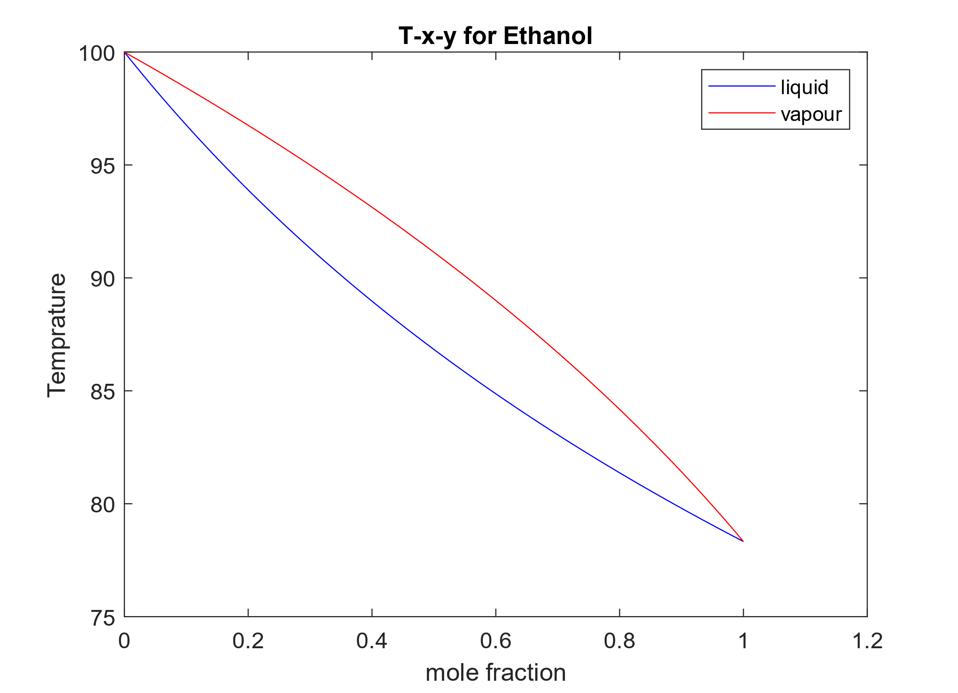

Description:

* This plot shows the T-x-y diagram for ethanol in the ethanol-water binary system.
* Similar to the T-x-y diagram for water, the x-axis represents the mole fraction of ethanol in the liquid phase.
* The y-axis represents the temperature in degrees Celsius.
* The blue curve represents the temperature of the liquid phase (ethanol) as a function of the mole fraction of ethanol.
* The red curve represents the temperature of the vapor phase (ethanol vapor) as a function of the mole fraction of ethanol.
* This diagram provides insights into the phase equilibrium behavior of ethanol in the binary system, showing how temperature varies with different ethanol mole fractions in the liquid and vapor phases.

**3.2.2** T-x-y of Water**:**

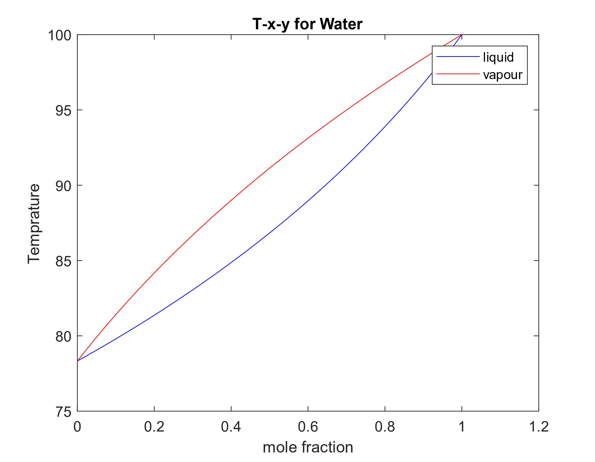

Description:

* This plot shows the T-x-y diagram for water in the ethanol-water binary system.
* The x-axis represents the mole fraction of ethanol in the liquid phase.
* The y-axis represents the temperature in degrees Celsius.
* The blue curve represents the temperature of the liquid phase (water) as a function of the mole fraction of ethanol.
* The red curve represents the temperature of the vapor phase (water vapor) as a function of the mole fraction of ethanol.
* This diagram illustrates how the temperature changes with varying mole fractions of ethanol in the liquid and vapor phases, providing insights into the phase equilibrium behavior of the system.

**3.2.3** x-y of Ethanol**:**

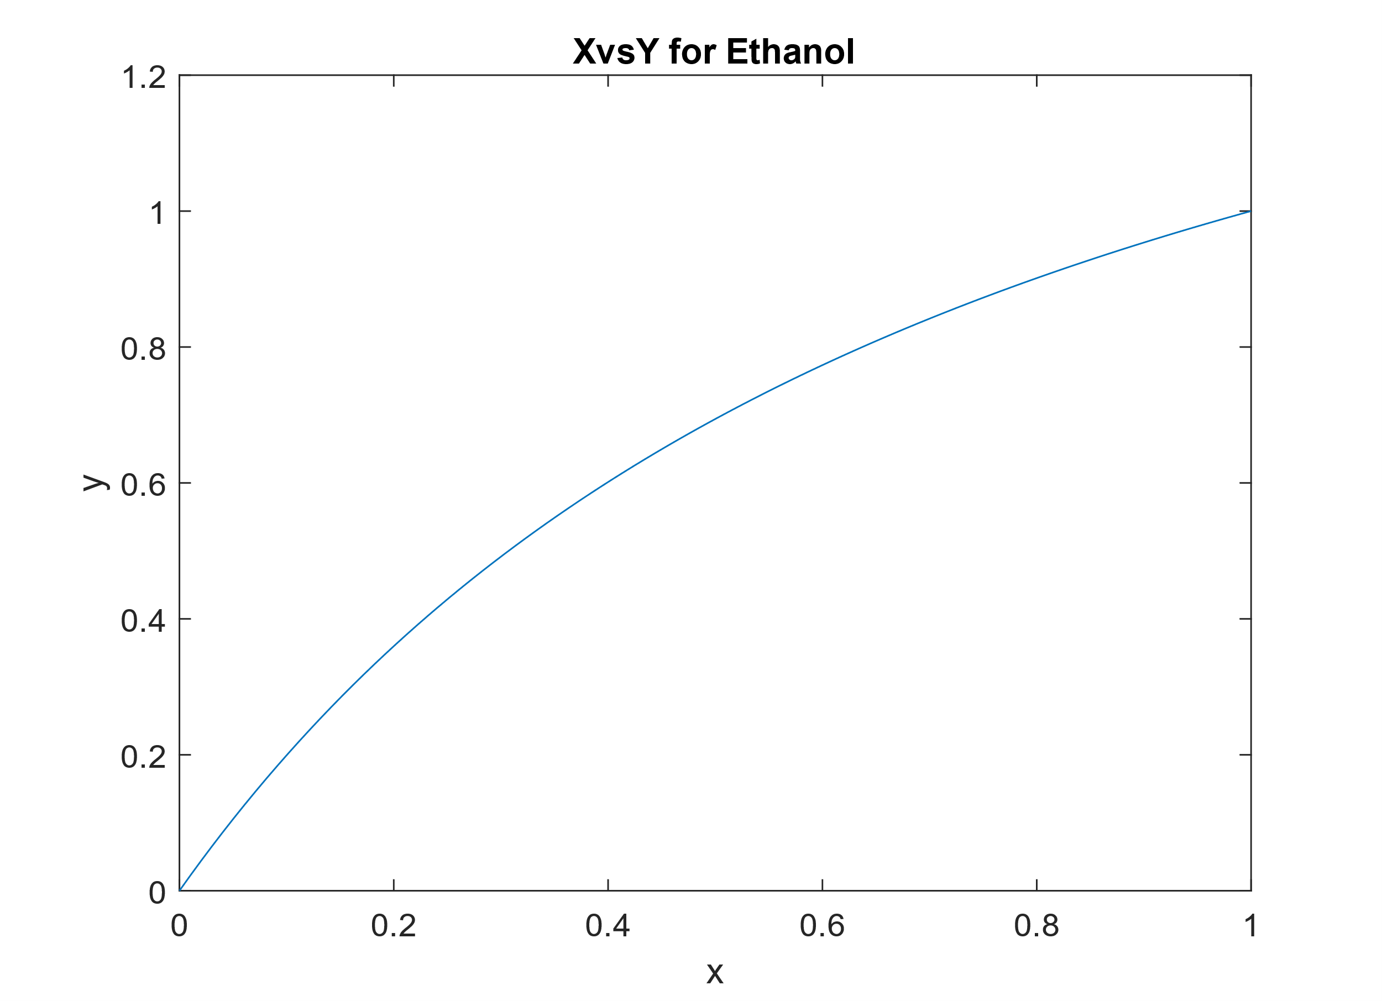

Description:

* This plot shows the x-y diagram for ethanol in the ethanol-water binary system.
* The x-axis represents the mole fraction of ethanol in the liquid phase.
* The y-axis represents the mole fraction of ethanol in the vapor phase.
* This diagram illustrates the distribution of ethanol between the liquid and vapor phases at equilibrium.
* It shows how the mole fraction of ethanol in the vapor phase varies with the mole fraction of ethanol in the liquid phase, providing insights into the separation behavior of ethanol during distillation or other processes.

4. Conclusion/Summary:

In conclusion, the analysis of the ethanol-water binary system using the Antoine equation and MATLAB programming provides valuable insights into the phase equilibrium behavior and composition of the system. The constructed T-x-y and x-y diagrams offer a visual representation of the system's behavior, aiding in the optimization of separation processes and unit operations. While the results provide valuable insights, further studies incorporating experimental data and considering non-ideal behavior are warranted for a more comprehensive understanding of the system.

5. Appendix:

Matlab code:

%defining all the variables

A_water=8.07131;

B_water=1730.63;

C_water=233.426;

A_ethanol=8.2133;

B_ethanol=1652.05;

C_ethanol=231.48;

P_atm=1;

P_mmHg=760;

%defining range

x_range=linspace(0,1,100);

%for water part

T_water=zeros(1,length(x_range));

y_water=zeros(1,length(x_range));

for i=1:100

fun=@(T) (760-(x_range(i)*(10^(A_water-B_water/(C_water+T))))-((1-x_range(i))*(10^(A_ethanol-B_ethanol/(C_ethanol+T)))));

T0=0;

T_water(i)=fsolve(fun,T0);

y_water(i)=(x_range(i)*10^(A_water-B_water/(C_water+T_water(i))))/P_mmHg;

end

figure

plot(x_range,T_water,'b',y_water,T_water,'r'), xlabel('mole fraction'),ylabel('Temprature'),legend('liquid','vapour'),title('T-x-y for Water')

%for ethanol part

T_ethanol=zeros(1,length(x_range));

y_ethanol=zeros(1,length(x_range));

for i=1:100

fun=@(T) (760-(x_range(101-i)*(10^(A_water-B_water/(C_water+T))))-((1-x_range(101-i))*(10^(A_ethanol-B_ethanol/(C_ethanol+T)))));

T0=0;

T_ethanol(i)=fsolve(fun,T0);

y_ethanol(i)=(x_range(i)*10^(A_ethanol-B_ethanol/(C_ethanol+T_ethanol(i))))/P_mmHg;

end

figure

plot(x_range,T_ethanol,'b',y_ethanol,T_ethanol,'r'), xlabel('mole fraction'),ylabel('Temprature'),legend('liquid','vapour'),title('T-x-y for Ethanol')

%2)

%X and Y for ethanol has been calculated in above section

%ploted x-y for ethanol

figure

plot(x_range,y_ethanol),xlabel('x'),ylabel('y'),title('XvsY for Ethanol');