HANOI UNIVERSITY
FACULTY OF INFORMATION TECHNOLOGY


Project 2 Report:
LSTM-Based Predictive Maintenance for Industrial Pump Systems
Group: 1
Members: Tran Duc Anh - 2201140007
Nguyen Quoc Hoang An - 2201140011
Pham Khanh Son - 2201140076
Lecturer: Nguyen Xuan Thang
Course: 62FIT4ATI

Fall 2025
TABLE OF CONTENTS
1. Introduction 2
2. Problem formulation 2
3. Model architecture 2
3.1 Rationale for using LSTM 2
3.2. Choice of LSTM over GRU 2
3.3. Network structure 3
3.4. Loss function and optimization 4
4. Training strategy 4
4.1. Temporal data splitting 4
4.2. Optimization techniques for training stability and class imbalance 4
4.3. Training dynamics and convergence analysis 5
5. Evaluation Metrics 6
6. Results 6
6.1. General 6
6.2. Confusion matrix analysis 7
7. Discussion 7
7.1. Architecture design and discussion 7
7.1.1. Number of LSTM layers 7
7.1.2. Window size selection 8
7.1.3. Regularization strategy 8
7.1.4. Impact of class weighting 8
7.2 Integrated Interpretation of Results 8
8. Limitations and future works 9
9. Conclusion 9

1. Introduction
Predictive maintenance relies on detecting early patterns in sensor data that indicate abnormal or failing machine states. In industrial pump systems, these patterns often manifest over time rather than at isolated moments, making time-series modeling essential.
This project focuses on multiclass time-series classification using sensor data collected from an industrial pump. The objective is to predict the machine’s operational state - NORMAL, BROKEN, or RECOVERING - based on historical sensor readings. To model temporal dependencies and capture long-range patterns, a Long Short-Term Memory (LSTM) neural network is employed.
The emphasis of this work is on model architecture design and result interpretation under class imbalance, rather than purely maximizing accuracy.

2. Problem formulation
Given a multivariate time-series of sensor measurements:
$$X=\{x_{1},x_{2},…,x_{T}\},x_{t}∈R^{d}$$
the goal is to learn a function:
$$f(X_{t-w:t})→y_{t}$$
where $w$ is the window size and $y_{t}$ is the machine state at the final timestep of the window. This formulation allows the model to learn precursor patterns that precede changes in machine condition.

3. Model architecture

3.1 Rationale for using LSTM
Standard feedforward models treat each sample independently and are unable to capture temporal dependencies. In contrast, LSTMs are specifically designed to model sequential data through gated memory cells that regulate information flow over time.
This makes LSTM networks well-suited for predictive maintenance tasks, where early sensor anomalies may precede failures by many timesteps.

3.2. Choice of LSTM over GRU
Although both Long Short-Term Memory (LSTM) networks and Gated Recurrent Units (GRU) are widely used for time-series modeling, LSTM was selected in this work due to its enhanced capability to model long-term temporal dependencies.
LSTM architectures employ separate input, forget, and output gates, allowing finer control over memory retention and information flow across long sequences. This is particularly relevant for predictive maintenance, where early sensor anomalies may precede failure events by many timesteps.
While GRU offers a more compact structure with fewer parameters and faster training, the additional gating mechanisms of LSTM provide greater expressive power for complex industrial sensor data. Given the sufficient dataset size and the emphasis on capturing long-range degradation patterns rather than minimizing computational cost, LSTM was chosen as the more appropriate recurrent architecture for this task.

3.3. Network structure
The final architecture consists of a stacked LSTM network with the following components:
- Input layer: Accepts sequences of shape (WINDOW_SIZE, num_features).
- First LSTM layer (64 units)
  - Configured with return_sequences=True
  - Captures low-level temporal patterns across the full sequence
  - Outputs a sequence of hidden states
- Second LSTM layer (32 units)
  - Processes the output of the first LSTM
  - Compresses temporal information into a final hidden representation
- Dropout layers (rate = 0.3)
  - Applied after each LSTM layer
  - Reduce overfitting by randomly disabling neurons during training
- Dense output layer with softmax activation
  - Produces class probabilities for the three machine states
This design balances expressive power and regularization, enabling the model to learn meaningful temporal representations without excessive complexity.

3.4. Loss function and optimization
The model is trained using sparse categorical cross-entropy loss, which is well suited for multiclass classification with integer-encoded labels and avoids the overhead of one-hot encoding. This formulation allows efficient optimization while maintaining numerical stability.
The Adam optimizer is employed due to its adaptive learning rate mechanism and strong empirical performance in training deep recurrent neural networks. Adam combines the benefits of momentum-based optimization and per-parameter learning rate adaptation, making it particularly effective for non-stationary objectives such as time-series classification.
Class weights are incorporated into the loss formulation to account for the imbalanced distribution of machine states. This design choice ensures that rare but critical failure-related classes contribute meaningfully to the optimization objective.

4. Training strategy

4.1. Temporal data splitting
To maintain realism and prevent information leakage, the dataset is split chronologically into training, validation, and test sets. This ensures that the model is evaluated on future data relative to the training period.

4.2. Optimization techniques for training stability and class imbalance
Training recurrent neural networks on industrial time-series data presents challenges related to both optimization stability and class imbalance. To address these issues, several complementary techniques are employed during training.
Class-weighted loss modifies the optimization landscape by increasing the penalty associated with misclassification of rare machine states. This encourages the model to allocate representational capacity to minority classes rather than converging to trivial majority-class solutions.
Training stability is further improved through the use of early stopping and learning rate reduction on plateau. Early stopping prevents over-optimization once validation performance stagnates, while adaptive learning rate scheduling enables finer convergence during later training stages. Together, these mechanisms reduce overfitting and improve generalization.
Dropout regularization is applied within the LSTM layers to mitigate co-adaptation of neurons and enhance robustness. The combined effect of these optimization techniques is reflected in stable training dynamics and consistent validation performance.

4.3. Training dynamics and convergence analysis
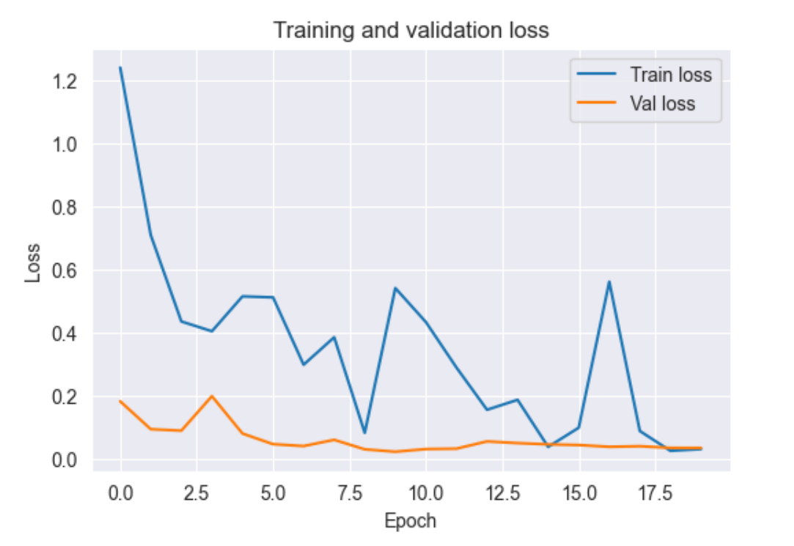
Figure 1: Training and validation loss over epochs
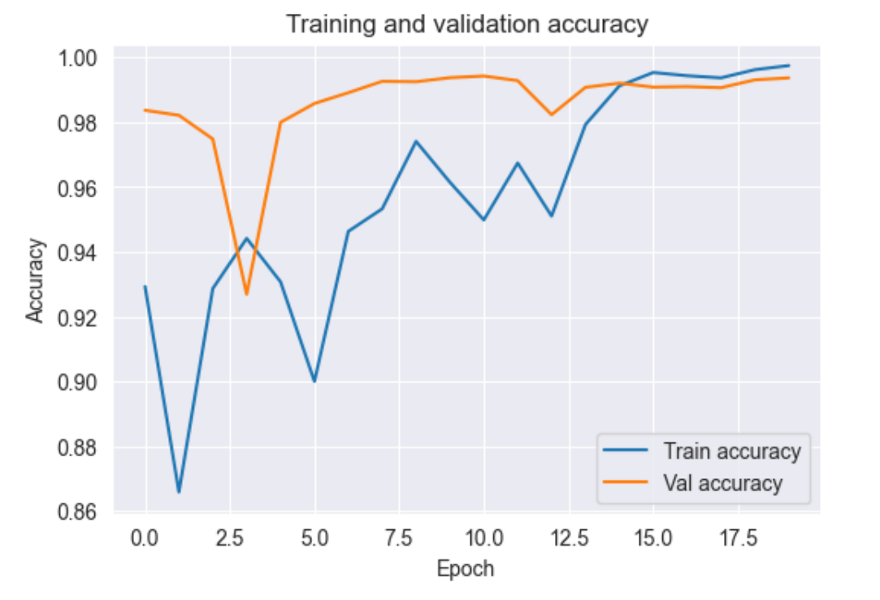
Figure 2: Training and validation accuracy over epochs
Figure 1 illustrates the training and validation loss curves across epochs, while Figure 2 shows the corresponding accuracy curves. The training loss decreases smoothly and plateaus after several epochs, indicating effective optimization by the Adam optimizer. Validation loss closely follows the training loss, with no significant divergence, suggesting that overfitting is well controlled.
The accuracy curves show a rapid increase during early epochs followed by stabilization, further confirming convergence. The absence of oscillatory behavior or sudden divergence supports the effectiveness of the chosen learning rate and regularization strategy. Early stopping prevents unnecessary training beyond the point of diminishing returns.
Overall, the training curves indicate that the model capacity is sufficient to learn meaningful temporal representations without memorizing the training data.

5. Evaluation Metrics
Given the strong class imbalance in the dataset, standard accuracy alone is insufficient to evaluate model performance. Instead, balanced accuracy and macro-averaged F1-score are used. Balanced accuracy computes the average recall across classes, ensuring that minority states contribute equally to the final score. Macro F1-score further emphasizes per-class performance by averaging F1 values without weighting by class frequency.
Balanced accuracy and macro-averaged F1-score were selected specifically to account for the severe class imbalance present in the dataset, ensuring that minority machine states contribute equally to the evaluation rather than being dominated by the majority class.

6. Results

6.1. General
The trained LSTM model achieves a high balanced accuracy, indicating strong recall across the machine states observed in the test set. In contrast, the macro-averaged F1-score is notably lower, reflecting the increased difficulty of accurately predicting rare machine states such as BROKEN and RECOVERING.
In some evaluation windows, the model predicts classes that do not appear in the test set, resulting in a warning during metric computation. This behavior is expected under temporal splitting when certain rare states are absent from the evaluation period and should be interpreted as a realistic deployment scenario rather than a modeling error.

6.2. Confusion matrix analysis
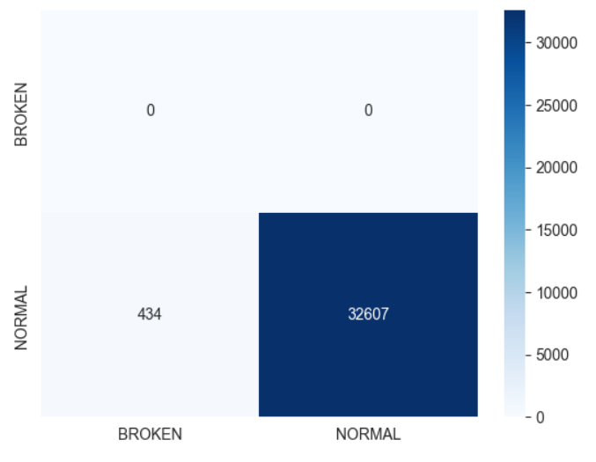
Figure 3: Confusion matrix on test set
Figure 3 presents the confusion matrix for the test set. The matrix reveals that the model correctly classifies the majority of NORMAL samples, reflecting the strong dominance of this class in the dataset. This behavior largely explains the high balanced accuracy observed during evaluation.
However, confusion between BROKEN and RECOVERING states is evident. These states are underrepresented and exhibit overlapping sensor patterns, making them inherently harder to distinguish. In some cases, the model predicts failure-related classes that do not appear in the test set window, which contributes to reduced macro F1-score.
This phenomenon highlights an important deployment consideration: in predictive maintenance, conservative predictions that occasionally flag rare failure states may be preferable to missing early failure signals altogether.

7. Discussion

7.1. Architecture design and discussion

7.1.1. Number of LSTM layers
A stacked LSTM architecture with two recurrent layers was selected to balance representational capacity and generalization. The first LSTM layer captures short-term temporal patterns across the input sequence, while the second layer aggregates this information into a higher-level temporal summary.
Preliminary experimentation with a single LSTM layer resulted in faster convergence but weaker minority-class performance, suggesting insufficient model capacity. Conversely, deeper architectures were found to increase training time and overfitting risk without clear performance gains. Two layers therefore represent a practical compromise.

7.1.2. Window size selection
A window size of 50 timesteps was chosen to provide sufficient temporal context while maintaining a manageable input size. Shorter windows limited the model’s ability to capture gradual degradation patterns, whereas significantly longer windows increased computational cost and redundancy due to highly overlapping sequences.
Empirically, a window of 50 timesteps allowed the model to learn precursor trends without introducing excessive noise or memory overhead.

7.1.3. Regularization strategy
Dropout layers with a rate of 0.3 were applied after each LSTM layer to mitigate overfitting. This was particularly important given the imbalance in class distribution and the large number of generated sequences. Training curves confirm that dropout contributes to stable validation performance.
Early stopping and learning-rate reduction further improved robustness by preventing over-optimization and enabling finer convergence near local minima.

7.1.4. Impact of class weighting
Class weighting significantly influenced training dynamics. Without class weights, the model quickly converged to predicting the dominant NORMAL class, yielding deceptively high accuracy but poor minority-class recall. Introducing class weights increased sensitivity to BROKEN and RECOVERING states, at the cost of increased variance in predictions.
This trade-off is reflected in the divergence between balanced accuracy and macro F1-score and underscores the importance of metric selection when evaluating imbalanced time-series models.

7.2 Integrated Interpretation of Results
Taken together, the training curves, confusion matrix, and evaluation metrics provide a coherent picture of model behavior. The LSTM architecture successfully learns temporal patterns from sensor data and generalizes well to unseen time periods. However, class imbalance fundamentally limits performance on rare states.
Rather than indicating model failure, the lower macro F1-score reflects the difficulty of detecting infrequent but critical events. In operational settings, such behavior may be acceptable or even desirable, depending on the cost of false positives versus missed failures.

8. Limitations and future works
Several limitations of the current approach suggest directions for future improvement. The severe class imbalance remains a fundamental challenge and may benefit from alternative loss functions such as focal loss, which place greater emphasis on hard-to-classify samples. Additionally, sequence-level resampling techniques could be explored to increase exposure to rare machine states during training.
From a modeling perspective, more advanced architectures such as bidirectional LSTMs or attention-based mechanisms may improve the model’s ability to capture complex temporal dependencies. Finally, incorporating domain-specific knowledge through engineered temporal features could further enhance predictive performance.

9. Conclusion
This project demonstrates that LSTM-based architectures are effective for modeling multivariate industrial sensor time series. The stacked LSTM design successfully captures temporal dependencies and provides robust performance on dominant machine states.
While class imbalance limits minority-class performance, the model offers a strong baseline for predictive maintenance and illustrates the importance of architecture choice and evaluation methodology in time-series classification tasks.

