Process Chars:
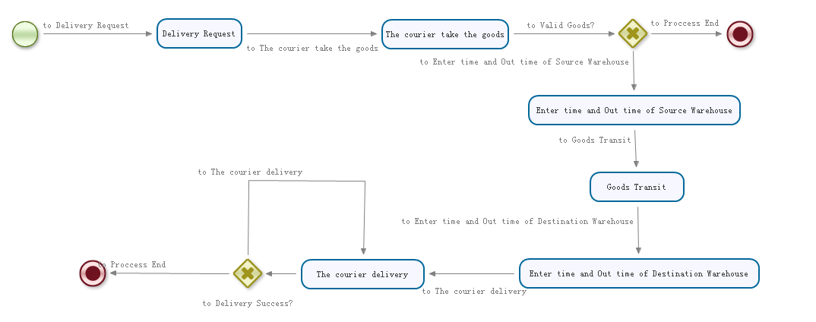
Task Description:
Task： | Delivery Request
Assignment(Group) | Shipment System 800 coordinator
Process Variables
Variables Name | Description
Sender_Address | Sender Address
Sender_Phone | Sender Phone Number

Task： |  | The courier takes the goods
Assignment(Group) |  | The courier
Process Variables
Variables Name | Description
Sender_Address | Sender Address
Sender_Phone | Sender Phone Number
Receiver_Address | Receiver Address
Receiver_Phone | Receiver Phone Number
Description | Express Description, such as: Goods name, Special requirements

Task： |  | Enter time and Out time of Source Warehouse
Assignment(Group) |  | Warehouse Administrator
Process Variables
Variables Name | Description
In_time | the time of the goods enter of warehouse
Out_time | the time of the goods out of warehouse

Task： | Goods Transit
Assignment | Transport company
Process Variables
Variables Name | Description

Task： | Enter time and Out time of Destination Warehouse
Assignment | Warehouse Administrator
Process Variables
Variables Name | Description
In_time | the time of the goods enter of warehouse
Out_time | the time of the goods out of warehouse

Task： | The courier delivery
Assignment | The courier
Process Variables
Variables Name | Description
Courier_ID | The courier user id
Delivery_time | Delivery Time

Database Design：
Table Name | User
Description | Shipment system user information, such as: customer service staff information, the courier information, the warehouse administrator
Column | Column Description
userid | User ID
username | User Name
password | Password
phone_number | User Phone Number
groupid | Group ID

Table Name | Group
Description | Shipment system group information
Column | Column Description
groupid | Group ID
groupname | Group Name

